Victorian Training Market Quarterly Report   
Q1 2013

Published by the

Department of Education and  
Early Childhood Development

Melbourne  
June 2013

©State of Victoria (Department of Education  
and Early Childhood Development) 2013

The copyright in this document is owned by the State of Victoria (Department of Education and Early Childhood Development), or in the case of some materials, by third parties (third party materials). No part may be reproduced by any process except in accordance with the provisions of the Copyright Act 1968, the National Education Access Licence for Schools (NEALS) (see below) or with permission.

An educational institution situated in Australia which is not conducted for profit, or a body responsible for administering such an institution may copy and communicate the materials, other than third party materials, for the educational purposes of the institution.

Authorised by the Department of Education  
and Early Childhood Development,   
2 Treasury Place, East Melbourne, Victoria, 3002

This document is also available on the internet at

www.education.vic.gov.au

Executive Summary 5

The Policy Context of Vocational Training 9

Purpose and Background 12

Notes about the data and time periods 12

Reporting scope 12

Victorian Vocational Training Summary 13

Vocational Training by Funding Type 13

Qualification Levels 18

Age Profile 22

Apprentices and Trainees 25

Government subsidised regional activity 28

Government Subsidised Delivery by Provider Type 30

Adult, Community and Further Education (ACFE) Performance 31

Responsiveness to Skills Needs 34

Overall Responsiveness of the Training Market 35

Analysis of Specialised and In Shortage Courses by Industry Sector 37

Analysis of Specialised and In Shortage Related Courses by occupations 39

Learner Cohorts and Foundation Level Training 42

Vocational Training Delivery to Specific Learner Cohorts 42

Indigenous Students 43

Students with a Disability 44

Students with a Culturally and Linguistically Diverse (CALD) Background 45

Unemployed Students 46

Young People (Aged 15 to 19) Without Year 12 or Equivalent and Not at School 47

Older Students with Low Prior Qualifications 47

Foundation Level Training 48

### Notes on data included in this report

The Victorian Training Market Report is compiled on the basis of training activity data submitted to the Department of Education and Early Child Development by funded training providers. Data included in the Report is based on reported date, i.e. the date training activity data is submitted to the Department. Quarter 1 2013 includes training activity data that was submitted to the Department between January and March 2013.

### Data collection

The commentary contained in the report generally compares first quarter reported figures for 2013 with first quarter figures in 2012. Full year figures from 2008 to 2012 are included to show longer term trends. The figures in the first quarter are a snapshot in time and should be treated as indicative only as they are based on preliminary enrolment data reported to the Department by training providers.

In some cases some providers may not have submitted their full quarter’s training data which could impact on the overall state result for the quarter. In particular, some providers may have students who have commenced a course in the later part of a quarter and as a consequence of provider processes this information may not be reported to the Department until the following quarter. For example, two TAFEs had about 2,000 course commencements that occurred in Quarter 1 2013, but were not reported until Quarter 2 2013 (quarter so far i.e. April-May 2013). Such activity not reported in Quarter 1 will be included as part of the Quarter 2 Training Market Report, which will include training activity cumulative up to June 2013.

All data is subject to change until the end of the calendar year.

**Data presentation**

Owing to the preliminary nature of this VET data, figures in the first quarter should be treated as being indicative only. Figures are generally rounded to the nearest 100.

# Executive Summary

This Victorian Training Market Report quarter one 2013 is the latest in an on-going series of reports produced by the Department of Education and Early Childhood Development (DEECD). The aim of the report is to provide a summary of Victorian training market performance and responsiveness to industry. The quarter one (Q1) report provides an overview based on a snapshot of preliminary data covering the period January to March 2013.

### Context

With expenditure of $2.5 billion in 2012-13, the DEECD has specific responsibility for the government-subsidised Vocational Training market in Victoria to support industry in the provision of a highly skilled and capable workforce.

The Victorian system does this through the Victorian Training Guarantee, which provides an unlimited number of government subsidised training places available to people who meet the eligibility criteria. In July 2012, further reforms to the system refocused training subsidies away from over-supplied courses or those with little connection to job prospects towards courses of greatest public benefit and future jobs growth.

### 2012 Outcomes (full year)

The Victorian training market has seen significant growth over the last five years. Between 2008 and 2012 there was a 76 per cent increase in government funded enrolments.

In 2012 603,000 people were enrolled in training. The vast majority of these, almost 510,000, were in government subsidised enrolments, up 18 per cent from 2011. Steady growth has occurred at all qualification levels and across TAFE, private and adult and community education providers.

In 2012, enrolments for ‘in shortage’ qualifications increased by 18 per cent to over 150,000 enrolments. Training in specialised qualifications increased by 11 per cent to over 80,000 enrolments.

In 2012 there were 134,300 apprentices and trainees in government subsidised training. This was a 6 per cent increase compared to 2011 and continues a rising trend seen since 2008.

Higher need learners are actively engaged in vocational education and training (VET) in Victoria, with growth across important groups such as indigenous students, students with a disability and culturally and linguistically diverse (CALD) students.

In 2012 there were approximately 6,200 indigenous students, over 40,000 students with a disability and 126,000 CALD students in vocational training. VET continues to be an important pathway to employment, almost 120,000 unemployed students engaged in government subsided training, a growth of 33 per cent between 2011 and 2012.

### Q1 2013 Overview

There were 278,200 government subsidised enrolments in the first quarter of 2013. While the data is preliminary, it does represent a slowdown in the market of 7 per cent (or 21,000 fewer enrolments) when compared to Q1 2012. However, in line with the full year trends, this still represents a 28 per cent increase (61,500) compared to the same period in 2011.

Similarly, there were 38,700 TAFE domestic fee for service[1] enrolments in Q1 2013. This is down by 6 per cent (2,500) compared to Q1 2012, but up by 12 per cent (4,200 extra enrolments) compared to the same quarter in 2011.

Government subsidised and TAFE Fee for service course enrolments, 2008-2012, Q1 2011, Q1 2012 and Q1 2013

### 

### Apprenticeships and trainees

More than half of the decrease in government subsidised enrolments in Q1 2013 can be attributed to a reduction in apprenticeship and traineeship training. In Q1 2013 there were 61,800 government subsidised apprentices and trainees enrolments, which represents a 16 per cent decline (or 12,100 fewer enrolments) compared to Q1 2012.

These trends are attributable to a number of factors. Apprentice numbers are highly correlated with business conditions. Fifty six per cent of all apprentices are employed in the construction sector which has faced a challenging 12 months.

The reduction in traineeship enrolments is attributable to a number of factors including government incentives[2], government subsidy levels and potential correction due to previous enrolment patterns. The decline in traineeships generally occurred in those qualifications which have attracted lower levels of subsidy with the introduction of the reforms from July 2012, for example qualifications in hospitality, retail and competitive manufacturing.

### Market Responsiveness

In contrast to the overall trends when comparing Q1 2012 to Q1 2013, there was a marked growth in vocational training activity in areas of critical importance to the Victorian economy, addressing skills shortages and occupations with specialised skill requirements. Government subsidised enrolments in Q1 2013 were 6 per cent higher in ‘in shortage’ qualifications and 1 per cent higher in ‘specialised’ qualifications, compared with Q1 2012 figures, equating to 80,600 and 44,000 enrolments respectively. TAFE institutes are currently delivering 51 per cent of training of this nature.

### Profile of Vocational Education and Training Government Subsidy

As part of the Refocusing Vocational Training reform, the government is retaining and strengthening the individual entitlement to a subsidised training place to ensure that businesses and students continue to have choice over what and where they study and ensuring the cost of such access remains sustainable and in areas of greatest public value. The public value of courses has been assessed on the basis of its value to the economy (in terms of jobs or productivity and essential services) and the extent to which government investment is required to stimulate delivery of, and participation in, this training to meet industry needs.

The subsidy for each course reflects an assessment of its current ‘public value’- with courses of greatest public value receiving the highest level of subsidy (Band A), and courses of lowest public value the least (Band E). For example, the highest subsidy bands (Bands A and B) include all apprenticeships, all foundation courses and many courses relating to skills shortage and specialised occupations such as builders, electricians, plumbers, aged care, nursing and renewable energy.

There has been a marked shift in commencement patterns since the reforms were introduced in July 2012. Following the reforms, 65 per cent of government subsidised commencing enrolments in July-December 2012 were within Bands A and B, whereas in the pre July 2012 period, 49 per cent of commencements were within these bands. In Q1 2013, 65 per cent of all government subsidised commencing course enrolments were within subsidy bands A and B. This compared with 52 per cent of commencements in subsidy bands A and B in Q1 2012. Courses with less vocational outcome, or labour market requirement (Band D & E) represented 11 per cent of all government subsidised commencements in Q1 2013, down from 25 per cent over the same period in 2012.

Commencing course enrolments by funding bands, July-December 2012, Q1 2012 and Q1 2013

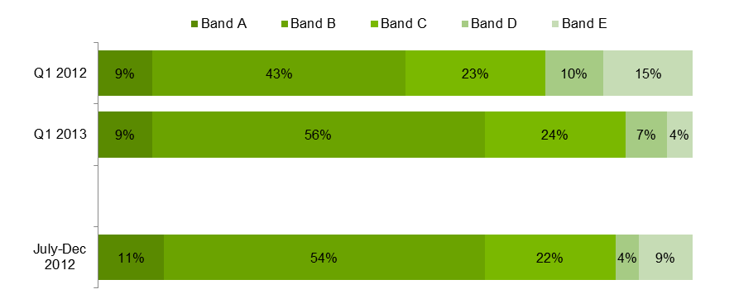

### Training Delivery Trends

While overall there was a 7 per cent decline in subsidised enrolments in Q1 2013 compared to Q1 2012, this pattern was not uniform across all Australian Qualification Framework (AQF) levels. Subsidised enrolments in Certificate I–II were up by 4 per cent, Certificate III-IV down by 6 per cent and Diploma down by 17 per cent. In Q1 2013, Certificate III–IV remains the largest qualification group representing 60 per cent of all AQF course enrolments.

### Government Subsidised Training Delivery by Regional Area

The decline in subsidised enrolments occurred across all of the Department’s four administrative regions, with South-Eastern Victoria having the largest decline of 8 per cent in Q1 2013 compared to Q1 2012. This picture changes somewhat when examining delivery by geographically smaller regional areas, three areas showed an increase in Q1 2013 compared to Q1 2012; Hume up by 42 per cent, Western Metropolitan Melbourne up by 3 per cent and Northern Metropolitan Melbourne up by 2 per cent.

Government subsidised enrolments by regional area, Q1 2012 and Q1 2013

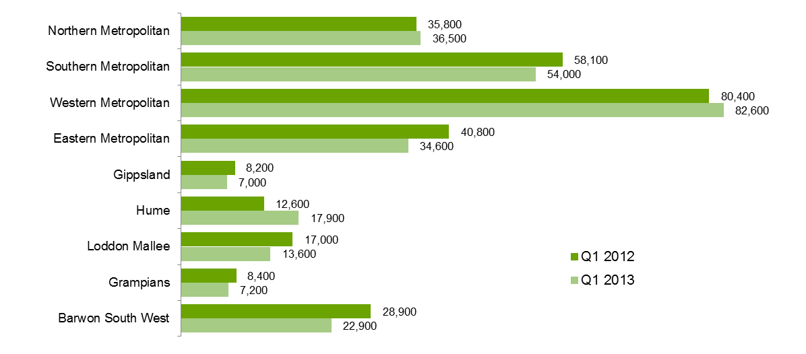

### Student Engagement and Wellbeing

Specific learner cohorts are actively engaged in vocational education and training with increases in Indigenous students and unemployed students. There were approximately 2,500 Indigenous students in government subsidised enrolments in Q1 2013, this was up by 2 per cent on the same period in 2012. Government subsidised enrolments by students with a disability declined by 4 per cent over the same period.

The vocational training sector continues to be an important pathway to employment, with 53,000 unemployed students engaged in government subsidised training in Q1 2013, an increase of 2 per cent compared to Q1 2012.

## The Policy Context of Vocational Training

The National Agreement for Skills and Workforce Development (NASWD) came into effect on 1 January 2009, and sets out the commitment between the Australian Government and State and Territory Governments to work towards increasing the skill levels of all Australians, and enhancing the accountability to the public for the outcomes achieved.

The NASWD has one overarching objective and two key performance targets. These performance targets are subsequently supported by seven performance indicators. A summary of Victoria’s performance against these targets and indicators is detailed in the Performance of Vocational Training section below.

| **National Agreement for Skills and Workforce Development**  **Objective:** A vocational education and training (VET) system that delivers a productive and highly skilled workforce, and which enables all working age Australians to develop the skills and qualifications needed to participate effectively in the labour market and contribute to Australia’s economic future; and supports the achievement of increased rates of workforce participation.  **Performance Targets:**   1. Halve the proportion of Australians nationally aged 20–64 without qualifications at Certificate III level and above between 2009 and 2020. 2. Double the number of higher level qualification completions (Diploma and Advanced Diploma) nationally between 2009 and 2020. |
| --- |

Vocational training is an area of shared responsibility. Commonwealth, state and territory governments provide funding, develop national and jurisdictional policies for the training system and share responsibility for the regulation, governance and quality assurance of the vocational training sector. State and territory governments manage the delivery of vocational training within their jurisdictions and have traditionally provided approximately two thirds of the funding in the vocational training system. Industry plays a role in identifying training needs and working directly with the training market and with Industry Skills Councils to develop appropriate training packages and qualifications to meet these needs.

Victoria has a strong focus on lifelong learning as a means of building human capital. As the Victorian economy shifts away from the reliance on the traditional agricultural and manufacturing sectors and moves to service industries having a greater share of economic activity and employment, we need a more highly skilled and more productive workforce.

The Victorian vocational training system has been on a reform trajectory for over twenty years. This trajectory has run in parallel with broader public management reform trends through the 1990s and 2000s and Victoria’s vocational training system had often been a public sector reform leader.

In the early 1990s the system involved a TAFE-centred, Government managed model. This evolved first to a Government planned purchaser-provider model which allowed a range of providers to deliver training services on behalf of Government. Despite the efficiency benefits realised, by the late 2000s it was clear a centrally planned and purchased system was not well suited to deliver the increasingly complex types of training Victoria needed and that delivery activity was misaligned with industry needs.

In 2008, the Victorian Training Guarantee (VTG) was introduced, placing the purchasing power for training in the hands of students. The VTG allowed individual students to access government subsidised training places in the course of their choice and at a range of providers. To facilitate this entitlement, the overall number of training places was uncapped and places were no longer allocated to particular providers. The introduction of the VTG released pent up, latent demand for skills training. Between 2008 and 2012 there was an increase in government funded VET enrolments from 381,300 to 670,400 people – representing 76 per cent growth in enrolments in the system.

While the VTG resulted in significant growth in government funded activity and in areas of industry and economic need, it also revealed opportunities for improvement as some elements of the new market-based training system design were sub-optimal. In response, the Victorian Government released the *Refocusing Vocational Training in Victoria* reform package in May 2012. The government is retaining and strengthening the individual entitlement to a subsidised training place to ensure that businesses and students continue to have choice over what and where they study and ensuring the cost of such access remains sustainable and in areas of greatest public value. The public value of courses has been assessed on the basis of its value to the economy (in terms of jobs or productivity) and the extent to which government investment is required to stimulate delivery of, and participation in, this training to meet industry needs.

All caps on the fees providers can charge have also been removed. Providers are now free to set prices they believe reflect the quality of their training. However, protections for low income students via retention of a concessions fee regime for Certificate I - Certificate IV level qualifications have been maintained, while VET FEE-HELP is available for students undertaking Diplomas and Advanced Diplomas.

The Government has continued and expanded access to subsidised training for low SES young people, Indigenous Victorians and students in regional and rural Victoria. The Government provides additional assistance through subsidy loadings for students most in need. Subsidised pathway programs through pre-accredited training have also been maintained to ensure pathways to vocational training for those most in need. These investments are making sure people facing barriers into employment and/or with low incomes are able to access quality vocational training.

As Victoria’s economy continues to experience significant change, a new industry architecture has also been developed that engages directly with industry to ensure the training market stays aligned with changes in industry need. The model features a series of mechanisms to facilitate direct industry engagement, such as the Industry Skills Consultative Committee, Industry Roundtables and one to one consultations with industry groups across all regions. These mechanisms enable government to monitor the responsiveness of the training market to industry skills needs and to identify priorities for market facilitation to improve responsiveness.

The new training system also recognises the need for stronger contract management, performance monitoring and quality assurance. There have been concerns about the quality of training which have come about because of the way the system used to operate. In some cases students and the Government were not getting what they paid for and employers were not finding vocational training graduates with the skills they need for their workplaces.

That said, the vast majority of providers do offer high quality training, focussed on the needs of students and industry. However a small number did not – and we needed to act on this.

Providers seeking to offer government-subsidised training now have to meet tougher contract standards than was the case previously. The Victorian Registration and Qualifications Authority has been given stronger regulatory powers of inspection and enforcement.

The market requires a better level and quality of information made accessible for people to decide about their training options. Employers and students can now access a new one-stop shop training website – the *Victorian Skills Gateway* - and providers will be required to disclose price and quality information upfront to prospective students. Industry is also being supported to engage much more directly with training providers to ensure their skills needs are met, rather than more passively accepting market outcomes or seeking additional government assistance to address skills gaps. This means that industry and business will better be able to attract people.

Victoria needs to ensure strong oversight of the new training market. A Market Monitoring Unit (MMU) has been established. The role of the MMU is to monitor how the training market is functioning including, quality, price and competition. The unit will track market activity and advise the Government on these issues to inform future subsidy levels.

In addition to a focus on improving outcomes for students and industry, the Refocusing Vocational Training in Victoria initiative recognised that a modern vocational training system requires a network of well-functioning and modern TAFE institutes delivering in their areas of strength alongside other providers.

As part of the Refocusing Vocational Training in Victoria reforms, the Government established an independent TAFE Reform Panel, to advise on ways to foster a strong, sustainable TAFE sector in an open and competitive training market.

The TAFE Reform Panel’s final report: A Strong and Sustainable Victorian TAFE sector provides findings and 19 recommendations relating specifically to the state’s 14 TAFE institutes and four dual-sector universities.

The Government has responded to these recommendations in Next Steps for Refocusing Vocational Training in Victoria – Supporting a Modern Workforce.

To strengthen Victorian TAFEs and encourage innovation in training delivery and content, the Government will:

* provide $200 million in contestable funding for proposals for structural adjustment and business transformation for TAFE institutes that have limited resources
* modernise the constitutions and supply commercial objectives for TAFE institutes to provide a clearer understanding of the Government’s expectations
* give TAFE institutes greater control of their assets
* reduce the regulatory burden on TAFE institutes through streamlined reporting requirements and clearly defining roles and responsibilities of TAFE institutes and the Department
* allow TAFE institutes to have more control over workplace relations
* remove the restriction on TAFE institutes being registered as Group Training Organisations
* reclassify the TAFE operations of dual-sector universities to bring them into line with other universities and reduce their reporting requirements.

# Purpose and Background

This report has been prepared for the Minister for Higher Education and Skills, the Senior Executive of DEECD and other key stakeholders in the vocational training system. Its purpose is to summarise emerging trends in the Victorian training market in quarter one 2013 and provide a comparative overview of market changes relative to the same period in 2012.

Key metrics include training delivery by funding source, qualification level and age of learners, higher needs learners and regional activity. An analysis of the responsiveness of training delivery to specific occupational needs and industry are also provided.

## Notes about the data and time periods

The main source of vocational training statistics in this publication is the training activity database referred to as SVTS. All government subsidised providers are required to submit their data using SVTS at least once a month in accordance with the Australian Vocational Education & Training Management Information Statistical Standard (AVETMISS). For TAFE Institutes, there is an additional regulatory requirement that they also submit their fee for service data.

The majority of the commentary contained in this report compares first quarter (Q1) reported data for 2013 with first quarter data in 2012. Full year data between 2008 and 2012 are included to show longer term trends.

Reported figures in the first quarter 2013 are a snapshot in time and are based on preliminary data as reported to Higher Education and Skills Group (HESG) in the Department by training providers. Caution should be exercised when comparing quarterly figures against the same period in the previous year. This is due to the way training providers upload their VET activity data which is not necessarily undertaken in a uniform manner while the training year is still in progress. In addition, adjustments are required to be made to VET activity data by providers after the end of a reporting period due to students withdrawing from modules or entire courses. In some limited cases some providers may not have submitted their full quarter’s training data which could impact on the overall state result. Hence reported figures in quarter one report may be revised in SVTS after the release of report.

Therefore, owing to the preliminary nature of VET data while the year is underway, figures in the first quarterly report should be treated as being indicative only.

The 2013 first quarter data is based on preliminary data extracted from SVTS as at 15 April 2013. Figures may be revised slightly prior to submission to National Centre for Vocational Education and Research (NCVER).

Data shown in the tables are rounded to the nearest 100 when the figures are greater than 1,000; to the nearest 50 when they are between 100 and 1,000; and to the nearest 10 when they are less than 100. The percentage change between figures in Q1 2012 and Q1 2013 is calculated based on the reported data.

## Reporting scope

This report includes government subsidised activities in all sectors at all qualification levels, and domestic fee for service activities in the TAFE sector at Australian Qualification Framework (Certificate I and above).

Fee for service activities below Certificate I in the domestic TAFE sector are not included, such as short courses. Fee for service activities that took place in the private RTO and Adult Community Education sectors are also outside the scope.

Since 2012, the scope of reporting of government subsidised training changed. ZC - Corrections delivery contracted directly with TAFE Institutes and ZP - Corrections funding through private prisons have been allocated to fee for service funding. Prior to 2012, these funded enrolments were allocated to government subsidised training.

# Victorian Vocational Training Summary

## Vocational Training by Funding Type

### Vocational Training Delivery by Funding Type

This section of the report provides an overview of training activity measured in terms of enrolments, student contact hours and student numbers. Full year results are shown from 2008 to 2012 and a comparison of figures for quarter one (Q1) of 2013, Q1 2012 and Q1 2011. Commentary focuses on comparisons of results between Q1 2012 and Q1 2013. Q1 2011 data are included in this section only as a broad reference for comparing quarter one figures over three years.

The Q1 2013 data show that the Victorian training system had over 278,200 government subsidised enrolments, down 7 per cent compared to Q1 2012. TAFE domestic fee for service provision has also experienced a decline of 6 per cent over the same period, with around 38,700 enrolments in Q1 2013. A comparison with the same period in 2011 shows that subsidised enrolments are up by 28 per cent in Q1 2013.

Table 1.1: Vocational training delivery by funding type, enrolments, 2008–2012, Q1 2011, Q1 2012 and Q1 2013



Fee for Service figures are TAFE on-shore domestic AQF Level 1 and above.

Figure 1.1: Vocational training delivery by funding type, enrolments, 2008–2012, Q1 2011, Q1 2012 and Q1 2013

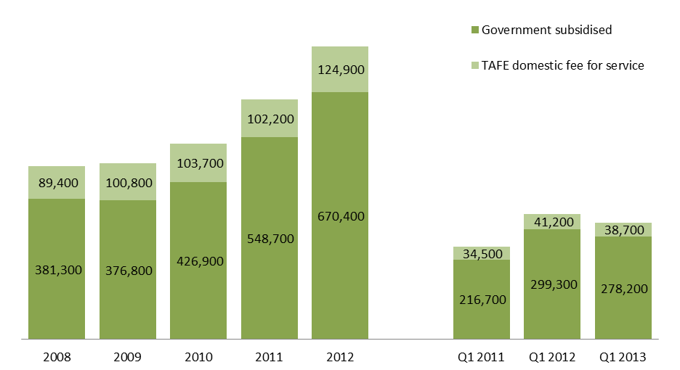

Table 1.2: Student contact hours[3] (millions) by funding type, 2008–2012, Q1 2011, Q1 2012 and Q1 2013



Fee for Service figures are TAFE on-shore domestic AQF Level 1 and above.

Figure 1.2: student contact hours (millions) by funding type, 2008–2012, Q1 2011, Q1 2012 and Q1 2013

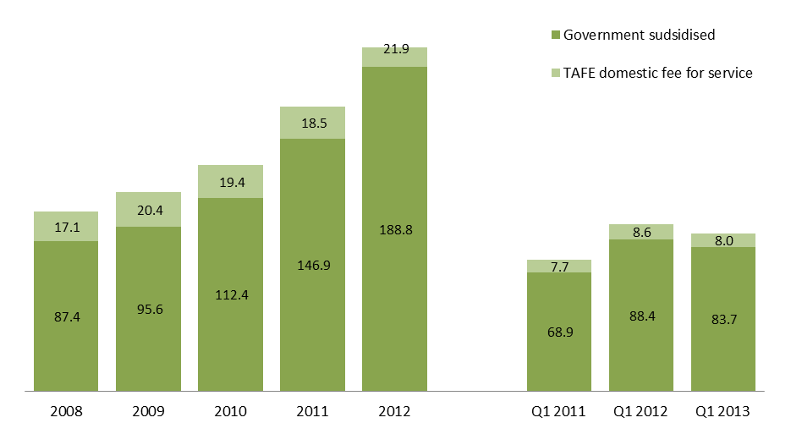

Table 1.3: Number of students by funding type, 2008–2012, Q1 2011, Q1 2012 and Q1 2013



Fee for Service figures are TAFE on-shore domestic AQF Level 1 and above.

*TAFE students whose enrolments are made up of a combination of government subsidies and self-funding have been counted in both funding categories. The total, however, has eliminated the duplicates.

Figure 1.3: Number of students by funding type, 2008–2012, Q1 2011, Q1 2012 and Q1 2013

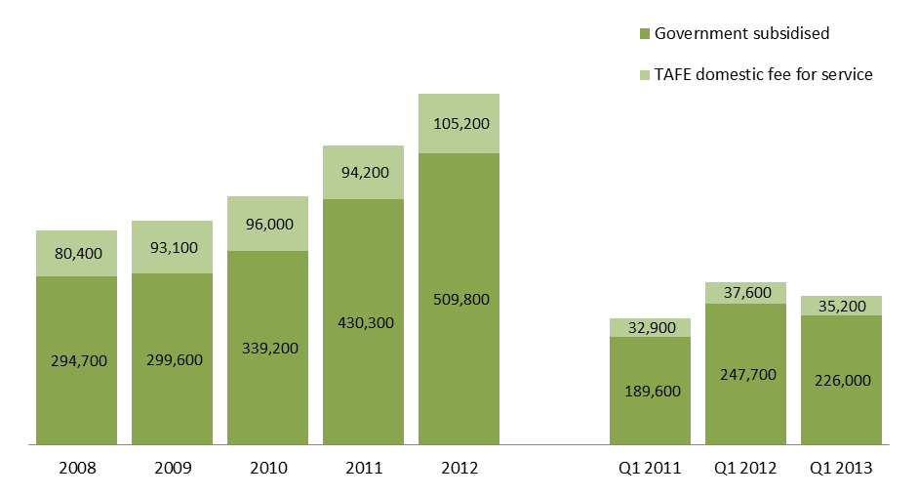

|  |
| --- |
| Key Points Early indications are that the Victorian vocational training system has experienced declines in both government subsidised and TAFE fee for service training segments. Compared to Q1 2012, the Q1 2013 preliminary figures show that:   * Total reported enrolments (government subsidised and TAFE fee-for-service) have declined by 7 per cent, to 316,900 enrolments in Q1 2013. Total reported student contact hours have decreased at the similar rate (down by 6 per cent). Total student numbers have also dropped by 9 per cent. * Government subsidised vocational training activity has declined, with 278,200 enrolments (down 7 per cent), 83.7 million student contact hours (down 5 per cent) and 226,000 students (down 9 per cent). * TAFE domestic fee for service activity showed a similar trend with 38,700 enrolments (down 6 per cent), 8.0 million student contact hours (down 8 per cent) and 35,200 students (down 6 per cent). |

### Vocational Training Funding Bands

As part of the Refocusing Vocational Training reform from July 2012 five funding bands for government subsidised training were introduced. Under these arrangements, higher rates have been attributed to foundation and apprenticeship qualifications and lower rates to Diplomas and above (where income contingent student loans are available) and to lower-level Certificates where direct vocational benefit is lower.

Under the new arrangements, weightings have been refined to apply at the course level according to an assessment of public value. Public value has been determined on the basis of the value of the course to the economy (in terms of specialist or in shortage occupations or essential services) and the extent to which government investment is required to stimulate delivery of, and participation in, this training to meet industry needs.

Overall, the highest subsidy levels have been provided to courses where contribution to the economy is assessed as high, and where government subsidy is seen as essential in enabling delivery and participation in training.

Table 1.4: Government subsidised commencing enrolments by funding band, Q1 2012 and Q1 2013



Figure 1.4: Government subsidised enrolments: proportion of commencing enrolments by funding bands,   
July-December 2012, Q1 2012 and Q1 2013



Subsidy bands were introduced in 2012 and apply specifically to qualifications in 2012 and onward. In order to allow comparison with previous years, superseded courses have been assigned a subsidy band for analysis purposes only based on the bands of the current course to which they most closely align.

|  |
| --- |
| Key Points  * There has been an increase in the number of government subsidised commencing enrolments in band B in Q1 2013 compared to Q1 2012 (up 17 per cent), but commencing enrolment numbers have declined across bands A, C, D and E. The increase in commencements in band B was largely attributable to foundation skills courses. * Proportionally there has been a marked shift in commencement patterns when comparing Q1 2013 with Q1 2012. Figures from Q1 2013 show 65 per cent of all government subsidised commencing enrolments were within subsidy bands A and B. This compared with 52 per cent of commencements in subsidy bands A and B in Q1 2012. Courses such as the Certificate III in Electrotechnology Electrician, Certificate III in Carpentry, Certificate III in Aged Care and the course in Initial General Education for Adults are represented in these funding bands. * Courses with less vocational outcome, or labour market requirement (Band D & E) represented 11 per cent of all government subsidised commencements in Q1 2013, down from 25 per cent over the same period in 2012. * Band D has a slightly greater proportion of commencements in Q1 2013 compared to commencements in July-Dec 2012 (7 per cent vs. 4 per cent). This was predominantly due to more Diploma and Advanced Diploma commencements at the beginning of the year. |

## Qualification Levels

Attainment of qualifications, rather than short courses (i.e. through module only delivery), has become an increasingly important focus of State and Commonwealth governments. Lower level qualifications (Certificate I-II) provide those without post-school qualifications the foundation level skills (literacy, numeracy, work preparation) necessary to undertake further study or to find employment. A review of Victorian foundation skills training is underway. The objective of the review is to compare the effectiveness of different approaches and models of foundation skills training delivery to best support young people and low skilled adults to develop the core skills they need to participate in the workplace and modern life.

Mid-level skills are essential to the Victorian economy and help drive economic activity across the State. A significant proportion of apprenticeships and traineeships entail attainment of a mid-level qualification and are crucial to many key industries. Apprenticeships and traineeships are undertaken as a contract between the apprentice/trainee and an employer. While undertaking on-the-job learning, the apprentice/trainee receives complementary training through a vocational training provider.

Higher level qualifications have grown in demand by industry and the labour market, with the demand for high level skills growing at 2.5 times the rate of unskilled jobs[4]. To meet this demand, State and Commonwealth governments have focused on raising the qualification profile of Australians over the last decade. Higher level vocational training qualifications (Diploma and above) provide entry to higher skilled jobs and to further study – generally at university level where vocational training graduates obtain credits towards their undergraduate studies.

### Vocational Training Delivery by Qualification Level, Government Subsidised Enrolments

Table 1.5: Government subsidised enrolments by qualification level, 2008–2012, Q1 2012 and Q1 2013



Note: SoA – Statement of Attainment

Figure 1.5: Government subsidised enrolments by qualification level (AQF1+ only), Q1 2012 and Q1 2013



| Key Points  * The overall number of government subsidised enrolments in Q1 2013 has declined compared to Q1 2012, but enrolment numbers at the Certificate I to II levels have increased by 2,300 or 4 per cent. * Over the same period, there were declines in enrolments at Certificate III to IV levels (down 6 per cent to 158,700 enrolments), Diploma & Above (down 17 per cent to 47,400), Module only training (down 16 per cent to 5,600) and secondary school subjects (down 16 per cent to 8,500). * The growth in course enrolments at Certificate I to II levels was predominately related to training in foundation skills courses. Almost three quarters of enrolments at Certificate I to II levels (73 per cent or 42,500 enrolments) were in foundation skills – work preparation, general education, language literacy and numeracy. * The decline in enrolments at Certificate III to IV levels can be explained in part by the reduction in take-up of apprenticeships and traineeships (see section on Apprentices and trainees for details). * The number of enrolments in Diploma & Above courses in Q1 2013 was broadly at a similar level to that in Q1 2011 and higher than that in Q1 2010. * Proportionally, Certificate III to IV remains the largest qualification group (60 per cent) across Australian Qualification Framework courses (i.e. Certificate I-II, Certificate III-IV and Diploma & Above). |
| --- |

### Vocational Training Delivery by Qualification Level, TAFE Domestic Fee for Service Enrolments

Table 1.6: TAFE domestic fee for service enrolments by qualification level (AQF1+ only), 2008–2012, Q1 2012 and   
Q1 2013



Figure 1.6: TAFE domestic fee for service enrolments by qualification level (AQF1+ only), Q1 2012 and Q1 2013



| Key Points  * TAFE domestic fee for service enrolments at Diploma & Above levels has increased by 16 per cent in Q1 2013 compared to Q1 2012. The numbers of enrolments in Certificate I to II, Certificate III to IV and Higher Education have declined by 7 per cent, 11 per cent and 3 per cent, respectively over the same period. * Module only enrolments[5] against this funding source are not in scope of this report. * Proportionally, there has been an increase in the share of Diploma & Above enrolments, from 11 per cent in Q1 2012 to 14 per cent in Q1 2013. Over the same period, the share of enrolments at the Certificate III to IV levels declined by two percentage points, from 40 per cent to 38 per cent. |
| --- |

### Vocational Training Delivery by Qualification Level, Government Subsidised Student Contact Hours

Table 1.7: Government subsidised student contact hours (millions) by qualification level, 2008–2012, Q1 2012  
 and Q1 2013



Note: SoA – Statement of Attainment

Figure 1.7: Government subsidised student contact hours by qualification level (AQF1+ only), Q1 2012 and Q1 2013



|  |
| --- |
| Key Points  * There was a 3 per cent increase in the number of government subsidised student contact hours at Certificate I to II levels in Q1 2013 compared to Q1 2012. This is at a similar rate to the increase in enrolment numbers at this qualification group over the same period. * The declines in student contact hours in Q1 2013 were at the Certificate III-IV (down 4 per cent) and Diploma & Above (down 14 per cent) levels. Again these percentages changes were broadly at a similar level to the changes in course enrolments of their respective qualification levels. * Student contact hours in module only training in Q1 2013 fell by 9 per cent compared to Q1 2012. This decline is considered small when comparing to the 16 per cent drop in module only enrolments over the same period. This could potentially indicate that the length of module only training has lengthened. * While there was a decline of 16 per cent in the number of government subsidised secondary school subjects in Q1 2013 compared to Q1 2012, the change in student contact hours was in an opposite trend with an increase of 10 per cent. |

## 

## Age Profile

### Vocational Training Delivery by Age Group

To enable the increased workforce participation levels required by the Victorian economy over the next decade, improved engagement with education and training by all age groups is required. The vocational training system is also focused on accessibility and gender equality, ensuring all Victorians have the same opportunity to succeed in their lives and maintain well-being through education and training.

### Students by Age Group in Government Subsidised Training

Table 1.8: Government subsidised students by age group, 2008–2012, Q1 2012 and Q1 2013



Figure 1.8: Government subsidised students by age group, Q1 2012 and Q1 2013



|  |
| --- |
| Key Points Government subsidised student numbers have generally declined across broad age groups in Q1 2013 compared to Q1 2012:   * The largest cohort- 25 to 44 year olds which accounted for 35 per cent of students in Q1 2013, has declined by 4 per cent. * Students aged 20-24 has moved from the third largest age group in Q1 2012 to the second in Q1 2013 and represent almost one quarter (23 per cent) of government subsidised student population. * The 15 to 19 age group has declined by 18 per cent (the largest decline among the age groups) and represents a 22 per cent share in Q1 2013. |

### TAFE Domestic Fee for Service Students by Age Group

Table 1.9: TAFE domestic fee for service: students by age group, 2008–2012, Q1 2012 and Q1 2013



Fee for Service figures are TAFE on-shore domestic AQF Level 1 and above.

Figure 1.9: TAFE domestic fee for service: students by age group, Q1 2012 and Q1 2013



|  |
| --- |
| Key Points  * The numbers of TAFE domestic fee for service students in 20-24 and 25-44 age groups in Q1 2013 were similar to those in Q1 2012. * The largest decline in TAFE domestic fee for service student numbers was in 15-19 age group with 13 per cent reduction from 12,000 students in Q1 2012 to 10,400 students in Q1 2013. |

## Apprentices and Trainees

### Apprentice and Trainee Activity

Providing formal training to apprentices and trainees is a key function of the vocational training system, building skills that are directly applied in the workplace. Several key sectors that are important to the Victorian economy and the community more broadly directly benefit from the formal training provided by the vocational training system to apprentices and trainees. These include Automotive, Construction, Tourism and Hospitality, Health Care and Children’s Services.

Trends in apprenticeships and traineeships align closely with the wider Victorian economy[6].

Table 1.10: Government subsidised enrolments by apprentices and trainees, 2008–2012, Q1 2012 and Q1 2013



### Apprenticeship

While this is a concern that enrolments in apprenticeship fell by 7 per cent in Q1 2013 compared to Q1 2012, apprentice numbers are highly correlated with business conditions. In Q1 2013, fifty six per cent of all apprentices are employed in the construction sector which has faced a challenging 12 months and this is reflected in the numbers of construction apprentices which have fallen significantly between the reporting periods. This close relationship is demonstrated in the chart below which shows recent decline in Apprenticeship commencements[7] is associated wth a similar trend to that for new dwelling commencements[8].

Figure 1.10: Number of apprenticeship commencements and new dwelling units commenced all sectors  
Q1 2000 to Q1 2013

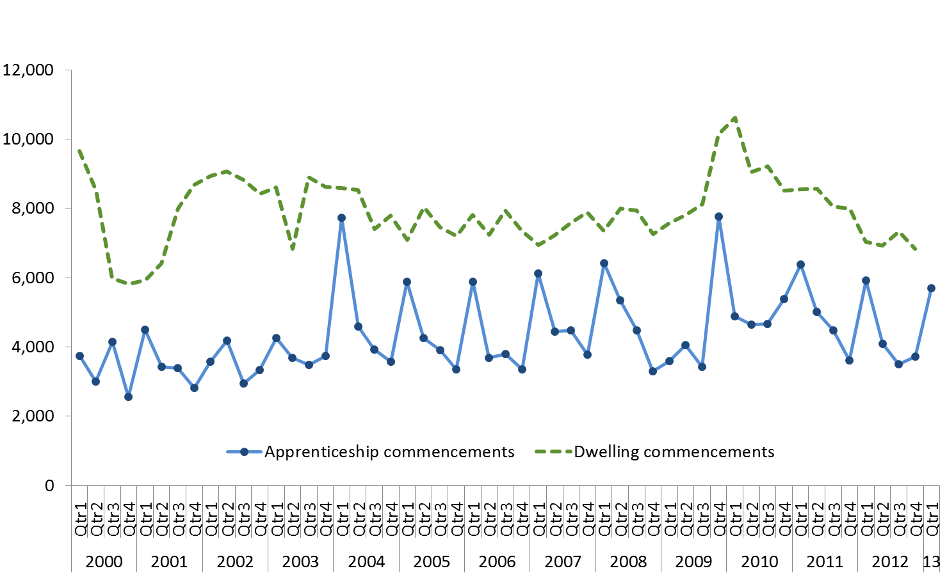

Table 1.11: Government subsidised enrolments by apprentices by qualification type, 2008–2012, Q1 2012 and Q1 2013



Note: There were no Certificate I-II apprentices in Q1 2013

### Traineeship

The reductions in enrolments are attributable to a number of factors including government subsidy levels, government incentives[9] and potential correction due to previous enrolment patterns. The decline has been driven by significant decline in those qualifications which have attracted lower levels of subsidy with the introduction of the reforms from July 2012, for example qualifications in hospitality, retail and competitive manufacturing.

Figure 1.11: Selected traineeship course commencements, potential correction, Q1 2011 – Q1 2013

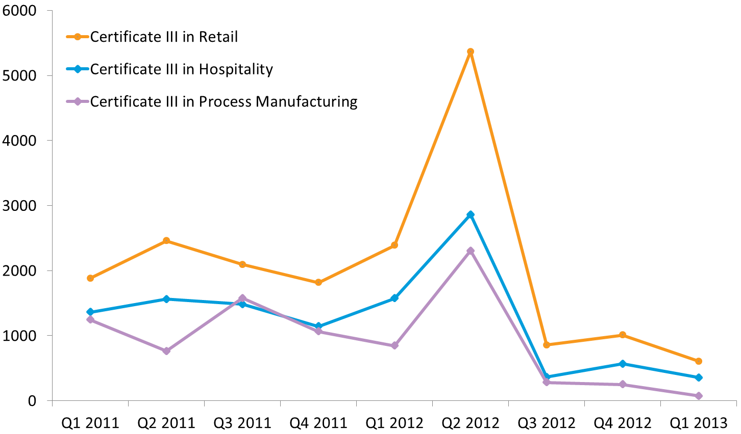

Table 1.12: Government subsidised enrolments by trainees by qualification type, 2008–2012, Q1 2012 and Q1 2013



|  |
| --- |
| Key Points  * Trainees decreased by 23 per cent (around 10,000 enrolments) compared to Q1 2012. While typically only half of trainee enrolments are recorded in Q1, the marked decline in trainees was largely attributable at Certificate III to IV levels. Courses such as Certificate III in Hospitality, Certificate III in Retail and Certificate III in Process Manufacturing have seen their enrolments decline significantly. * The decline in trainees at Certificate I to II levels was largely due to a reduction in traineeships within the Certificate II in Retail. The reduction in Diploma & Above trainee training was within the Diploma of Management. * There were small increases in traineeships in some industry sector, such as Transport, Postal and Warehousing (up 430), Construction (up 130) and Agriculture, Forestry and Fishing (up 120). |

## Government subsidised regional activity

For the purpose of providing an overview of regional training activity, government subsidised enrolment numbers are presented for the four departmental regions from 2008 to 2012, and Quarter One data for 2012 and 2013. For the purpose of this report, data on government subsidised enrolments are further disaggregated into nine smaller geographical areas to provide more granular data.

South-Western departmental region comprises Barwon South West, Grampians and Western Metropolitan regional areas. North-Western departmental region comprises Loddon Mallee and Northern Metropolitan regional areas. North-Eastern departmental region comprises Hume and Eastern Metropolitan regional areas. South-Eastern departmental region comprises Gippsland and Southern Metropolitan regional areas.

Table 1.13: Government subsidised enrolments by departmental region, 2008–2012, Q1 2012 and Q1 2013



Table 1.14: Government subsidised enrolments by regional area, 2008–2012, Q1 2012 and Q1 2013



|  |
| --- |
| Key Points  * Government subsidised enrolment numbers have declined across four departmental regions in Q1 2013 compared to Q1 2012. This reflects the overall decline in government subsidised enrolments over the same periods. * Further disaggregation of regions’ data into nine regional areas, Q1 2013 data show that against the declining trend, Hume, Western Metropolitan and Northern Metropolitan regional areas have experienced increases in government subsidised enrolments (up 42 per cent, 3 per cent and 2 per cent, respectively) compared to Q1 2012. * The growth in government subsidised enrolments in Hume in Q1 2013 has occurred across all Australian Qualification Levels: Certificate I to II (up 59 per cent), Certificate III to IV (up 36 per cent) and Diploma & Above (up 29 per cent) compared to Q1 2012. The large increase in enrolments in Hume regional area was associated with:   + Increase in course enrolments at Certificate I to II levels that was mainly driven by a significant increase in foundation skills courses (up 225 per cent, from 820 in Q1 2012 to 2,700 in Q1 2013).   + At Certificate III to IV levels, industry sectors with a large increase in enrolments were:   + Education and Training (from 300 in Q1 2012 to 1,000 in Q1 2013);   + Arts and Recreation Services (from 310 in Q1 2012 to 900 in Q1 2013); and   + Construction (from 740 in Q1 2012 to 1200 in Q1 2013).   Within this qualification group, enrolment numbers in foundation skills courses have also increased from 130 in Q1 2012 to 300 in Q1 2013.   * + For Diploma & Above qualifications, the biggest increase in course enrolments was in Health Care and Social Assistance sector. |

## Government Subsidised Delivery by Provider Type

Table 1.15: Government subsidised enrolments by provider type, 2008–2012, Q1 2012 and Q1 2013



Figure 1.12: Government subsidised enrolments by provider type, Q1 2012 and Q1 2013



|  |
| --- |
| Key Points  * The decline in government subsidised enrolments occurred across all provider groups in Q1 2013 compared to Q1 2012. ACE providers and TAFEs fell by 11 per cent and 10 per cent, respectively. Private RTOs declined slightly by 3 per cent. * Of all government subsidised enrolments, the proportional share of private RTOs has increased by  2 percentage points to 47 per cent in Q1 2013 compared to Q1 2012, while there has been a one percentage point of decline in the shares from each of ACE and TAFEs groups. |

## Adult, Community and Further Education (ACFE) Performance

Figure 1.13: Government subsidised ACFE enrolments, accredited and pre-accredited, 2008-2012, Q1 2012 and Q1 2013



Figure 1.14: Government subsidised ACFE student contact hours (millions), accredited and pre-accredited, 2008-2012, Q1 2012 and Q1 2013



|  |  |  |  |  |  |  |
| --- | --- | --- | --- | --- | --- | --- |
| Key Points  * Accredited enrolments fell by 11 per cent to 16,600 in Q1 2013 compared to Q1 2012 with a minimal change in reported student contact hours. The major contraction in enrolments by industry sector were Accommodation and Food Services, down by 2,200 enrolments or 89 per cent, Retail and Trade down by 430 enrolments or 61 per cent. There was an increase of 1,600 enrolments or 23 per cent for Foundation Skills and LOTE courses. * Pre-accredited enrolments fell by 12 per cent to 6,600 with minimal change in reported student contact hours in Q1 2013 compared to Q1 2012, a return to the long term trend of students undertaking courses of a lengthier duration. | | | | | | |
| Table 1.16: Government subsidised ACFE Students by Departmental region, accredited and pre-accredited,  2008-2012, Q1 2012 and Q1 2013    AEIs: Adult Education Institutes  Figure 1.15: Government subsidised ACE students by regional area, accredited and pre-accredited, 2008-2012, Q1 2012 and Q1 2013 | | | | | |
|  | | | | | |
| BSW | Barwon South West | HUM | Hume | NWM | North Western Metropolitan |
| GRA | Grampians | GIP | Gippsland | SM | Southern Metropolitan |
| LMR | Loddon Mallee | EM | Eastern Metropolitan | AEIs | Adult Education Institutes |

|  |
| --- |
| Key Points  * The number of students participating in Learn Local organisations and Adult Education Institutions across the state fell in Q1 2013 compared to Q2 2012. Participation from the combined accredited and pre-accredited student population contracted by 13 per cent, down by 2,800 students. * At the Departmental region level, compared to Q1 2012 the North-Western region recorded a growth of 6 per cent in Q1 2013. The remaining three regions and Adult Education Institutions contracted their training delivery over the comparative period with the major falls in South-Western (30 per cent) and North-Eastern regions (21 per cent). * The most significant regional area movement was in Barwon South West, down by 46%, or 1,900 students compared to Q1 2012. Grampians regional area reported a contraction in student participation of 45 per cent, or 500 students reflecting the downturn in student contact hours for that region. North Western Metropolitan and Loddon Mallee regional areas reported increased student participation of 10 per cent and 9 per cent, respectively. |

Figure 1.16: Government subsidised hard to reach students, accredited and pre-accredited Learn Local Organisations and Adult Education Institutions, 2008-2012, Q1 2012 and Q1 2013



Note: Hard to reach categories are not mutually exclusive.

|  |
| --- |
| Key Points  * The number of ‘hard to reach’ students participating in the Learn Local sector generally declined across each of the ‘hard to reach’ groups in Q1 2013 compared to Q2 2012. * Contraction was strongest in the early school leavers cohort, down 18 per cent (to 4,200 students) and male students aged 45 to 64 years of age 15 per cent (to 1,400). The fall in participation from other ‘hard-to-reach’ groups was CALD 11 per cent (to 4,959), unemployed students 9 per cent (to 5,900), vulnerable workers 8 per cent (to 4,200), persons reporting a disability 8 per cent (to 4,200) and disengaged youth 2 per cent (to 1,500). * Unemployed students made up the largest number of 'hard to reach' students at Learn Local organisations and Adult Education Institutions, followed by students from a CALD background or vulnerable workers. |

# Responsiveness to Skills Needs

This section reports on VET training delivery in the first quarter of 2013 and how it corresponds to the skills required by the market based on occupational requirements. ‘Responsiveness’ considers the extent to which VET training responds to training required for specialist and/or skills shortage occupations.

The three responsiveness categories relate to government subsidised training to onshore domestic students only. The category 'Industry-specific qualifications' allows like-with-like comparison of training performance by excluding non-accredited training and training in generic skills such as literacy and numeracy. While this foundational training is crucial, it is not by itself sufficient to meet demand for training in a particular occupation.

|  |  |  |  |  |
| --- | --- | --- | --- | --- |
| 'Industry-specific  qualifications' |  | 'Specialised'  occupations |  | 'In Shortage'  occupations |
| * Includes all accredited vocational qualifications at Certificate I and above, but excludes generic training such as foundation skills, education pathways and low-level LOTE courses |  | * Uses the Australian Workforce and Productivity Agency (formerly Skills Australia) list of specialised occupations, which is used to inform the skilled migration program * These occupations have a long lead-time for training, high economic value and a significant match between training and employment |  | * Uses the 2012 DEECD Skills Shortage list * List compiled with reference to reports from Victorian industry training bodies and direct consultation with industry groups and workforce planning agencies * National advice included where it had relevance to Victoria |
| * Allows like-with-like comparison of specialised and in shortage categories against broader training delivery trends |  |  |
|  |  |

The first part of this section examines top-level trends in training delivery against these categories. As only a small number of specialised occupations are not also on the skills shortages list the subsequent detailed analysis considers a combined set. The second and third parts of this section provide summary breakdowns per industry and occupation of training in the combined specialised or in shortage categories.

## Overall Responsiveness of the Training Market

Analysis of this early data for 2013 shows a marked difference from trends observed from full-year 2011-2012. Early indications are that the deliberate policy interventions of 2012 appears to have shifted growth to those qualifications linked to specialised and in shortage occupations, and reduced growth in other qualifications (excluding foundation training).

As the chart below shows, the broader context of training delivery in Q1 2013 compared to Q1 2012 has seen a 7 per cent decline in overall reported government subsidised enrolments. Within this total, enrolments in industry specific qualifications have declined by 14%. However, this overall decrease includes a 4 per cent increase in enrolments in qualifications related to either specialised or in shortage occupations, providing an early indication of a potential shift in the structure of training delivery in 2013.

Figure 2.1: Responsiveness of training market in the context of all government subsidised training, Q1 2012 and   
Q1 2013

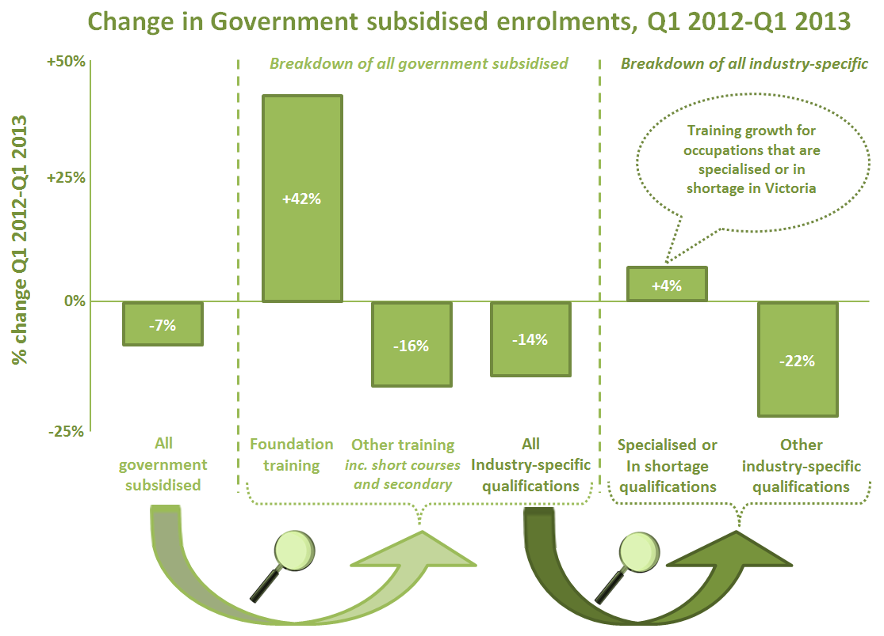



Training against the combined set of specialised or in shortage occupations now represents 40 per cent of all industry-specific qualifications (see chart above), a significant increase from 33 per cent in the first quarter of 2012.

The following tables show the number and percentage change against the four categories of training market responsiveness, as well as the comparison category 'Industry-specific qualifications’, for reported enrolments and student contact hours. In the first quarter of 2013 there was an increase in training against both specialised and in shortage occupations compared to the same period in 2012.

Table 2.1: Government subsidised enrolments and student contact hours by responsiveness category, 2008–2012,   
Q1 2012 and Q1 2013

|  |  |  |  |  |  |  |  |  |  |
| --- | --- | --- | --- | --- | --- | --- | --- | --- | --- |
| **All Industry Specific** | | | | | | | | | |
|  | 2008 | 2009 | 2010 | 2011 | 2012 | % 2008 - 2012 | **Q1 2012** | **Q1 2013** | **% Q1 2012 - Q1 2013** |
| **Enrolments** | 276,400 | 285,500 | 337,100 | 443,500 | 506,000 | 83% | **246,500** | **212,000** | **-14%** |
| **Hours** (millions) | 75.2 | 82.7 | 100.3 | 130.1 | 164.2 | 118% | **77.5** | **70.0** | **-10%** |
|  |  |  |  |  |  |  |  |  |  |
| **Specialised** | | | | | | | | | |
|  | 2008 | 2009 | 2010 | 2011 | 2012 | % 2008 - 2012 | **Q1 2012** | **Q1 2013** | **% Q1 2012 - Q1 2013** |
| **Enrolments** | 57,000 | 59,300 | 64,900 | 72,300 | 80,300 | 41% | **43,800** | **44,000** | **0.5%** |
| **Hours** (millions) | 16.6 | 19.6 | 21.1 | 21.8 | 25.9 | 56% | **13.0** | **13.5** | **4%** |
|  |  |  |  |  |  |  |  |  |  |
| **In Shortage** | | | | | | | | | |
|  | 2008 | 2009 | 2010 | 2011 | 2012 | % 2008 - 2012 | **Q1 2012** | **Q1 2013** | **% Q1 2012 - Q1 2013** |
| **Enrolments** | 84,200 | 95,900 | 108,900 | 129,400 | 152,400 | 81% | **76,200** | **80,600** | **6%** |
| **Hours** (millions) | 26.7 | 31.7 | 36.9 | 42.1 | 50.9 | 90% | **25.6** | **28.2** | **10%** |
|  |  |  |  |  |  |  |  |  |  |
| **Both Specialised and In Shortage** | | | | | | | | | |
|  | 2008 | 2009 | 2010 | 2011 | 2012 | % 2008 - 2012 | **Q1 2012** | **Q1 2013** | **% Q1 2012 - Q1 2013** |
| **Enrolments** | 49,800 | 52,500 | 57,400 | 64,400 | 69,600 | 40% | **38,900** | **40,100** | **3%** |
| **Hours** (millions) | 14.9 | 17.7 | 19.1 | 19.6 | 21.9 | 47% | **11.2** | **12.2** | **9%** |
|  |  |  |  |  |  |  |  |  |  |
| **Either Specialised or In shortage** | | | | | | | | | |
|  | 2008 | 2009 | 2010 | 2011 | 2012 | % 2008 - 2012 | **Q1 2012** | **Q1 2013** | **% Q1 2012 - Q1 2013** |
| **Enrolments** | 91,400 | 102,600 | 116,500 | 137,300 | 163,100 | 78% | **81,100** | **84,600** | **4%** |
| **Hours** (millions) | 28.4 | 33.6 | 38.9 | 44.3 | 54.9 | 93% | **27.4** | **29.5** | **8%** |

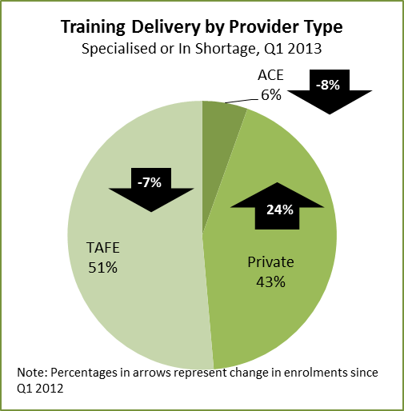

**Key Points**

* There is continued evidence of rising trends in student enrolments and contact student contact hours in courses related to specialised and in shortage occupations in the first quarter of 2013.
* Enrolments in qualifications related to specialised or in shortage occupations accounted for 40 per cent of all industry enrolments in the first quarter of 2013, compared 33 per cent reported during the same period in 2012.
* In the first quarter of 2013, training delivery of courses related to specialised and in shortage occupations has been primarily driven by TAFEs (accounts for 51 per cent of enrolments), followed by private RTOs (43 per cent). Compared to the first quarter of 2012, enrolments in private RTOs for these courses have risen by 24 per cent, whereas that it has fallen for ACE and TAFE providers.

## Analysis of Specialised and In Shortage Courses by Industry Sector

Tables 3.2 and 3.3 look at the industry share of employment, economic output and enrolments in qualifications related to specialised and in shortage occupations.

It is evident from the statistics that enrolments in specialised and in shortage occupations are aligned to some of the larger industries, characterised by high economic output and employment, such as the Health Care and Social Assistance, Construction and Manufacturing sectors.

Table 2.2: Industry share of employment and economic output[10]

|  |  |  |  |  |
| --- | --- | --- | --- | --- |
| **Industry** | **Employment** | | **Economic Output[11]** | |
| **Share 2012** | **Forecast change 2012 - 2017** | **Share 2012** | **Forecast change 2012 - 2017** |
| Accommodation and Food Services | 6% | 1% | 3% | 9% |
| Administrative Services | 4% | 5% | 3% | 15% |
| Agriculture, Forestry and Fishing | 3% | 22% | 3% | 26% |
| Arts and Recreation Services | 2% | 2% | 2% | 19% |
| Construction | 9% | 12% | 8% | 16% |
| Education and Training | 8% | 9% | 6% | 10% |
| Electricity, Gas, Water and Waste Services | 1% | 2% | 2% | 40% |
| Financial and Insurance Services | 4% | 5% | 14% | 10% |
| Health Care and Social Assistance | 12% | 4% | 7% | 14% |
| Information Media and Telecommunications | 2% | -3% | 2% | 18% |
| Manufacturing | 11% | 3% | 10% | 7% |
| Mining | 0.4% | 28% | 3% | 36% |
| Other Services | 4% | 5% | 3% | 16% |
| Professional, Scientific and Technical Services | 8% | 6% | 8% | 20% |
| Public Administration and Safety | 5% | 1% | 4% | 11% |
| Rental, Hiring and Real Estate Services | 2% | -2% | 8% | 12% |
| Retail Trade | 11% | 6% | 6% | 6% |
| Transport, Postal and Warehousing | 5% | 1% | 6% | 8% |
| Wholesale Trade | 4% | 13% | 5% | 26% |

Table 2.3: Industry enrolments in qualifications related to either specialised or in shortage occupations

|  |  |  |  |  |  |  |  |  |
| --- | --- | --- | --- | --- | --- | --- | --- | --- |
| **Industry** | **Enrolments (All industry specific qualifications)** | | | | **Enrolments (Specialised OR In Shortage)** | | | |
| **Share Q1 2013** | **Q1 2012** | **Q1 2013** | **Difference Q1 2012 - Q1 2013** | **Share Q1 2013** | **Q1 2012** | **Q1 2013** | **Difference Q1 2012 - Q1 2013** |
| Accommodation and Food Services | 6% | 16,600 | 12,100 | -4,500 | 4% | 3,500 | 3,100 | -400 |
| Administrative Services | 4% | 11,400 | 8,200 | -3,200 | 0% | 0 | 0 | 0 |
| Agriculture, Forestry and Fishing | 1% | 3,000 | 2,600 | -400 | 1% | 400 | 400 | 0 |
| Arts and Recreation Services | 4% | 15,300 | 9,400 | -5,900 | 1% | 400 | 900 | 500 |
| Construction | 13% | 27,400 | 27,400 | 0 | 25% | 21,500 | 21,500 | 0 |
| Education and Training | 2% | 5,000 | 5,300 | 300 | 2% | 2,800 | 2,000 | -800 |
| Electricity, Gas, Water and Waste Services | 0% | 600 | 300 | -300 | 0% | 500 | 200 | -300 |
| Financial and Insurance Services | 1% | 4,400 | 1,700 | -2,700 | 0% | 700 | 100 | -600 |
| Health Care and Social Assistance | 21% | 39,400 | 44,500 | 5,100 | 48% | 35,400 | 40,200 | 4,800 |
| Information Media and Telecommunications | 1% | 2,800 | 2,200 | -600 | 0% | 300 | 200 | -100 |
| Manufacturing | 10% | 19,400 | 20,800 | 1,400 | 6% | 5,100 | 5,200 | 100 |
| Mining | 0% | 200 | 100 | -100 | 0% | 0 | 0 | 0 |
| Other Services | 5% | 11,200 | 10,800 | -400 | 4% | 2,900 | 3,200 | 300 |
| Professional, Scientific and Technical Services | 4% | 9,100 | 7,700 | -1,400 | 2% | 1,900 | 1,800 | -100 |
| Public Administration and Safety | 1% | 2,900 | 3,000 | 100 | 0% | 200 | 100 | -100 |
| Rental, Hiring and Real Estate Services | 0% | 1,100 | 900 | -200 | 0% | 0 | 0 | 0 |
| Retail Trade | 4% | 15,400 | 8,900 | -6,500 | 1% | 800 | 1,100 | 300 |
| Transport, Postal and Warehousing | 5% | 11,000 | 11,700 | 700 | 4% | 2,700 | 3,200 | 500 |
| Wholesale Trade | 0% | 600 | 400 | -200 | 0% | 0 | 0 | 0 |
| *Cross Industry e.g. project manager[12]* | 16% | 49,800 | 33,800 | -16,000 | 2% | 2,100 | 1,300 | -800 |
| **Total** | **100%** | **246,500** | **212,000** | **-34,500** | **100%** | **79,000** | **83,200** | **4,200** |

Note the growth in Arts and Recreation Services enrolments is mainly due to an increase in Welfare Worker occupations. Welfare Workers generally sit within the Health and Social Assistance industry; however there are a small number of Welfare Workers included in the Arts and Recreation Services industry and this occupation has seen growth in enrolments in recent years.

The top six industries with the largest number of enrolments related to specialised or in shortage occupations account for 92 per cent of either specialised or in shortage enrolments. The following table outlines these industries.

Table 2.4: Top six industries with enrolments in either specialised or in shortage occupations

|  |  |  |  |
| --- | --- | --- | --- |
| **Key Industries** | **Q1 2012** | **Q1 2013** | **% Q1 2012 – Q1 2013** |
| *Health Care and Social Assistance* accounted for 48% of enrolments in specialised/in shortage occupations in Q1 2013. Primary occupations include Child Carers, Aged and Disabled Carers, Enrolled and Mothercraft Nurses. | 35,400 | 40,200 | 14% |
| *Construction* accounted for 25% of enrolments in specialised/in shortage occupations in Q1 2013. Primary occupations include Electricians, Plumbers, Carpenters and Joiners. | 21,500 | 21,500 | 0% |
| *Manufacturing* accounted for 6% of enrolments in specialised/in shortage occupations in Q1 2013. Primary occupations include Sheetmetal Trades Workers, Mechanical Engineering Draftspersons and Technicians. | 5,100 | 5,200 | 2% |
| *Other Services accounted for 4% of enrolments in specialised/in shortage occupations in Q1 2013. Primary occupations include Motor Mechanics, Panelbeaters, Vehicle Painters and Automotive Electricians.* | 2,900 | 3,200 | 10% |
| *Transport, Postal and Warehousing* accounted for 4% of enrolments in specialised/in shortage occupations in Q1 2013. Primary occupations include Truck Drivers, Train and Tram Drivers. | 2,700 | 3,200 | 19% |
| *Accommodation and Food Services* accounted for 4% of enrolments in specialised/in shortage occupations in Q1 2013. Primary occupations include Café and Restaurant Managers, Bakers and Pastrycooks. | 3,500 | 3,100 | -11% |

Figure 2.2: Top enrolling industries

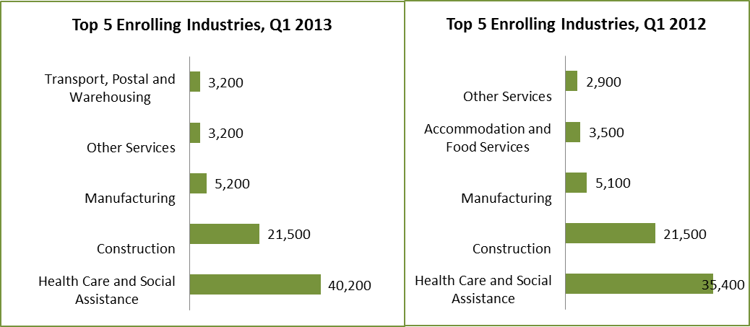

As seen in figure 3.2, Healthcare and Social Services, Construction, Manufacturing, Transport, Postal and Warehousing consistently feature as the highest enrolling industries for specialised or in shortage occupations. The first quarter of 2013 reported Other Services as one of the highest enrolling industries. This may be attributed to the large increase in enrolments for qualifications related to the occupation of Motor Mechanics who are generally employed within this industry. Detailed analysis at occupational level is available in the next section.

## Analysis of Specialised and In Shortage Related Courses by occupations

In order to study the responsiveness of the training market in more detail, this analysis focuses on a granular level of occupational groupings[13]. There has been an overall rise (4 per cent) in enrolments related to either specialised or in shortage occupations in the first quarter of 2013 compared to the first quarter of 2012. The largest shares of enrolments were in courses related to the occupations of Child Carers and Aged and Disabled Carers.

Table 2.5: Top 10 enrolling specialised or in shortage occupations

|  |  |  |  |  |  |  |  |  |  |  |  |  |  |  |  |  |  |  |  |  |  |  |  |  |  |  |  |  |  |  |  |  |  |  |  |  |  |  |  |  |  |  |  |  |  |  |  |  |
| --- | --- | --- | --- | --- | --- | --- | --- | --- | --- | --- | --- | --- | --- | --- | --- | --- | --- | --- | --- | --- | --- | --- | --- | --- | --- | --- | --- | --- | --- | --- | --- | --- | --- | --- | --- | --- | --- | --- | --- | --- | --- | --- | --- | --- | --- | --- | --- | --- |
| |  |  |  |  | | --- | --- | --- | --- | | **Occupation** | **Q1 2012** | **Q1 2013** | **% change Q1 2012 - Q1 2013** | | Child Carers | 13,200 | 15,000 | 14% | | Aged and Disabled Carers | 7,200 | 8,700 | 21% | | Welfare Support Workers | 5,200 | 6,400 | 23% | | Electricians | 5,300 | 5,400 | 2% | | Enrolled and Mothercraft Nurses | 4,800 | 5,300 | 10% | | Carpenters and Joiners | 5,300 | 4,600 | -13% | | Plumbers | 4,900 | 4,400 | -10% | | Motor Mechanics | 3,200 | 3,600 | 13% | | Architectural, Building and Surveying Technicians | 2,400 | 3,600 | 50% | | Truck Drivers | 2,400 | 2,800 | 17% | | *All other occupations* | *27,300* | *24,800* | *-9%* | |
| Figure 2.3: Top 10 enrolling specialised or in shortage occupations |
| Figure 2.4: Top enrolling occupations |
|  |
| As seen in figure 3.2, Child Carers, Aged and Disabled Carers, Welfare Support Workers, Motor Mechanics, Plumbers, Electricians, Carpenters and Joiners consistently feature as the highest enrolling occupations for specialised or in shortage occupations. Many of these occupations fall within the Construction and the Health and Social Assistance industries, which are also some of the highest enrolling industries for qualifications related to specialised or in shortage occupations.  The first quarter of 2013 reported Architectural, Building and Surveying Technicians as one of the highest enrolling occupations. This may be attributed to the large increase in enrolments for Certificate IV and Diploma level qualifications in Building and Construction. |
| **Key Points**   * In the first quarter of 2013, the top ten highest enrolments in courses related to specialised or in shortage occupations, accounted for 71 per cent of all enrolments in courses related to either specialised or in shortage occupations. * 18 per cent of enrolments (15,000 enrolments) in either specialised or in shortage occupations were in courses related to Child Carers. This was followed by 10 per cent (8,700 enrolments) in Aged and Disabled Carers and 8 per cent (nearly 6,400 enrolments) in Welfare Support Workers. * Other top enrolling courses related to the specialised / in shortage occupations were for Electricians, Enrolled and Mothercraft Nurses, Carpenters and Joiners, Plumbers, Motor Mechanics, Architectural, Building and Surveying Technicians and Truck Drivers. * The largest growth in enrolments in the first quarter of 2013 compared to the first quarter of 2012, were in courses related to the occupations of Dental Hygienists, Technicians and Therapists, Train and Tram Drivers, Dieticians, Structural Steel and Welding Trades Workers, Child Care Centre Managers and Architectural, Building and Surveying Technicians. In contrast, there has been a decline in the uptake of qualifications related to Retail Managers, Counsellors, Fire and Emergency Workers, Electrical Distribution Trades Workers and Financial Brokers. |

# Learner Cohorts and Foundation Level Training

## Vocational Training Delivery to Specific Learner Cohorts

Young people and adult learners who may be members of more than one equity group, can have complex and multiple learning needs, and may have contact with a suite of government services and programs. There is a significant evidence base that demonstrates the value and importance of education and training to these population cohorts. However, higher needs learners may face a combination of barriers to effective engagement in education and training including low levels of previous educational achievement, low aspirations, and poor access to training and broader barriers such as poverty, homelessness and poor health.

Vocational training has continued to be a critical enabler in opening up pathways for higher needs and disadvantaged learners through the provision of tailored, individualised services, often in partnership with other service providers.

Table 3.1: Number of government subsidised students by higher needs group*, 2008 – 2012, Q1 2012 and Q1 2013



*The above cohorts of students are not mutually exclusive.

|  |
| --- |
| Key Points  * Against a 9 per cent drop in overall government subsidised student numbers in Q1 2013 when comparing with Q1 2012, Indigenous students, students with a disability, Culturally and Linguistically Diverse (CALD) students and unemployed students are still actively engaged in vocational education and training. * In Q1 2013, there were small increases in the numbers of Indigenous students and unemployed students undertaking government subsidised training courses compared to Q1 2012. * The number of students who were aged 15-19, not in school and without a year 12 or equivalent undertaking a Certificate II or higher declined by 17 per cent, from 15,000 in Q1 2012 to 12,400 in Q1 2013. * Older students aged 20-64 years without a Certificate III or higher qualification also declined by 5 per cent over the same period. |

## Indigenous Students

### Enrolments

Table 3.2: Indigenous students: Government subsidised enrolments by qualification level, 2008 – 2012, Q1 2012 and   
Q1 2013



Figure 3.1: AQF qualifications by Indigenous students, Q1 2012 and Q1 2013



|  |
| --- |
| Key Points  * Consistent with the increase in Indigenous student numbers undertaking government subsidised training courses in Q1 2013 compared to Q1 2012, the number of government subsidised course enrolments undertaken by Indigenous students has also increased by 3 per cent over the same period. * Of those enrolments in industry-specific qualifications (2,200 enrolments) which exclude foundation skills and short courses in Q1 2013, 40 per cent were in courses related to specialised or in shortage occupations. It was 35 per cent in Q1 2012. * Proportionally, more than half of Australian Qualification Framework course enrolments undertaken by Indigenous students in Q1 2013 were in Certificate III to IV levels. |

## 

## Students with a Disability

### Enrolments

Table 3.3 Students with a disability: government subsidised enrolments by qualification level, 2008 – 2012, Q1 2012 and Q1 2013



Figure 3.2: AQF qualifications by students with disability, Q1 2012 and Q1 2013



|  |
| --- |
| Key Points  * Against a 4 per cent drop in students with a disability undertaking government subsidised courses in Q1 2013 compared to Q1 2012, course enrolment numbers undertaken by this student cohort remained relatively stable over the same period. * Of those enrolments in industry-specific qualifications (13,700 enrolments) which exclude foundation skills and short courses in Q1 2013, 37 per cent were in courses related to specialised or in shortage occupations. It has increased from 33 per cent in Q1 2012. * In terms of the proportional share of AQF enrolments, there has been an increase in the percentage of enrolments at Certificate I to II levels in Q1 2013 (40 per cent) compared to Q1 2012 (37 per cent). The proportional decline was in enrolments in Diploma & Above levels over the same period. |

## Students with a Culturally and Linguistically Diverse (CALD) Background

### Enrolments

Table 3.4 Students from a CALD background: government subsidised enrolments by qualification level, 2008 – 2012,   
Q1 2012 and Q1 2013



Figure 3.3: AQF qualifications by students from a CALD background, Q1 2012 and Q1 2013



|  |
| --- |
| Key Points  * The total number of government subsidised course enrolments undertaken by students from a CALD background declined by 2 per cent in Q1 2013 compared to Q1 2012. However there were increases in enrolments at the Certificate I to II and Certificate III to IV levels over the same period. * Of those enrolments in industry-specific qualifications (49,600 enrolments) which exclude foundation skills and short courses in Q1 2013, 44 per cent were in courses related to specialised or in shortage occupations. It was an increase of 11 percentage points from 33 per cent in Q1 2012. * Proportionally, more than half of Australian Qualification Framework course enrolments undertaken by students from a CALD background in Q1 2013 were in Certificate III to IV levels. |

## Unemployed Students

### Enrolments

Table 3.5: Unemployed students: government subsidised enrolments by qualification level, 2008 – 2012, Q1 2012 and Q1 2013



Figure 3.4: AQF qualifications by unemployed students, Q1 2012 and Q1 2013



|  |
| --- |
| Key Points  * The total number of government subsidised course enrolments undertaken by unemployed students in Q1 2013 was similar to that in Q1 2012. * While the number of government subsidised enrolments undertaken by unemployed students at the Certificate I to II has increased by 18 per cent over the same period, enrolment numbers have declined in the Diploma & Above levels, Module only training and senior secondary subjects. * Of those enrolments in industry-specific qualifications (45,700 enrolments) which exclude foundation skills and short courses in Q1 2013, 40 per cent were in courses related to specialised or in shortage occupations. It was at 29 per cent at the same time in 2012. * Proportionally, more than half of Australian Qualification Framework course enrolments undertaken by unemployed students in Q1 2013 were in Certificate III to IV levels. |

## Young People (Aged 15 to 19) Without Year 12 or Equivalent and Not at School

### Enrolments

Table 3.6 Youth transition: government subsidised enrolments Cert II and above by students aged 15 to 19 who did not complete Year 12 or equivalent and not at school, 2008 – 2012, Q1 2012 and Q1 2013



|  |
| --- |
| Key Points  * The total number of government subsidised enrolments at Certificate II and above of young people without a Year 12 or equivalent and not in school has declined by 19 per cent in Q1 2013 compared to Q1 2012. The drop in enrolment numbers was across all certificate levels. * Of those enrolments in industry-specific qualifications (12,000 enrolments) which exclude foundation skills courses in Q1 2013, 45 per cent were in courses related to specialised or in shortage occupations. This is an increase from 41 per cent in Q1 2012. |

## Older Students with Low Prior Qualifications

### Enrolments

Table 3.7: Government subsidised enrolments by students aged 20-64 not holding a Cert III or above, 2008 – 2012,   
Q1 2012 and Q1 2013



Up-skilling refers to studying at a higher level than their current qualification.

|  |
| --- |
| Key Points  * The enrolments of people with low prior qualifications in government subsidised training decreased by 4 per cent in Q1 2013 compared to Q1 2012. * Of enrolments in industry-specific qualifications (118,000 enrolments) which exclude foundation skills and short courses in Q1 2013, 39 per cent were in courses related to specialised or in shortage occupations. It was 33 per cent in Q1 2012. |

## Foundation Level Training

An efficient and effective training market plays a vital role in providing better outcomes for individuals and employers, as well as the wider Victorian community. Of particular importance is ensuring school leavers and adults without solid foundation skills in literacy and numeracy are given the opportunity to acquire them and thus greatly improve their chances of employment, further education opportunities and broader social participation.

Figure 3.5: Government subsidised enrolments in foundation skills courses, 2008 – 2012, Q1 2012 and Q1 2013



Table 3.8: Top 10 government subsidised foundation skills course enrolments, Q1 2012 and Q1 2013



Table 3.9: Government subsidised students in foundation skills courses by age group, 2008-2012, Q1 2012 and Q1 2013



|  |
| --- |
| Key Points  * Despite an overall 7 per cent drop in government subsidised enrolments in Q1 2013 compared to Q1 2012, the number of government subsidised foundation skills course enrolments has continued to increase by 42 per cent over the same period. * The highest number of foundation skills course enrolments were within the Certificate I in Vocational Preparation, the Certificate II in General Education for Adults and the Certificate I in General Education for Adults. * Of students enrolled in a government subsidised foundation skills courses in Q1 2013, 50 per cent of them were aged between 15 and 24 years. * Government subsidised students studying foundation skills courses represented one fifth (21 per cent) of all government subsidised student populations in Q1 2013. It was 13 per cent in Q1 2012. |

1. TAFE fee for service figures include domestic AQF Level 1 and above. Refer to section on Reporting scope for further detail.
2. The NCVER in their publication *APPRENTICES & TRAINEES, Early trend estimates March Quarter 2013*, noted that at a national level “*The substantial growth in non-trade commencements up to the June quarter 2012 and the subsequent decline in the September quarter is predominately due to changes to Commonwealth incentive payments for existing workers, namely the removal of the commencement incentive payment for those apprenticeships and traineeships not on the National Skills Needs List. Under the changes, training needed to have commenced prior to 1 July 2012 to attract the old subsidy rate.”*
3. Note that a course enrolment indicates an enrolment by a student in specified course at a registered training organisation. Training hours on the other hand measures the hours taken to deliver training. Total student hours is not an indicator of training provider revenue.
4. Skills for Australians http://www.dpmc.gov.au/publications/skills_for_all_australians/chapter1_overview.html
5. TAFE domestic fee for service module only enrolments has declined from 12,600 in Q1 2012 to 10,400 in Q1 2013.
6. Karmel, T. and Misko, J. 2009, p. 3ff.
7. Commencements data is sourced from the DELTA system used to manage and monitor training contracts. This data was used for this purpose only as the Training Market Quarterly Report is based on VET training activity.
8. Australian Bureau of Statistics, Building Activity, Australia, 8752.0 Table 34. Number of Dwelling Unit Commencements by Sector, States and Territories.
9. The NCVER in their publication APPRENTICES & TRAINEES, Early trend estimates March Quarter 2013, noted that at a national level The substantial growth in non-trade commencements up to the June quarter 2012 and the subsequent decline in the September quarter is predominately due to changes to Commonwealth incentive payments for existing workers, namely the removal of the commencement incentive payment for those apprenticeships and traineeships not on the National Skills Needs List. Under the changes, training needed to have commenced prior to 1 July 2012 to attract the old subsidy rate.
10. Employment and economic output forecasts are derived from Monash CoPS, June 2012
11. Economic output is measured as GDP in $ million
12. For analytical purposes, HESG has created a new industry sector that captures those occupations (e.g. project managers) whose skills are applicable across several industries.
13. Occupations by ABS ANZSCO 4 digit occupational groupings