Victorian Training Market Report
Half Year 2014 Highlights

The Victorian training system has undergone sustained reform over the last 20 years. These changes have sought to increase participation, particularly for those unemployed or at risk of unemployment, and create better alignment between training and the skills needed in a service-oriented, knowledge-based economy.
Today the Victorian training system:
- Has the highest participation rate in Australia. 16.1 per cent of working age Victorians are in training, compared to the national average of 11.9 per cent.
- Reaches more students. There are 311,900 students enrolled in government subsidised training, 1 per cent more than the same time in 2013 and 44 per cent more than 2010.
- Supports more training in occupations and skills areas that are forecast to grow (in both employment share and output) between now and 2017-18. This training grew to 72 per cent in the first half of 2014 from 68 per cent in 2010.
- Creates more opportunities for students who will benefit most. There were 142,100 enrolments by Indigenous, disabled, unemployed and culturally and linguistically diverse students at Certificate III (or above) or in specialised or in shortage occupations. This is 20 per cent more than 2013 and 128 up per cent on 2010.
- Better supports regional Victoria. There are now 47 per cent more enrolments in regional Victoria in trades and other high-skill occupations than there were in 2010.

Training for real jobs
Our training system continues to provide training that leads to real jobs and to adapt to the demand for more people with the skills and capabilities necessary in skilled occupations.
This is increasingly important because employment opportunities are changing as Victoria’s economy becomes more service-oriented and knowledge-based, and we see that jobs in skilled occupations are growing at more than twice the rate of unskilled jobs.
A key measure of improvement of economic opportunities for Victorians is the proportion of the population that have a Certificate III or higher qualification, or who are employed in a skilled occupation. This is because this indicator measures the opportunity to gain skills for entry-level jobs, and it also captures how well the economy provides skilled job opportunities to people as a means of improving living standards and wellbeing.
In 2007, 65 per cent of the Victorians aged between 20 and 64 were employed in a skilled occupation or had a Certificate III or above. By 2012, this proportion had increased to 72 per cent, generally with year-on-year growth seen in the proportion for each of the five intervening years.

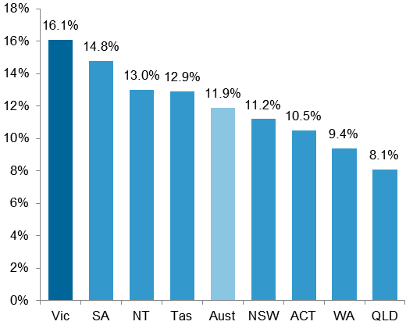
Participation rate in training of 15 to 64 year olds in VET training in 2013

These economic changes mean that:
- Workers can no longer count on a job for life. Increasingly, workers will need to have the skills to move between employers, industries and occupations in response to changes in the job market.
- Even within those occupations that are forecast to grow, the mix and level of skills required by employers is changing. The need for routine skills is declining, and the demand for higher-level cognitive, analytical and interpersonal skills is growing.
- A Certificate III qualification is emerging as the minimum qualification needed to achieve a rewarding career.
Our training system continues to align training to the needs of skilled occupations and to provide opportunities for students. In the first half of 2014 we saw that:
- 46 per cent of enrolments were in qualifications aligned to specialised or in shortage occupations, compared to 42 per cent in 2013 and 37 per cent in 2010.
- 63 per cent of vocational training was in the six industries forecast to grow through to 2017-18, compared to 62 per cent in 2013 and 60 per cent in 2010.
- There was a 12 per cent increase in enrolments in Certificate III or IV qualifications, with enrolments in these levels of qualification now representing 64 per cent of all government subsidised enrolments (up from 54 per cent in 2013 and 49 per cent in 2010).
- Apprenticeship enrolments have remained stable. However, there was a modest increase in enrolments in specialised or in shortage apprenticeships (28,800 enrolments up from 28,600 enrolments in the first half of 2013).
Number of students enrolled in government subsidised training, 2010 to 2014 (half year)
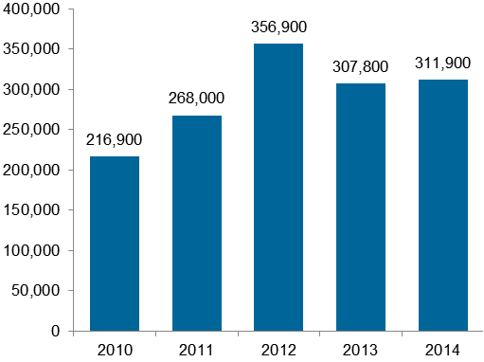

Expanding opportunities for students
Victoria has the highest rate of participation in training in Australia, with 16.1 per cent of working age Victorians participating in vocational training in 2013.
Victorian government subsidies have increased significantly since 2010 to support these higher levels of participation, in contrast to fairly stable levels of investment in other jurisdictions.
Government funding for VET in Victoria, other jurisdictional funding of VET and Commonwealth higher education funding
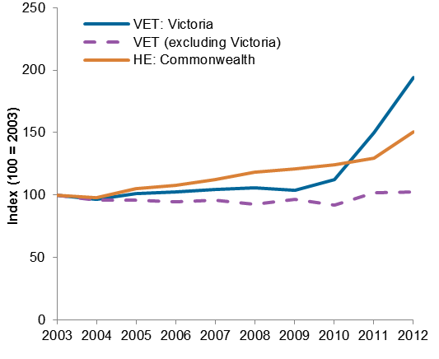
High levels of participation in vocational training have continued in the first half of 2014 with:
- 311,900 students enrolled in government subsidised training, 1 per cent more than the same time in 2013 and 44 per cent more than 2010.
- 378,000 government subsidised enrolments, 5 per cent fewer than in 2013 but 48 per cent more than in 2010, with enrolments in vocational courses (excluding Foundation courses) up by 8 per cent on 2013 and 38 per cent on 2010.
Regional participation in training has increased:
- 78,800 regional students enrolled in government subsidised training, 17 per cent more than 2010 but marginally fewer (5 per cent down) than 2013.
- Training at Certificate III-IV levels in regional Victoria increased by 3 per cent in the first half of 2014 over the same period in 2013 and by 47 per cent on 2010.
- 79,200 enrolments in vocational courses (excluding Foundation courses) delivered in regional Victoria, 3 per cent more than in 2013 and 11 per cent more than in 2010.
- 62 per cent of enrolments in regional Victoria were in four of the top five highest employing industries (construction, health care and social assistance, manufacturing and agriculture, and forestry and fishing).
Educational attainment is important to give people the opportunities, means, and ability to have a high standard of living. People with higher-level educational qualifications are more likely to be employed, and earn more than those without.
ABS data shows that 83 per cent of Australians aged 15-64 years with a Certificate III qualification or higher have a job, compared with only 57 per cent of unqualified early school leavers.
Percentage change in number of students in government subsidised training from 2010 to 2014 (half year)
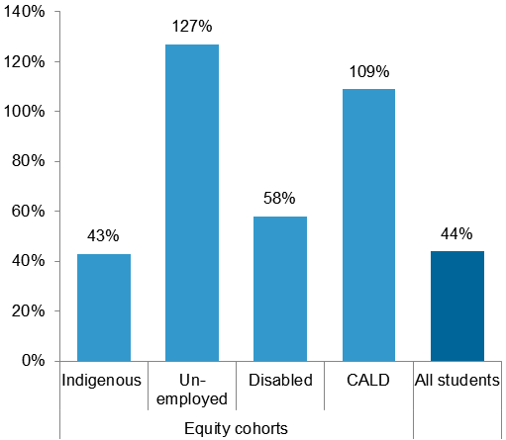
For people facing disadvantage and barriers to employment, vocational training can improve their job prospects. The number of Victorians who are undertaking training to help them overcome barriers to workforce participation continues to grow and in the first half of 2014 there were:
- 4 per cent more students in training than in 2013 from those areas of Victoria with the highest levels of educational and occupational disadvantage. This is an increase of 62 per cent since 2010.
- 4,180 Indigenous students enrolled, 6 per cent more than in 2013 and 43 per cent more than in 2010.
- 89,000 unemployed students enrolled, 12 per cent more than in 2013 and 127 per cent more than in 2010.
- 28,400 students with a disability enrolled, 7 per cent more than in 2013 and 58 per cent more than in 2010.
- 94,200 Culturally and linguistically diverse students enrolled, 14 per cent more than in 2013 and 109 per cent more than in 2010.
Training delivered to these learners is becoming better targeted to their needs. In the first half of 2014:
- 142,100 government subsidised enrolments in the first six months of 2014 were either at Certificate III (or above) or in specialised or in shortage occupations. This is up by 20 per cent on 2013 and 128 per cent on 2010.
- 42 per cent of Foundation courses enrolments in 2014 were by students who were not at school and who did not have either at least Year 12 completion or a Certificate II. This is an increase from 34 per cent in 2013 and indicates that Foundation training is being better targeted.

Building modern, competitive TAFEs
Victoria’s training providers are as diverse as the students and businesses they support. Students and businesses can choose from small and large community providers, private providers and public providers for their training. A decision on a provider is influenced by; the course on offer, student or employer preferences for a particular mode of delivery and additional services, as well as an understanding of cost and quality.
TAFE institutes continue to be the major providers of government subsidised apprenticeship enrolments in Victoria – delivering 62 per cent of enrolments in the first six months of 2014. And due to their course mix, TAFE institutes received a greater share of government spending on training than their actual market share in 2013.
Government operating grants to TAFE institutes increased from $487 million in 2010 to $600 million in 2013.
Like other providers, the success of TAFE institutes will be dependent on their ability to maintain financial sustainability by attracting students and employers to their training programs.
To achieve this, TAFEs need:
- Strong governance and management.
- The capacity to attract students and employers with relevant and quality training offers.
- High quality financial and other business systems.
- Sophisticated market analysis and business intelligence tools.
- More efficient cost structures and asset bases and a sustainable scale.
Our TAFE institutes are at different stages of transformation as they adjust to open vocational training markets in their regions and sectors. While some TAFE institutes have adapted quickly, others are at an earlier point in their transformation.
Most TAFE institutes have taken actions to improve the efficiency of their operations, including through streamlining internal business processes, consolidating similar courses, and ensuring better alignment between employment and training delivery costs. This means that inefficiencies need not be passed on in higher student fees.
To improve their scale and competitiveness, four TAFEs sought approval from government to amalgamate and transform their businesses in the first half of 2014. Government approved amalgamations in Gippsland and along the Bendigo/Calder corridor. Government has allocated $120 million of structural adjustment funding across the sector to support these amalgamations and other adjustment programs at other institutes.
The Department will continue to work in partnership with TAFE institutes and support their transformations by:
- Helping TAFE institutes respond to student preferences and emerging market needs.
- Encouraging initiatives by TAFE institutes that enhance student experiences and outcomes.
- Encouraging greater operating efficiencies, by providing incentives for improved asset utilisation and more efficient cost structures.
- Supporting initiatives by TAFE institutes that improve their competitiveness, market share and financial sustainability (for example, by increasing economies of scale or diversifying income streams).
- Continuing to improve the performance reporting framework for TAFE institutes.

