ACFE BOARD PRE-ACCREDITED
TRAINING DELIVERY GUIDELINES - 2018

2018 PRE-ACCREDITED TRAINING DELIVERY ALLOCATION PROCESS – TIMELINES

ACTION | DUE DATE
2018 Pre Accredited Training Delivery Allocations process commenced with a Memo. | 15 August 2017
WEBINARS 2018 Allocation Process – registration details in memo of 15 August  Registration Link -Webinar Registration  Webinar Participant Link - https://au.bbcollab.com/invite/6cc61d3d135a42e8b0263bc9eb4e6628 | 11am 23 August 2017  2 pm 28 August 2017
REGIONAL WORKSHOPS - registration details will be emailed to providers | Throughout September
Department staff will email providers a provisional allocation of hours by LGA with a Pre-accredited Training Delivery Plan. | Between 23 August 2017 – 30 August
Pre-accredited Training Delivery Plans, accompanied by Course Plans, for all programs being proposed for 2018 must be completed and submitted to: training.participation@edumail.vic.gov.au, | By 16 October 2017
Department staff will review and confirm final allocations by LGA with Providers. | 27 October 2017
Department staff will finalise any remaining Course Plan and A frame requirements and finalise Delivery Plans with Providers | Mid November
A Service Plan will be loaded into SAMs 2 for your authorised signatory to accept. | December 2017
ACFE Board makes first payment to you once all steps are complete. | January 2018  (earliest payment)

CONTENTS
2018 GOVERNMENT SUBSIDISED PRE ACCREDITED ALLOCATION PROCESS 4
GOVERNMENT SUBSIDISED PRE-ACCREDITED TRAINING 5
Purpose of government subsidised pre-accredited training 5
The role of the ACFE Board 5
Priorities for Pre-accredited Training 5
Eligibility for Delivery of Pre-Accredited Training 6
Who can enrol in Government subsidised pre-accredited training 7
ACFE REGIONAL COUNCILS 8
Regional Council Priorities 8
2018 ALLOCATION PROCESS 9
COMPLETING THE DELIVERY PLAN 10
Provisional Allocation Of Student Contact Hours (Sch) 10
Program Categories 10
Work Experience 10
Intel® Learn Easy Steps 10
Local Module Codes 11
SAMS 2 - SERVICE AGREEMENT 12
Variations to the Pre-accredited Delivery Plan 12
Service Agreement Compliance Certificate (SACC) 13
Insurance 14
PAYMENTS 15
Pre Accredited Training Delivery 15
Unacquitted Funds - Reconcilliation Of The Pre Accredited Training Delivery Service Plan 15
Training Delivery Support Grant (TDSG) 15
Fee concession arrangements for pre-accredited delivery 15
Loading 15
REPORTING - DATA QUALITY 16
Student Management System 16
Victorian Training Information System’ – (VTIS) 16
Reporting pre-accredited delivery 16
Fee concession arrangements for pre-accredited delivery 17
THE PRE ACCREDITED QUALITY FRAMEWORK 18
WHO DO I CONTACT IF I NEED ASSISTANCE? 19
COMMUNICATION WITH LEARN LOCAL ORGANISATIONS 20
BRANDING REQUIREMENTS 20
PUBLICITY AND ACKNOWLEDGEMENT GUIDELINES 20
PRIVACY NOTICE FOR STUDENT ENROLMENT 21
USEFUL LINKS 22
ACFE REGIONAL LOADING POSTCODES 23

2018 GOVERNMENT SUBSIDISED PRE ACCREDITED ALLOCATION PROCESS

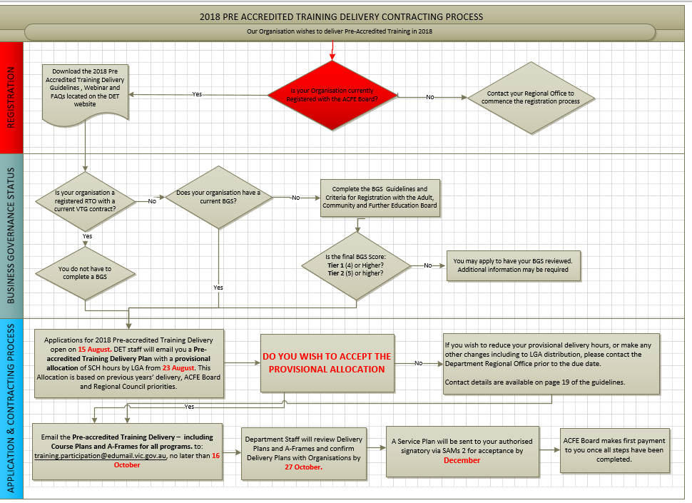

GOVERNMENT SUBSIDISED PRE-ACCREDITED TRAINING

Introduction
Victoria’s adult community education sector has a long, proud history. Currently, more than 300 Learn Local Organisations deliver a wide range of education and community programs, including government-subsidised pre accredited training to almost 28,000 Victorians. Learn Local Organisations have a great record of supporting Victorians who face barriers in accessing education and training, and in building people’s capabilities and confidence for work and life.
Learn Local Organisations deliver accessible, locally-based training throughout Victoria including in places where there are fewer training options. They are among Victoria’s most valuable community assets, improving the lives and prospects of many Victorians, and playing a positive role in strengthening local economies and communities.

Purpose of THE PRE ACCREDITED TRAINING DELIVER GUIDELINES
The information provided in these guidelines has been developed to assist Adult Education Institutions and organisations registered with the Adult, Community and Further Education Board (ACFE Board) as Learn Local providers in planning pre-accredited training delivery for 2018.

Purpose of government subsidised pre-accredited training
The primary purpose of pre-accredited training programs is to provide vocational training to engage the most educationally disadvantaged learners and initiate vocational and/or employment pathways for them.

The role of the ACFE Board
The Adult, Community and Further Education (ACFE) Board is a statutory authority under the Education and Training Reform Act 2006. Its role is to plan and promote adult learning, allocate resources, develop policies, and advise the Minister for Training and Skills on matters related to adult education in Victoria.
Through the Board, the Victorian Government provides funding to community-based organisations, known as Learn Local organisations, and two adult education institutions, the CAE and AMES Australia, for delivery of education and training programs to a broad range of Victorians over compulsory school-leaving age – young people, older people, people with special needs, people from diverse cultural backgrounds – with a special focus on people who have had limited prior access to education.
The Board’s priorities, criteria and processes for the allocation of pre accredited training funds by ACFE Regional Council area are based on demographic data and the strategic objectives the Board has set.
Further information on the ACFE Board can be found at ACFE Board

Priorities for Pre-accredited Training
The ACFE Board has identified the following learner groups for specific emphasis in pre-accredited programs:
- Women, including young mothers, women seeking to re-enter the workforce after significant time away, women who have experienced or are experiencing family violence
- People in low socio-economic status localities
- Early school leavers (both mature and youth)
- Indigenous people
- Low skilled and vulnerable workers
- Unemployed/underemployed people
- People from a culturally or linguistically diverse background
- People with a disability
- Young people who may be at risk of disengaging or who may have already disengaged from the community and/or education

Eligibility for Delivery of Pre-Accredited Training
To be eligible to receive funding for government subsidised pre-accredited training organisations must:
- Be currently registered with the ACFE Board or be an Adult Education Institution.
- Registration does not guarantee funding. For more information on registration with the ACFE Board see: Guidelines and Criteria for Registration with the Adult, Community and Further Education Board
- Pass an ACFE Board Business and Governance Status Assessment
- Learn Local Organisations (LLOs) or Registered Training Organisation (RTOs) that do not hold a current Victorian government accredited training contract must have an ACFE Board Business and Governance Status Assessment (BGS).
- Learn Local Registered Training Organisations with a contract to deliver Victorian government subsidised accredited training in 2018 will not be required to complete an ACFE Board Business and Governance Status Assessment.
- For more information about completing the BGS see: Business and Governance Status Assessment.
- Submit a 2018 Pre-accredited Training Delivery Plan that reflects ACFE Board and relevant Regional Council priorities, accompanied by Course Plans for all proposed programs for 2018 delivery, by the 16 October 2017.
- To be funded, a pre-accredited program must be 20 hours or more in duration and be part of total planned pre-accredited delivery of at least 500 student contact hours for the calendar year.
- Maintain an AVETMISS compliant, up-to-date student management system and meet the requirements in the Victorian VET Student Statistical Data Collection Guidelines as well as ensuring that appropriate and sufficient personnel trained in the use of their Student Management System and the SVTS are available to ensure integrity, accuracy and currency of data and reporting.

Who can enrol in GOVERNMENT subsidised pre-accredited training
Learners must be:
- an Australian citizen
- a holder of an Australian permanent visa
- a New Zealand citizen.
Australian citizens, permanent visa holders or New Zealand citizens who are not eligible for places in government-subsidised Pre-Accredited Programs:
- They are, within the meaning of the Corrections Act 1986, a prisoner held at a prison.
- They are detained under the Mental Health Act 1986; or the Crimes (Mental Impairment and Unfitness to be Tried) Act 1997 or the Sentencing Act 1991 at the Thomas Embling Hospital.
- They are detained (other than on weekend detention) under the Children, Youth and Families Act 2005 or the Sentencing Act 1991 or who is held on remand in the Malmsbury Juvenile Justice Centre or Parkville Youth Residential Centre.
- People enrolled at school.
Please note that citizenship requirements apply for accessing all Adult, Community and Further Education (ACFE) Board subsidised pre-accredited programs. There is currently no exemption for asylum seekers to participate in government subsidised pre accredited training through the ACFE Board.

ACFE REGIONAL COUNCILS

ACFE Regional Councils
There are eight ACFE Regional Councils, Barwon South Western, Gippsland, Grampians, Hume, Loddon Mallee, North Western Metropolitan, Eastern Metropolitan and Southern Metropolitan, established in line with the Education and Training Reform Act 2006.
Regional Councils draw together different expertise and aspects of local knowledge about adult education to advise the ACFE Board on the needs of adult education across their region. They also contribute to statewide planning and policy development.

PREACCREDITED TRAINING AND Role of REGIONAL Councils
Regional Councils prepare advice on local priority learner cohorts to inform and assist the ACFE Board in determining the allocation of pre-accredited training resources across Victoria. Each year Regional Councils provide advice on regional priorities based on their knowledge, research and local intelligence. Regional Councils prepare this advice based upon a consideration of the priorities and strategic objectives of the ACFE Board, relevant local demographic and training data, and the socio-economic and employment profile of the region and local intelligence on learner needs. It is expected that organisations seeking to deliver pre-accredited training in 2018 will align their delivery plans with Regional Council Priorities for the appropriate area.

REGIONAL COUNCIL PRIORITIES
The detailed Regional Council Priorities are available on the DET website. See: Regional Council Priorities

ACFE Regional Councils
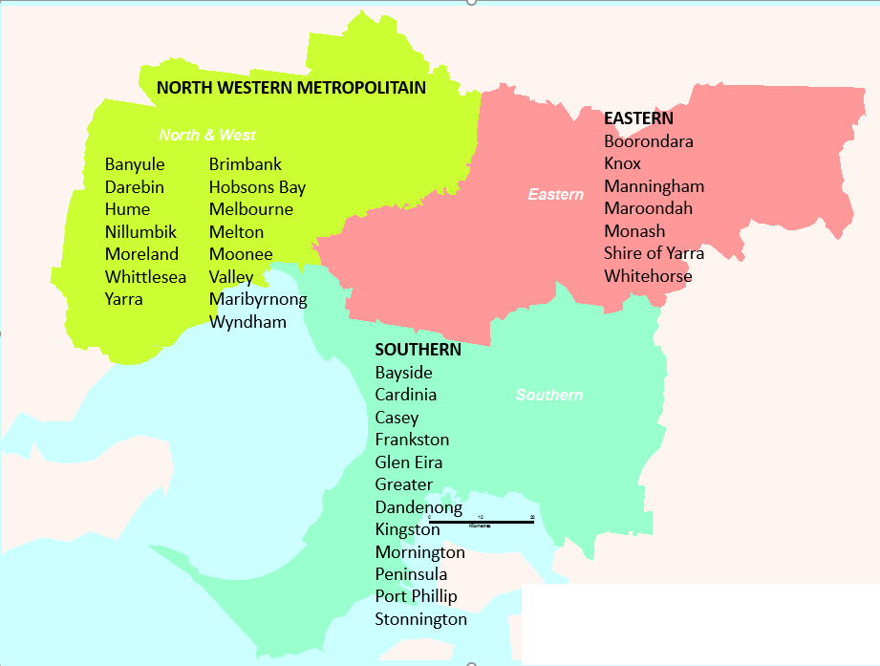
Barwon South Western
Eastern Metropolitan
Gippsland
Grampians
Hume
Loddon Mallee
North Western Metropolitan
Southern Metropolitan

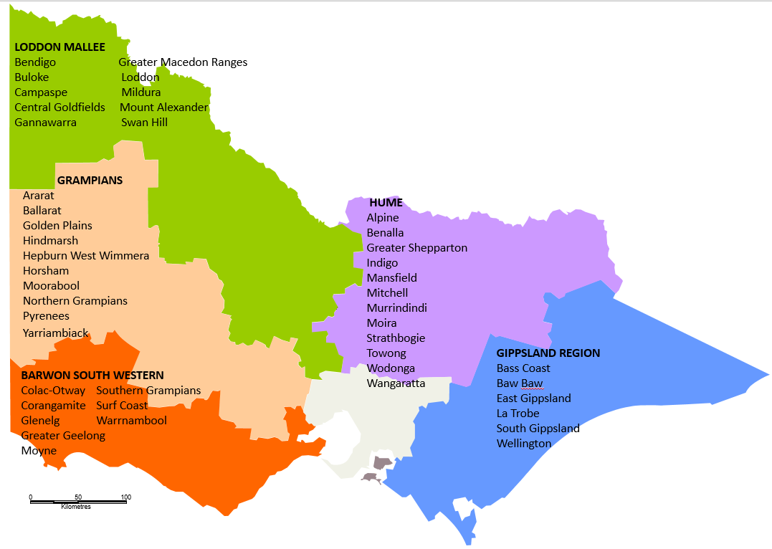

2018 ALLOCATION PROCESS
Organisations who wish to receive an allocation of ACFE Board pre accredited training hours in 2018 must complete the following steps:
The allocation process commenced on 15 August 2018 with a Provider Memo
- If you wish to deliver pre-accredited training in 2018 and have not delivered in 2017 please contact your Regional Office prior to 25 August 2017 if you have not already done so.
- Participate in a Webinar on the 2018 allocation process for ACFE Board pre accredited training hours as advised in the Memo of 15 August 2017 at one of the following sessions:
11am 23 August 2017
2pm 28 August 2017
After 29 August 2017 – Webinar recording available on ACFE Website
- Download and read the 2018 ACFE Board Pre-Accredited Training Delivery Guidelines
- Download and consider the 2018 Regional Council Priorities for the region you wish to deliver in from the DET website and begin planning your 2018 pre-accredited delivery.
- Check and ensure that your organisations contact details and signatories are up to date in SAMs.
- Attend regional workshop where regional priorities and allocation requirements will be discussed. These workshops will be held throughout September 2017 with advice on specific times and dates to be provided via Memo and Regional Offices.
- Department staff will email you details of a Provisional Allocation of pre-accredited student contact hours (SCH) by LGA by the 30 August 2017. This offer is based on your previous delivery, ACFE Board and Regional Council priorities and available budget.
- Prepare a delivery plan, accompanied by Course Plans for all programs being proposed for 2018 delivery, up to the provisional allocation of hours by LGA and submit it for review at the latest by COB 16 October 2017 via email to: training.participation@edumail.vic.gov.au. Early submissions are appreciated. Please note: You must complete all sections of the A Frame if you are proposing to deliver a new course in 2018.
- If you wish to reduce your provisional delivery hours, or make any other changes including to LGA distribution, please contact the Department Regional Office as soon as possible to negotiate if the changes are possible.
- Department staff will consider your proposed delivery plan in light of the ACFE Board and Regional Council priorities and the demand for training in each Local Government Area. Department staff will liaise with you if any issues are identified or further clarification is required by 27 October 2017.
- A Service Agreement Variation - Service Plan will be sent to your organisation’s signatory via SAMs 2 once all steps have been completed for execution in December 2017. Please note: Your signatory will have a five day window to review and accept the Service Plan, after which SAMs will automatically accept on behalf of your signatory.
- Your first mile stone payment will be processed once all steps are complete.

COMPLETING THE DELIVERY PLAN
The Pre-accredited Training Delivery Plan provides the basis for Learn Local Providers, Adult Education Institutions and the Department to negotiate and approve the allocation of subsidised pre-accredited training by Local Government Areas (LGA) across the state in the three program categories.

PROVISIONAL ALLOCATION OF STUDENT CONTACT HOURS (SCH)
Department staff will email you details of a Provisional Allocation of pre-accredited student contact hours (SCH) by LGA by the 30 August 2017. This offer is based on previous years’ delivery, ACFE Board and ACFE Regional Council priorities and available budget.
If you wish to reduce your provisional delivery hours, or make any other changes including to LGA distribution, please contact the Department Regional Office as soon as possible to negotiate if the changes are possible.
Please consider the following in completing your 2018 Delivery Plan:
2018 Delivery Plans will be reviewed with strong consideration of how the Delivery Plan addresses the Regional Council’s priorities, and meets the needs of the identified LGA for delivery.

PROGRAM CATEGORIES
Please ensure that program categories are used to classify all pre-accredited programs contracted by the Board as follows:
- Adult Literacy and Numeracy − Training in literacy and numeracy skills including teaching English language to people from culturally and linguistically diverse backgrounds, for example English as a Second Language (ESL).
- Employment Skills − Training in basic skills to support work or further learning, such as communications, teamwork and problem solving, job search and return to study skills.
- Vocational Programs – Introduction to vocational education that assists people with skills acquisition required specific occupations to start work, return to work or to change jobs.

WORK EXPERIENCE
The ACFE Board is currently investigating a model of pre-accredited work experience that is broadly accessible and provides adequate legal and insurance coverage to safeguard learners, providers and host employers.
The ACFE Board will circulate comprehensive pre-accredited work experience guidelines to the sector by the end of August, including detail about the complex associated legislative and insurance environment.
It will be expected that all government subsidised pre accredited programs delivered in 2018 will comply with this policy.

INTEL® LEARN EASY STEPS
The Intel® Learn Easy Steps digital literacy program is supported by the ACFE Board as an option for pre-accredited digital literacy delivery in 2018. The program provides an opportunity for Learn Local Organisations to access an internationally recognised digital literacy program and opportunity to share teaching experiences and knowledge with their peers in other countries through the online teaching community. The program also provides access to training and curriculum supports ensuring course quality and strong classroom delivery.
For further information on the program see: Intel Learn Easy Steps

LOCAL MODULE CODES
Course module codes must be developed for all pre accredited programs to facilitate effective reporting noting:
- All 2018 pre-accredited programs should use a local course code which should be entered into your delivery plan and used when reporting. A national or state recognised course code must not be used on the pre-accredited delivery plan and must not be used when reporting pre-accredited training.
- Codes should be alphanumeric and can be up to 12 characters in length.
- The Local Code (Subject Identifier), Local Name (Subject Name) and ACFE Category in your Delivery Plan must be reported identically in subsequent SVTS data.
- Providers who are delivering Intel Learning Easy Steps should include the name of the program in the program name field on the Plan and when uploading data in to SVTS.
- Some initiatives, which may be separately funded, require the use of specific codes. For these initiatives providers must ensure use of the appropriate code for the program (eg LEAP, Asylum Seeker LLN program and Reconnect)
- We have provided some general examples of Local Codes for the three ACFE categories as a guide.
Examples of Local Codes
18VOCCONENG = [year] 2018 – [ACFE Category] VOCATIONAL – [Local Name] CONVERSATIONAL ENGLISH
18ALNLLANNUM = [year] 2018 -[ACFE Category] ADULT LITERACY & NUMERACY - [Local Name] LANGUAGE & NUMBERACY
18EMPPREP= [year] 2018-[ACFE Category] EMPLOYMENT SKILLS - [Local Name] EMPLOYMENT PREPARATION

A FRAMES AND COURSE PLANS
- Course Plans must be submitted for all modules being proposed in your 2018 delivery plan at the time of submitting the delivery plan. All sections of the A Frame should be completed and submitted if you are proposing to deliver a new course in 2018.
- The latest moderated version of A-frame documents for any pre-accredited programs funded by the ACFE Board must be provided on request
- A Frame and Course Plan templates are available here: Pre accredited Quality Framework and Aframe

SAMS 2 - SERVICE AGREEMENT
The current ACFE Board Service Agreement cycle is aligned to the Department of Education and Training cycle however, commenced on 1 January 2017 and ends on 30 June 2019.
The Service Agreement terms and conditions set out the key obligations, objectives, rights and responsibilities of the organisation delivering services and the Department/Authority providing funding to the organisation. The Service Agreement Information Kit for Funded Organisations only details the terms and conditions of the Service Agreement.
Organisations offered pre accredited training delivery subsidies enter into an agreement with the ACFE Board. This agreement between the Organisation and the ACFE Board will be made via a Service Agreement in the SAMs 2 system.
The Service Agreement:
- outlines the general terms and conditions on which it is made; further information about the Terms and Conditions of the Service Agreement can be found on the Funded Agency Channel.
- establishes the principles guiding the relationship between the ACFE Board and the organisation; and
- obtains the organisation’s commitment to support government policies that have a bearing on the provision of adult, community and further education to Victorians.
Further information about the Service Agreement can be found on the DHHS SAMs Funded Agency Channel (FAC) see: http://www.dhs.vic.gov.au/funded-agency-channel/home.

Service Plan
Service plans listed in Schedule 1, 2 & 3 of the Service Agreement, group together like service activities specific to a program area, and identify the department's region/division/group providing funding and as negotiated annually on behalf of the ACFE Board.

Variations to the Pre-accredited Delivery Plan
Training delivery and data reporting must match the agreed content in the Delivery Plan. Organisations proposing to vary their contracted Delivery Plan must negotiate the variation and obtain prior approval through the relevant Department staff before making any changes and commencing delivery.
Please ensure that the Chairperson (or approved delegate) of your organisation approves any variation prior to submitting a request. An email from your approved delegate would suffice.
Once approved, should the variation include a change in total student contact hours, or to the distribution of hours by LGA, a Variation Agreement with a revised Service Plan will be issued through SAMS2.
Requested variations to the Delivery Plan that include changes to LGA targets or payments can only happen during the two Variation Windows offered between April/May and July/August each year.
Please note: Variation Agreements will need approval of an ACFE Board financial delegate and anauthorised signatory from the organisation before taking effect.

SERVICE AGREEMENT COMPLIANCE CERTIFICATE (SACC)
From the 2016-17 financial year reporting period organisations funded by the ACFE Board are required to complete a Service Agreement Compliance Certification (SACC).
The SACC consists of a series of questions to be completed annually by the funded organisations, which certifies compliance with Service Agreement requirements. The questions relate to:
- Financial management: that the organisation has used funding as outlined in their Service Agreement, is financially viable, has prepared its financial reports and any audit reports and maintains an asset register.
- Risk management: that risks are managed in accordance with the Australian/New Zealand Risk Management Standard
- Staff safety screening: that referee checks, police record checks and, if relevant, Working with Children Checks have been completed.
- Privacy: that the organisation’s practices and systems are compliant with the Privacy and Data Protection Act 2014 and the Health Records Act 2001 to protect personal and health information.
- ACFE Board Business and Governance Status (BGS): that the organisation has submitted an up-to-date ACFE BGS assessment or is eligible for an exemption to the BGS requirement under current ACFE Board guidelines.
By submitting a SACC form, organisations are making a commitment to the Department/Authority that they have appropriate systems in place to comply with the relevant Service Agreement requirements.
The SACC form reduces administrative burden for a large number of funded organisations by replacing two forms with one SACC form. In addition, disability service providers no longer need to complete the Disability Services Employment Safety Screening Compliance form which has been replaced by the SACC form. Most funded organisations will be required to complete the SACC in full.
How do I complete the SACC Form?
The SACC notifications will be emailed to your organisation via SAMs 2 and is due 90 days after the end of your organisation's reporting period. However, if your organisation's annual general meeting (AGM) is after the due date you can now insert your organisation's AGM date in SAM and the SACC due date will automatically update to seven days after the AGM.
Organisations should ensure the Contacts tab in SAMs 2 is updated regularly to avoid delays in this process.
- The SACC will need to be completed in My Agency, the secure area of the Funded Agency Channel (FAC) website, where organisations update records and information regarding their funded services.
- Within My Agency, registered users of funded organisations will enter the Service Agreement Module (SAM) and be required to complete and submit their organisation's Service Agreement Compliance Certification (SACC).
- The SACC can be saved at anytime, allowing for different areas of your organisation to individually complete different sections.
- Once completed, the SACC should be submitted by an authorised person, such as the director, chairperson, chief executive officer, president, principal or treasurer.
For further information about how to complete the SACC Form see: http://www.dhs.vic.gov.au/funded-agency-channel/search?mode=results&queries_normal_query=sacc

Insurance
Under the Terms and Conditions of the Service Agreement Learn Local Organisations and Adult Education Institutions who deliver Pre Accredited Training must ensure they have appropriate insurance coverage for its operation and business risks with one or more of the following:
    - the Victorian Managed Insurance Authority or, if the Organisation is a Council, Liability Mutual Insurance;
    - an insurer authorised under the Insurance Act 1973 (Cth);
    - an insurer approved in writing by the Authority; and
      - provide the Authority with proof of the Organisation's insurance cover on request; and
      - maintain appropriate insurance coverage for the Term, and, if those policies are underwritten on a 'claims made' basis, for no less than six (6) years after the completion of the Services; and
      - undertake periodic reviews to make sure the Organisation's operational and business risks are adequately insured, particularly in regard to public and products liability and professional indemnity risks.

PAYMENTS

Pre Accredited Training Delivery
Organisations contracted for 2018 Pre Accredited Training Delivery will receive payment upon successful completion of the identified milestone. The second, third and final payments will only be processed upon upload of student enrolment data via SVTS data that reflects reasonable progress against annual delivery targets. Payments will be released where sufficient data has been uploaded, accordingly the:
- First instalment will be paid on acceptance of the Service Plan
- Second instalment will be paid on the upload of student enrolment data via SVTS by 15 March for payment in April 2018.
- Third instalment will be paid on the upload of student enrolment data via SVTS by 15 May for payment in June 2018.
- Fourth instalment will be paid on the upload of student enrolment data via SVTS by 15 September for payment in October 2018.

UNACQUITTED FUNDS - RECONCILLIATION OF THE PRE ACCREDITED TRAINING DELIVERY SERVICE PLAN
In accordance with the terms and conditions of your Service Agreement Section 4.9, the ACFE Board may in its discretion give notice to the Organisation to repay un-acquitted funds as part of its pre accredited reported data analysis against the agreed Service Plan and approved Delivery Plan.
Only data successfully reported via the Skills Victoria Training System (SVTS) will be accepted by the ACFE Board as evidence of meeting agreed pre-accredited training delivery targets.

TRAINING DELIVERY SUPPORT GRANT (TDSG)
The Training Delivery Support Grant (TDSG) provides funds to eligible to purchase resources or equipment that will support delivery of quality programs and services to learners facing barriers to participation and attainment in education and training.
A grant of $5,500.00 (excluding GST) will be paid to ACFE Board registered Learn Local organisations and Adult Education Institutions that have a current contract with the ACFE Board to deliver government subsidised pre-accredited training in 2018. For further information, please refer to the Training Delivery Support Guidelines.

Fee concession arrangements for pre-accredited delivery
Some learners in pre-accredited programs are eligible for fee concessions. The ACFE Board has a budget to reimburse organisations for a proportion of the revenue foregone by granting fee concessions to learners in government subsidised pre-accredited programs. Final SVTS data reports will be the source for calculating these payments.

REGIONAL LOADING
As part of a coordinated strategy to grow regional delivery, the ACFE Board has committed $2.6 million over three years to fund a 20% Regional Loading for pre-accredited training delivered in regional Victoria. Payments will be based upon reported data for delivery that occurs in the identified postcode areas. (Attachment 1)
This measure is intended to increase regional participation in the context of the persistent challenge of achieving viable class sizes in regional areas. A schedule for Regional Loading payments will be advised by December 2017.

REPORTING - DATA QUALITY
Accurately reporting the delivery of pre-accredited training programs is essential to assist the ACFE Board in understanding and responding to community need for pre-accredited training delivery. All providers must ensure that they accurately report all pre accredited delivery in accordance with the agreed delivery plan.

STUDENT MANAGEMENT SYSTEM
Organisations contracted to deliver Pre Accredited Training with the ACFE Board, must meet the requirements in the Victorian VET Student Statistical Data Collection Guidelines and maintain an AVETMISS compliant, up-to-date student management system.
Organisations must ensure that appropriate and sufficient personnel trained in the use of their Student Management System and the SVTS are available to ensure integrity, accuracy and currency of data and reporting.

Victorian Training Information System’ – (VTIS)
Learn Local organisations and Adult Education Institutions currently use the Department’s Skills Victoria Training System (SVTS) to input data on training delivery for ACFE Funded Pre Accredited Training Delivery.
As part of the Skills First implementation, the current SVTS system will be replaced in the first half of 2018 with a new system called the ‘Victorian Training Information System’ – VTIS.
VTIS will deliver new technology capabilities as well as a better user experience for student administration teams. Once implemented Organisations will use VTIS to submit their quarterly training activity data to the Department. To accommodate this change, the Department will roll out a Change Program including a suite of user guides. Information sessions will be held prior to rolling out the system, to upskill users in how to use VTIS.

Reporting pre-accredited delivery
Learn Local organisations and Adult Education Institutions must upload data through (SVTS) to meet the requirements in the Victorian VET Student Statistical Data Collection Guidelines. Only data successfully reported via the Skills Victoria Training System (SVTS) will be accepted by the ACFE Board as evidence of meeting agreed 2018 pre-accredited training delivery targets.
Please note: the Department will replace SVTS early 2018 with Victorian Training Information System (VTIS) and further information will be available nearer to the time.
- Organisations must report their pre-accredited Student Contact Hour data quarterly at a minimum (or where requested monthly) by the following dates: 15 March 2018, 15 May 2018, 15 September 2018 and 15 January 2019. It is highly recommended that Learn Local providers report regularly to become familiar with the system and how to correct any errors.
- Learn Local providers can upload their pre-accredited data at any time.
- Students do not need to have fully completed a pre-accredited course before the data is reported.
- For assistance please submit an SVTS enquiry, or if you have problems logging-in, please refer to the SVTS Login User Guide on the SVTS log in page.

INSTRUCTIONS FOR UPLOADING DATA TO THE SKILLS VICTORIA TRAINING SYSTEM (svts)
- Identify ONLY as ‘Code 61 – Community-based Adult Education Provider’ in SVTS reporting
- Report pre-accredited programs with the Module VET flag set to “Y”.
- Learn Local RTOs must report pre-accredited program data and accredited course data in the same SVTS upload.
- Report every pre-accredited program via SVTS with the same local code and local name used in your Pre-accredited Delivery Plan (even if a different name is used to advertise the course).
- The Local Code (Subject Identifier), Local Name (Subject Name) in your Delivery Plan must be reported identically in subsequent SVTS data uploads.
Item | Delivery Plan Categories | SVTS Categories*
Module Code | Local Code | Subject (Module/Unit of Competency) Identifier
Module Name | Local Code | Subject (Module/Unit of Competency) Name
* SVTS categories are detailed in the Victorian VET Student Statistical Collection Guidelines
Report NAT60 ‘Module’ Files (and relevant module fields in NAT120 enrolment files) ONLY for pre-accredited program data via SVTS. DO NOT use NAT30 ‘Course’ files (or linked course fields in NAT120 enrolment files) for Pre-accredited delivery. For SVTS reporting purposes, modules are the unit of delivery in pre-accredited programs.
Pre-accredited training must not be:
- Linked in reporting to a Training Package Qualification or a nationally recognised accredited module or course by use of a nationally recognised accredited course or module code.
- Marketed as accredited training. The names and codes of advertised courses or modules must be local.
- Assessed for the purpose of award or credit.

Fee concession arrangements for pre-accredited delivery
Some learners in pre-accredited programs are eligible for fee concessions. The ACFE Board has a budget to reimburse organisations for a proportion of the revenue foregone by granting fee concessions to learners in pre-accredited programs. Final SVTS data reports will be the source for calculating these payments. Ensure concessions are flagged appropriately when uploading your statistical data to SVTS in order to be considered for a reimbursement.

monitoring
Department staff will monitor the delivery of your reported data against your Pre accredited Service Plan with the ACFE Board. They will compare your reported delivery against the LGA of delivery in each of the three Program Categories in the Pre accredited Service Plan throughout the year. Your organisation will be contacted where any issues are identified.

THE PRE ACCREDITED QUALITY FRAMEWORK
The Pre-accredited Quality Framework (PQF) is a quality improvement mechanism developed by the ACFE Board to improve outcomes for learners not ready to undertake an accredited course but wishing to improve their skills to secure employment, access further study, and to build their capacity to engage and remain a part of a complex and fast changing society.
The PQF supports teachers and managers to plan, develop, teach and review pre-accredited courses. The PQF is comprised of a number of components such as the teaching guide or the induction guide.
All PQF components are available as a series of volumes electronically at: www.education.vic.gov.au/training/organisations/learnlocal/Pages/pqf.aspx.
Key components of the PQF are the A-frame curriculum, Moderation and Verification.

A-frame – pre-accredited curriculum
The central component of the PQF is the pre-accredited curriculum model known as the A-frame. The A-frame provides for the development of adult centered learning, for planning, delivering and documenting educational practices, and includes practical tools (the Course Plan and the Learner Plan) for planning pre-accredited courses.
Learn Local Organisations contracted by the ACFE Board to deliver pre-accredited programs must use the A-frame to design and develop these programs. Copies of A-frame- Course Plans for any pre-accredited program subsidised by the ACFE Board must be provided to the Board if requested.
Note: A Course Plan must be submitted for all program being delivered in 2018 on your Pre-Accredited Delivery Plan.

Moderation
The ACFE Board has developed moderation processes for subsidised pre-accredited programs. Moderation is a collaborative, peer appraisal process that promotes a shared understanding of what constitutes quality course design, delivery and outcomes for learners.
The Pre-accredited Quality Framework (PQF) moderated courses have documented evidence to provide an assurance to the ACFE Board that the courses they subsidise are of a high quality. All Pre Accredited A frames must be moderated by providers.

Verification
Regional Offices of the Department of Education and Training will request Learn Local Organisations to provide them with a sample of moderated pre-accredited courses at least once over a three-year period for verification. The verification of moderated pre-accredited courses provides:
- an opportunity for Learn Local Organisations to review and sign-off on their moderation processes
- for Learn Local Organisations to receive feedback about how sampled courses align to the PQF Quality Indicators
- an assurance to the ACFE Board that quality assurance processes have been used to develop and review the pre-accredited courses they subsidise.

WHO DO I CONTACT IF I NEED ASSISTANCE?

Role of Department of Education and Training Staff
The role of the Department is to design and manage the allocation of funds within the parameters set by the ACFE Board, execute and monitor contracts with Learn Local providers within the delegations set by the Board, and make regular reports to the Board on progress towards the targets set in contracts and in meeting broader strategic priorities.
All enquiries regarding the 2018 Pre-accredited training delivery allocation process should be directed to the Training Participation Regional Support Unit. Adult Education Institutions and Learn Local providers delivering across multiple DET regions should contact the Central Office. Contact details for Training Participation Regional Support Unit staff are listed below.
South Western Victoria Region (SWV) (Barwon South Western, Grampians Regional Council Areas)
Manager SWV: Georgina Ryder, 5225 1063 ryder.georgina.se@edumail.vic.gov.au.
Senior Project Officer: Ruth Barnes, 5225 1084 barnes.ruth.e@edumail.vic.gov.au.
Senior Project Officer: David Harris, 5225 1062 harris.david.d1@edumail.vic.gov.au
Project Officer: Peter Mcnabb, 5225 1027 mcnabb.peter.p@edumail.vic.gov.au
South Eastern Victoria Region (SEV) (Southern Metropolitan & Gippsland Regional Council Areas)
Manager SEV: Robyn Downie, 8765 5701 downie.robyn.m@edumail.vic.gov.au
Senior Project Officer: Jeremy Brewer, 8765 5703 brewer.jeremy.d@edumail.vic.gov.au
Senior Project Officer: Val Macgregor, 8765 5700 macgregor.valerie.j@edumail.vic.gov.au
Senior Project Officer, Marcia Thomas (Gippsland Project) 8768 5700thomas.marcia.j@edumail.vic.gov.au
Project Officer: 8765 5669 TBA
North Western Victoria Region (NWV) (Loddon-Mallee & North Western Metropolitan Regional Council Areas)
Manager NWV: Kaye Callaghan, 5440 3182 callaghan.kaye.k@edumail.vic.gov.au
Senior Project Officer: vacant, 5770 3348 TBA
Senior Project Officer: William Trimble 5440 3183 trimble.william.r@edumail.vic.gov.au.
Project Officer: Ashwini Prasad, 5440 3171 prasad.ashwini.a@edumail.vic.gov.au
North Eastern Victoria Region (NEV) (Eastern Metropolitan & Hume Regional Council Areas)
Manager NEV: Julie Hebert 8392 9342 hebert.julie.a@edumail.vic.gov.au
Senior Project Officer: Iwona Jonasz, 8392 9378 jonasz.iwona.i@edumail.vic.gov.au
Senior Project Officer: Sue O’Brien 8392 9341 obrien.susanne.e@edumail.vic.gov.au
Project Officer: Janine Summers, 8392 9384 summers.janine.j@edumail.vic.gov.au
Training Participation Regional Support Unit Central Office
Manager Teresa Durka, 9947 1847 durka.teresa.t@edumail.vic.gov.au
Senior Project Officer: Andrew Kaighin, 9637 3897 Kaighin.andrew.m@edumail.vic.gov.au
Project Officer: Effie Kene, 9637 2319 kene.effie.e@edumail.vic.gov.au

COMMUNICATION WITH LEARN LOCAL ORGANISATIONS
The Department of Education and Training, on behalf of the ACFE Board, provides regular memos, information and advice to Organisations. See Notifications
In addition, Provider Forums and Information Sessions are arranged at regular intervals to give the Department and Learn Local Organisations the opportunity to meet and discuss issues, share experiences, knowledge and expertise. These can be Face-to-Face or electronic via Forums and Webinars.
Your Regional Office will provide further correspondence, information and support.

BRANDING REQUIREMENTS

Learn Local Brand guidelines
The Learn Local Brand Guidelines (pdf-3.08mb) is the official style guide for all visual aspects of the Learn Local network brand. The Guidelines contain the design specifications for each aspect of the brand identity as well as explanations and examples of key principles and typical applications.

PUBLICITY AND ACKNOWLEDGEMENT GUIDELINES
All Organisations are required to adhere to the Victorian Government Acknowledgement and Publicity Guidelines. If you have any questions in relation to these guidelines you should contact the ACFE Governance and Planning Unit (03 9637 2077).
Under clause 4.17 of the Service Agreement Organisations must acknowledge the funding support provided by the Victorian Government for the services funded.
This acknowledgement must be made in:
- publications and publicity related to services funded – for example, websites, media releases, print and electronic documents and speeches/launches
- an organisation’s annual report.
Please note: No acknowledgement is required for general administrative notices or messages such as weekly newsletters relating to operational aspects of the business. These guidelines are focused on publications that directly relate to services funded by the Victorian Government.
By acknowledging this support, Organisations are informing the community about how public funding is spent.
For a copy of the current Acknowledgment and publicity guidelines for Victorian Government funding support see: Victorian Government Acknowledgement and Publicity Guidelines

PRIVACY NOTICE FOR STUDENT ENROLMENT
When enrolling learners in government subsidised pre-accredited training, organisations are required to use the student enrolment privacy notice set out in the latest version of the Victorian VET Student Statistical Collection Guidelines. The Student Enrolment Privacy Notice is currently in Appendix 1.
The privacy notice must be used in all enrolment forms for all students who are commencing or re-enrolling. Organisations may need to add further information to cover their training organisation’s use of student data.
Where electronic enrolment forms are provided, appropriate electronic confirmation procedures should be implemented for the student to confirm that the details provided are correct and that the student has accepted the privacy notice.
Please ensure that you are using the latest version of these Guidelines at all times.

USEFUL LINKS

ACFE Board
- Who we work with

Registration & Business and Governance Status Assessment (BGS)
- ACFE Board Registration
- Business and Governance Status Assessment (BGS).

Data Reporting
- Australian Vocational Education and Training Management Information Statistical Standard

Data Collection
- Skills Victoria Training System (SVTS)

Learn Local Resources

Victorian Government Acknowledgement and Publicity Guidelines

Curriculum Resources

Fire Risk Management

Intel® Learn Easy Steps

Learn Local Toolkit
- Memos/Communication
- Microsoft Agreement

Pre Accredited Quality Framework
- Victorian VET Student Statistical Collection Guidelines

ATTACHMENT 1

ACFE REGIONAL LOADING POSTCODES
Postcode | Postcode | Postcode | Postcode | Postcode | Postcode | Postcode | Postcode | Postcode | Postcode
3212 | 3271 | 3330 | 3413 | 3490 | 3564 | 3631 | 3699 | 3816 | 3890
3213 | 3272 | 3331 | 3414 | 3491 | 3565 | 3633 | 3700 | 3818 | 3891
3214 | 3273 | 3332 | 3415 | 3494 | 3566 | 3634 | 3701 | 3820 | 3892
3215 | 3274 | 3333 | 3418 | 3496 | 3567 | 3635 | 3704 | 3821 | 3893
3216 | 3275 | 3334 | 3419 | 3498 | 3568 | 3636 | 3705 | 3822 | 3895
3217 | 3276 | 3340 | 3420 | 3500 | 3570 | 3637 | 3707 | 3823 | 3896
3218 | 3277 | 3342 | 3423 | 3501 | 3571 | 3638 | 3708 | 3824 | 3898
3219 | 3278 | 3345 | 3424 | 3505 | 3572 | 3639 | 3709 | 3825 | 3900
3220 | 3279 | 3350 | 3431 | 3506 | 3573 | 3640 | 3711 | 3831 | 3902
3221 | 3280 | 3351 | 3434 | 3507 | 3575 | 3641 | 3712 | 3832 | 3903
3222 | 3281 | 3352 | 3435 | 3509 | 3576 | 3643 | 3713 | 3833 | 3904
3223 | 3282 | 3355 | 3437 | 3512 | 3579 | 3644 | 3714 | 3835 | 3909
3224 | 3283 | 3356 | 3438 | 3515 | 3580 | 3646 | 3715 | 3840 | 3921
3225 | 3284 | 3357 | 3440 | 3516 | 3581 | 3649 | 3717 | 3841 | 3922
3226 | 3285 | 3360 | 3442 | 3517 | 3583 | 3658 | 3718 | 3842 | 3923
3227 | 3286 | 3361 | 3444 | 3518 | 3584 | 3659 | 3719 | 3844 | 3925
3228 | 3287 | 3363 | 3446 | 3520 | 3585 | 3660 | 3720 | 3847 | 3945
3230 | 3289 | 3364 | 3447 | 3521 | 3586 | 3662 | 3722 | 3850 | 3946
3231 | 3292 | 3370 | 3448 | 3522 | 3588 | 3663 | 3723 | 3851 | 3950
3232 | 3293 | 3371 | 3450 | 3523 | 3589 | 3664 | 3724 | 3852 | 3951
3233 | 3294 | 3373 | 3451 | 3525 | 3590 | 3665 | 3725 | 3854 | 3953
3234 | 3300 | 3374 | 3453 | 3527 | 3591 | 3666 | 3726 | 3856 | 3954
3235 | 3301 | 3375 | 3458 | 3529 | 3594 | 3669 | 3727 | 3857 | 3956
3236 | 3302 | 3377 | 3460 | 3530 | 3595 | 3670 | 3728 | 3858 | 3957
3237 | 3303 | 3378 | 3461 | 3531 | 3596 | 3671 | 3730 | 3859 | 3958
3238 | 3304 | 3379 | 3462 | 3533 | 3597 | 3672 | 3732 | 3860 | 3959
3239 | 3305 | 3380 | 3463 | 3537 | 3599 | 3673 | 3733 | 3862 | 3960
3240 | 3309 | 3381 | 3464 | 3540 | 3607 | 3675 | 3735 | 3864 | 3962
3241 | 3310 | 3384 | 3465 | 3542 | 3608 | 3676 | 3736 | 3865 | 3964
3242 | 3311 | 3385 | 3467 | 3544 | 3610 | 3677 | 3737 | 3869 | 3965
3243 | 3312 | 3387 | 3468 | 3546 | 3612 | 3678 | 3738 | 3870 | 3966
3249 | 3314 | 3388 | 3469 | 3549 | 3614 | 3682 | 3739 | 3871 | 3967
3250 | 3315 | 3390 | 3472 | 3550 | 3616 | 3683 | 3740 | 3873 | 3971
3251 | 3317 | 3391 | 3475 | 3551 | 3617 | 3685 | 3741 | 3874 | 3979
3254 | 3318 | 3392 | 3477 | 3552 | 3618 | 3687 | 3744 | 3875 | 3984
3260 | 3319 | 3393 | 3478 | 3555 | 3619 | 3688 | 3746 | 3878 | 3987
3264 | 3321 | 3395 | 3480 | 3556 | 3620 | 3689 | 3747 | 3880 | 3988
3265 | 3322 | 3396 | 3482 | 3557 | 3621 | 3690 | 3749 | 3882 | 3990
3266 | 3323 | 3400 | 3483 | 3558 | 3622 | 3691 | 3756 | 3885 | 3991
3267 | 3324 | 3401 | 3485 | 3559 | 3623 | 3694 | 3758 | 3886 | 3992
3268 | 3325 | 3407 | 3487 | 3561 | 3624 | 3695 | 3763 | 3887 | 3995
3269 | 3328 | 3409 | 3488 | 3562 | 3629 | 3697 | 3764 | 3888 | 3996
3270 | 3329 | 3412 | 3489 | 3563 | 3630 | 3698 | 3779 | 3889

