Higher Education and Skills Group

Participation Branch Memo

Department of Education and Training

NUMBER: 2016 / November / 2
TO:
Learn Local organisations  – ALL | ACFE Board | ACFE Regional Councils
Adult Education Institutions | Learn Local Stakeholders | Participation Branch Staff

FROM: Ryan Collins, Director - Participation Branch

DATE: 2 November 2016

SUBJECT: Second CGEA workshop for 2016

The ACFE Board’s second 2016 Certificates in General Education for Adults (CGEA) professional development for teachers will be held on Wednesday 16 November 2016 at Victoria University, 300 Flinders Street Melbourne.

This event is organised by the General Studies and Further Education Curriculum Maintenance Manager.

CGEA teachers from Learn Local organisations are encouraged to attend this event and are given priority registration. Further information is attached, including registration details.

CMM CGEA half day PD 2016
Learning from each other: sharing ideas and practices
Wednesday November 16th
9.30am – 1.30pm
Victoria University, 300 Flinders Street, Melbourne
Level 9 Room 9.15

This is an ACFE Board funded activity – no cost to participants. Priority will be given to Learn Local representatives. Program is subject to change.

Lindee Conway is the Head of School of Foundation and Preparation at Melbourne Polytechnic. She is also – and more importantly- an educator of almost three decades experience, mainly in Melbourne’s west and now in the north. She is still curious about the mystery of good teaching and learning and what makes a lesson work.

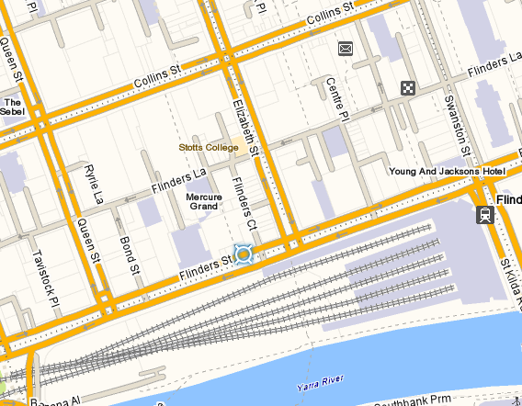
Victoria University 300 Flinders St Melbourne

CMM CGEA Half Day PD
REGISTRATION FORM
Wednesday November 16th 2016
10.00AM – 1.30PM (registration from 9.30am)

Victoria University, 300 Flinders Street, Melbourne: Level 9, Room 9.15
Please complete this form and return via email to: nadia.casarotto@vu.edu.au
no later than close of business: Wednesday November 9th
Inquiries please phone 9919 5300 / 5302
Please note that due to restrictions on numbers (30 participants) there is a limit of 2 registrations from any one organisation.

PARTICIPANT DETAILS
Name:
Current Position:
Organisation:
Street Address:
Suburb: |  |  |  | Postcode:
Telephone: |  | Fax:
Mobile: |  | Email:
Special Dietary Requirements:
(To complete this form electronically, use TAB to move forward and SHIFT+TAB to move backward from section to section)

