Higher Education and Skills Group

Participation Branch Memo

Department of Education and Training

NUMBER: 2016 / June / 29
TO:
Learn Local organisations  – ALL | ACFE Board | ACFE Regional Councils
Adult Education Institutions | Learn Local Stakeholders | Participation Branch Staff

FROM: Verna Kearney, A/Director Participation Branch

DATE: 29 June 2016

SUBJECT: CGEA professional development opportunity

The ACFE Board’s first 2016 Certificate in General Education for Adults (CGEA) professional development for teachers will be held on Thursday 14 July 2016 at Victoria University, 300 Flinders Street Melbourne. This event is organised by the General Studies and Further Education Curriculum Maintenance Manager.

The focus for this half day workshop is on exploring ways in which blended learning approaches can be integrated into CGEA programs.

CGEA teachers from Learn Local organisations are encouraged to attend this event and are given priority registration. Further information is attached, including registration details.

CMM CGEA half day PD 2016
Using a blended teaching and learning approach with the CGEA

Registration from 9.30am

Tea and coffee on arrival

10.00am – 10.10am Welcome and introduction

Nadia Casarotto/Cheryl Bartolo Curriculum Maintenance Manager (CMM) General Studies and Further Education

Session 1: 10.10am – 11.30 am Blending Teaching and Learning in the CGEA with Technology: Michael Gwyther

Blended Learning is such a loaded term that the possibilities often overwhelm rather than inform our teaching practice. Often confused with putting static learning content "online", in this conversation we'll explore together considerations and strategies for using blended learning as an extension of existing good practice teaching. We'll start by looking at what teaching with technology might look like and how this relates to digital literacy. Then we'll pose some questions:
- How do I decide which units/parts of my CGEA program are suitable for blended learning and what are some approached?
- What factors/criteria do I need consider in designing the approach?
- How do I overcome some of the difficulties or barriers I could encounter?
- How do I ensure my blended program supports student centred learning?

At the end of the hour together the aim is to help you see opportunities within your own teaching in the CGEA that you can integrate with a blended learning approach.

11.30am – 11.50am Morning tea (networking and informal discussion)

Session 2: 11.50am- 12.30pm An example of Blended Learning in the CGEA: Bronwyn Stretton The Gordon

This session will provide an overview of how the principle of ‘blended learning’ works in the Certificate III in General Education Bridging into Nursing Studies (BINS) course at The Gordon. Incorporating a ‘purposes built’ online component into a course gives teachers the opportunity to design visual and interactive activities that their students can access independently on a range of devices. This promotes the idea of practising and consolidating skills both inside and outside of the classroom. Blended learning has come to mean many things in an educational setting. This is just one picture of how it is working in a CGEA context.

Session 3: 12.30pm – 1.15pm Workshop

This workshop will provide you with an opportunity to further explore how you can integrate a blended learning approach into your CGEA program.

Summary and close: 1.15 – 1.30 pm
Thursday July 14th
9.30am – 1.30pm
Victoria University, 300 Flinders Street, Melbourne
Level 9 Room 9.15

This is an ACFE Board funded activity – no cost to participants. Priority will be given to Learn Local representatives. Program subject to change.

Michael Gwyther
Michael commenced e-learning working with ALBE & ESL learners in Adult & Community Education in the mid 90s. He began mentoring adult community education teachers in 1998 before setting up Yum Productions with his videographer partner Erin. Now part of private RTO Yum Productions he oversees a variety of coaching, mentoring and training programs to assist practitioners and RTOs to introduce learner centred approaches to e-learning. Michael is also an e-learning developer working with corporate, TAFE, RTO and ACE clients. He currently delivers the TAE e-learning competencies to organisations Australia wide. Michael has been an e-mentor for ACPET Victoria for the past eight years. He has also been an ementor for ACFE providers.
Bronwyn Stretton
Bronwyn is a teacher in General Education at The Gordon. She has taught literacy and other units from the CGEA across four certificate levels for the past 12 years. In this time she has also used the CGEA for the delivery of LN Support to a wide range of students, including nursing, plumbing, youth work and engineering. Currently, Bronwyn is using face-to-face and online learning strategies in her teaching in the Bridging into Nursing Studies course, which includes a selection of units from Certificate III in General Education for Adults. She is also working on developing materials suitable for a blended delivery model in the CGEA Certificate II Learning Plan and Project units.

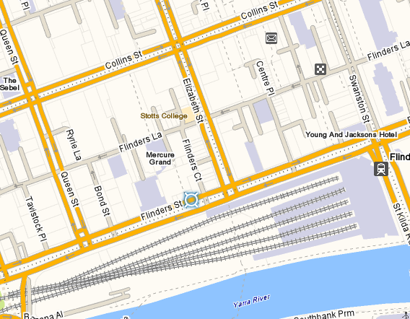
Victoria University 300 Flinders St Melbourne

CMM CGEA Half Day PD
REGISTRATION FORM
Thursday July 14th 2016
10.00AM – 1.30PM (registration from 9.30am)

Victoria University, 300 Flinders Street, Melbourne: Level 9, Room 9.15
Please complete this form and return via email to: nadia.casarotto@vu.edu.au
no later than close of business: Thursday July 7th
Inquiries please phone 9919 5300 / 5302
Please note that due to restrictions on numbers (30 participants) there is a limit of 2 registrations from any one organisation.

PARTICIPANT DETAILS
Name:
Current Position:
Organisation:
Street Address:
Suburb: |  |  |  | Postcode:
Telephone: |  | Fax:
Mobile: |  | Email:
Special Dietary Requirements:
(To complete this form electronically, use TAB to move forward and SHIFT+TAB to move backward from section to section)

