Higher Education and Skills Group

Participation Branch Memo

Department of Education and Early Childhood Development

NUMBER: 2015 / September / 15
TO:
Learn Local organisations  – ALL or RTOs only | ACFE Board | ACFE Regional Councils
Adult Education Institutions | Learn Local stakeholders | Participation Branch staff

FROM: Bronwen Heathfield, Director, Participation Branch
DATE: 10/09/2015
SUBJECT: Professional development

ACTIONS / CRITICAL DATES:
- CMM CGEA Half Day Professional Development on Tuesday 29 September 2015
- Registrations close COB Wednesday 23 September 2015
___________________________________________________________________________________

The Adult, Community and Further Education (ACFE) Board is subsidising professional development that is particularly targeted at teachers who have undertaken responsibilities for teaching Certificate in General Education for Adults (CGEA) courses.
The half-day session is the second in a series of 3 sessions with a focus on the theme of Assessment validation for the CGEA courses. The focus of the session is on Benchmarking evidence for CGEA assessment tasks through the development of explicit criteria to support consistent assessment judgements.
The half day workshop has been developed by the General Studies and Further Education Curriculum Maintenance Manager.
There is a limit of 30 places for this event so you are encouraged to register early by completing the attached registration form and emailing it to the Curriculum Maintenance Manager to secure your place.

The General Studies and Further Education Curriculum Maintenance Manager Professional Development 2015
Certificate in General Education for Adults
Theme: Assessment Validation
Tuesday September 29th
9.30am – 12.30pm
Victoria University, 300 Flinders Street, Melbourne
Level 9, Room 9.15

Registration from 9.30am

Tea and coffee on arrival

Session 1: 10.00am - 11.00am –Benchmarking evidence for CGEA assessment tasks: What am I looking for? – Room 9.15

Nadia Casarotto/Cheryl Bartolo Curriculum Maintenance Manager (CMM) General Studies and Further Education

Benchmarking evidence and how this is manifested in an assessment task is essential in making a consistent assessment judgement of competency. What does benchmarking evidence mean? Why is it important to have a benchmark for your CGEA assessment tasks? What is the assessor looking for? How do you benchmark evidence and record what you are looking for? This session will discuss these questions and examine how benchmarking can be applied to an example of a CGEA task to support consistent assessment decisions.

11.00 – 11.20.am Morning tea (networking and informal discussion)

Session 2: 11.20 – 12.15 pm – Workshop – Room 9.15

This workshop will enable participants to identify and document benchmarking criteria for a sample CGEA task.

Summary and close: 12.15 – 12.30 pm

Workshop groups share key points from workshop
This is an ACFE Board funded activity – no cost to participants. Priority will be given to Learn Local representatives. Program subject to change.
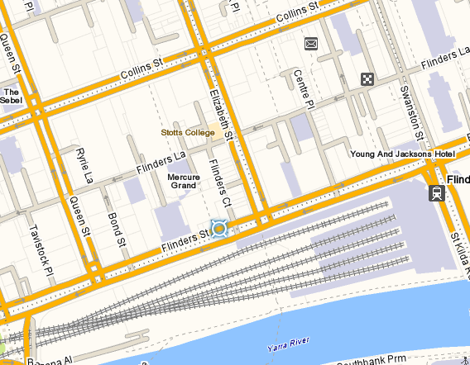
Victoria University 300 Flinders St Melbourne
Certificate in General Education for Adults
Half Day Professional Development

REGISTRATION FORM
Tuesday September 29th 2015
10.00AM – 12.30PM (registration from 9.30am)
Victoria University, 300 Flinders Street, Melbourne: Level 9, Room 9.15
Please complete this form and return via email to: nadia.casarotto@vu.edu.au
no later than close of business: 23 September 2015
Inquiries please phone 9919 5300 / 5302
Please note that due to restrictions on numbers (30 participants) there is a limit of 2 registrations from any one organisation.

PARTICIPANT DETAILS
Name:
Current Position:
Organisation:
Street Address:
Suburb: |  |  |  | Postcode:
Telephone:
Mobile: |  | Email:
Special Dietary Requirements:
(To complete this form electronically, use TAB to move forward and SHIFT+TAB to move backward from section to section)

