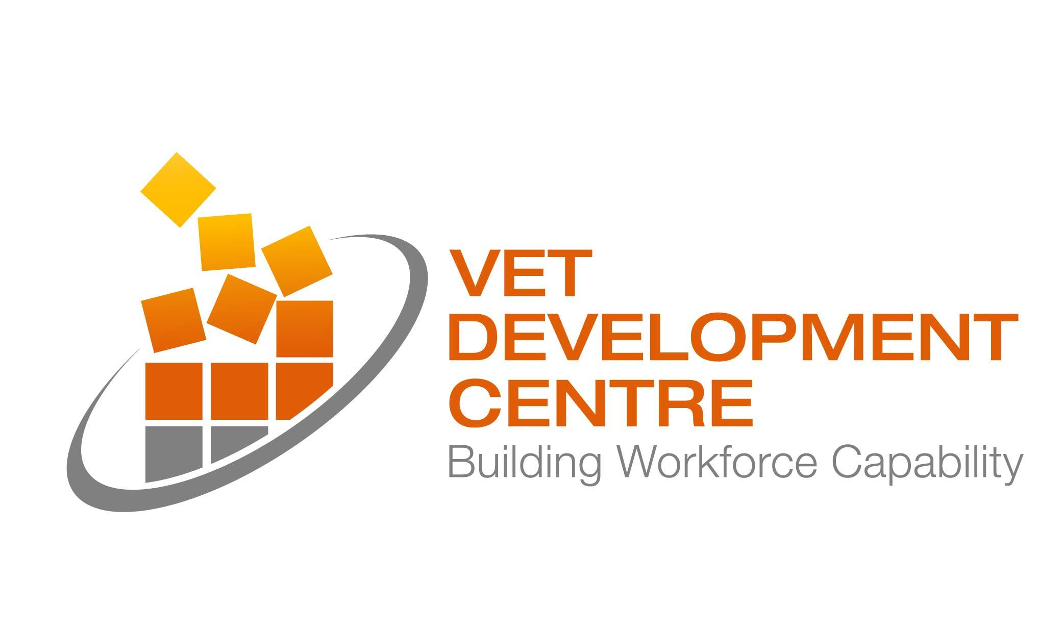 | ACFE  BOOKING  FORM | Please complete (one form per person)  and return by either email or fax to:  Maria Romanin  VET Development Centre  E mromanin@vetcentre.vic.edu.au  F (03) 9663 6674  T (03) 9250 6008

Personal details
Full Name:
Position:
Organisation:
Mailing Address:
Contact Phone:
Email (Personal or work specific – not generic)
Dietary Requirements:
Registration
RPL for beginners (30 July 2014) – 1 Day
Applying the Australian Core Skills Framework (5 August 2014) – 1 Day
Mapping and designing training and assessment programs (28 August 2014) – 1 Day
NEW! Are my assessments ok? Validating your assessment tools (11 September 2014) – 1 Day
Unpacking units of competency (31 October 2014) – 1 Day
NEW! Mapping your assessments to a unit of competency (26 November 2014) – 1 Day

Please note that funded professional learning places are restricted to two (2) per Learn Local organisation, and only one (1) per participant.

