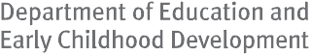 Skills & Training Needs 2013

Victorian Public Administration and Safety Industry

Published by HESG

Department of Education and Early Childhood Development

Melbourne May 2014

©State of Victoria (Department of Education and Early Childhood Development) 2014

The copyright in this document is owned by the State of Victoria (Department of Education and Early Childhood Development), or in the case of some materials, by third parties (third party materials). No part may be reproduced by any process except in accordance with the provisions of the Copyright Act 1968, the National Education Access Licence for Schools (NEALS) (see below) or with permission.

An educational institution situated in Australia which is not conducted for profit, or a body responsible for administering such an institution may copy and communicate
the materials, other than third party materials, for the educational purposes of the institution.

Authorised by the Department of Education and Early Childhood Development

2 Treasury Place, East Melbourne, Victoria, 3002.

Contents Introduction 5
Industry and data scope 7
Public Administration and Safety trends
and issues 8
Government administration 9
Defence 9
Justice 9
Public order/safety services 9
Regulatory services 10
Public Administration and Safety workforce and skills 14
Employment by age 17
Employment by gender 17
Employment by qualification 18
Public Administration and Safety vocational training provision 22
Enrolments 22
Apprentices and trainees 22
Specialised and in-shortage occupations 23
Qualification level 23
Completed qualifications 23
Government subsidised enrolments 23
Specialised or in-shortage 23
Qualification levels – 2013 24
Completed qualifications 24
Courses by funding band 26
Enrolments by funding band 26
Appendix A 31

Introduction

In the context of Victoria’s dynamic economy, a demand-led approach is the best way to ensure a responsive vocational training system that will help as many people as possible build skills that lead to better jobs. This is most evident in the results of the market approach embodied in the Victorian
Training Guarantee, which has achieved positive outcomes for both students and the economy.

The Refocusing Vocational Training in Victoria reforms are designed to satisfy important criteria for a strong vocational training market. Through these reforms the Government
is ensuring that the vocational training system continues to produce positive outcomes for students, businesses and Victoria.

Through Refocusing Vocational Training, there is a role for Government in monitoring, providing information and responding to the performance of the vocational training
system. A key mechanism by which the government exercises this role is through the Industry Participation Model. The Industry Participation Model is based on a new partnership approach between Government, industry and training providers. It increases industry influence within the training market by supporting more direct relationships between industry and training providers and by increasing direct consultation with Government.

An aim of the Industry Participation Model is to seek to improve information sharing about training provision, options, outcomes, gaps and associated barriers between industry, training providers and employers to improve alignment between industry needs and training delivery. A suite of information products and tools are being developed, of which this report is one, to support this aim and an overview of these are provided overleaf.

This report describes training and economic activity and developments related to Victoria’s Public Administration and Safety industry, bringing together a range of qualitative and quantitative insights from desk research and industry engagement. It highlights both the challenges the industry faces in attracting the right skills, and the opportunities businesses, training providers and government have to address these challenges. Key metrics used in this report include enrolments by sub-industry, qualification level, occupation, courses, age group, gender, learners facing

barriers, provider type, reason for study and completions. The report also covers apprentices and trainees, and an analysis of the alignment between training delivery and specific industry skills needs. The report produces industry, sub-industry and region-specific findings and, wherever possible, presents comparisons to developments at the State level.

The purpose of this report is:

- To provide a basis for understanding the Public Administration and Safety industry in relation to employment levels, skills shortage occupations, current alignment and responsiveness of the vocational training market to the needs of the sector and to provide an overview of the challenges and opportunities in meeting industry vocational skills needs both now and into the future.

- To give detailed information around vocational training enrolments by occupation, location, qualification levels and other student characteristics, as it relates to the Public Administration and Safety industry in order to gauge current trends in vocational training delivery.

- To summarise the context of the Public Administration and Safety industry in relation to the size and scale of the labour and training markets as well as the current policy, economic and social drivers that it is facing.

Suite of Information Products & Tools
Victorian Quarterly Training Market Reports  On-going series of quarterly reports aimed at providing a summary of Victorian training market performance following the introduction of the student entitlement system. The report covers three sections – the first provides an overview of the performance of the Victorian training market, the second section examines the participation of learners facing barriers and the third examines the alignment of training to industry skills needs.  http://www.education.vic.gov.au/ training/providers/market/Pages/ reports.aspx | Vocational Training: Victoria’s Region  Annual publication examining training delivery in each of Victoria’s regions in the context of the local population, economy and workforce, building a  picture of the relationship between the local training system and regional skills needs, training market performance and responsiveness.  http://www.education.vic.gov.au/ training/providers/market/Pages/ regionaltrends.aspx | Vocational Training: Victoria’s Industry Report  Published annually, this report combines industry intelligence and economic analysis with training data to build a more complete picture of the relationship between industry skills needs, employment opportunities and skills training. Each of the 19 industry training profiles provides economic context and a summary of training challenges and highlights from IPM initiatives.  http://www.education.vic.gov.au/ training/employers/industry/Pages/ marketinfo.aspx
Industry Sub-sector Summary Reports and Industry Factsheets  46 sub-sector industry summary reports produced annually which highlight industry labour and training market dynamics with an overview of current and forecast employment needs and vocational training patterns across the sectors and at the regional level.  http://www.education.vic.gov.au/ training/employers/industry/Pages/ marketinfo.aspx | Business Toolkit and Case Studies  Toolkit for employers providing information on how to get government- subsidised training under the Victorian Training Guarantee; getting the best training for your business, with a helpful checklist; information of Recognition of Prior Learning; and a range of interesting employer and training provider case studies.  http://www.education.vic.gov.au/ training/employers/workforce/Pages/ marketfacilitation.aspx | Portfolio Industry Reports  These reports describe training and economic activity and developments related to key Victoria’s industry sectors. Highlighted are both the challenges the industry faces in attracting the right skills, and the opportunities businesses, training providers and government have to address these challenges. A range  of key workforce and training metrics are also provided. There are two tiers of reports. One is detailed reports, representing the focus industries for the Department in 2013, and summary reports covering other industry sectors.  http://www.education.vic.gov.au/ training/employers/industry/Pages/ marketinfo.aspx
Industry Blog  A forum for people interested in industry skills and training issues in Victoria, the blog features a range of topics relevant to stakeholders, information on recent industry events, groups and forums and new initiatives focused on enhancing market performance through facilitation activities.  http://skillsblogvic.wordpress.com/ | Industry Skills Update - e-Alerts  Regular email updates featuring the latest news about IPM activities; market facilitation and related government initiatives; reports; and training performance information.  To subscribe contact: Department of Education & Early Childhood  Development, skills.online@edumail.vic. gov.au | Web Pages – Industry Training Market Information  19 webpages with information about the skills and training market for Victorian industries. For each industry, there’s a training snapshot, information about skills in demand, training market intelligence reports along with more detailed reporting for each industry sub- sector. Information is updated regularly.  http://www.education.vic.gov.au/ training/employers/industry/Pages/ marketinfo.aspx
Rate Your Training  Ratings tool for industry and employers which is a simple-to-use system where employers can rate the performance  of a training provider in a particular study area against selected criteria,  and review and compare the ratings of other employers.  http://rateyourtraining.com.au/ | E-Marketplace (in development)  Website which facilitates connections between employers and training providers. Employers can anonymously post their training requirements and training providers are able to provide structured response online. Employers are then able to review the response with no obligation, create a shortlist and follow up directly with their preferred providers. | Victorian Skills Gateway  One-stop-shop of Victorian vocational education and training to help find the best option for students. Searches can be performed on occupations, courses, training providers, video and written case studies. This website is also viewable via a purpose-built smartphone interface. http://www.education.vic.gov.au/ victorianskillsgateway/Pages/home.aspx

Industry and data scope

This section summarises the scope of the Public Administration and Safety industry1 as well as key data sources.

Public Administration and Safety industry defined

Public Administration and Safety includes businesses and agencies mainly engaged in Central, State or Local
Government legislative, executive and judicial activities; in providing physical, social, economic and general public safety and security services; and in enforcing regulations.

Central, State or Local Government legislative, executive and judicial activities includes:

- the setting of policy;

- the oversight of government programs;

- collecting revenue to fund government programs;

- creating statute laws and by-laws;

- creating case law through the judicial processes of civil, criminal and other courts; and

- distributing public funds.

Public Administration and Safety also includes military defence, government representation and international government organisations. Activities in this area include:

- police services;

- investigation and security services;

- fire protection and other emergency services;

- correctional and detention services;

- regulatory services;

- border control; and

- other public order and safety services.

Government ownership is not a criterion for classification to this industry.

- As defined by the Australian Bureau of Statistics, Australian and New Zealand Standard Industrial Classification (ANZSIC), 2006.

Figure 1.1: Public Administration and Safety ANZSIC breakdown

ANZSIC  code | ANZSIC industry
75 | Public Administration
 | 751 | Central Government Administration
 | 752 | State Government Administration
 | 753 | Local Government Administration
 | 754 | Justice
 | 755 | Government Representation
76 | Defence
77 | Public Order, Safety and Regulatory Services
 | 771 | Public Order and Safety Services
 | 772 | Regulatory Services

Data

The main source of data on vocational training activities is the training activity database referred to as SV Training System (SVTS).

The report presents findings for the time period from 2008 to 2013, with an emphasis on developments and patterns in the 2013 calendar year. The 2013 data is based on data extracted from SVTS as at 11 February 2014 and subject to revision.

This report includes government subsidised training enrolments and domestic fee for service activities of TAFEs. However, TAFE fee for service activities below Certificate level and those provided by private RTOs and Adult Community Education (Learn Local) providers are not included. Data on completions contain all government subsidised and fee for service enrolments at any course level by all providers.

Note that enrolment numbers have been rounded to the nearest ten.

Public Administration and Safety trends and issues

This section focuses on the Public Administration and Safety industry as a whole. It covers the key issues and challenges, including economic conditions, new regulations, demographic changes, changing social attitudes, new technology/ processes, changing consumer tastes, environmental sustainability and the direction of industry restructuring.

Key messages

- In Victoria, the Public Administration and Safety industry contributed around four per cent of Victoria’s total output in 2012-13 (approximately $12 billion).

- Industry output is projected to grow by approximately five per cent over the five years to 2017-18. This growth in output is below the anticipated State growth rate of 14 per cent across all Victorian industries.

- Public Administration and Safety organisations are fairly evenly distributed throughout the state of Victoria, reflecting the need for these services in all geographic areas.

- Federal and state governments face budget pressures, putting pressure on the budgets of many Public Administration and Safety organisations.

- Public sector organisations are facing greater service level demands due to issues such as population growth, increased frequency of natural disasters and extreme weather events, and greater consumer expectations.

- Technological advancements, such as the National Broadband Network (NBN) and the increased use of mobile technologies and tablet computers, are
impacting the industry and offer significant productivity improvements if well implemented.

Industry trends and outlook

The Public Administration and Safety industry is diverse, and includes emergency services, international government organisations and local councils.

While the industry is varied, there are some common challenges and opportunities across sub-sectors. This section will discuss some of these common issues, before covering each sub-sector of the industry.
Many Public Administration and Safety organisations grew strongly in the years following the global financial crisis as governments implemented economic stimulus measures to moderate an expected fall in demand and private sector activity, and a rise in unemployment. These measures contributed to an increase in government debt, a trend
governments are now actively addressing. While deficits and public debt will fall as the economy grows and government revenue increases, expenditure is likely to grow more slowly than in the past, or be reduced by governments.

While expenditure may stagnate or fall, community expectations of Public Administration and Safety organisations are likely to continue to grow. The ageing of the population will contribute to this as demand for health care and aged care services is likely to rise. This is likely to increase demand for skills in these areas – indeed the
health care industry is already experiencing skills shortages. Community expectations of public safety services have also been rising, as demonstrated by recent media coverage of late night violence in city centres.

As a result of pressure on government budgets and increasing community expectations, across much of the Public Administration and Safety industry there will be pressure
on organisations to become more efficient in order to maintain, and at times, increase service provision in the face of tightening budgets.2 This is likely to increase the premium on management skills in the sector as organisations look for change leaders and those with skills in ‘lean enterprise’ to modify their operations.

Technological change continues to play a role in the way in which the industry operates. Emerging areas include video conferencing, the proliferation of CCTV cameras, the increasing use of social media, and capitalising on large data collections through analysis and machine learning.
These changing technologies are likely to be a major driver of changing skills needs across the majority of the industry’s subsectors. Some organisations are well placed to take up these new areas, due to the skills of their current workforce. Other organisations will need to work to recruit and develop internally the skills needed to take full advantage of new technologies.

- Government Skills Australia, Environmental Scan 2013.

Government administration
Government administration includes federal and state/ territory governments, local councils, statutory bodies and state-owned corporations. Government employees develop, review and implement government policies and provide an array of services for the community. There is a diverse range of occupations within the public sector, covering areas such finance, economics, education, health, and essential services.

In recent years there has been an increase in the outsourcing of functions previously performed by the public sector. There is also a trend towards using labour hire. These trends are being driven by the need to reduce expenditure and to ensure a more flexible workforce, and mean there continues to be a greater focus on contract and project management in public sector roles.

Local councils are seeing an increase in demand for their services, linked in part to population growth, while also experiencing budgetary constraints. Importantly, around 60 per cent of local councils have a volunteer workforce, aiding the delivery of effective and responsive services to the community.3 The volunteer workforce does, however, increase the complexity of workforce development for these councils. This large volunteer workforce has implications for
the skills required in the paid workforces of councils. The paid workforce requires strong management skills, including the ability to motivate and maintain the volunteer workforce, to ensure volunteers’ skills are fully utilised.

Defence
The Australian Defence Force (ADF) consists of the Navy, Army, Air Force and members of the Australian Public Service. The primary focus of the ADF is to ‘protect and advance Australia’s strategic interests by providing military forces and supporting those forces in the defence of Australia and its strategic interests’.4

In recent years, the ADF has also played a crucial role in natural disaster responses in Australia and overseas, including the Queensland floods, the Victorian bushfires and earthquakes in Japan and New Zealand.

Importantly for the sub-sector, in 2012, the National Skills Standards Council endorsed the Defence Training Package

- Government Skills Australia, Environmental Scan 2013.
- Department of Defence 2012, Defence Portfolio Budget Statements 2012 2013.
(DEF12) which formally separated the Defence training material from the Public Safety Training Package. The change means updating Defence-related courses should take place more quickly, allowing evolving operational needs to be better met.

Justice
The Justice sub-sector includes civil and criminal courts, and royal commissions and similarly constituted inquiries. Justice organisations create case law through the judicial processes of civil, criminal and other court operations. This sub-sector is small and does not include lawyers who represent clients in the courts.

There is also a move to make the justice system more accessible and easier to understand for the public as well as carrying out sentencing reform.

Public order/safety services
The public order/safety organisations include police, fire, search and rescue, emergency services and emergency management services. These organisations play a key role in the preparation for, response to, and recovery from
natural and man-made threats. The sub-sector also includes correctional services, which involves the management and supervision of offenders in both custodial and community- based corrections.

Over recent years, the public safety sector has seen increased demand for accountability and interoperability among agencies. Public safety organisations are reporting that they are increasingly required to collaborate with other organisations, primarily in the context of emergency responses.5 Increased media attention on public safety organisations is also increasing the accountability faced by these agencies.

Corrections services has recently seen a wave of outsourcing as services previously carried out by government have been moved to the private sector in Victoria. Within the correctional services sector there has also been an increased focus
on reducing the risk of reoffending through services and programs focussed on successful reintegration of prisoners on their release.6

- Government Skills Australia, Environmental Scan 2013.
6 Steering Committee for the Review of Government Service Provision 2013, Report on Government Services Volume 1: Early Childhood, Education and Training, Justice, Emergency Management.

Regulatory services
Regulatory services involve enforcing regulations, granting licenses and carrying out inspection activities. Relevant regulations are established by Acts of Parliament and cover technical details that may be subject to frequent change. Organisations in this sub-sector work in the regulation of casinos, qualifications, and food.

Increased globalisation is presenting challenges for this sector as regulating food and agricultural standards plays an important part of free trade agreements and so is regularly changing.

Table 2.1: Key trends in the Public Administration and Safety industry and their potential impacts on skills

Grouping | Change drivers |  |  | Skills impact
 | Government administration |  | Defence | Justice |  | Public order/ safety services | Regulatory services
Political | Government expenditure reviews |  |  |  |  |  | 
Economic | Employment market and job skill requirements | = | = |  | = | = | =
 | Outsourcing of functions |  | = |  | = |  | 
Social | Trends in volunteerism | = | = |  | = |  | =
 | Community expectations |  |  |  |  |  | =
Technological | Improved technology |  |  |  | = |  | 
Key:
 Driver has indirect impact on skills; = Driver has low skills impact, and places marginal pressure on skills development;
 Driver has high skills impact, and places upward pressure on skills development;  Driver places downward pressure on skills development.

Economic contribution

Victoria’s Public Administration and Safety industry contributed approximately $12 billion to the State economy in 2012-13, around four per cent of total output. The industry
directly employs approximately 133,000 workers, representing five per cent of Victorian employment.

Industry output is projected to grow by approximately five per cent over the five years to 2017-18, to around $12.5 billion. This growth in output is below the anticipated State growth rate of 14 per cent across all Victorian industries.
The distribution of Victoria’s Public Administration and Safety businesses by turnover size is approximately representative of the State average. There is a slightly higher proportion of Public Administration and Safety businesses turning over less than $50,000 (31 per cent compared with the State average of 28 per cent) and a slightly smaller proportion turning over between $50,000 and $200,000 (31 per cent compared with 35 per cent).

Figure 2.2: Share of businesses by employment and turnover size, Victoria, 2012

70

A highly skilled workforce leads to increased productivity and economic growth. High quality education and skills training is essential for Victorians to access the opportunities of a growing and changing economy, and an increasingly sophisticated and information-rich society.

Figure 2.1: Public Administration and Safety output

($ million), 2012-13 and 2017-18
14,000

60
53%
50

40

30

20

10

0
61%

36% 35%

9%
4%

1% 0%

12,000

10,000

3,103

3,495
Non Employing 1 to 19 20 to 199 200+ Public Administration and Safety All industries

8,000

6,000

4,000

2,000

0

1,659

7,137

1,739

7,315

40

35
31%
30

25

20

15

28%

31%

35%

32% 31%

Public Administration
2012-13 2017-18 10
Defence Public Order, Safety and Regulatory Services
5

7% 6%

Source: Monash Centre of Policy Studies (CoPS) Employment Forecasts, June 2013

Employer profile

At the end of June 2012, there were an estimated 1,790 businesses in the Victorian Public Administration and Safety sector.
The distribution of Public Administration and Safety businesses by employment level is skewed towards businesses that employ many workers: 10 per cent employ more than 20 employees, compared with the State average of four per cent.

0
Zero to $50k $50k to $200k $200k to $2m $2m or more Public Administration and Safety All industries
Source: Australian Bureau of Statistics (ABS), Count of Australian Businesses, including entries and exits, 2012.

The geographic distribution of Public Administration and Safety firms is shown in Figure 2.3. In metropolitan Melbourne, Public Administration and Safety firms are concentrated outside the central area – Werribee and Dandenong are centres of particularly high concentration.

In regional Victoria, the industry is fairly evenly distributed, with areas of slight concentration in major regional centres, reflecting the need for Public Administration and Safety establishments in all areas.

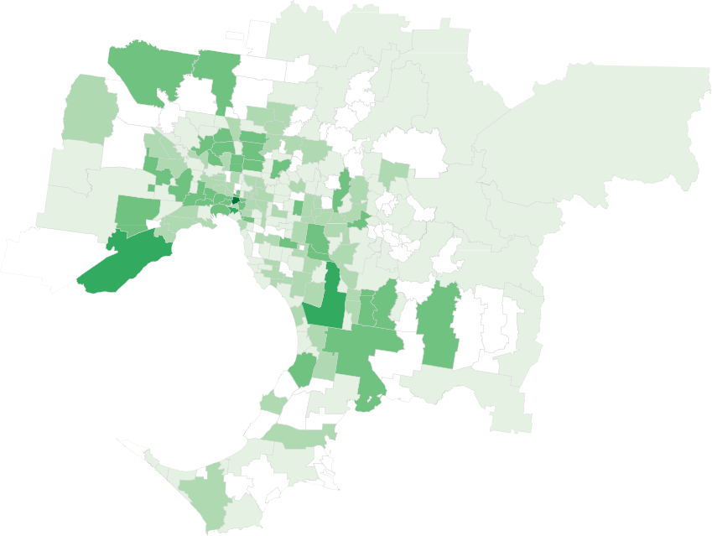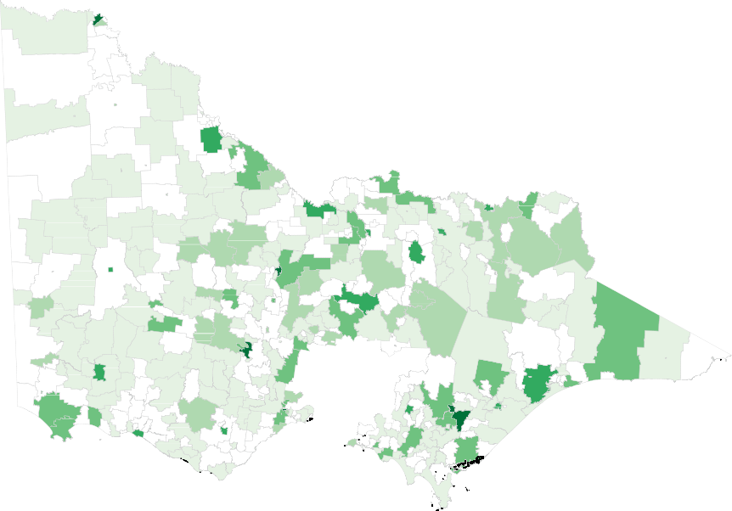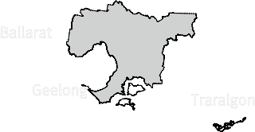Figure 2.3: Number of Public Administration and Safety industry establishments in metropolitan and regional Victoria, 2010-11

Melbourne

South Melbourne

Werribee

Dandenong

1 to 5
5 to 10
10 to 20
20 to 100
100 or more

Mildura
1 to 3
3 to 5
5 to 10
10 to 20
20 or more

Bendigo

Ballarat

Geelong

Traralgon

Source: Department of State Development, Business and Innovation (DSDBI), Public Administration and Safety Industry. Business location in Victoria: A decade of change, October 2012 (based on data from WorkSafe Victoria).

Labour productivity

Labour productivity is defined as real gross value added per hour worked. Figure 2.4 shows the average annual compound rate of growth in labour productivity for the Public Administration and Safety industry over the period 2003 to 2013. Nationally, the average annual growth rate of labour productivity for Public Administration and Safety was modest, at 0.7 per cent, below the State average of 1.3 per cent.

Up-skilling the workforce continues to be an important focus for increasing productivity, and producing more with less. A well- trained, job-ready workforce is the life-blood of Victoria’s industry and business and the largest determinant of productivity in the State’s economy.

Figure 2.4: Labour productivity measure by gross value added (GVA) per hour worked, average annual growth, Australia, 2003 to 2013

Administration and Safety

All industries
0.7%

1.3%

0.0% 0.2% 0.4% 0.6% 0.8% 1.0% 1.2% 1.4%

Source: Australian Bureau of Statistics (ABS), Australian System of National Accounts, 5204.0.

Public Administration and Safety workforce and skills

This section focuses on the Public Administration and Safety industry’s workforce. It covers employment levels and trends, as well as workforce characteristics such as age and skill level.

Key messages

- The Victorian Public Administration and Safety industry employs approximately 133,000 people, five per cent of the Victorian workforce. Employment growth has been stronger than the average for all Victorian industries over the five years to 2012-13, a trend that is not expected to continue for the five years to 2017-18

- Average annual demand for new jobs due to growth and replacement over the period is expected to be approximately 6,700 jobs.

- The workforce is expected to retain the current mix between high- and low-skill roles

- The workforce is relatively representative in terms of gender profile (there is a slightly higher proportion of males than females, as with the State average). However, the age profile of the industry is slightly older than the Victorian average, with employees aged 24 and under particularly under-represented in the Public Administration and Safety industry workforce.

- The training level of the workforce is relatively high, with a smaller proportion of unqualified workers and a larger proportion of workers with higher degrees than the Victorian average.

Employment

Approximately 133,000 people are employed in Victoria’s Public Administration and Safety industry. The industry has seen employment grow by 19 per cent over the five years to 2012-13, equating to approximately 21,000 employees over the period. The outlook over the next five years to 2017-18 is for employment to continue to grow, but at a far slower rate: approximately 3 per cent over the period (equating to approximately 2,000 jobs).
In comparison, employment in all Victorian industries grew by approximately 30 per cent in the five years to 2012-13.
Statewide employment is expected to grow at eight per cent in the five years to 2017-18, faster than the expected growth in Public Administration and Safety employment.

Figure 3.1: Public Administration and Safety employment, Victoria, 2012-13 and 2017-18
16,0000

14,0000
43,300 | 43,300
5,700 | 5,700
86,200 | 86,200
2017-18 | 2017-18

39,800 | 43,300
5,700 | 5,700
87,800 | 86,200
2012-13 | 2017-18

12,0000

10,0000

80,000

60,000

40,000

20,000

0

Public Administration Defence Public Order, Safety and Regulatory Services

Source: Monash Centre of Policy Studies Employment Forecasts, June 2013

Skills composition

Shown in Figure 3.2 are the relative proportions of high and low skill jobs in the Public Administration and Safety industry.

The proportion of highly skilled jobs in the industry has risen since 2004-05, from 39 per cent of the workforce to 33 per cent. This proportion is forecast to rise slightly through to 2020-21, to 34 per cent of the workforce.

The proportion of lower-skilled jobs within the industry has experienced a corresponding decline over the period, from 34 per cent of the workforce in 2004-05 to 32 per cent in 2012-13.

Figure 3.2: Public Administration and Safety industry skill levels, Victoria, 2004-05 to 2020-21

Forecast 2012-13 to 2020-21

50%

40%

30%

20%

10%

0%
2004-05

2006-07

2008-09

2010-11

2012-13

2014-15

2016-17

2018-19

2020-21

High Skill
Medium Skill
Low Skill

Source: Monash Centre of Policy Studies Employment Forecasts, June 2013

Note: High skill—managers and professionals. Medium skill—technicians and trades workers, community and personal service workers. Low skill—clerical and administrative workers, sales workers, machinery operators, drivers and labourers.

Job vacancies

The figure below highlights the number of vacancies posted online in Victoria over the two years to September 2013 for selected key Public Administration and Safety occupations. The number of online job advertisements across the larger Public Administration and Safety occupations has fallen steadily over the period, consistent with the decreasing trend seen in the national Internet Vacancy Index. 7

There were approximately 3,900 newly lodged vacancies in key Public Administration and Safety occupational groupings in September 2013. General Clerks made up the majority of these jobs, with almost 1,900 vacancies. Aged and Disabled Carers recorded approximately 500 newly lodged vacancies, while Contract, Program and Project Administrators recorded over 350.

Figure 3.3: Number of newly lodged online vacancies in Public Administration and Safety occupations in Victoria, 2011–2013

3,000 General Clerks

2,500

2,000

1,500

1,000
Aged & Disabled Carers Contract/Prog/Project Admin Inspectors/Regtory Officers Security Officers & Guards
Intelligence/Policy Analysts

500

0

Mar-11

Jun-11

Sep-11

Dec-11

Mar-12

Jun-12

Sep-12 Dec-12 Mar-13

Jun-13

Sep-13

Source: Department of Education, Employment and Workplace Relations (DEEWR) Internet Vacancy Index (based on a count of online vacancies newly lodged on SEEK, My Career, CareerOne and Australian JobSearch), major advertising occupations only. Note: caution advised when using monthly occupation data as it is susceptible to
fluctuation from month to month.

- Department of Education, Employment and Workplace Relations, DEEWR Vacancy Report, February 2013

Labour market characteristics

Employment by age
The Public Administration and Safety workforce has an older age demographic than the average age profile across the Victorian workforce as a whole. The younger age group – 15 to 24 year-olds – is relatively under-represented within the industry, making up nine per cent of the industry workforce compared with the State average of 16 per cent. In contrast, employees aged 35-54 are slightly over-represented when compared with Victorian averages.

Figure 3.4: Proportion of employment by age, Victoria, 2012-13

Public Administration and Safety
9% | 25% |  | 25% |  | 24% |  | 17%
16% |  | 24% |  | 23% |  | 21% | 17%

All industries

0% 10% 20% 30% 40% 50% 60% 70% 80% 90% 100%

15-24 25-34 35-44 45-54 55+

Source: Monash Centre of Policy Studies Employment Forecasts, June 2013

Employment by gender
The gender profile of the Public Administration and Safety industry workforce is representative of the State average. Forty-six per cent of the workforce is female, the same proportion as the State average.

Figure 3.5: Proportion of employment by gender, Victoria, 2012-13

Public Administration and Safety
46% | 54%
46% | 54%

All industries

0% 10% 20% 30% 40% 50% 60% 70% 80% 90% 100%

Females Males

Source: Monash Centre of Policy Studies Employment Forecasts, June 2013

Employment by qualification
The Public Administration and Safety industry workforce is more highly qualified than the State average. A smaller proportion of the industry workforce (34 per cent, compared with the State average of 40 per cent) has no post-school qualifications. Similarly, a smaller proportion of the workforce (18 per cent compared with 21 per cent) has a Certificate-level qualification.

Eighteen per cent of the industry workforce has a Diploma or Advanced Diploma, and 30 per cent has a higher education qualification, higher than the State average of 14 per cent and 25 per cent respectively.

Figure 3.6: Proportion of employment by qualification level, Victoria, 2012-13
34% | 3% | 15% |  |  | 18% |  | 30%
40% |  |  | 3% | 18% |  | 14% |  | 25%

Public Administration and Safety

All industries

0% 10% 20% 30% 40% 50% 60% 70% 80% 90% 100%

No post school quals Certificate I or II Certificate III or IV Diploma Higher education

Source: Monash Centre of Policy Studies Employment Forecasts, June 2013

Occupations in demand

Table 3.1 highlights the occupations at four-digit ANZSCO level (Australian and New Zealand Standard Classification of Occupations) that align to the Public Administration and Safety industry. Note that while some occupations also align to other industries, the figures shown are specific to the Public Administration and Safety industry.

Forecasts presented in the table estimate the employment growth and replacement demand in terms of the average number of jobs required for each occupation annually up to 2017-18.

Employment growth is the net number of new jobs that the occupation is currently forecasting within the industry. Replacement demand is the number of existing workers required to replace those that are forecast to leave each occupation through attrition, either via retirement or other movement out of the occupation.

Across all occupations in the Public Administration and Safety industry (including office support occupations such as book- keepers, receptionists etc.) projected average annual employment needs between 2012-12 and 2017-18 are around 8,500 jobs each year.

The occupation with the largest employment is Police, followed by Security Officers and Guards, which also have the highest average annual employment needs due to growth and replacement (640 and 610 annual jobs respectively).

The occupation forecast to grow most strongly through to 2017-18 is Aged and Disabled Carers, Followed by Contract, Program and Project Administrators and Fire and Emergency Workers.

Table 3.1: Estimated annual employment growth and replacement demand figures for occupations in the Public Administration and Safety sector across Victoria

Occupation name | Employment total  2012-13 | Average annual employment needs | Overall employment growth to 2017-18
Police | 13,310 | 640 | 690
Security Officers and Guards | 9,440 | 610 | 540
Aged and Disabled Carers | 6,280 | 350 | 1,030
Inspectors and Regulatory Officers | 5,320 | 290 | 290
Contract, Program and Project Administrators | 5,110 | 310 | 1,000
General Clerks | 4,870 | 220 | 350
Fire and Emergency Workers | 3,480 | 450 | 780
Inquiry Clerks | 3,160 | 160 | 270
Other Miscellaneous Labourers | 3,130 | 160 | 340
Intelligence and Policy Analysts | 2,580 | 230 | 540
Welfare Support Workers | 2,490 | 140 | 140
Prison Officers | 2,290 | 220 | 100
Other Information and Organisation Professionals | 2,240 | 140 | 350
Court and Legal Clerks | 2,010 | 180 | 230
Accounting Clerks | 1,960 | 80 | 220
Policy and Planning Managers | 1,710 | 200 | 360
Civil Engineering Professionals | 1,600 | 150 | 160
Judicial and Other Legal Professionals | 1,560 | 110 | 120

VET occupations highlighted in green

Source: Monash Centre of Policy Studies Employment Forecasts, June 2013

Specialised and in-shortage occupations

This section focuses on current skills shortages in specific occupations aligned to the Public Administration and Safety industry as well as those occupations that are specialised.8 The Department’s analysis of skill shortages considers both quantitative evidence and intelligence gathered through industry consultation.

No skills shortages have been identified in occupations directly aligned to the Public Administration and Safety industry. However, specialised occupations of relevance to this industry include Fire and Emergency Workers.

As a major employer of health care and community services workers, the industry is also affected by shortages in occupations such as Aged and Disabled Carers and Welfare Workers, primarily aligned to the Health Care and Social Assistance industry.

Table 3.2 highlights key occupations within Victoria’s Public Administration and Safety industry (based on employment size), along with a summary of their specialised and in-shortage status. This table includes occupations primarily associated with other industries (such as Aged and Disabled Carers).

Table 3.2: Occupations ‘in-shortage’ or ‘specialised’

Occupation name | In-shortage | Specialised
Police | No | Yes
Security Officers and Guards | No | No
Aged and Disabled Carers | Yes | Yes
Inspectors and Regulatory Officers | No | No
Contract, Program and Project Administrators | No | No
General Clerks | No | No
Fire and Emergency Workers | No | Yes
Welfare Support Workers | Yes | No
Prison Officers | No | No
Court and Legal Clerks | No | No
Policy and Planning Managers | No | No
Judicial and Other Legal Professionals | No | Yes

- DEECD uses the Australian Workforce and Productivity Agency list of specialised occupations. These occupations have a long lead-time for training, high economic value and a significant match between training and employment.

Workforce skills needs

Public Administration and Safety organisations are increasing their focus on internal planning and review processes to improve efficiency. Other strategies include collaborating across similar organisations, outsourcing functions or tasks and increasing the use of productivity-aiding technology.

Skills shortages in the industry are likely to be caused by a number of factors. Some Public Administration and Safety organisations face competition with other industries for the attraction and retention of staff. The Mining industry is considered to be a key competitor for skilled and unskilled labour.9 Particular occupations in demand from the mining industry which crossover with the Public Administration and Safety include occupational health and safety officers, engineers and tradespeople.

As highlighted above, the Public Administration and Safety workforce has an older than average age profile and could soon face large numbers of staff retiring, with an associated loss of corporate knowledge. Employers are working to retain older staff through a variety of workforce development and human resources approaches. The recruitment of new staff is also important for the industry.

Technological advancements are impacting the industry and will require continued up-skilling in information technology and other areas. Generic ICT skills and ‘digital literacy’ have emerged as prerequisites or highly desired skills for many jobs across the sector, and are also central to the process of learning, institutions increasingly utilising technology in the delivery of educational programs.

- Government Skills Australia, Environmental Scan, 2013

Governments are increasingly generating large amounts of data on their services. As such, the industry will need workers with the skills to interrogate, interpret and explain these data to improve the quality and efficiency of government services. This will include quantitative skills such as in statistics and programming, but also the skills required to relay findings to clients in a comprehensible manner.

Employees within the industry are increasingly being required to expand their scope of duty, requiring further up-skilling and multi skilling. For example firefighter roles are expanding into the provision of emergency medical response and
surf lifesavers roles are expanding from traditional beach activities to disaster response and large scale search and rescue. Similarly corrections services will increasingly require skills in dealing with an ageing prisoner population, mental health issues and community-based monitoring.10

There is scope for Public Administration and Safety organisations to improve the representation of people from culturally and linguistically diverse backgrounds, and Indigenous Australians. In Victoria, the Government has developed the Aboriginal Pathway to the Graduate Recruitment and Development Scheme to address the low
number of Aboriginal graduates entering the Victorian Public Service. The Scheme, launched in 2012, uses mainstream and Indigenous media, and contact with Victorian tertiary student groups and the Aboriginal community to reach its intended audience. Once in the program, Aboriginal graduates are matched with an Aboriginal mentor already working for the Victorian Government.

- Government Skills Australia, Environmental Scan, 2013

Public Administration and Safety vocational training provision

This section focuses on training provided for the Public Administration and Safety industry. It covers training activity (including a regional analysis), courses, providers and
student characteristics.

Key messages

- In 2013, there were 8,130 government subsidised enrolments in Public Administration and Safety courses in Victoria. This was down from 8,370 in 2012, but up from 7,870 in 2011.

- Apprenticeships and traineeships comprise a relatively small proportion of enrolments in this industry, four per cent compared with an average across all industry training of 23 per cent.

- Beginning in 2012, the Certificate II in Security Operations has had the highest concentration of enrolments across courses related to Public Administration and Safety.
Security Officer is the largest occupational grouping in terms of training delivery, with approximately 4,890 enrolments in 2013.

- A majority of training is delivered by private training providers, representing approximately 72 per cent of the enrolments in 2013.

- In 2013, the largest region in terms of Public Administration and Safety training delivery was Western Metropolitan Melbourne (which includes the Melbourne CBD), accounting for around 40 per cent of industry enrolments.

- Students from a culturally and linguistically diverse background represented more than one-third of enrolments in this industry in 2013. Students reporting a disability comprised seven per cent of enrolments.

- Students who are unemployed made up a relatively high proportion of enrolments in 2013, accounting for 43 per cent compared with an average across all industry training of 25 per cent.

Training activity

Table 4.1 opposite gives a summary of training activity for the Public Administration and Safety industry over the period 2008 to 2013.

Enrolments
Government subsidised enrolments in Public Administration and Safety courses have increased significantly since 2008, almost doubling to 8,130. This has been driven by large increases in enrolments in qualifications related to security operations.

In 2013, Public Administration and Safety courses accounted for 2.1 per cent of all government subsidised enrolments
in Victoria, making it Victoria’s thirteenth largest industry training sector.

Over the same period, TAFE fee for service enrolments have fallen from around 1,800 in 2008 to 860 in 2013.

Apprentices and trainees
Apprentices and trainees comprise a small proportion of enrolments in Public Administration and Safety, accounting for just four per cent of training in 2013. This compares with an average across all industry training delivery of approximately 23 per cent.

There were 240 trainee enrolments and 100 apprentice enrolments in 2013.

Specialised and in-shortage occupations
There were 350 enrolments in courses related to the Public Administration and Safety occupations that were specialised or
in-shortage in 2013. Enrolments aligned to specialised or in-shortage occupations have fallen by 16 per cent between 2012 and 2013.

Qualification level
Around 10 per cent of enrolments in Public Administration and Safety courses are at the Diploma level or above. The remaining enrolments are relatively split evenly between Certificate I-II and Certificate III-IV, each accounting for approximately 45 per cent of enrolments.

Completed qualifications
In 2013, there were 6,070 reported qualification completions in courses associated with the Public Administration and Safety industry – a 19 per cent increase on the number in 2012.

Table 4.1: Key training activity in the Public Administration and Safety industry, 2008 to 2013

Government subsidised enrolments

Industry sub-sector | 2008 | 2009 | 2010 | 2011 | 2012 | 2013
Public Administration | 1,110 | 930 | 1,210 | 1,230 | 1,460 | 2,170
Public Order, Safety and Regulatory Services | 2,880 | 2,290 | 4,260 | 6,640 | 6,910 | 5,960
Total | 3,990 | 3,220 | 5,470 | 7,880 | 8,370 | 8,130

Apprentice or trainee

Apprentice trainee status | 2008 | 2009 | 2010 | 2011 | 2012 | 2013
Trainee | 210 | 80 | 60 | 50 | 100 | 240
Apprentice | 70 | 90 | 100 | 100 | 110 | 100
Total | 270 | 170 | 160 | 150 | 210 | 340

Specialised or in-shortage

Industry sub-sector | 2008 | 2009 | 2010 | 2011 | 2012 | 2013
Public Order, Safety and Regulatory Services | 1,490 | 1,350 | 1,620 | 400 | 420 | 350
Total | 1,490 | 1,350 | 1,620 | 400 | 420 | 350

Qualification levels – 2013

Industry sub-sector | Certificate I-II | Certificate III-IV | Diploma+
Public Administration | - | 1,180 | 990
Public Order, Safety and Regulatory Services | 3,510 | 2,450 | <10
Total | 3,510 | 3,630 | 1000

Completed qualifications

Industry sub-sector | 2008 | 2009 | 2010 | 2011 | 2012 | 2013
Public Administration | 830 | 630 | 740 | 340 | 560 | 820
Public Order, Safety and Regulatory Services | 1,820 | 2,260 | 2,520 | 4,590 | 4,560 | 5,250
Total | 2,650 | 2,890 | 3,260 | 4,940 | 5,120 | 6,070

Courses

The top ten courses in Public Administration and Safety, as set out in Table 4.2, accounted for more than 85 per cent of all government subsidised enrolments in 2013. The Certificate II and III in Security Operations together represented 60 per cent of all enrolments in this industry.

Table 4.2: Public Administration and Safety qualifications ranked by 2013 enrolments, government subsidised, 2008 to 2013

Course name | 2008 | 2009 | 2010 | 2011 | 2012 | 2013
Certificate II in Security Operations | - | - | - | - | 1,460 | 3,250
Certificate III in Security Operations | - | - | - | - | 1,060 | 1,600
Certificate IV in Justice | - | - | - | - | 10 | 660
Diploma of Justice | - | - | - | - | - | 530
Advanced Diploma of Justice | - | - | - | - | - | 260
Certificate III in Correctional Practice | - | - | - | - | 30 | 170
Advanced Diploma of Justice | 290 | - | - | 770 | 740 | 160
Certificate III in Public Safety (SES Operations) | - | - | - | 100 | 180 | 140
Certificate II in Public Safety (Aquatic Rescue) | - | - | - | - | 680 | 130
Certificate III in Locksmithing | 60 | - | - | 110 | 120 | 100

Note: course totals include equivalent superseded courses.

Enrolments by occupation

Security Officer is the largest occupational grouping, accounting for 60 of enrolments. Enrolments for this occupation showed strong growth between 2009 and 2011, before falling over the last two years. Law Clerk saw the second highest enrolments numbers in 2013 after significant growth from 2012.

Table 4.3: Public Administration and Safety occupations ranked by 2013 enrolments, government subsidised, 2008 to 2013

Occupation | 2008 | 2009 | 2010 | 2011 | 2012 | 2013
Security Officer | 200 | 300 | 2,010 | 5,640 | 5,280 | 4,890
Law Clerk | 70 | 250 | 230 | 130 | 380 | 1,220
Parole or Probation Officer | 300 | 340 | 590 | 770 | 740 | 420
Prison Officer | 720 | 50 | 80 | 190 | 240 | 340
Lifeguard | - | - | - | - | 730 | 200
Emergency Service Worker | 1,160 | 960 | 1190 | 100 | 190 | 190
Program or Project Administrator | 290 | 180 | 210 | 150 | 70 | 120
Inspectors and Regulatory Officers n.e.c. | 120 | 40 | 50 | 80 | 120 | 120
Locksmith | 60 | 100 | 100 | 110 | 120 | 100
Agricultural Technician | 30 | 10 | <10 | 50 | 80 | 90

n.e.c. = not elsewhere classified

Please see Appendix A for occupations and associated qualifications with funding bands (available for 2012 and 2013)

Training providers

A total of 26 training providers delivered government subsidised Public Administration and Safety industry training in 2013. The majority of training delivery is with private providers, who accounted for 72 per cent of industry enrolments in 2013.
Table 4.4: Proportion of enrolments by provider type, government subsidised, 2008 to 2013
Provider type | 2008 | 2009 | 2010 | 2011 | 2012 | 2013
Private | 0% | 0% | 31% | 76% | 78% | 72%
TAFE | 99% | 100% | 69% | 24% | 22% | 28%
ACE | 1% | 0% | 0% | 0% | 0% | 0%

Funding patterns

From July 2012 funding bands for government subsidised training were introduced. The allocation of funding within these bands is designed to better target areas of greatest public benefit and future jobs growth. Where there is not a strong need for Government support the training subsidies are lower.

Courses by funding band
In 2013, around half of Public Administration and Safety courses were in Band C for Government subsidies, with more than a third in Band B. The remaining courses were in Band D (14 per cent) and Band A (three per cent).

Table 4.5: Public Administration and Safety courses by funding subsidy band, 2013

Subsidy Band | 2013 | % total
Band A | 2 | 3%
Band B | 22 | 35%
Band C | 30 | 48%
Band D | 9 | 14%
Band E | - | 0%

Enrolments by funding band
Of all Public Administration and Safety enrolments in 2013, 43 per cent were in Band D courses, with 38 per cent in Band C courses. Band B accounted for 18 per cent of enrolments.

See Appendix A for a list of courses with associated subsidy bands for 2012 and 2013.

Figure 4.1: Enrolments by subsidy band, government subsidised, 2012 and 2013
1% 18% 38% 43%
2 | % 11% | 45% | 42%

2013

2012

Band A Band B Band C Band D

Regional training activity

In 2013, the largest region in terms of Public Administration and Safety training delivery was Western Metropolitan (which includes the Melbourne CBD), accounting for around 40 per cent of industry enrolments. Northern Metropolitan and Southern Metropolitan each had approximately 20 per cent of enrolments.

Table 4.6: Victorian regions ranked by 2013 enrolments, government subsidised, 2008 to 2013

Region | 2008 | 2009 | 2010 | 2011 | 2012 | 2013
Western Metropolitan | 110 | 180 | 1,360 | 4,050 | 2,490 | 3,120
Northern Metropolitan | 370 | 620 | 630 | 960 | 1,440 | 1,750
Southern Metropolitan | 920 | 320 | 850 | 1,710 | 2,960 | 1,530
Loddon Mallee | <10 | <10 | 100 | 360 | 270 | 430
Hume | <10 | - | 100 | 240 | 410 | 400
Eastern Metropolitan | 530 | 570 | 630 | 310 | 340 | 360
Barwon South West | 70 | 50 | 100 | 180 | 350 | 330
Gippsland | 150 | 40 | 40 | 40 | 80 | 140
Grampians | 150 | 100 | 50 | 160 | 150 | 120

Note: regional enrolment figures sum to slightly more than the overall Victoria-wide figures due to a small number of students undertaking training in campuses in more than one region

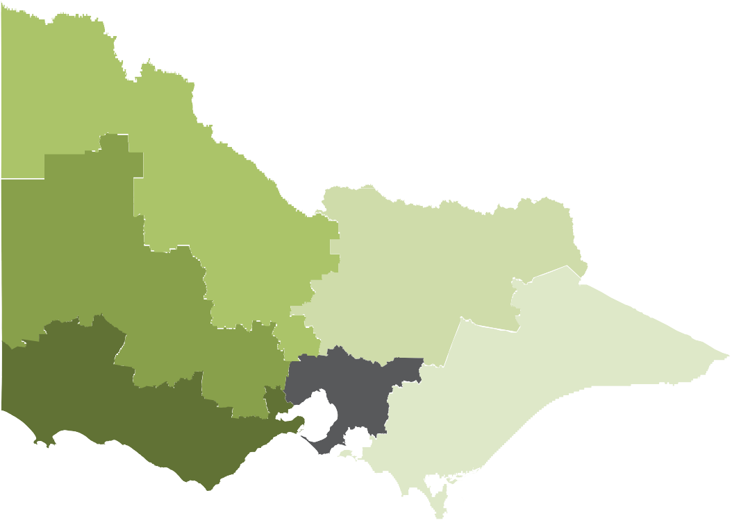Figure 4.2: Public Administration and Safety industry training providers and enrolments, 2013

Grampians
<10 providers
120 enrolments
Loddon Mallee
<10 providers
430 enrolments

Hume
<10 providers
400 enrolments

Barwon South West
<10 providers
330 enrolments
See metro inlay

Gippsland
<10 providers
140 enrolments

Northern Metropolitan
10 providers
1750 enrolments

Western Metropolitan
(inc. CBD)
10 providers
3120 enrolments

Eastern Metropolitan
<10 providers
360 enrolments

Southern Metropolitan
<10 providers
1530 enrolments

Student characteristics

Students in the 25+ age group accounted for around half of

Figure 4.3: Enrolments by highest prior qualification, government subsidised, 2013

the enrolments in Public Administration and Safety in 2012 and 2013. This is down from 74 per cent in 2008, although the actual number of enrolments by students within this age cohort has increased by 35 per cent over this period.
Students who are unemployed made up 43 per cent of enrolments in 2013. This proportion has risen significantly since 2008, when unemployed students comprised eight per cent of enrolments, and compares with an average across all industry training of 25 per cent.
Bachelor Degree 0% or Higher Degree level 1%

Advanced Diploma, 2% Diploma or Associate Degree 2%

Certificate III-IV Year 12 or Certificate II
Certificate I 1%
1%

Year 11 or below

12%

20%

34%
35%

42%

50%

Students from a Culturally and Linguistically Diverse (CALD) background accounted for more than a third of enrolments in 2013, students reporting a disability comprise seven per cent of enrolments.

Table 4.7: Learners Facing Barriers enrolments, government subsidised, 2008 to 2013
Learner Groups | 2008 | 2009 | 2010 | 2011 | 2012 | 2013
Indigenous | 30 | 30 | 40 | 40 | 70 | 100
Disability | 290 | 290 | 350 | 610 | 550 | 480
CALD | 690 | 560 | 1,270 | 2,270 | 3,190 | 2,850
Unemployed | 310 | 430 | 1,310 | 1,560 | 1,940 | 3,480
Aged 25+ | 2,950 | 2,160 | 2,880 | 4,440 | 4,180 | 3,980

Public Administration and Safety
All industries

The main reason students gave for enrolling in vocational training related to Public Administration and Safety was ‘To get a job’ (64 per cent). The next two most important reasons were ‘I wanted extra skills for my job’ (nine per cent) and ‘For personal interest or self-development’ (seven per cent), as shown in Figure 4.4.

Figure 4.4: Enrolments by reason for study, government subsidised, 2013

At the time of enrolment, students enrolling in Public Administration and Safety courses were less likely to have obtained a Certificate III-IV but more likely to have completed Year 12 or Certificate II than the average across all industry training. Half of Public Administration and Safety enrolments were by students who had completed Year 12 or Certificate
II prior to beginning their studies in the sector in 2013. This compares with an average across all industry training of 39 per cent.

14%

6%

7%

9%

64%
To get a job

I wanted extra skills for my job

For personal interest or self-development

It was a requirement of my job
Other

Appendix A

Table 5.1: Enrolments by occupation, course and subsidy band, 2012 and 2013

Occupation | Course name | Subsidy band | 2012 | 2013
Agricultural Technician | Certificate IV in Animal Control and Regulation | Band B | 80 | 90
 | Total |  | 80 | 90
Clerk of Court | Certificate IV in Government (Court Services) | Band C | 20 | 50
 | Total |  | 20 | 50
Court Bailiff or Sheriff | Certificate IV in Government (Court Compliance) | Band B | 10 | 10
 | Total |  | 10 | 10
Earthmoving Plant Operator | Certificate III in Local Government (Operational Works) | Band C | - | 60
 | Certificate IV in Local Government (Operational Works) | Band C | - | 20
 | Total |  | - | 80
Electrical or Telecommunications Trades Assistant | Certificate II in Technical Security | Band B | 20 | 30
 | Certificate III in Technical Security | Band B | <10 | 10
 | Total |  | 20 | 40
Emergency Service Worker | Certificate II in Public Safety (SES) | Band B | - | 50
 | Certificate III in Public Safety (Community Safety) | Band B | <10 | -
 | Certificate III in Public Safety (SES Operations) | Band B | 200 | 150
 | Total |  | 200 | 200
Firefighter | Certificate II in Public Safety (Firefighting and Emergency Operations) | Band B | <10 | -
 | Certificate II in Public Safety (Firefighting Operations) | Band B | 10 | -
 | Certificate III in Public Safety (Firefighting and Emergency Operations) | Band B | 40 | 50
 | Certificate III in Public Safety (Firefighting Operations) | Band B | 10 | <10
 | Certificate IV in Fire Technology | Band A | 40 | -
 | Diploma of Fire Technology | Band C | 10 | -
 | Total |  | 100 | 60
General Clerk | Certificate II in Local Government | Band C | 10 | -
 | Total |  | 10 | -

Occupation | Course name | Subsidy band | 2012 | 2013
Inspectors and Regulatory Officers n.e.c. | Certificate IV in Government (Investigation) | Band C | 10 | 10
 | Certificate IV in Government (Statutory Compliance) | Band C | 100 | 100
 | Diploma of Government (Investigation) | Band D | <10 | -
 | Total |  | 100 | 100
Law Clerk | Certificate IV in Justice | Band B | 300 | 700
 | Diploma of Justice | Band C | 90 | 550
 | Total |  | 400 | 1,200
Lifeguard | Certificate II in Public Safety (Aquatic Rescue) | Band D | 700 | 150
 | Certificate III in Public Safety (Aquatic Search and Rescue) | Band B | 50 | 70
 | Total |  | 750 | 200
Locksmith | Certificate III in Locksmithing | Band A | 100 | 100
 | Total |  | 100 | 100
Motor Vehicle Licence Examiner | Certificate IV in Government (Road Transport Compliance) | Band C | - | 40
 | Total |  | - | 40
Parole or Probation Officer | Advanced Diploma of Justice | Band C | 750 | 400
 | Total |  | 750 | 400
Policy Analyst | Diploma of Government | Band D | 40 | 30
 | Total |  | 40 | 30
Prison Officer | Certificate III in Correctional Practice | Band B | 30 | 150
 | Certificate III in Correctional Practice (Community) | Band B | 50 | 40
 | Certificate III in Correctional Practice (Custodial) | Band B | 100 | 90
 | Certificate IV in Correctional Practice | Band B | 50 | 30
 | Total |  | 250 | 350
Private Investigator | Certificate III in Investigative Services | Band C | 50 | 70
 | Total |  | 50 | 70

Occupation | Course name | Subsidy band | 2012 | 2013
Program or Project Administrator | Certificate III in Government | Band C | 20 | 20
 | Certificate IV in Government | Band C | 40 | 70
 | Certificate IV in Government (Revenue Administration) | Band C | 10 | 10
 | Certificate IV in Local Government | Band C | - | 10
 | Certificate IV in Local Government (Health and Environment) | Band C | - | 10
 | Certificate IV in Local Government (Planning) | Band C | 10 | -
 | Total |  | 70 | 100
Security Consultant | Certificate IV in Security and Risk Management | Band C | 50 | 70
 | Diploma of Security and Risk Management | Band D | 100 | 10
 | Total |  | 200 | 80
Security Officer | Certificate I in Security Operations | Band D | 50 | 50
 | Certificate II in Security Operations | Band D | 2,700 | 3,200
 | Certificate III in Security Operations | Band C | 2,600 | 1,600
 | Total |  | 5,300 | 4,900

n.e.c. = not elsewhere classified

