Overview

Student Reporting 2017
At a Glance
There is now a much greater degree of autonomy and flexibility in determining how schools report student progress and achievement to parents. They have the capacity to make their own decisions and adjust their reporting to reflect their teaching and learning program.
Schools:
- determine the timing, frequency and format of student reports in partnership with students, parents and the local community. A single common report format is no longer mandated.
- report student achievement against the achievement standards indicating the level of attainment reached by each student at least twice per year.
- ensure student reports on student learning are clear, individualised and provide accurate information about student learning progress related to the achievement standards of the Victorian Curriculum F-10.
- develop a five point scale or equivalent that enables a greater level of detail to be provided to parents about their child’s achievement and progress.
Teachers:
- make informed and consistent judgements about student progress against the achievement standards provided in the curriculum.
- clearly identify the areas of strength and areas for improvement for each individual student.

victorian curriculum f-10
The Victorian Curriculum F–10 incorporates the Australian Curriculum and reflects Victorian priorities and standards. It is structured as a learning continuum that enables teachers to identify the current levels of achievement and then plan for progression.
- The achievement standards are provided in 11 levels for English and Mathematics and in five or six bands for all the other learning areas and capabilities.
- The achievement standards are provided in four levels (Towards Foundation Levels A to D) for students with additional learning needs or a disability.
- There are eight learning areas (The Arts, English, Health and Physical Education, The Humanities, Languages, Mathematics, Science, Technologies) and four capabilities (Critical and Creative Thinking, Ethical, Intercultural and Personal and Social) included in the curriculum.

reporting against the Victorian Curriculum F-10 achievement standards
Learning Areas
English, Mathematics and Science
Schools report student achievement against the achievement standards indicating the level of attainment reached by each student and the age expected level of attainment for every student in every year.
For English and Mathematics schools report student achievement, twice a year, in English against the modes and in Mathematics against the strands.
For Science schools report student achievement, at least once a year, commencing in Year 3 or earlier if this is part of the teaching and learning program.
Health and Physical Education
For Physical Education schools report student achievement twice a year, against the achievement standards. Health is reported on whenever it is taught within the two year band of schooling, in accordance with the whole-school teaching and learning plan.
Year levels
Years Foundation to 2
Schools report student achievement against the achievement standards in English, Mathematics, Health and Physical Education, The Arts and Personal and Social Capability. The focus at the Foundation stage is on these five curriculum areas however if schools choose to teach other curriculum areas then these should be reported against also.
Years 3 to 10
Schools report student achievement against the achievement standards in English, Mathematics and Physical Education twice a year; and Science at least once a year. Other curriculum areas are reported during each two year band of schooling, in accordance with the whole school teaching and learning plan.

Students of English as an Additional Language (EAL)
The progress of a student who is learning English as an additional language (EAL) should be reported against the stages of the EAL standards rather than the English achievement standards.
The EAL standards are organised into three broad stages:
- A Stages for Years Prep to 2
- B Stages for Years 3 to 6
- S Stages for Years 7 to 10.
In all of the EAL stages, students are assessed in the modes of:
- Speaking and Listening
- Reading and Viewing
- Writing.

Students with ADDITIONAL LEARNING NEEDS OR A DisabilitY
The Victorian Curriculum F–10 includes Levels A to D (Towards Foundation Level Victorian Curriculum) for students with additional learning needs or a disability. Levels A to D outline student learning from a pre-intentional to intentional engagement in learning, are integrated directly into the curriculum and are not associated with any set age or year level.
Schools are required to report on the achievement of all students including those with additional learning needs or a disability ‘without exception’. Schools are expected to report against the relevant curriculum area achievement standards based on evidence collected through the teaching and learning program delivered during the reporting period. Schools can report on a student’s progress anywhere on the continuum from Level A to Beyond Level 10.

FISO Improvement model
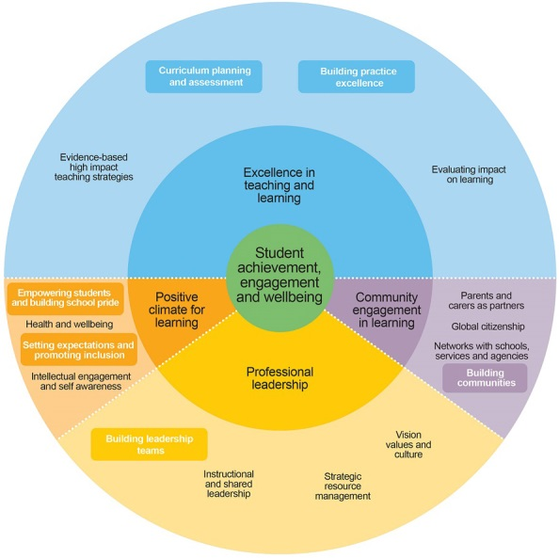

Student reporting and FISO
The Framework for Improving Student Outcomes (FISO) allows schools to make improvements based on the needs of their students, school and local community.
Curriculum planning and assessment focuses schools on strengthening the use of student assessment data and feedback to evaluate students’ progress.
Building practice excellence focuses teachers, principals and schools on working together to develop and strengthen teaching and assessment approaches, master the use of data and enhance feedback to students and staff.
High quality reporting processes and practices enables frequent and ongoing feedback and is a significant means of improving progress and achievement in learning.

Further advice
Student reporting | www.education.vic.gov.au/school/teachers/support/Pages/studentreports.aspx
Students with disabilities and additional learning needs | http://victoriancurriculum.vcaa.vic.edu.au/overview/diversity-of-learners
English as an additional language reporting | www.vcaa.vic.edu.au/Documents/viccurric/eal/EAL_companion_to_AusVELS.pdf
Mandatory requirements for reporting to parents | www.education.vic.gov.au/school/principals/spag/curriculum/Pages/reporting.aspx
Victorian Curriculum F-10 | http://victoriancurriculum.vcaa.vic.edu.au/
VCAA Insight Assess Portal | www.insight.vic.edu.au/
Education State | www.education.vic.gov.au/about/educationstate/Pages/default.aspx
Framework for Improving Student Outcomes (FISO) | https://edugate.eduweb.vic.gov.au/edrms/project/fiso/SitePages/Home.aspx

Frequently Asked Questions

Reporting To Parents
- What are the requirements for reporting to parents vs reporting to the Department?
Student reports are issued to parents and carers, using a five point rating scale or equivalent to show student progress and achievement, at the time of reporting.
Schools provide the Department with a score based on the teacher judgement of each student’s level of achievement against the curriculum areas taught during the reporting period. Scores are entered into CASES21 via the school’s student reporting software package or via direct entry method (for use by smaller schools).
- What curriculum areas must be reported on and how often?
Reporting reflects what has been taught. During the three broad stages of schooling, schools will focus on particular curriculum areas in their curriculum planning and provision. Whenever a curriculum area is taught student achievement is reported.
English and Mathematics: twice a year.
Science: at least once a year from Year 3 onwards, earlier if taught as part of the whole-school teaching and learning plan
Physical Education: twice a year.
Other curriculum areas, including Health: whenever taught within the two-year band of schooling in accordance with the whole-school teaching and learning plan.

Student Report Formats
- What information should be displayed on the report and how should it be displayed?
Victorian schools have the flexibility to determine the timing, frequency and format of reports in partnership with students, parents and the local community. Schools will determine how student progress and achievement and other information in the student report will be displayed – either as a written or a graphic representation.
Schools should have the capacity to report against both what has been taught and, where appropriate, against individual learning goals and targets. Setting of individual learning goals and targets is part of effective reporting to parents. Schools can commence this as soon as they are ready.
In 2017 progress in the Victorian Curriculum F-10 will not be linked to historical AusVELS achievement data as the data chain will be broken in all curriculum areas except English and Mathematics (Victorian Curriculum F-10 taught during 2016), and English as an Additional Language (EAL) and several Languages (AusVELS for 2017).
- Will samples of student reports be provided to schools?
Resources are under development and are being updated to support schools to develop high quality processes and practices for assessing and reporting student learning achievement against the Victorian Curriculum F-10.
VCAA will progressively publish student report samples during 2017. For further information see: VCAA Curriculum planning and assessment.
Schools should discuss their needs with their third party software provider to develop suitable methods to display student progress and achievement.

Teacher Judgements
- How much of the achievement standard does a student need to meet to say they have attained a level?
There is one achievement standard per level or band. Teachers will make a judgement based on evidence of achievement against the standards.
Reporting using the five point scale will enable schools to provide a greater level of detail to parents about their child’s achievement and progress.
- Can you report a student’s achievement at different levels for different curriculum areas or modes/strands?
The focus for the purpose of reporting student achievement is on the extent to which a particular set of knowledge and skills has been demonstrated. Teachers and schools are expected to report against the relevant curriculum area achievement standards based on evidence collected through the teaching and learning program delivered during the reporting period.
Not all students will be expected to achieve the same level of attainment in all curriculum areas. Students’ levels of achievement can also vary within curriculum areas, especially in the early stages of learning. For example, some students progress more quickly in learning oral language than reading in English.

Reporting Achievement for Students with Personalised Learning and Support Planning
- What are the teaching, learning and reporting requirements for students with disabilities?
Schools are required to report on the achievement of all students including those with additional learning needs or a disability ‘without exception’.
That means schools can report on a student’s progress anywhere on the continuum between Levels A to Level 10. For example, if a student is in Year Three their teacher is not compelled to report their achievement at Level Three. Teachers and schools are expected to report against the relevant curriculum area achievement standards based on evidence collected through the teaching and learning program delivered during the reporting period.
- What do I report if a student only sometimes demonstrates a skill/knowledge?
Students need to demonstrate the skill consistently in different environments with different people, otherwise consider the achievement standard below. Look at levels either side and ascertain what areas they have strengths in and focus on the areas that are lower in order to bring their learning closer aligned.
- Do students with disabilities have to learn a Language?
There are two sequences of learning for Languages curriculums: F-10 sequence and 7-10 sequence.
If students with disabilities are taught a Language then their achievement will be reported against the achievement standard they have best demonstrated their skills and understanding.
Reporting Achievement for Students for whom English is an Additional Language (EAL)
- Is it possible for a student to be reported against an EAL achievement standard for one mode of English, and then against the AusVELS or Victorian Curriculum F-10 for the other modes?
If a teacher’s assessment of an EAL student against the English achievement standards places the student well below their peers, and the student still requires substantial support in learning English as an additional language, then teachers should continue to use the EAL standards.
It is not appropriate for an EAL student to be assessed against the English standards in one mode, such as Speaking and Listening, and the EAL standards in other modes. While the oral language proficiency of an EAL student may appear to correspond to that of their peers, as students progress through year levels, the demands of the curriculum become more complex, and these students can struggle to cope with the academic requirements of the English curriculum.
Once an EAL student has reached the ‘at standard’ level of their respective A, B or S Stage in all three modes of Speaking and listening, Reading and viewing and Writing, they can be transferred to the English AusVELS (or the Victorian Curriculum in 2017) for assessment and reporting purposes.

Questions related to student reporting are welcome through the Student Reports mailbox at student.reports@edumail.vic.gov.au

