At a glance - Literacy and Numeracy Teaching Resources

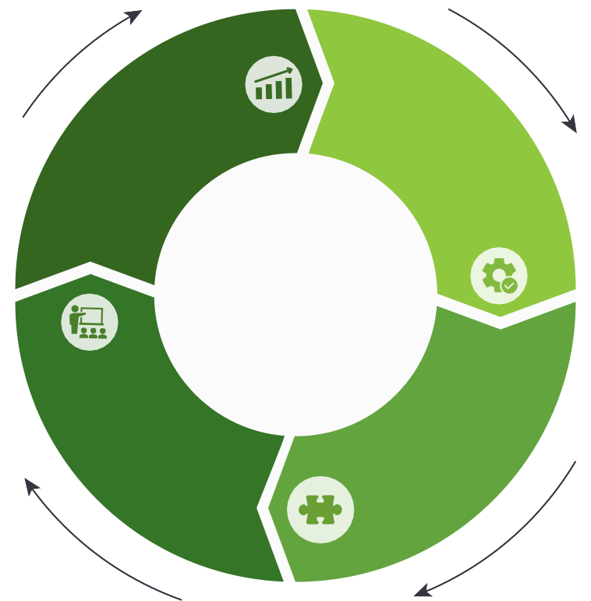Assess

Resources available:
- Insight Online Assessment Platform
  - Transition Learning and Development Statements (Level F)
  - English Online Interview (EOI) (Levels F-10)
  - Diagnostic Assessment Tools in English (DATE) (Levels A-4)
  - Abilities Based Learning and Education Support (ABLES) (Levels F-10)
  - Early ABLES (ages 2-5 for children with additional needs)
  - Mathematics Online Interview (MOI) (Levels F-4)
  - Fractions and Decimals Online Interview (FDOI) (Levels 3-8)
- Assessment for common misunderstandings

Teach

Resources available:

- VCAA On Demand Tests English/ Mathematics (Levels 3-10)
- Tools for Enhancing Assessment Literacy (TEAL)
- NAPLAN
- VCAA Annotated Work Samples in Reading and Viewing, Speaking and Listening and Writing
- Scaffolding Numeracy in the Middle Years
- School based assessment such as: e
r
o
  - Feedback and reflection
  - Student self assessments
  - Student Portfolios
  - Validated tools
  - Anecdotal evidence
  - Teacher moderated student assessment tasks
  - Student self reflections/ interests/surveys (student voice)

Use student data

Resources available:
    - Insight Online Assessment Platform
      - Transition Learning and Development Statements (Level F) (2018)
      - English Online Interview (EOI) (Levels F-10)
      - Diagnostic Assessment Tools in English (DATE) (Levels A-4)
      - Abilities Based Learning and Education Support (ABLES) (Levels F-10)
      - Mathematics Online Interview (MOI) (Levels F-4)
      - Fractions and Decimals Online Interview (FDOI) (Levels 3-8)
    - VCAA On Demand Tests English/Mathematics (Levels 3-10)
    - Early ABLES (ages 2-5 for children with additional needs)
    - Tools for Enhancing Assessment Literacy (TEAL)
    - NAPLAN
    - School based assessment data, such as:
      - Validated tools
      - Anecdotal evidence
      - Teacher moderated student assessment tasks
      - Student self reflections/interests/surveys (student voice)

    - High Impact Teaching Strategies (HITS)
    - Teaching and Learning Tool Kit
    - Abilities Based Learning and Education Support (ABLES) (Levels F-10) teaching advice
    - Literacy Portal:
      - Literacy Teaching Toolkit
    - Numeracy Portal:
      - Birth to Level 10 Numeracy Guide
      - Mathematics Curriculum Companion
    - Practice Principles of Excellence in Teaching and Learning
    - Koorie Teaching Resources
    - Learning difficulties and dyslexia
    - Building academic vocabulary
Plan

Resources available:

Identify learning goals
or
rri
ea
ent
Resources available:
    - Victorian Curriculum F-10 achievement standards*
    - Curriculum mapping templates – English and Mathematics
    - Literacy and Numeracy Learning Progressions
    - Abilities Based Learning and Education Support assessment tools - achievement advice (ABLES) (Levels F-10)
    - Tools for Enhancing Assessment Literacy (TEAL)

    - Victorian Curriculum Content Descriptors and Achievement Standards
    - Literacy Portal
      - Literacy Teaching Toolkit
    - Numeracy Portal
      - Birth to Level 10 Numeracy Guide
      - Mathematics Curriculum Companion
    - FUSE Digital Resources (Numeracy)
    - EduSTAR Catalogue
    - High Impact Teaching Strategies (HITS)
    - Practice Principles for Excellence in Teaching and Learning
    - Victorian Early Years Learning and Development Framework Illustrative maps (Birth to 8 years)
- Tools for Enhancing Assessment m
Literacy (TEAL) e
- VCAA Curriculum Planning Resource including
  - School Planning
  - Curriculum Area Planning
  - Year Level Planning
  - Unit/Lesson Planning
  - Self Assessment tool
- VCAA sample units English (F-10)
- VCAA sample programs Mathematics (F-10)
- Scope and Sequence Charts – English and Mathematics (Levels A – 10)
- Guide to Formative Assessment Rubrics
- High Impact Teaching Strategies (HITS) Including learning intentions, setting goals and success criteria
- Victorian Early Years Learning and Development Framework (Birth to 8 years)
- School based resources, such as:
  - Individual Education Plans
  - 1:1 Conferences
  - Student Reflections

* Foundation level (F) is inclusive of Towards Foundation levels A to D

