Task Description
Students are presented with the following shopping situation:

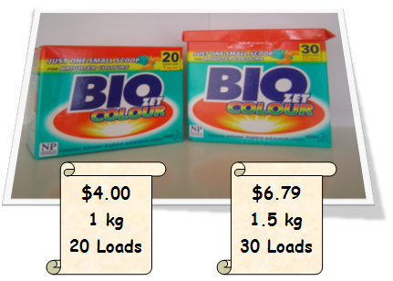
You are shopping for washing powder and your favourite brand is on special. For one kilogram of this powder you would pay $4.00, but for 1.5 kilograms you would pay $6.79. Which is the better buy?

Students find this real-world activity very engaging; teachers find it insightful. The variety of approaches to solving this problem is highlighted when students conclude by sharing their strategies with their classmates.

Key Mathematical Concepts
- Choosing an appropriate operation to solve mathematical problems
- Applying appropriate strategies to solve problems
- Simple ratio and equivalence
- Lowest common multiple

Links to VELS

Key VELS references

Dimension | Standard
Number (Level 4) | (students) create sets of number multiples to find the lowest common multiple of the numbers.  They add, subtract, and multiply fractions and decimals (to two decimal places) and apply these operations in practical contexts, including the use of money.
Structure (Level 4) | They solve equations by trial and error.
Working Mathematically (Level 4) | Students recognise and investigate the use of mathematics in real…situations.  Students use the mathematical structure of problems to choose strategies for solutions. They explain their reasoning and procedures and interpret solutions. They create new problems based on familiar problem structures.

Teacher Advice and Feedback
This task is well suited to upper primary school children with some experience in problem solving. Teachers considered this activity provided them with insightful information regarding students’ skill levels, and how effectively they could apply their knowledge in problem solving situations.

In the trial, students generally took between 20 and 40 minutes to complete the task. Group sharing time was in addition to this.

Teachers in the trial found it was helpful if students had some background knowledge of ratios. They considered it critical that students explain and share their answers with the group after the activity, as this developed a greater understanding of the task and expanded their knowledge of problem solving strategies.

Teachers noted that students were very engaged and on task during this activity, as the majority could work independently to find a solution, and most could see a way to solve it. One class noted that a more positive attitude flowed through to subsequent related tasks, as a direct result of this activity. Teachers considered the lesson went as well as they had hoped, and that the mathematical goals for the lesson were achieved very successfully.

Around 70% of the 68 student survey respondents considered they had learned some new mathematics during this activity and that they had felt challenged. Over 90% reported being able to start without assistance; had thought about maths for most of the lesson and could now use the maths from this activity on other problems.

Potential Student Difficulties
Some students in the trial had difficulty in working out a way to make the two products comparable (e.g., recognising that they need to find the lowest common multiple) and in using ratios. This resulted in some of the students taking the view that they would prefer to buy a bigger box because they wouldn't have to go back to the supermarket as often and it would last longer, rather than using a mathematical approach to compare value.

Possible Enabling Prompts
Ask students:
- What information do we know?
- Is there a way we can compare the two products? Which parts are easiest to compare?
- How can we make the products easier to compare?
- Can we only buy one packet? What if we bought more?

Extension Suggestions
Using supermarket catalogues, choose a product and find the brand or size that is the best value for money.

Solution
To be working at Level 4, it is expected that students be able to apply reasonable strategies and select appropriate operations to solve this problem. Student Work Examples 2, 3 and 4 all provide examples of the various approaches that can be taken to solve this problem.

Acknowledgements
Thanks to the Berwick South Cluster Numeracy Action Team for the multiple trials and valuable feedback on this activity.

Example 1
Working below VELS Level 4.

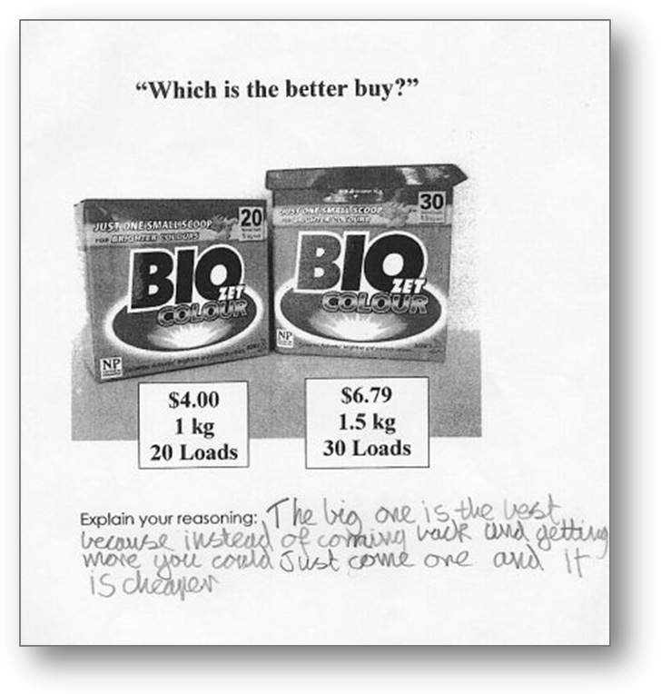

This student has not compared the value of the soap powder boxes in terms of cost per volume. A mathematical approach has not been used.

Example 2
Working at VELS Level 4.

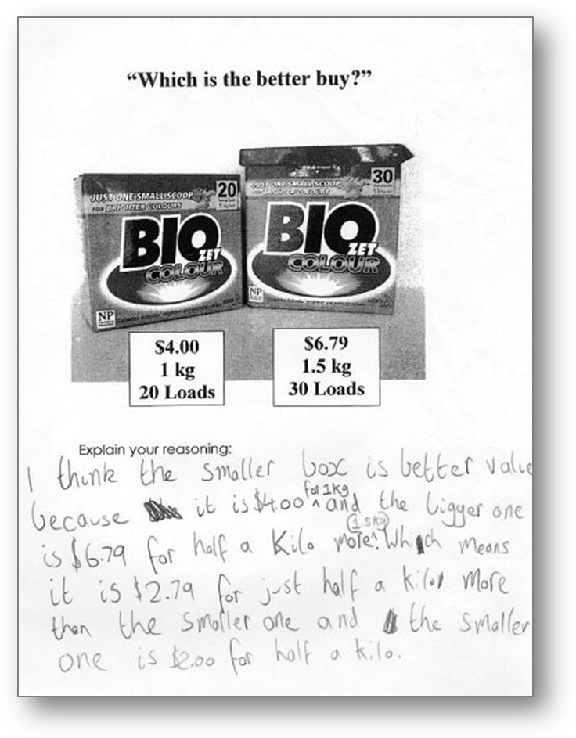
This student has chosen to scale up the 1 kg box in terms of weight and cost to 1.5 kg and noted the extra 0.5 kg would cost only $2.00, not $2.79 as with the larger box. He/she has correctly deduced that the smaller box provides better value for money.

Example 3
Working at VELS Level 4.

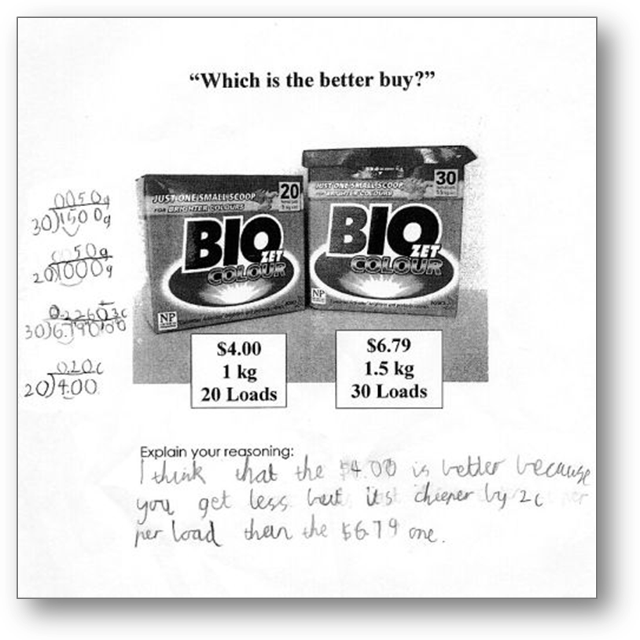
This student has calculated a cost per load of the soap powder from each box ($0.226 for the larger box and $0.20 for the smaller, thus making the cost of the two boxes directly comparable. He also checked that each box had the same volume (50 g) per load and correctly deduced that the smaller box provides better value for money.

Example 4
Working at VELS Level 4.

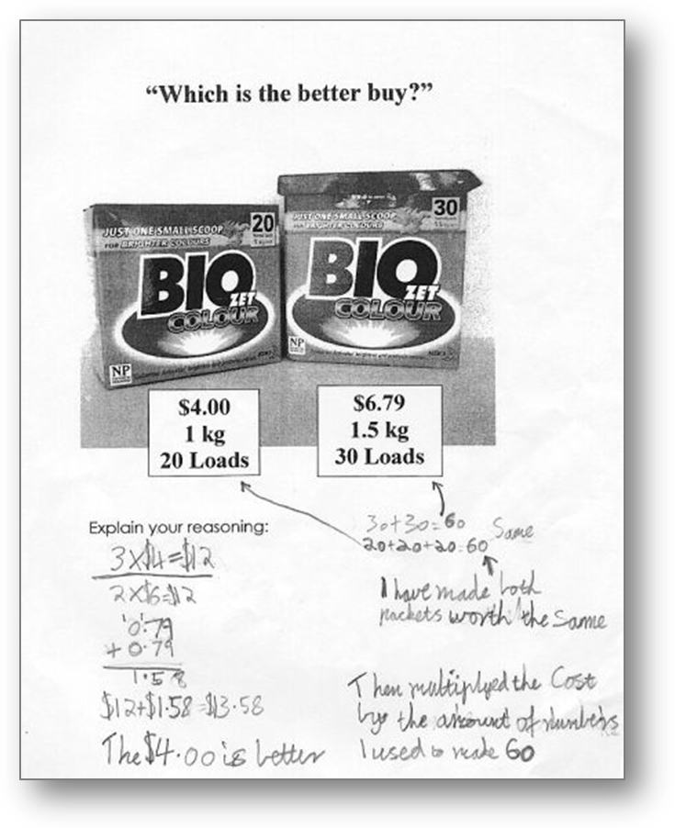
This student has found the lowest common multiple of loads (60) and upsized both boxes’ cost and size to this amount. For 60 loads the larger box would cost $13.58 while 60 loads for the smaller box would cost $12. This makes the cost of each box directly comparable, and the student correctly deduces that the smaller box is better value for money.

