Task Description
The students are given a 30 cm tall teddy bear pattern and must construct a 40 cm tall teddy bear.

Length of Task
Duration of the unit

Materials
- Teddy Bear Pattern, graph paper, calculators, plush material, stuffing, dressmaker scissors, cotton thread, sewing needles.

Using the Activity
Introductory
The teacher shows the students a homemade 40 cm 3D teddy bear. The teacher explains that the students will be creating their own teddy bear from the pattern and materials provided. ‘However, there is one catch, the teddy bear pattern we have only makes a 30cm tall teddy bear and we want a 40 cm tall teddy bear. The challenge is for you to develop a method to create the larger teddy bear based on this pattern.’

Main Activity
The students discuss a variety of methods for enlarging the teddy bear. The following are strategies observed or suggested during the trialling of this task.

- A couple of students used the data projector and zoom function in 'Word' to adjust the teddy bear pattern until they found the correct ratio. They redrew the teddy bear onto a grid placed on the enlarged image.
- Some students attempted to enlarge the pattern by simply tracing the shapes about 1cm outside the original grid to make them bigger. This method is not to scale.
- Some students suggested photocopying the pattern and using the enlarge function set at 133%.
- Another suggestion was to create larger graph paper in a ratio of 3:4 and copy each part onto the new graph paper.
- The students calculated that for every 3 cells on the grid they needed 4 cells on a new grid. They calculated where the widest and narrowest point of a body part should be and placed a dot at that point on the new graph paper. The students then drew in the rough shape of the larger body part onto the new graph paper. This enlarged template was transferred to stiff cardboard. The material was traced using the new template.

The task is undertaken throughout the course of the unit. During this time, students share their strategies with the class to seek feedback to further refine the enlarging process. Students use any spare time during the day or as a part of their homework to complete the sewing.

Reflection
The students present their completed teddy bears and share their methods for scaling the pattern to create a 40cm teddy bear.

Key Mathematical Concepts
- Understanding of the use of ratio to enlarge a shape.

Prerequisite Knowledge
- Understanding simple ratio, fractions, decimals and percentages.

Links to VELS

Dimension | Standard
Number (Level 4) | Students use decimals, ratios and percentages to find equivalent representations of common fractions (for example, 3/4 = 9/12 = 0.75 = 75% = 3 : 4 = 6 : 8).
Space (Level 4) | Students develop and follow instructions to draw shapes and nets of solids using simple scale.
Working Mathematically (Level 4) | Students use the mathematical structure of problems to choose strategies for solutions. They explain their reasoning and procedures and interpret solutions. They create new problems based on familiar problem structures.

Assessment
To be working at Level 4, students should be able to:
- Use ratio to create a 40cm teddy bear from a 30cm pattern.

Extension Suggestions
For students who would benefit from additional challenges:
- The students create a family of ginger bread cookie cutters. They investigate the average size of a new born, 5 year old child, 12 year old child and adult. They calculate the ratio and apply this knowledge to creating a template made from plastic or cardboard for their own cookie cutter set.

Teacher Advice and Feedback
Many students experienced success through the task and saw the importance of accurate and correct calculation when joining the body parts of the pattern.

The teachers were pleased with the connections made to other curriculum areas, such as Design, Creativity and Technology and Personal Learning. This task also developed the students’ measurement skills. The students were aware of the direct real-life application of ratio to this task.

Potential Student Difficulties
Most students struggled with this task initially and needed support to develop a strategy for enlarging the grids using ratio. The students may benefit from experience with simple one piece patterns (e.g. a cookie cutter) and explore the problem of making a cookie template twice the size, three times the size, etc. As the students build their understanding of the use of ratio to enlarge 2D shapes, they may move on to creating a simple 3D cube using thick cardboard. The students experiment with various sized cubes that are 50%, 100%, etc. larger.

References / Acknowledgements
Thank you to the teachers and students from Lloyd Street PS, for providing valuable feedback on the use of this activity.

Image of teddy bear sourced from http://www.thecolor.com/images/The-Teddy-Bear.gif

Students creating teddy bears

Example 1: This student is creating a template for the teddy bear based on prior calculations to determine the size of each piece of the pattern.

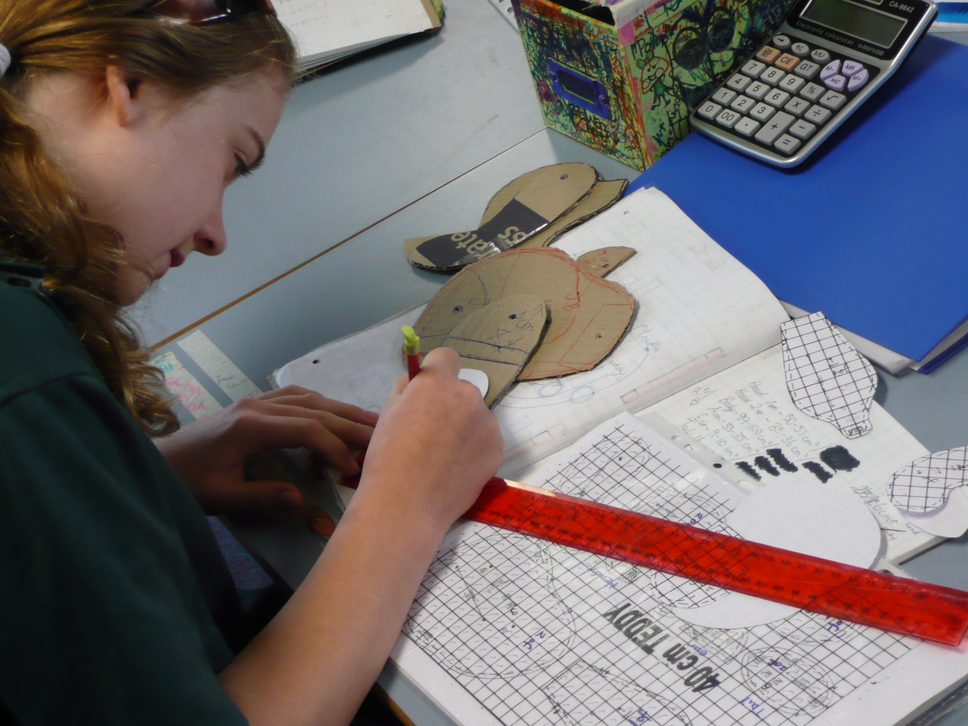

Example 2: These students are cutting out the material for the teddy bear’s body parts.

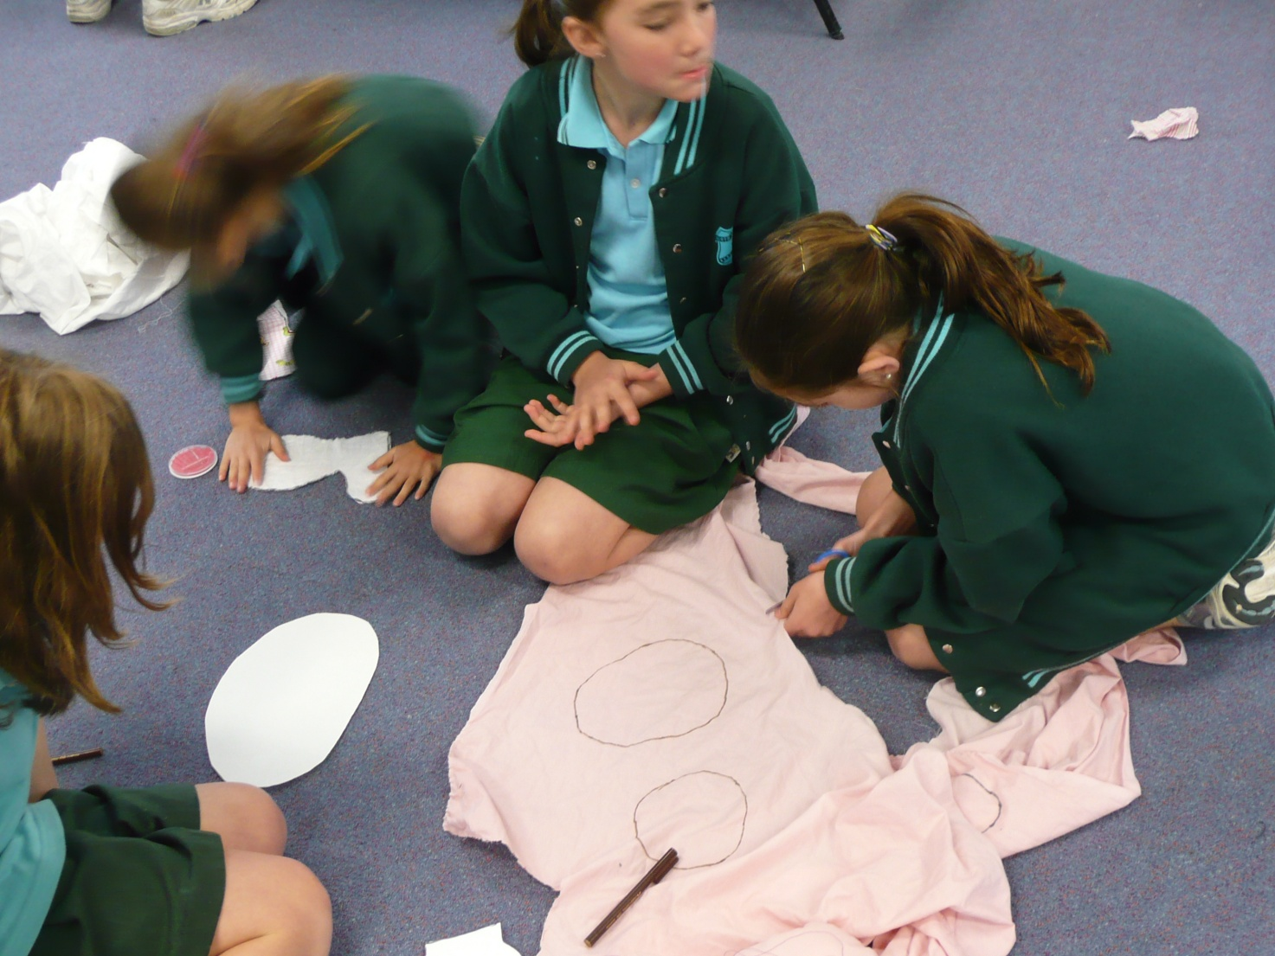

Example 3: Giving the teddy bear some shape.

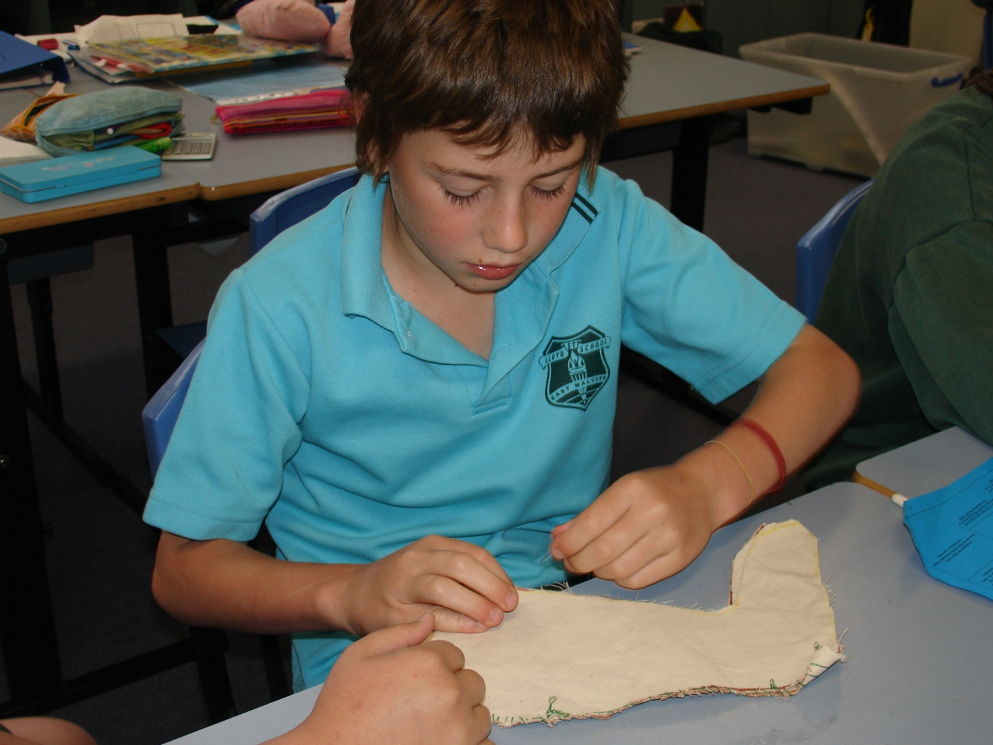

Student work samples

Example 1: Working at Level 4

The template below was created by allowing 4 cells for every 3 cells on the graph paper both length and width ways. The student determined the widest and narrowest points of each body part and redrew freehand each piece onto graph paper.


