Students survey their peers on a range of questions to calculate the ratio of student preferences in the classroom.

Length of Task
60 minutes

Materials
- Ratio in the Classroom survey worksheet

Using the Activity
Introductory
The teacher poses the question to the class, ‘Are you a tongue folder or creaser?’ The students experiment with trying to fold and crease their tongue. The teacher tallies the result and records these data as a ratio of the absolute numbers of students on the board (see below). This means the ratio includes all students in the class and is not simplified, e.g. 24 students = 21:3 is the absolute measure and 7:1 is the simplified ratio. If the numbers allow, the teacher demonstrates how to simplify a ratio.

Folders : Creasers

: _21 folders compared to _3_ creasers.
21
3

The teacher explains the importance of the order of number in the writing of ratio terms. The terms must match the order of the items you are comparing, e.g. folders is the first item so the first number of the ratio must match the rollers in the classroom.

Main Activity
The teacher distributes the survey worksheet and the students complete the first line to include these data gathered on rollers and folders. The teacher asks the students to consider other interesting questions to be asked of their classmates and determine the ratio. The students brainstorm questions.

The students formulate 2 – 3 preference-based questions (Do you prefer chocolate to strawberry ice-cream?) they wish to survey small groups or the whole class. The students move around the room questioning their peers and tabulating results.

The whole class come together to share their findings. The teacher asks, ‘What can we learn about the class from these ratios?’ ‘Was anyone able to simplify their ratio? Explain how you did this.’ If this class had twice as many students what might the ratios look like?’ ‘How might we describe these ratios as a fraction / decimal / percentage?’

Key Mathematical Concepts
- Representation of simple ratios.

Prerequisite Knowledge
- Surveying skills, e.g. formulating questions and tabulating results.

Links to VELS

Dimension | Standard
Number (Level 4) | Students use decimals, ratios and percentages to find equivalent representations of common fractions (for example, 3/4 = 9/12 = 0.75 = 75% = 3 : 4 = 6 : 8).
Measurement, Chance and Data (Level 4) | Students organise and present grouped and ungrouped data  using displays such as simple frequency tables.
Working Mathematically (Level 4) | Students develop and test conjectures.

Assessment
To be working at Level 4, students should be able to:
- Use ratio to compare the relationship between preferences.

Extension Suggestions
For students who would benefit from additional challenges:
Using any of the digits from 1 to 9 once each, create two-digit numbers that are in a ratio of 1:2. How many solutions can you find?
Now try the ratio 1:2:3.

The above problem was modified from the following question asked by Mike on http://statspuzzles.blogspot.com/2007/03/ratio-of-123.html
Using all of the digits from 1 to 9 once each, create three-digit numbers that are in a ratio of 1:2:3.
There are four solutions, can you find them all?

The solutions are: 192:384:576 219:438:657 273:546:819 327:654:981

Teacher Advice and Feedback
During the trial of this task it was noted that some students required more than the two categories offered in the survey, for example, an ‘other’ category. The teacher demonstrated how another term could be added to the ratio. For example, in answer to the question, ‘How do you travel to school, car or walk?’ the surveyor may need to add an ‘other’ category to cater for those who rode a bike or travelled by public transport.

Car : Walk : Other
: :

It is important for students to recognise that more than two items can be compared. Alternatively, students might find it useful to practise rephrasing their questions to produce only two possible responses.

During the reflection, teachers are advised to focus on the ratio component of the lesson rather than on the interpretation of the data.

Potential Student Difficulties
Some students in the trial group held the misconception that the larger or smaller number always goes first when record the ratio. It is key for the teacher to emphasise the significance of recording the ratio in the same order as the items compared. A good example is when demonstrating how many parts of cordial concentrate to water are required to make drinkable cordial. For example, 1 part of cordial to 6 parts of water is okay to drink; however, 6 parts of cordial to 1 part of water will be too sweet to swallow. Therefore 1:6 ≠ 6:1.

References / Acknowledgements
Thank you to the teachers and students from Lloyd Street PS, for providing valuable feedback on the use of this activity.

Access 28 January 2010 http://statspuzzles.blogspot.com/2007/03/ratio-of-123.html

Students surveying
These students are surveying their peers and recording the data and ratio.



Teacher feedback
This teacher noticed that some students required an extra category for comparing items and therefore added a third term to the ratio. This example has a ‘neither/other’ category in response to the question, ‘Which do you prefer, football or soccer?’ One child loved both games and could not decide, while another child did not like either sport.

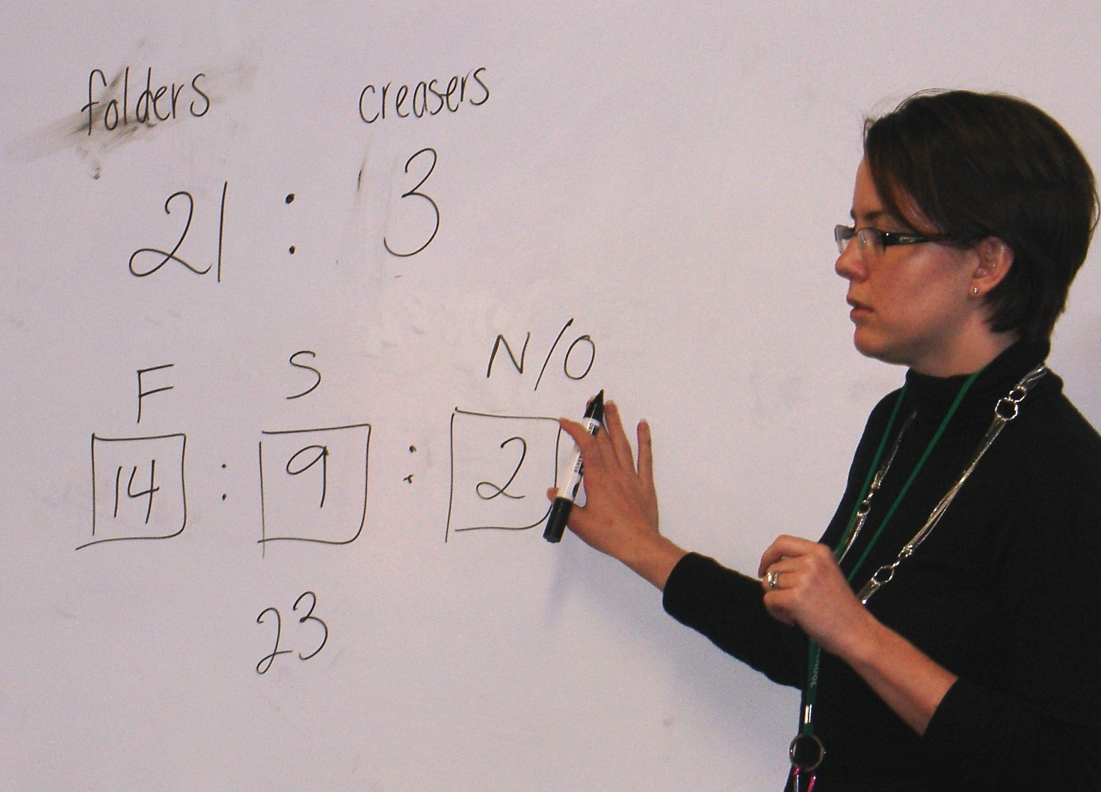

Student work sample

Example 1: Working at Level 4

This student has gathered the data from the class and demonstrates an understanding of adding another term to the ratio in order to cater for the extra category.

