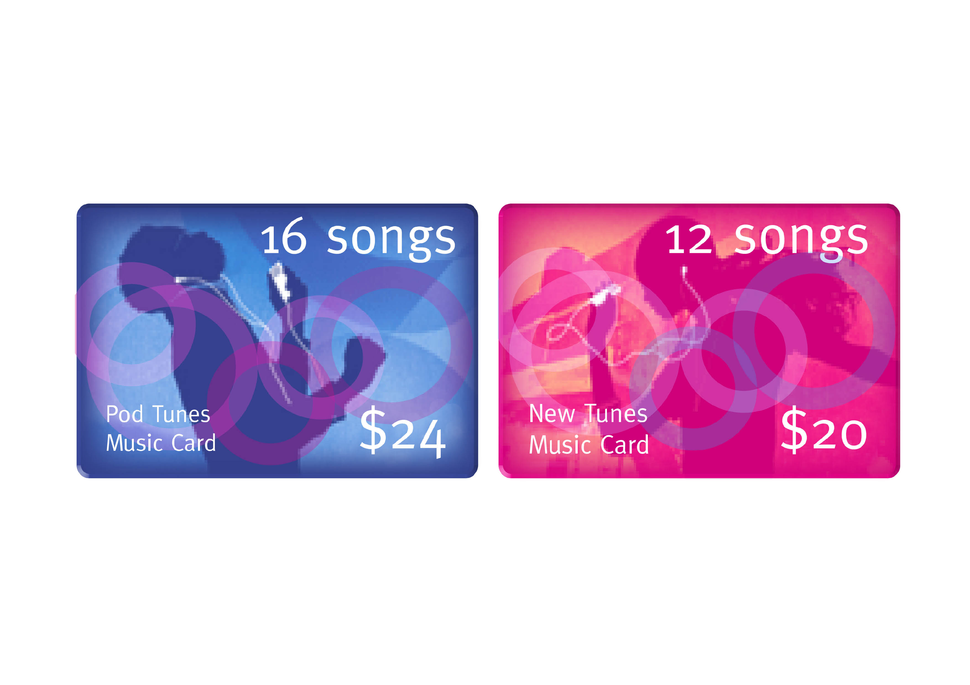
A shop sells two styles of music download cards, each allowing a different number of songs to be downloaded.

Which card is better value for money? Show all workings and explain your answer.

