Task Description

Students are told they have won a prize. The prize can be one of:

- 1 metre of $2 coins (lying flat)
- one square metre of five-cent pieces (filled in, lying flat)
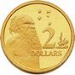
- one litre milk carton full of 20-cent pieces; or
- 1 kg of $1 coins.

Which prize would they choose?

This activity highlights the various ways we can measure objects, and compels students to develop problem-solving strategies using money as a focus. Students predict the outcome then measure the money in a variety of ways to enable them to calculate the values for each of the above scenarios. This activity is well suited to either group or individual work.

Materials
Metre rulers and tape measures, 1 Litre milk cartons, digital scales, balance scales, assorted coins ($1, $2, 20 cents and 5 cents).

Key Mathematical Concepts
- Measurement of length, area, volume and mass
- Units of measurement
- Money
- Using number operations in context
- Working mathematically.

Links to VELS
Dimension | Standard
Number (Level 4) | They add, subtract, and multiply fractions and decimals (to two decimal places) and apply these operations in practical contexts, including the use of money.  They use estimates for computations and apply criteria to determine if estimates are reasonable or not.
Measurement, chance and data (level 4) | Students…measure as accurately as needed for the purpose of the activity. They convert between metric units of length, capacity and time (for example, L–mL, sec–min).
Working mathematically (level 4.5) | Identification of the mathematical information needed to solve a problem or carry out an investigation.
Measurement, chance and data (level 5) | At Level 5, students measure length …area, mass, volume… using suitable units for these measurements in context.

Teacher Advice and Feedback
The time taken to complete this activity varied greatly and directly depended on the skill level of students undertaking it in the trial. On average, it took 2 periods to complete for upper primary/lower secondary aged students.

To reduce the amount of time the exercise takes, it can be run in groups. Students can be grouped together, so that each group can solve a different problem. The class needs to regroup to discuss the strategies used.

This activity needs to be well prepared in advance, as it can be challenging collecting the variety of resources needed.

Students will need an opportunity to discuss questions prior to starting the activity. In the trial, many questions such as ‘how are the coins stacked?’ and ‘will the coins be melted down?’ were asked by students prior to being able to commence the activity.

Potential Student Difficulties
Students without sufficient background in measurement of length, area, volume and mass found this activity challenging, and some students benefited from revision of calculating these measurements. However, many students completed the activity quite quickly, highlighting the necessity for extension activities to be prepared ahead of time.

Common problems observed in the student work samples included difficulty in accurately converting metric units of length, difficulty in starting the task for some of the measurements (e.g. volume or area), and in many cases, difficulty in logically writing down their method (which was highly correlated with erroneous answers). The most common calculation error was in volume, where many of the students approaching the task mathematically made erroneous assumptions (e.g. that the weight of 1 litre of coins is 1,000 g).

Possible Enabling Prompts
If I give you fifty 5 cent pieces, how much money do you have? If I give you fifty 20 cent pieces, how much money do you have? If I give you fifty $1 pieces, how much money do you have?

Draw a 10 cm x 10 cm square (10 cm²). Using a 5 cent coin as a stencil, how many 5 cent circles can you draw with no gaps between them in this area? Can you think of a way to work this out without counting each coin?

What are the dimensions (measurements of each side) of a 1 litre container (use a ruler or tape measure)? Choose one side and work out how many 20 cent coins you can fit on this side with the least number of gaps between them. How might this information help you to work out how many coins will fill your 1 litre container?

Extension Suggestions
How many different three-dimensional shapes can you calculate that will have a volume equivalent to 1 litre? Will the same dollar value of coins fit into each shape? If not, why not and which of your shapes will have the most money in it? Which shape will have the least money in it?
Which would you prefer – your height in $1 coins or your weight in 5 cent pieces?

Solution
Student Work Sample 1 shows a mathematically sound approach to this problem.

Acknowledgements
Thanks to the teachers and students from the Merging Minds cluster of schools for providing valuable feedback on the use of this task.

Example 1
Working at VELS Level 4.5

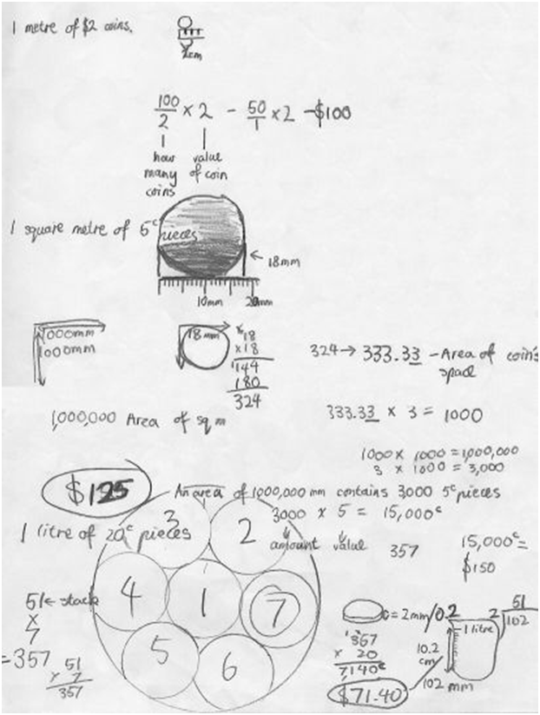
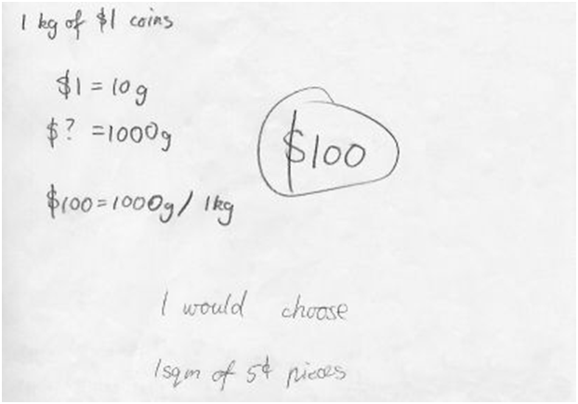
This student has correctly identified a mathematically sound method for working out each of the four challenges:

- 1 m of $2 coins by measuring the coin, and determining the number of coins that would fit into the distance and what value that would have. ($100)
- 1 m² of 5 cent coins by measuring the area of the "coin space" (the square containing the coin) and determining how many would fit into 1 m² (and what value that would have). ($150) – the $125 remains a mystery.
- 1 litre of 20 cent coins by physically fitting 7 coins into the base of a 1 litre cylindrical jug (the 1 L milk carton was not specified in the original prompt for this student). The student measured the depth of the coin and determined how many coins would then fit in the jug, and what value that would have in total. ($71.40)
- 1kg of $1 coins by measuring the weight of a $1 coin and determining how many would fit into 1kg. ($100)

This student accurately converted between different metric units and clearly articulated the method used.

Example 2
Working below VELS Level 4.5

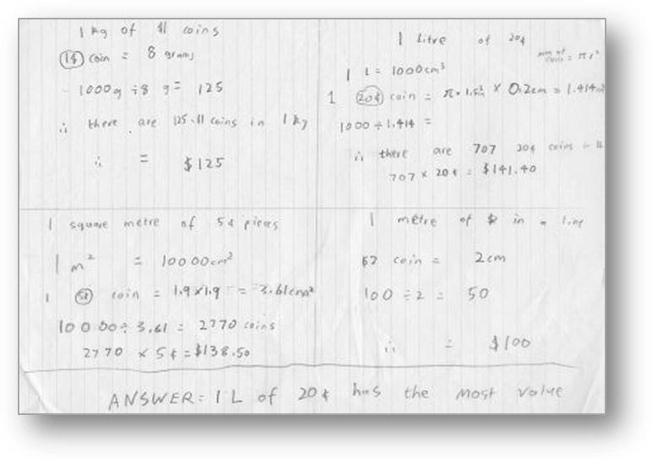

This student has correctly identified mathematical approaches to three of the four challenges (viz. 1 kg of $1 coins, 1 m² of 5 cent pieces and 1 m of 1$ coins), but has assumed that there will be no wastage of space between coins in the 1 litre scenario. The mathematical calculations are accurate, but there is an error in visualisation and practical application when working with three dimensions.

Example 3
Working below VELS Level 4.5

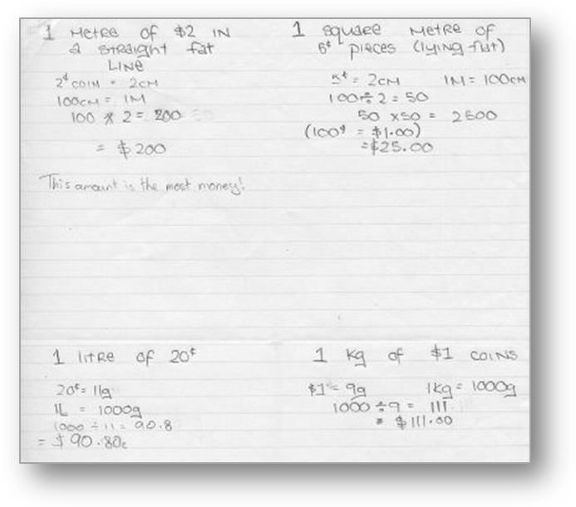

This student has only correctly identified the mathematical approach for 1 kg of $1. For 1 metre of $2 coins s/he did not take into account that the $2 coins were about 2 cm wide and therefore only 50 of these coins would fit into a length of 1 metre. For the square metre of 5 cent pieces, they correctly calculated there would be 2500 coins but then assumed this amount represented the “cents”, rather than that amount of 5 cents. For the litre of 20 cent pieces the student has assumed there will be no space wasted between the coins and in effect has calculated the space taken by the coins, had they been melted.

Example 4
Working below VELS Level 4.5
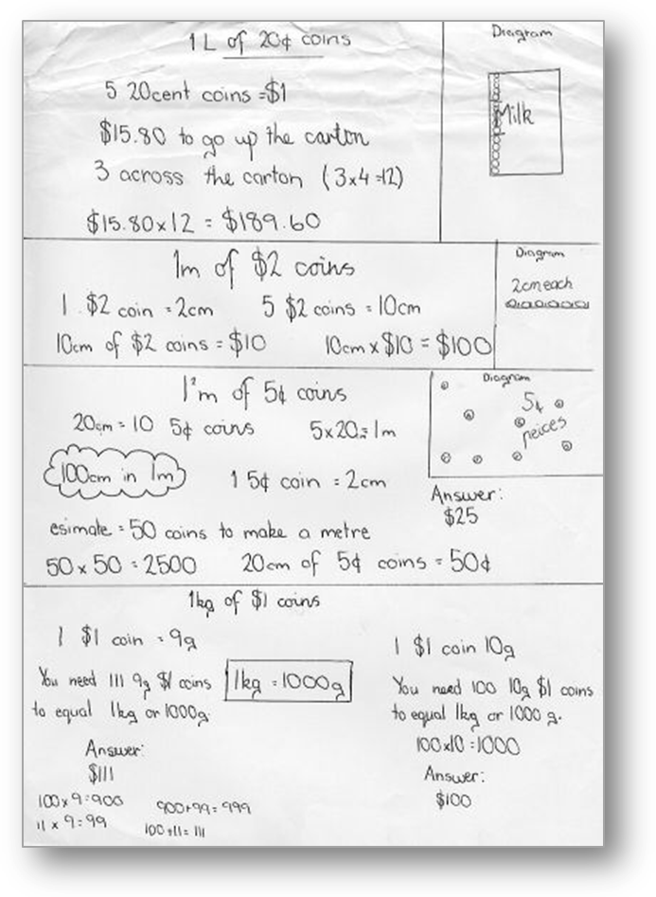

This student has correctly identified mathematical approaches to three of the four challenges (viz. 1 kg of $1 coins, 1 litre of 20 cent coins and 1 m of 1$ coins), but has made a calculation error in 1 m² of 5 cent coins (determining that 2,500 coins have a value of $25).

Example 5
Working below VELS Level 4.5

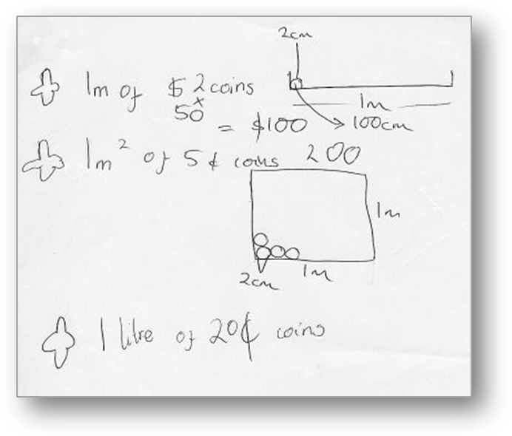

This student has correctly calculated that 50 $2 coins would stretch 1 metre and has drawn and labelled a diagram representing this. While incomplete this student appears to be on the road to solving 1 metre of 5 cent pieces.

