Task Description
Mike from Devonport in Tasmania wrote down every number from 1 to 1,000,000 in his spare time over a two-year period in the 1980s. At the time, one local newspaper reported that the total number of digits Mike wrote was 5,878,936.

Students are asked to investigate whether the newspaper's claimed number of digits was correct or not.

Key Mathematical Concepts
- Place Value – the number of digits in numbers to one million
- Multiplication and addition of large numbers
- Patterns recognition
- Problem solving strategies

Links to VELS

Key VELS Links

Dimension | Standard
Working Mathematically  (Level 3.75) | Understanding of patterns through the use of systematic strategies.
Number (Level 4) | Comprehend the size and order of small numbers (to thousandths) and large numbers (to millions).
Working Mathematically (Level 4) | Recognise and investigate the use of mathematics in real … situations.

Teacher Advice and Feedback
A number of teachers in the trial considered this activity as one of their top three context- based tasks that they trialled.

This task is well suited to students who have had experience with problem solving.
Teachers in the trial suggested breaking the task down into simple steps first, as it is quite challenging (97% of student survey respondents confirmed this observation).

In the trial, this task was reported as taking students between 50 minutes to 2 hours to complete, although many students in the shorter sessions could not complete the task.

Potential Student Difficulties
Over 1/3 of the 69 students who responded reported they had difficulty starting without assistance. When faced with the problem, some students found it difficult to see the connection between the task and their understanding of numbers and place value, and had difficulty seeing number patterns.

A number of students also devised strategies that were not correct, often because they came to the conclusion that because there are 9 digits between 1 and 9, there will be 89 digits between 10 and 99. In order to get the students to reconsider this amount, the teacher might ask the student how many numbers are there from 1 to 99 (“99 of course”) and then point out that they have 9 single digit numbers and 89 double digit numbers which adds to 98! As students search for the missing number they will hopefully recalculate that there are 90 double digit numbers between 10 and 99. Another common source of error was from students not adding the last seven digits (from the number 1,000,000).

Possible Enabling Prompts
Ask students:
- What numbers did Mike write down?
- What do we know about the numbers that Mike wrote down?
- What do we need to know before we can work out how many digits Mike wrote?
- How can we work out how many two digit/three digit (etc.) numbers he wrote?

For students who still cannot grasp the concepts, the task could also be simplified, for example, investigate how many digits there are between:
- 1 – 10
- 1 – 100
- 1 – 1000

Extension Suggestions
Mike used 97 ball point pens to write out his numbers. On average, how many characters can the ink in one pen write, given a character of text is a single letter or number? Look over your maths workbook and estimate how many maths workbooks one pen might last you.

One solution

Number range | Number of numbers | Number of digits
1 – 9 | 9 | 9 (1 x 9)
10 – 99 | 90 | 180 (2 x 90)
100 – 999 | 900 | 2,700 (3 x 900)
1,000 – 9,999 | 9,000 | 36,000 (4 x 9,000)
10,000 – 99,999 | 90,000 | 450,000 (5 x 90,000)
100,000 – 999,999 | 900,000 | 5,400,000 (6 x 900,000)
1,000,000 | 1 | 7 (7 x 1)
TOTAL |  | 5,888,896

Source

Pilgrim, Angela. The Advocate, Burnie, Tasmania, 20 February 1989.
Acknowledgements

Thanks to teachers in the Merging Minds Cluster (2007) and the Berwick South Cluster Numeracy Team Action Research Project (2008) for their invaluable input through the use and feedback of this activity in their classrooms.

Example 1

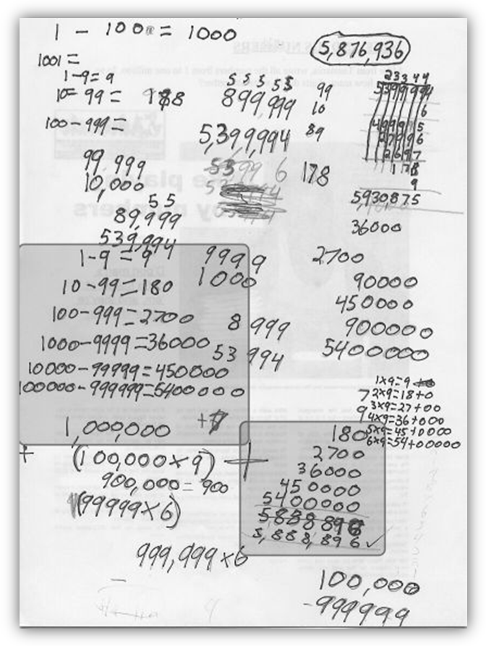

While this work is a little difficult to follow, this student has clearly demonstrated (in the highlighted sections) an understanding of numbers up to millions. He/she has identified a correct systematic strategy for solving the problem, identifies and uses number patterns, and chose multiplication over repeated addition. This piece of work is representative of VELS Level 4 for this problem.

Example 2

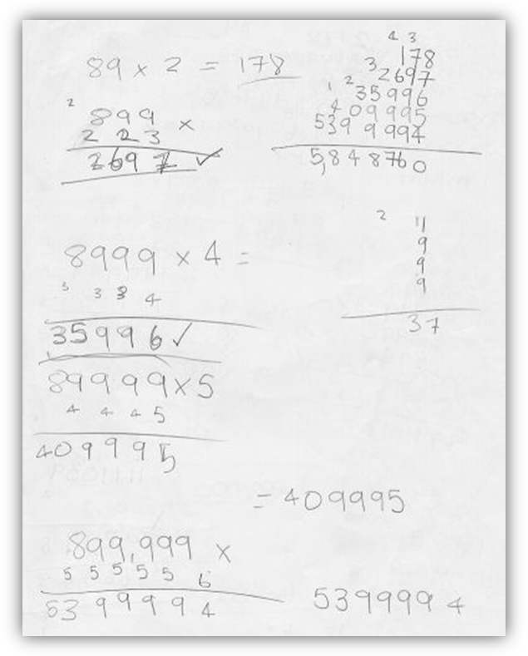

This student has identified a systematic strategy for solving the problem that identifies and uses number patterns, and has chosen multiplication over repeated addition. However, he/she was unable to correctly identify the number of digits in a range of numbers (for example, between 10 – 99 = 90 digits, not 89), therefore not arriving at the correct answer. This piece of work is not representative of VELS Level 4 for this problem.

Example 3

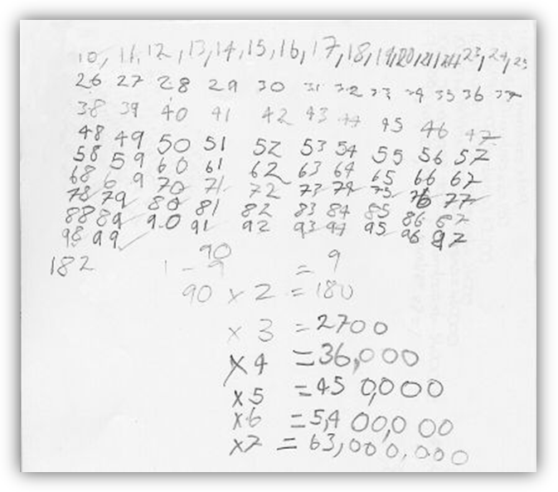

This student has identified a systematic strategy for solving the problem that identifies and uses number patterns, and has chosen multiplication over repeated addition. However, the algorithm used to determine the number of digits in a range of numbers was inaccurate, resulting in an incorrect answer. This piece of work is not representative of VELS Level 4 for this problem.

