Mathematics Online Interview (MOI) - Information Guide
For information on the Mathematics Online Interview (MOI), its structure and alignment with the Framework for Improving Student Outcomes (FISO 2.0)

What is MOI?
The Mathematics Online Interview (MOI) is an online tool for assessing the mathematical understanding of students in the early years of schooling. The Interview assesses students’ knowledge, skills and strategies in relation to key ‘growth points’ in the strands of Number and Algebra, and Measurement and Geometry.
MOI has been developed from the Early Numeracy Research Project (ENRP), commissioned by the Department of Education, Employment and Training (1999 – 2001). Through the ENRP, a framework of growth in numeracy learning was created to provide a means of tracking student learning.
MOI is a branched assessment tool, where an algorithm determines a student’s pathway through an overall assessment based on their performance on each small group of items, enabling finer grained information about individual student achievement and helps to identify misconceptions or gaps of student learning in mathematics.
The Interview primarily targets students in the early years of schooling however it may also be used as an assessment tool for ‘at risk’ students in middle to upper primary levels. Teachers record student responses directly into the online system, which can generate a range of profiles of student understanding, organised around the growth points. These profiles provide information for teachers in planning to meet student learning needs.

Structure of the Interview
The assessment takes the form of a one-to-one interview and consists of 77 questions. Students are engaged in hands-on assessment tasks where they demonstrate mathematical understanding and strategies for solving increasingly complex tasks. The assessment takes approximately 30 to 45 minutes to administer.
An ongoing record of student assessment and achievement data recorded through the online interview supports monitoring of student learning and progress over time.
Sections of the Interview are as follows:
- Section A: Counting
- Section B: Place Value
- Section C: Addition and Subtraction
- Section D: Multiplication and Division
- Section E: Time
- Section F: Length measurement
- Section G: Mass measurement
- Section H: Properties of Shape
- Section I: Visualisation
- Foundation Detour (for students in the first year of school)

Insight Assessment Platform
The Insight Assessment Platform aims to help teachers assess the progress of all learners and to support more targeted teaching practices.
The Insight Assessment Platform has been run by the VCAA since August 2017 and provides a collection of quality online assessment instruments aligned to the Victorian Curriculum F – 10.
Insight supports high-quality assessment practices and provides teachers with specific information to target the learning needs of students through its powerful data analytics and instrument reporting capabilities. Students' assessment data can be reviewed by teachers for diagnostic, formative and summative assessments.
For a full list of assessment instruments available on the Insight Assessment Platform, please visit the VCAA website.

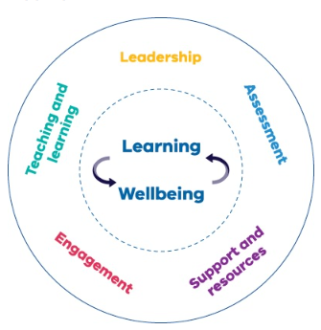
Framework for Improving Student Outcomes (FISO 2.0)
Assessment is an integral part of the teaching and learning cycle. The Insight Assessment Platform provides support to schools to strengthen the assessment of student learning. FISO 2.0 sets out 5 cores elements that together realise the goals of excellence and equity through developing the learning and wellbeing of every Victorian student. ‘Assessment’ is identified as one of the 5 core elements that make the most difference to student outcomes.
For more information please visit the Department’s Framework for Improving Student Outcomes 2.0 policy.

