Insight assessment platform
User guide: Step-by-step guidance on using the Mathematics Online Interview (MOI)

Logging in
- Navigate to the Insight Assessment Platform on the Victorian Curriculum and Assessment Authority (VCAA) website: https://www.vcaa.vic.edu.au/assessment/f-10assessment/insight/Pages/login.aspx
- Read the privacy statement and click the DET button at the bottom of the page.
- Use your Department User ID (TO number) and password to log in.

Assigning an MOI assessment to your students
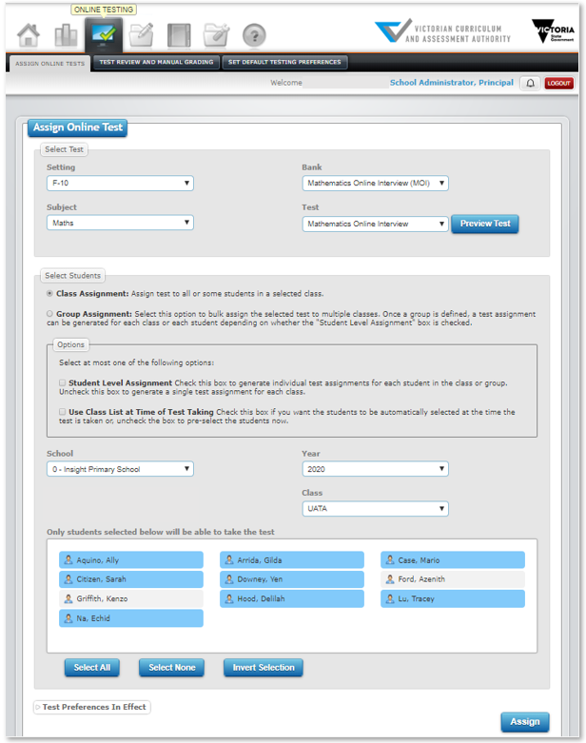
To assign an MOI assessment to some, or all, of your students:
- Go to Online Testing > Assign Online Tests.
- In the Select Test section, complete:
  - Setting: F–10.
  - Subject: Maths
  - Bank: Mathematics Online Interview (MOI)
  - Test: Mathematics Online Interview
- In the Select Students section:
  - Select Class Assignment.
  - Select a Class if you have more than one. Your students are automatically brought into Insight and attached to you via CASES21. If you are attached to more than one class, each student list will appear when you select the corresponding class.
- Options: You do not have to choose an option.
  - Student Level Assignment creates an individual test code for each student (this is used for student-led assessments and is not recommended for MOI).
  - Use Class List at Time of Test Taking assigns the entire class to the assessment, including students who join your class at a later date. The student list will disappear if you select Use Class List.
- If you do not choose Use Class List, select the students you would like to assign the assessment to by clicking on their names to select (blue) or deselect (grey) them.
Important: You do NOT need to assign a different test code to each student in your class. You can assign an MOI module to multiple students from a class at the same time and when you click on the test code you created, all the students you selected will appear in the Test Taker list.
- Click Assign. This will create a single test code for the students you selected.

About test codes
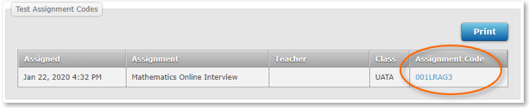
When you assign an assessment, a unique test code is automatically generated and appears at the bottom of the Assign Online Test window and in Test Review and Manual Grading under the Online Testing tab.
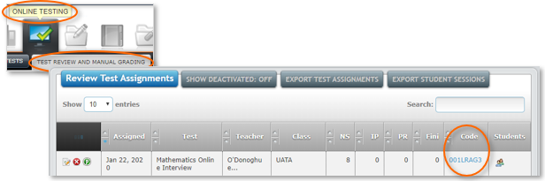
When you log out of Insight and log back in, your previously assigned assessments will only be listed in Test Review and Manual Grading.
Review = view the responses for each student’s assessment.
NS = Not Started
IP = In Progress
Fini = Submitted
Mouse over numbers to see associated students.

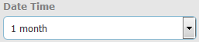
Tip: If you assigned your assessment a while ago, you may need to adjust the Date Time filter for it to appear in the list.

Conducting the Interview in the test taker

Kits
MOI uses a kit during the interview. The equipment required for each page of questions are on the left of the interview window. For the kit checklist, see: https://www.education.vic.gov.au/school/teachers/teachingresources/discipline/maths/assessment/Pages/mathsassess.aspx
Suppliers that provide the full kit may be difficult to locate. Schools may print the resources required for each kit and purchase any manipulables needed.

Undertaking MOI
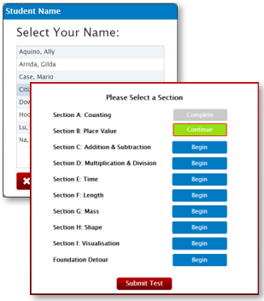
To undertake MOI:
- Click on the test code (it is hyperlinked) to open the Test Taker, OR, go to https://test.linkitau.com and enter the test code.
- You will see the list of students you assigned to the MOI assessment. Click on a student’s name and click Select to begin their assessment.
- After selecting a student to assess, you will be given the option of which section to start or continue from.
- MOI will guide you through which questions to answer in each section and prompt you to select another section or submit the assessment at certain points, depending on the student’s responses or completion of a section.
- Click the Submit icon to submit the assessment. The student’s data and reporting analytics will only appear when the assessment has been submitted.

Test Taker navigation
Arrows: Click the forward arrow to save the responses and move to the next page, or the back arrow to return to previous questions. If the arrow background is grey, there are still questions on the page requiring a response.
Speech bubble: Indicates instructions to be read to the student.
Pause: Click if you need to temporarily halt an assessment. Closing the test window will also pause the assessment. Results only appear in the data analytics once the assessment is submitted.
Tools: Basic accessibility tools to help when assessing, such as zoom.
Test Sections: Shows a list of the sections and
Submit: Finalises the assessment. The student’s data for the assessment will not appear in Reporting until Submit is clicked.

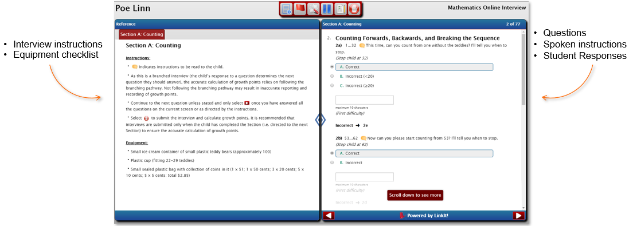

MOI was updated for 2020 to provide teachers with a clearer pathway through the questions. Questions that are conditional upon previously answered questions will have their responses greyed out until required. This also reduces visual clutter as some instructional text is no longer required.
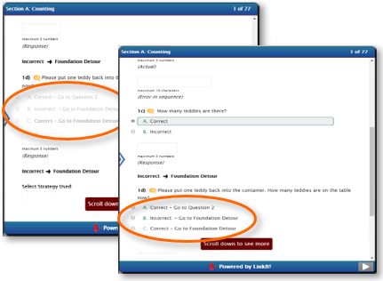
For example, Q1d should only be asked/answered if the student correctly answers Q1c. Until then, the question will have its responses greyed out.
If the student correctly answers Q1c, Q1d will no longer be greyed out and a response can be entered.
The Save and Continue arrow will turn red .

Tip: MOI is an ongoing assessment, but needs be submitted each time the student is assessed to generate data analytics and reporting. If you would like to administer MOI a student several points during the year, assign the MOI assessment to them again and use the new test code to assess them. This is different to pausing an assessment, which is a temporary halt, e.g. for lunch.

Data analytics and reports
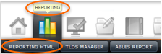
To access MOI data analytics and reporting, go to: Reporting > Reporting HTML

TIP: Use the Breadcrumb trail at the top of the screen to navigate around the Dashboard. It shows you where you are, and you can click back to prior windows.
Summary
What it shows | Number of student assessments and percentage distribution across growth points for your students within a given timeframe.
How to access | 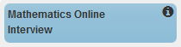  - On the Teacher Dashboard, drag and drop MOI into the viewing area below to see summary data.
Tips | - Alter the time period covered by clicking on the Set Date Range icon and adjusting the dates.

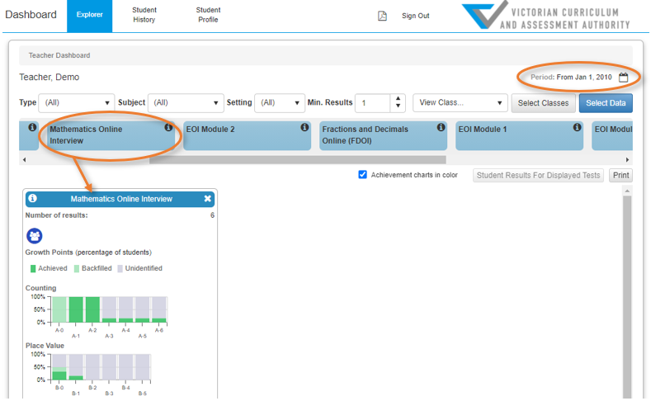

Class Profile, including Foundation Detour
What it shows | Growth points achieved and achieved by backfill for each student. Foundation Detour shows students’ responses if they have undertaken the Foundation Detour.
How to access | - In the MOI Summary report, click theClass Profile icon .  - Select a class.
Tip | - Select Show Dates to view the date the growth point was achieved.  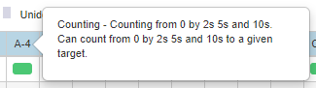  - Mouse over the column headers to view information about the growth point or Foundation Detour question.

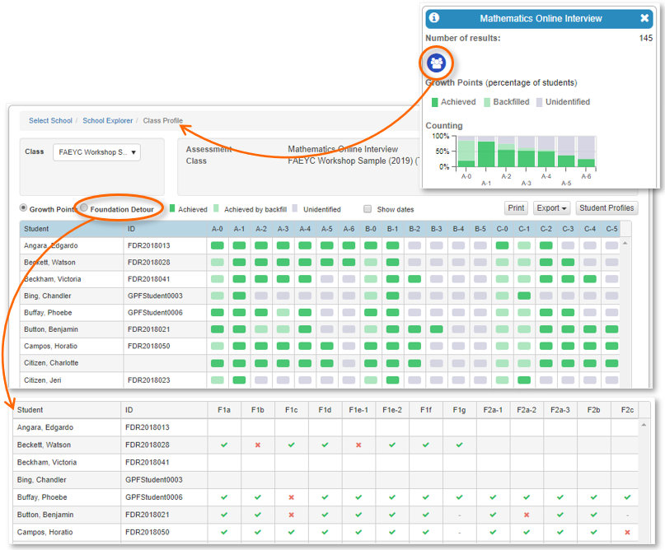
Student Profile
What it shows | Shows growth points achieved and growth points achieved by backfill for each student and the date they were achieved.
How to access | - In the MOI Summary report, click theClass Profile icon .  - Click Student Profiles and select a student.

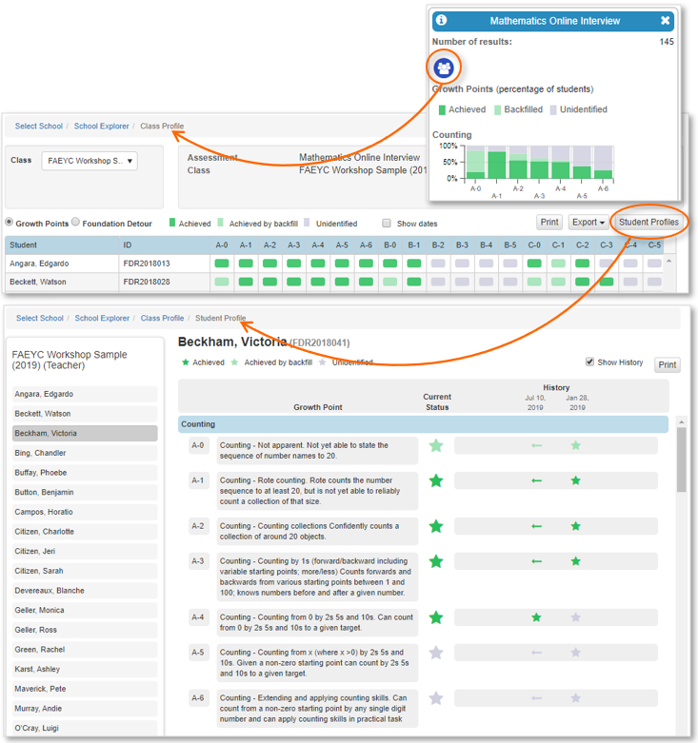
Student History
What it shows | Individual student assessment history for your current students
How to access | Click Reporting > Reporting HTML > Student History
Tips | - Click Select Tests to filter results to MOI only  - You can Print Current Student or Batch Print Class. If you Batch Print, the PDF icon will turn green when the PDF is created. Click the PDF icon, select the report and click Open to view the PDF.

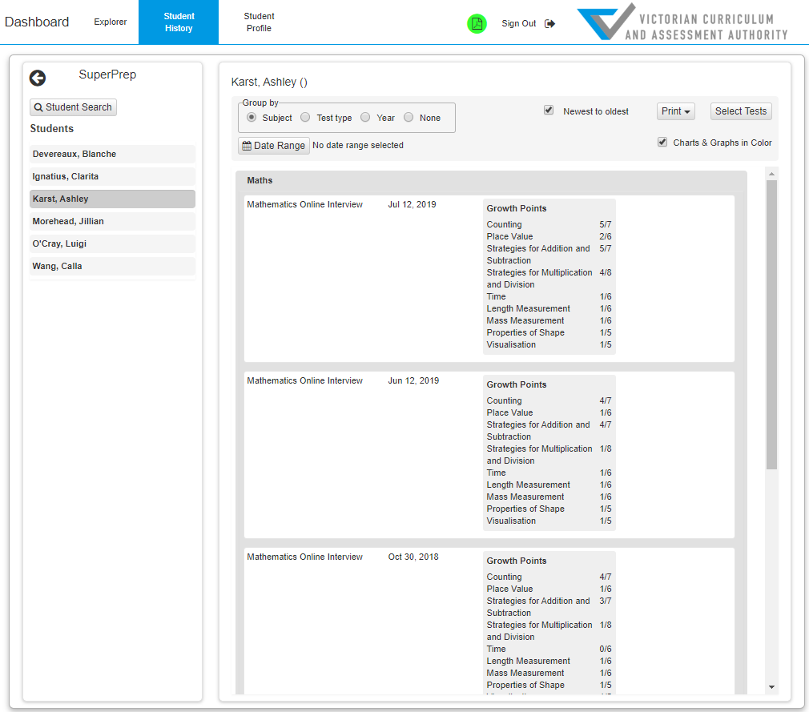

Printing reports
Browsers are not always set up to print background colours and images. If you notice that there are no data graphics in a report when you print it or save it as a PDF, your browser settings may need changing.
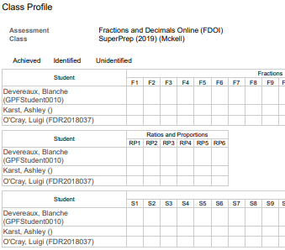
In Chrome, the Background graphics checkbox appears in the print window:
- Once you click on Print, the print window will open, click on More settings.
- Tick the Background graphics checkbox.
In Edge, the Background graphics checkbox appears in the print window:
- Once you click on Print, the print window will open, click on More settings.
- Tick the Background graphics checkbox.
In Firefox, background printing can be set up as a default setting in the browser:
- Click File > Page Setup.
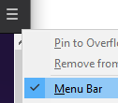
- Format & Options > Tick the Print Background (colours & images) checkbox.
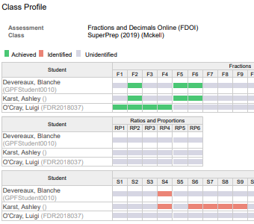
* If you can’t see File, you might have the browser menu hidden. Right-click on the hamburger in the browser’s top right corner and select Menu bar.

In Safari, the Background graphics checkbox appears in the print window:
- Once you click on Print, the print window will open, click on More settings.
- Tick the Background graphics checkbox.

In Internet Explorer, background printing can be set up as a default setting in the browser:
- Click File* > Page Setup.
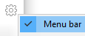
- Tick the Print Background Colours and Images checkbox.
*If you can’t see File, you might have the browser menu hidden. Right-click on the cog in the browser’s top right corner and select Menu bar.

Further support

Resources
- VCAA Insight Assessment Platform: www.vcaa.vic.edu.au/assessment/f-10assessment/insight/Pages/login.aspx
- DE MOI information and resources: https://www.education.vic.gov.au/school/teachers/teachingresources/discipline/maths/assessment/Pages/mathsassess.aspx
- Insight support on FUSE: https://fuse.education.vic.gov.au/pages/insight
- Insight workshops and training: https://arc.educationapps.vic.gov.au/eventhub/providers/AssessmentImpl

For technical assistance
If you have a technical issue you cannot resolve, escalate it to your School Assessment Administrator. By default, your school’s Administrator is your principal. Principals can nominate other people in your school to have the Administrator role as well. If the Administrator cannot resolve the issue, contact the Service Desk:
- Services Portal: services.educationapps.vic.gov.au/dp
- Email: servicedesk@education.vic.gov.au
- Phone: 1800 641 943.

For training and professional learning queries
- Student Learning Email: studentlearning@education.vic.gov.au

