Insight Assessment Platform
  - Steps to display a class profile with historical data (prior to 2017)

- Click on Reporting, then click Reporting HTML. | 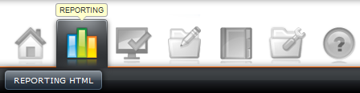
- Alter the time period displaying results by clicking on the calendar icon. | 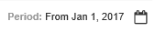
- Use the calendar under the word From to track back to the when the student results would have been achieved, e.g. if the student is in Year 2 in 2017, select 1 January 2015.  - The checkbox Any date can be left as checked unless a more specific range is required.  - Click OK. | 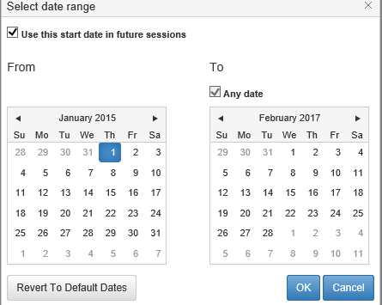
- Select the teacher of the 2017 class using the drop down menu View Teacher.  *Depending on your role in the school, you may not need to complete this step. | 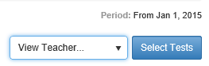
- Select the name of the 2017 class using the drop down menu View Class. | 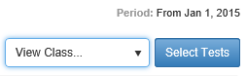
- De-select the checkbox Restrict to tests taken in this class.
- Click on Select Tests. | 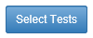
- Select the option MOI – Historical Data by clicking on the checkbox. | 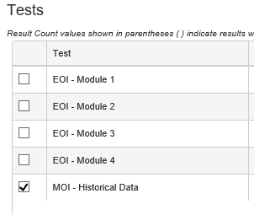
- Click on View Summary Results. | 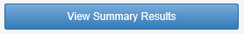
- Scroll down to the bottom of the Summary Results graph. | 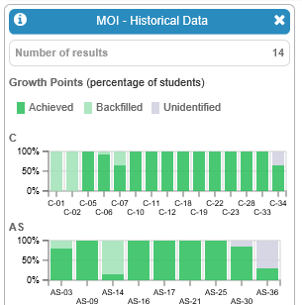
- Click on the Class Profile icon.
- The Class Profile view is displayed. This indicates the points of growth achieved (dark green), achieved by backfill (light green), and not achieved (grey). Select the Show dates check box to display when the point of growth was achieved. For further information on analysing the data to determine a starting point, please refer to Mathematics Online Interview: Starting points for subsequent assessments: http://www.insight.vic.edu.au/insight-platform/insight-platform-support
- For more detailed information regarding the points of growth achieved for each student, click on Student Profiles. | 