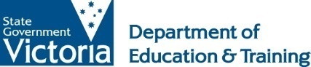
IN-COUNTRY INDONESIAN Language COURSE
Approved language course providers

Teachers must select a course from the following Approved Language Course Providers.

Course/Institution Name | Institution Website
Australian Consortium for 'In-Country' Indonesian Studies (ACICIS) - Indonesian Language Short Course, Salatiga | http://www.acicis.edu.au/programs/tour/indonesian-language-short-course-ilsc/
Indonesian Language and Culture Learning Service (INCULS), Universitas Gadjah Mada, Yogyakarta | http://www.ugm.ac.id/id/akademik/3544-inculs
Indonesia Australia Language Foundation (IALF), Jakarta | https://www.ialf.edu/learningindonesianinjakarta.html
Balai Bahasa Universitas Pendidikan Indonesia, Bandung | http://balaibahasa.upi.edu/services/language-course

