  - Interacting and relating with others through the image

Students learn that authors of images make visual design choices to build relationships and interactions between the participants in the text. These text participants are: the author, the audience, and the subject/s (characters in a literary text, or the main things/objects in a factual text).
The author also makes visual design choices to express knowledge, skills, trustworthiness, power and status, attitudes, feelings, and opinions. For example, the author makes visual design choices which can establish a particular attitude or point of view about the topic or subject, and tries to align the audience with this position.
For each question, ask students to expand on their responses by explaining reasons w hy, and encourage them to use evidence from the image to justify their responses, using visual design metalanguage.
- As the audience, how are you positioned to see and interact with the subject/s in this image?
  - Who are you positioned to see this image as? (focaliser)
  - How close or far away is the subject to you? (social distance)
  - Is the subject looking directly at you or away from you? (gaze)
  - Is the subject turned towards or away from you?
  - Does the subject appear to have the same level of power, as you, more power, or less power, in this interaction?
- How do these design choices affect how you feel about the subject/s and what is happening in this image?

Focaliser
The focaliser is how the author has chosen to position how the audience 'sees' the subject and action in the image (O’Brien, 2014). It is also known as point of view. The focaliser options for designing how the audience sees events are: direct as viewer [yourself]; or to see events mediated through a character, either as a character [first-person]; or alongside a character (Painter, Martin, Unsworth, 2012).
The following general discussion prompts are intended to develop student knowledge of these options for choice of focaliser in an image or visual text, and the possible impact this might have the viewer.
Students are encouraged to examine the choice of focaliser in each image, and to consider how this affects viewer alignment with characters.
Discussion prompts:
How are you positioned to see this image? Is it direct to you ? Or is it mediated through a character? How do you know? What evidence is there in the image to support this?
How does this choice of focaliser affect how you feel about these characters, or this subject, and what is happening to them? Do you feel more closely aligned to one character? Why do you think the author made this choice of focaliser for this image? If you changed the focaliser, for example from direct 'as viewer', to 'as character', or vice versa, how do you think this might change your feelings about, or response to, what is happening in this image?

Direct as viewer
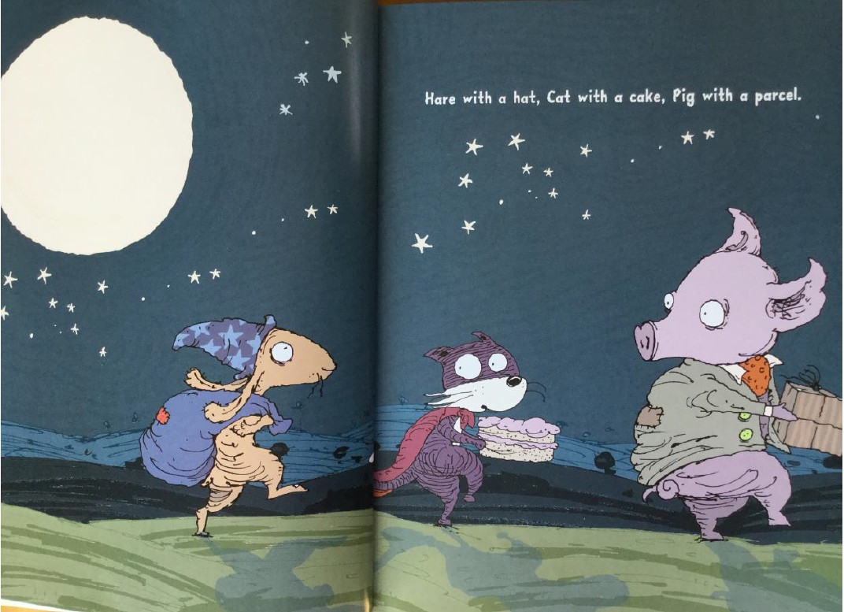
Direct as viewer is the most common choice of focaliser. The viewer is positioned as an outsider looking in at the events and actions within the image. Everything is laid out for you to see.
From Scary Night by Lesley Gibbes and Stephen Michael King
Copyright © 2014, Adelaide SA: Working Title Press

Mediated focaliser: as character
Focalising as a character shows what the character can see, as if through a character's eyes. This is designed to align the viewer more closely with the focalising character. Focalising as a character means that your view point is restricted to see only what this character can see.
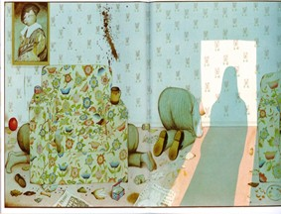
Focalising as a character can be inscribed through use of the focalising character’s shadow as in the example from Piggy Book by Anthony Browne below. Here, the reader understands that we are positioned to see this scene through the eyes of the mother. This meaning is inscribed by the mother's shadow which indicates she is standing exactly where we, as the viewer, are positioned. In this image, the shadow also creates a strong vector leading the eye into the image. Other options for an inscribed 'as character' focaliser, include showing a body part from the focalising character, for example, a hand on a door handle, or stretching out in the foreground of the image.
From PIGGY BOOK by Anthony Browne
© 1986 Anthony Browne
Reproduced by permission of Walker Books Australia Pty Ltd
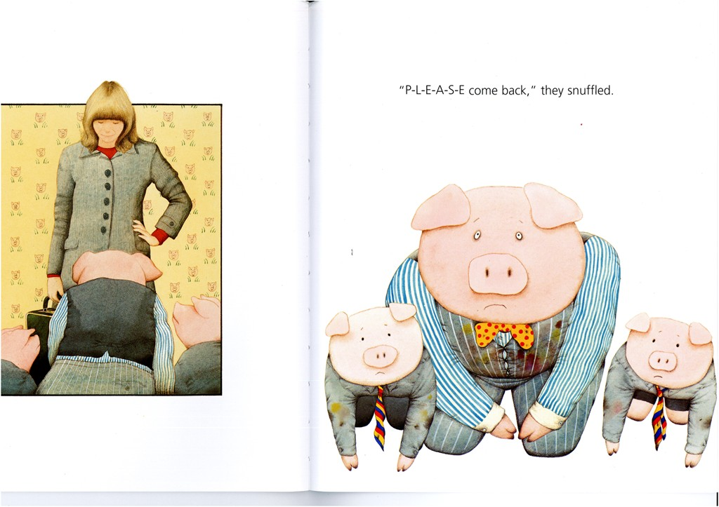
Focalising through the eyes of a character can also be inferred across a sequence of two images. For example, in the double page spread from Piggy Book below, the subjects are introduced in the first image. We see the mother facing towards us, and the father pig and the two sons have their backs to us, facing her. In the following image we are now positioned to look directly at the pigs who remain kneeling on the ground. Based on what we saw previously, we can infer that we are now positioned as the mother and what we see is now mediated through her eyes. This technique strongly aligns the viewer with the mother in this example.This is a shot, reverse-shot technique.
From PIGGY BOOK by Anthony Browne
© 1986 Anthony Browne
Reproduced by permission of Walker Books Australia Pty Ltd

Mediated focaliser: along with character
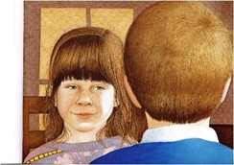
The other option for a mediated focaliser is to position the viewer to see events from just behind or close beside a character. As seen in the example below from The Tunnel by Anthony Browne, this option allows the viewer to see exactly what the focalising character (the boy) sees, but not directly as him. This technique aligns the viewer with the boy. This can be described as an over-shoulder view.
From THE TUNNEL by Anthony Browne
© 1989 Anthony Browne
Reproduced by permission of Walker Books Australia Pty Ltd

Social Distance
Social distance is the distance between the viewer/focaliser and subject. How close or far away is the subject shown from the viewer? Social distance is measured on a continuum from extremely close, to extremely remote. This is based on how comfortable we generally feel with people being close to us, in real life situations.
The following general discussion prompts are intended to develop student knowledge of these options for choice of social distance in an image or visual text, and the possible impact this might have the viewer, and the type of interaction created between the viewer and the subject.
Students are encouraged to examine the choice of social distance between the viewer and the subject in each image, and to consider how each design choice affects viewer connection to, and alignment with characters.
Discussion prompts:
How are you positioned to see this image? Is the subject close or far away? How does this choice of social distance affect how you feel about these characters or this subject, and what is happening? Why do you think the author made this choice of social distance here? If you changed the social distance in this image, for example from close to public, or remote, or vice versa, how do you think this might change your feelings about, or response to, what is happening in this image?

Close social distance
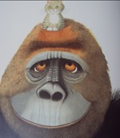
If the subject is shown to be very close to you, it takes up most of the frame, and you can only see part of the subject. As seen in the example from Little Beauty by Anthony Browne below, a close framing of the subject is created through a close-up. A close-up can imply a close, intimate and familiar relationship with the subject. This can be comfortable if you like the character, but might be confronting if the character is a bully for example.
From LITTLE BEAUTY by Anthony Browne
© 2008 Brun Limited
Reproduced by permission of Walker Books Australia Pty Ltd

Mid social distance
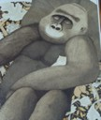
This is where the subject is quite close to you. As shown in the second image from Little Beauty below, we are positioned quite close to the subject, we can see the half or most of the subject’s body in the frame, and a little bit of the setting. This is considered a friendly distance as in real life, we would be close enough to touch each other and talk. This framing of the subject is created through a mid-shot.
From LITTLE BEAUTY by Anthony Browne
© 2008 Brun Limited
Reproduced by permission of Walker Books Australia Pty Ltd

Group social distance
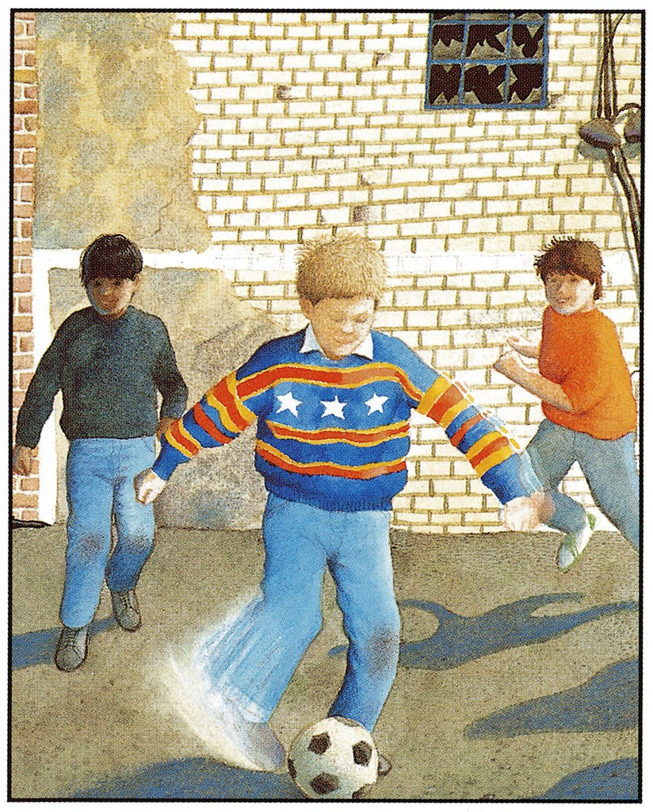
When you can see the character’s whole body, and perhaps other characters, and more of the setting, this indicates that the subject is further away from you. This is a group social distance where you are positioned to be part of a larger group. As evident in the image below from The Tunnel by Anthony Browne, we are positioned close enough to feel involved with these boys and their ball game, but it is less personal. This framing of the subject is created through a mid-long shot.
From THE TUNNEL by Anthony Browne
© 1989 Anthony Browne
Reproduced by permission of Walker Books Australia Pty Ltd

Public social distance
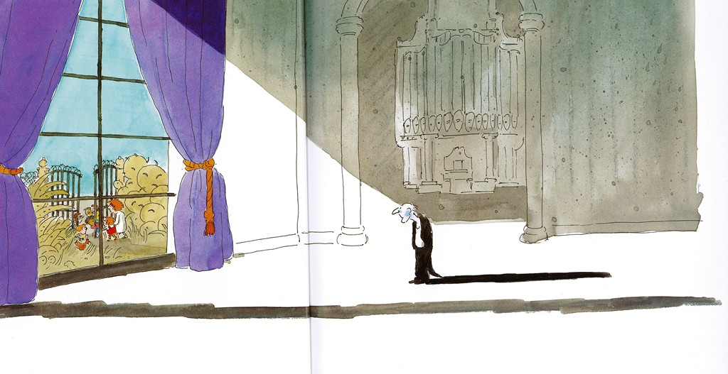
The further a subject is positioned away from you, the less connection you feel, and subjects therefore appear like strangers. We are too far away to easily talk to the subject. In the example below from Rose meets Mr Wintergarten by Bob Graham, Mr Wintergarten is small and distant, and Rose and her family are even further away outside the window. As the subjects become further away, and therefore smaller, the setting becomes more dominant. The framing of the subject at this distance is created through a long shot.
From ROSE MEETS MR WINTERGARTEN by Bob Graham
© 1992 Blackbird Design Pty Ltd
Reproduced by permission of Walker Books Australia Pty Ltd

Remote social distance
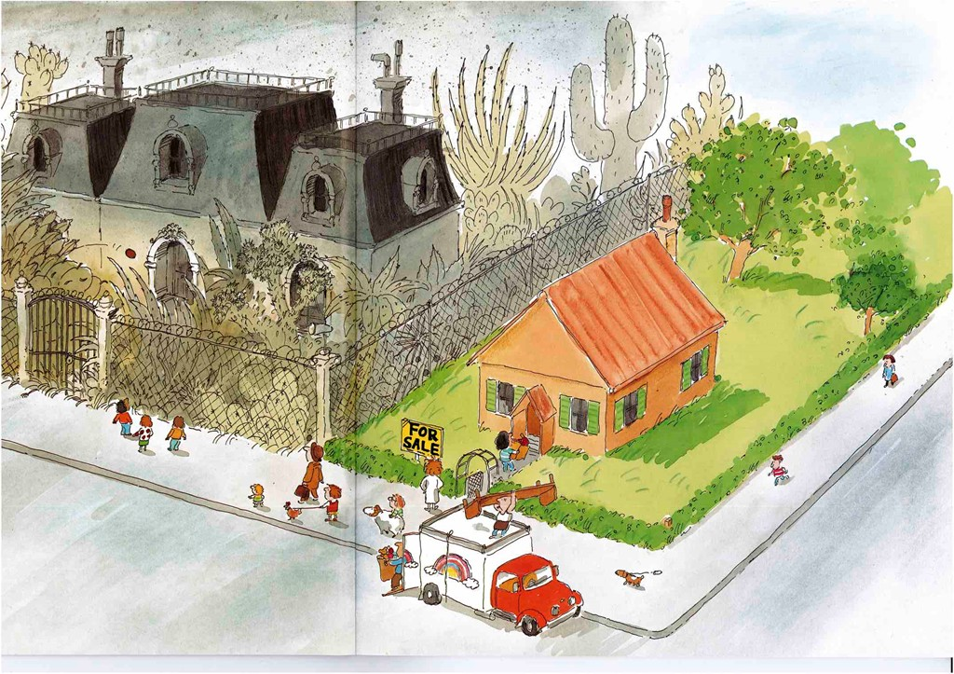
When the subject is positioned a very long way away from you, the subjects are tiny and hard to recognise in the vast setting. This remote social distance means there is no opportunity for social interaction. This remote framing of the subject is created through an extreme long shot. This is shown in the example below from Rose meets Mr Wintergarten by Bob Graham. This image from the front of the book, shows the setting in detail, but the subjects are tiny and a very long way from the viewer. There is no social connection possible.
From ROSE MEETS MR WINTERGARTEN by Bob Graham
© 1992 Blackbird Design Pty Ltd
Reproduced by permission of Walker Books Australia Pty Ltd

Subject Gaze
There are only two options for subject gaze: direct gaze, or no-gaze.
The following general discussion prompts are intended to develop student knowledge of these options for choice of gaze from a subject in a visual text, and the possible impact this might have the viewer.
Students are encouraged to examine the use, or not, of direct subject gaze in each image, and to consider the impact of this on the nature of the interaction between the character and the viewer, and how this affects viewer alignment with, and connection to characters.
Discussion prompts:
Is the subject looking directly at you? How does use of subject gaze, or no gaze, affect how you feel about this subject and what is happening? Why do you think the author made this choice ? If you changed this image so the subject now gazes directly at you, or the subject now looks away ignoring you, how might this change your feelings about, or response to, this subject and what is happening?

Direct Gaze
When the subject gazes directly at the viewer, this simulates eye contact and positions the viewer as a participant in the interaction. Direct subject gaze, such as seen in the Piggy Book example below, where the three pigs are looking directly at the viewer, demands the viewer’s attention and for us to share the experience. Subject gaze creates a connection between the subject and the viewer, simulating a powerful personal connection. This has even more impact on the viewer if combined with a close social distance such as in this example.
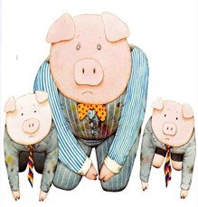
In this example, the direct gaze is mediated to the viewer through the mother, as we are seeing this through her eyes, as discussed above. This strengthens the alignment of the viewer to the mother's perspective in this story.
From PIGGY BOOK by Anthony Browne
© 1986 Anthony Browne
Reproduced by permission of Walker Books Australia Pty Ltd

No gaze
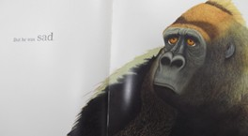
This is the most common type of image. As seen in the image from Little Beauty by Anthony Browne, below, the subject’s eyes are turned away from the viewer. This positions us as an observer to what is happening, the subject does not acknowledge the viewer and we are kept outside the story world.
From LITTLE BEAUTY by Anthony Browne
© 2008 Brun Limited
Reproduced by permission of Walker Books Australia Pty Ltd

