  - Rhyme Awareness & Production
The adapted diagram below shows rhyme awareness and production is positioned second on the continuum of phonological awareness skills.
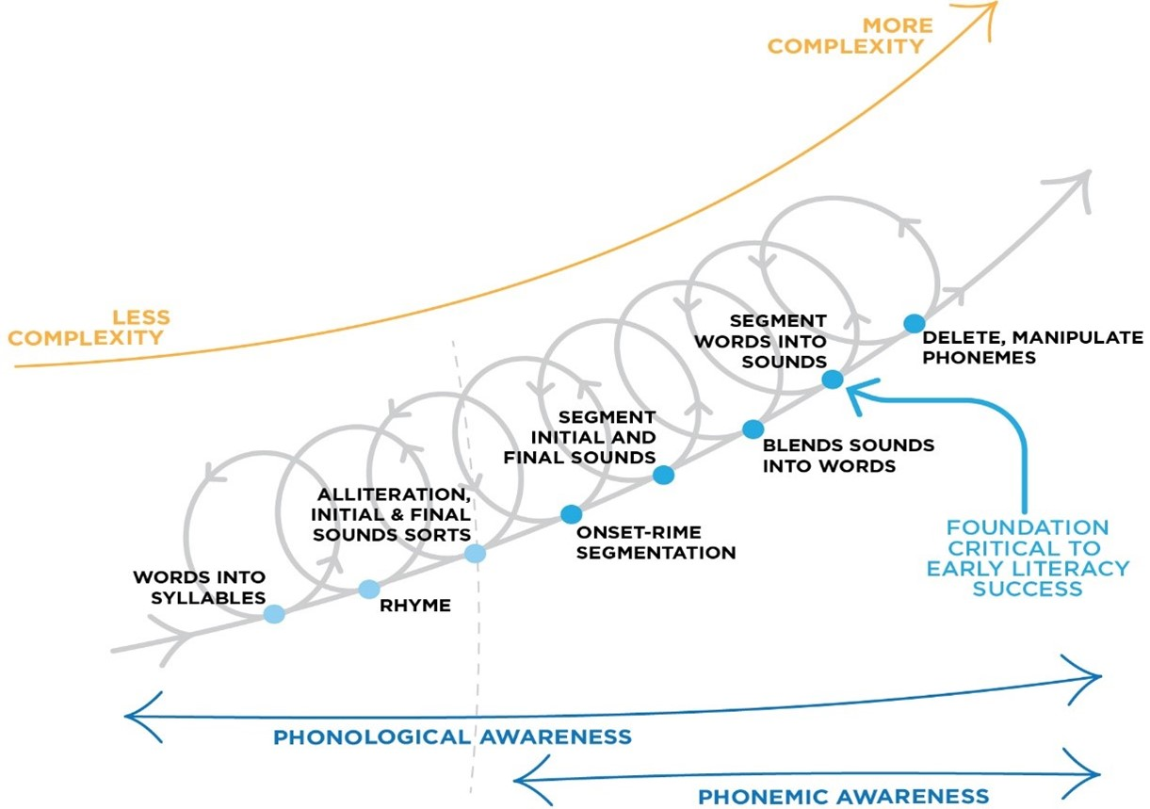
Rhyme awareness is another important phonological awareness task, referring to the awareness of words that rhyme and words that do not rhyme.
For example, children with rhyme awareness would be able to identify the rhyming words from this group below.
The teacher and students would say the words "cat" "hat" and "tap", and students would identify "cat" and "hat" as the rhyming words. NB. Seeing the spelling (or reading) of these words is not required to focus on phonological awareness here. But the written word could also be used to make this activity a phonics activity as well.
Rhyme production refers to the ability for students to think up words that rhyme with a given word, and is also an important phonological awareness task.
For example, students would be asked to hear the rhyme in the words below (students and teacher would say "hand", "band" and ….)
and the student would come up with another rhyming word, like "sand"
Some rhymes are more complex than others, with more complex syllable types, and numbers of syllables in the rhyme
For example, the following words have multiple syllables in the rhyming part of the word:

One Syllable Rhyme  (with syl.la.ble breaks) | Two Syllable Rhyme  (with syl.la.ble breaks) | Three Syllable Rhyme  (with syl.la.ble breaks)
cop  top  mop  stop  drop  teak  seek  peek  streak  sneak  leak  bleak  u.nique*  *In all these words except unique, the words are divided into the onset and rime (underlined above). In the case of unique there is an extra syllable before the rhyme. | na.tion  sta.tion  dal.ma.tian  dic.ta.tion  fru.stra.tion  lo.ca.tion  al.ter.na.tion  cal.i.bra.tion  can.cel.la.tion  sca.ry  va.ry  wa.ry  hai.ry  fai.ry  ca.na.ry  cul.in.a.ry  mon.e.ta.ry  nec.e.ssa.ry | bar.ba.ri.an  Bul.ga.ri.an  ve.ge.ta.ri.an  e.gal.i.ta.ri.an  se.ri.ous  del.i.ri.ous  mys.te.ri.ous  del.e.te.ri.ous

Teachers can incorporate rhyme awareness into many incidental and planned activities, as well as formal teaching practices, such as Modelled, Shared and Guided Reading.

References
Diagram above adapted from Schuele & Boudreau (2008). Phonological Awareness Intervention: Beyond the Basics. Language, Speech, and Hearing Services in Schools 39, 3-20.

