  - Segmenting words into sounds
The adapted diagram below shows segmenting words into sounds is the fourth skill contributing to phonemic awareness. Phonemic awareness is an important sub-set of phonological awareness because it has a reciprocal relationship with reading (Hoover & Tunmer, 2020, p. 66).
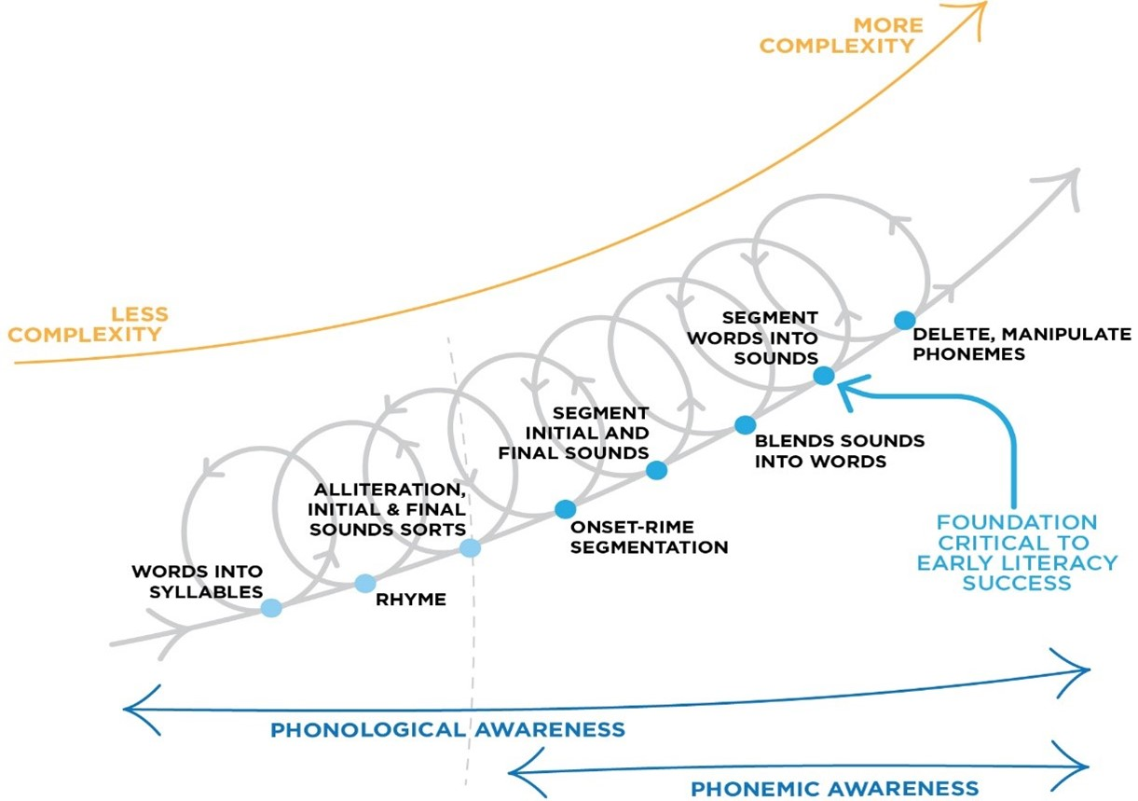

Segmenting words into sounds is the reverse process of blending sounds into words, and involves the breaking up of words into their component sounds (phonemes). This process can be seen in the example below.
- A whole word would be spoken (by a teacher or the student - using a picture stimulus):
- The student would be asked to hear each individual sound in the word, or teachers could model this segmentation:
- Counters can be used (or student can count on their hand) to count the phonemes in the word.
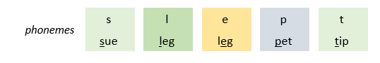
- The student has identified that there are five sounds (phonemes), including two consonants, a vowel, then another two consonants
5 Phonemes
2 x Consonants 1 x Vowel 2 x Consonants

Segmenting words into sounds can also be used in writing activities. When children know a word they want to spell, then can break the word down into its sounds (phonemes), then think of the potential graphemes to use to spell each word. This is shown in the example below:
- The student thinks of the word they want to write:
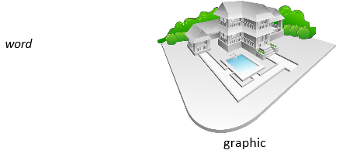
- The student segments the word into its syllables, and phonemes (using their hand or counters)
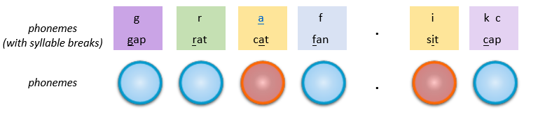
- The student thinks of the graphemes that could map onto the phonemes and chooses the most likely graphemes
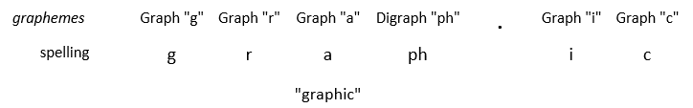
6 Phonemes/Graphemes

A particularly useful activity is using sound boxes. These involve providing pictures of words, and asking students to place a counter in a box for each sound they can hear. See the below examples.
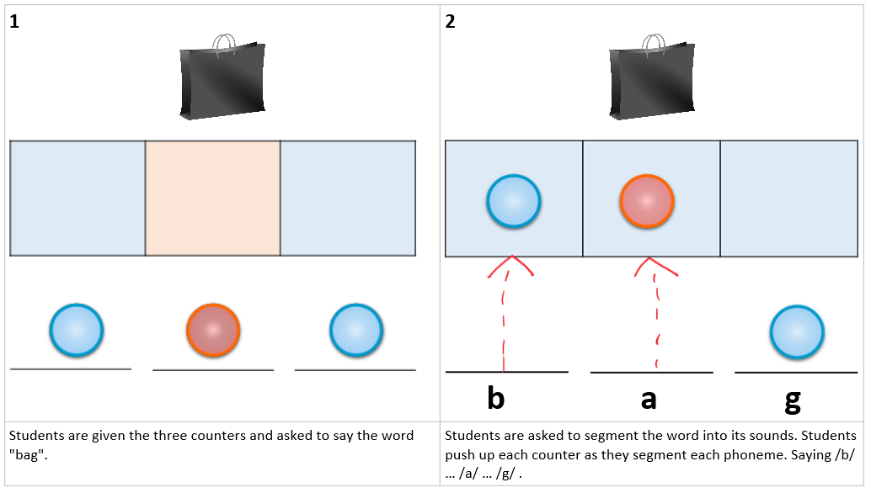
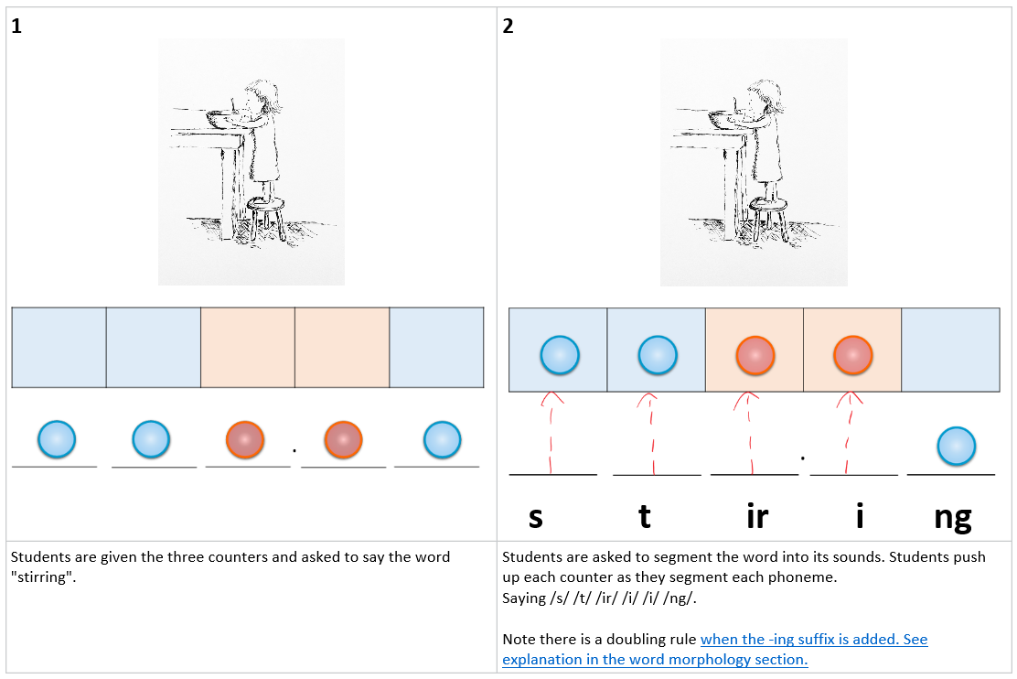

References
Hoover, W. A., & Tunmer, W. E. (2020). The cognitive foundations of reading and its acquisition: A framework with applications connecting teaching and learning. Cham: Springer.
Diagram above adapted from Schuele & Boudreau (2008). Phonological Awareness Intervention: Beyond the Basics. Language, Speech, and Hearing Services in Schools 39, 3-20.

