  - Initial and final sound segmentation
The adapted diagram below shows initial and final sound segmentation. It is the second skill contributing to phonemic awareness. Phonemic awareness is an important sub-set of phonological awareness because it has a reciprocal relationship with reading (Hoover & Tunmer, 2020, p. 66).
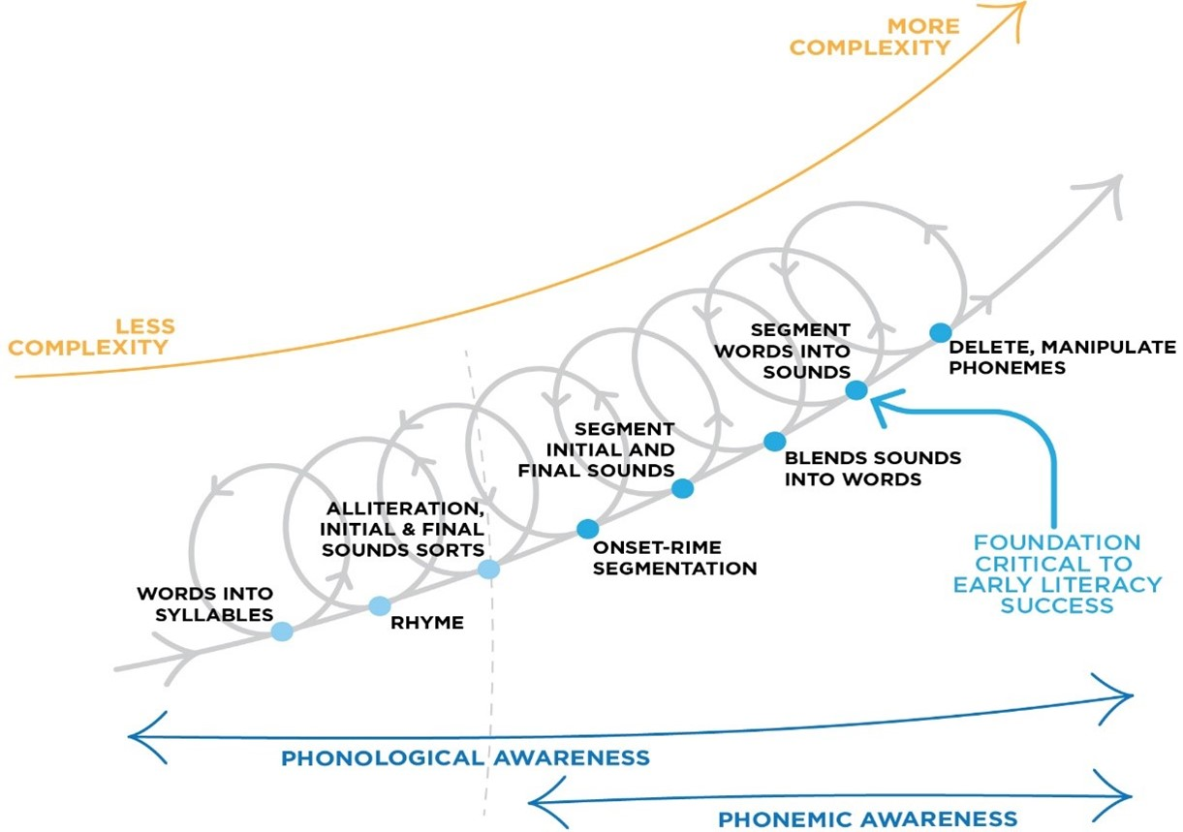

Finding and naming the initial and final sounds of words is an important phonemic awareness activity. This a more sophisticated version of alliteration activities, that requires children to identify and name the initial or final sounds in words, rather than just sort words according to their initial sound.
For the examples below, to demonstrate abilities in initial sound identification, children would successfully identify the initial sound of pillow and pancake as the /p/ sound (as in pet), and phone and physical as /f/ (as in fan).
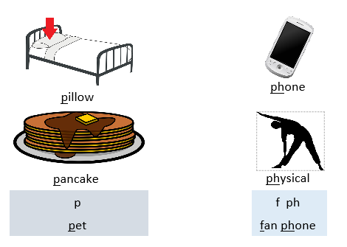
Similarly, to demonstrate abilities in final sound identification, children would successfully identify the final sound of bat, cat, and slept as the /t/ sound (as in tip), and bad, heard, and glide as /d/ (as in dip).
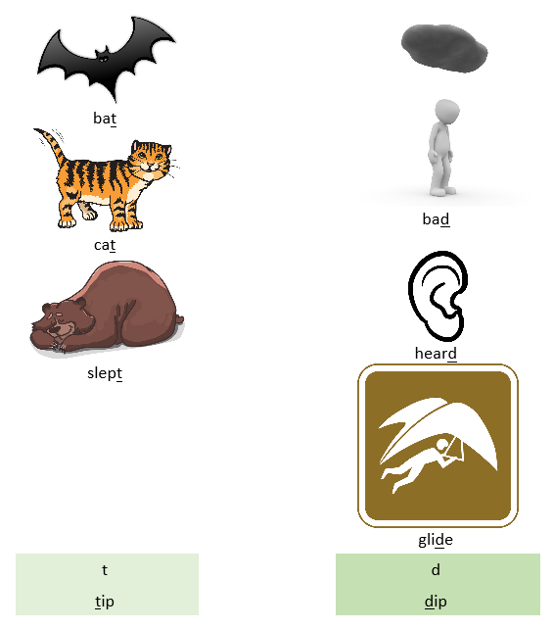

Remember that identifying the initial or final sounds is different from the first or last letter. For the examples below, students would need to identify the initial sounds in these words as /s/ and /sh/ respectively.
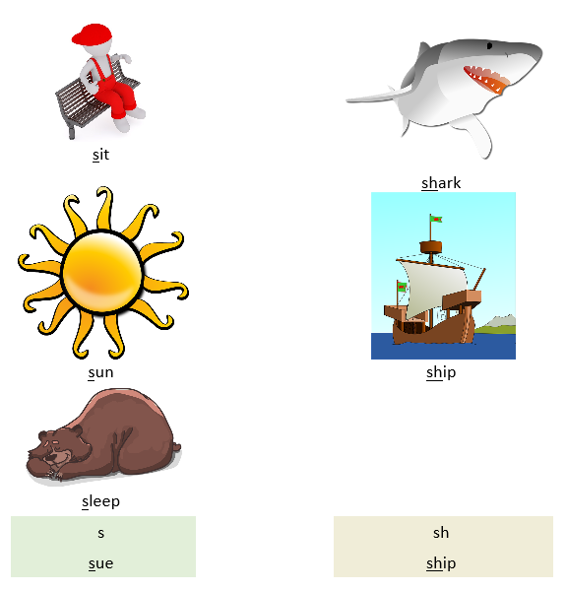
References
Hoover, W. A., & Tunmer, W. E. (2020). The cognitive foundations of reading and its acquisition: A framework with applications connecting teaching and learning. Cham: Springer.
Diagram above adapted from Schuele & Boudreau (2008). Phonological Awareness Intervention: Beyond the Basics. Language, Speech, and Hearing Services in Schools 39, 3-20.

