  - Comprehension Example Lesson: Inferential Comprehension

Reading Model Text Participant/Text Analyst
Lesson Configuration Whole-Part-Whole: Modelled reading-Independent reading-Reflection
Lesson Two Learning Intention We are learning the strategy of asking and answering questions as we read to help us understand what we read.
Success Criteria I can ask and answer at least one inferential question as I read to help me check for understanding. I can write the inferential question on a post it note and share the answer with the class at the end of the lesson.
- Introduce the learning intention and the success criteria for the lesson.
  - Today we are learning about a strategy that can help us understand what we read. As we read we can ask ourselves questions to check that we have understood. Today I am going to show you how to ask and answer an inferential question as I read. Inferential questions ask us to look carefully at the text and the images (we call these ‘text clues’) and then match with our background knowledge of the topic to help us make an inference. I will use this anchor chart to help me ask some inferential questions. Refer to an anchor chart displayed so all students can view it. It will have the inferential question stems listed. See: Comprehension
  - After I have shown you what to do, you are going to read independently. As you read I want you to check for your own understanding. You can do this by asking yourself an inferential question and then thinking about the answer. You can look at the anchor chart to help you think of a question. You will know if you are successful at asking and answering an inferential question if you can write your question on a post it note and stick it on the page where you found the text clues. At the end of the session, you need to share your question and answer with each other.
- Reread the picture story book Refugees (David Miller, Lothian Books an imprint of Hachette, 2005). Model the strategy
  - The story does not tell us directly why the swamp and the island have gone. I will have to ask myself an inferential question about that to help my understanding.
Refer to the anchor chart for an inferential question stem. Write the question on a post it note.
    - Why has the swamp and island gone?
Refer to the relevant text clues: pictures of large machinery such as front end loaders and excavators. Place the post it note next to the relevant text clues.
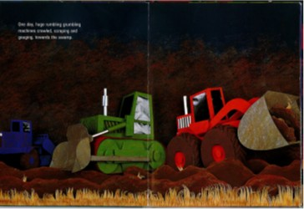
Model tapping into background knowledge e.g. When have I seen front end loaders and excavators? What were they doing? The teacher talks through examples of when they have seen this type of equipment and what they were used for: making new roads, clearing land to build houses, shopping complexes or factories.
The teacher uses the images of the machinery and their background knowledge of what these machines are used for to make an inference that the swamp and island are gone because the land has been cleared to make room for new houses and buildings.
- Continue reading. Model the strategy one more time. The ducks were captured and placed in a box on the back of a truck. Refer to the anchor chart for a suitable question stem. Write the question on a post it note.
  - Can you explain why the ducks were put in a box?
Refer to relevant text clues: picture of a dog and hunters, descriptive words such as “dark box”, picture of a truck.

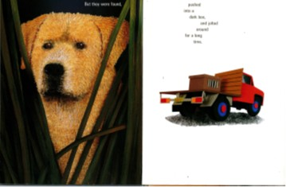
Model tapping into background knowledge e.g. What do I know about duck hunters? What do I know about dogs who go hunting with their owners? What do I know about other people that do not like killing animals? The teacher talks through examples. People shoot ducks for eating and for sport. They use dogs to go and collect the shot birds. Some other people don’t like shooting ducks and protest/try to save animals.
The teacher uses the image of the box on the back of the truck and their knowledge of animal activists to make an inference. I think that the ducks have not been captured but have been rescued instead by animal activists who want them to be safe. I think they are taking them to a new and safe habitat.
- Read the remaining page. Ask students to turn and talk. What inference did they make about the ducks in the box? What were they thinking?
- Revise expectations for independent reading e.g. Sit in one place, select a book from your individual book box and start to read straight away, read quietly for 20 minutes and read for meaning.
- Revise success criteria.
  - To practise this skill, today I want you to look at the anchor chart, find a question stem and ask yourself an inferential question as you read. Write down the question on a post-it note and stick it on the page where you find the text clue. Put your name on the post-it note because I am going to collect them at reflection time. Hand out post-it notes.
  - Be prepared to share your questions and possible answers at reflection time. Last 10 minutes of the session.
- Students read independently for 20 minutes. During independent reading the teacher will work with a small group such as guided reading, or conduct reading conferences and goal setting with individual students.
- Reflection Time-Whole Group
  - Students put their name on their inferential question and bring their book with the post-it note(s) attached to the relevant pages.
  - Ask some students to share their question and answer. Repeat this several times.
  - Collect the questions and stick on a prepared sheet with the heading ‘Inferential Questions’ Display. Use these charts as an assessment record. Who can successfully ask an inferential question? Teacher annotates student records. (See Photo below: Example of questions we can ask to check for understanding).
- Revisit Success criteria. Check if everyone has at least one written inferential question. Clarify students’ understanding of inferential questions. Write a class definition and display.
Going further: Repeat the explicit teaching of asking and answering inferential questions with a range of text types, see: Multiple Exposures: High Impact Teaching Strategy

