Alkira Secondary College
Alkira Secondary College is a single campus Year 7 to 12 coeducational school located in Cranbourne North in Melbourne’s south east. The school has a large proportion of students from culturally and linguistically diverse backgrounds with 30 percent of students speaking a language other than English at home.

Whole school approach to Literacy
Alkira Secondary College has introduced a range of strategic and structural measures to support a whole school approach to literacy and lift student literacy outcomes.

Independent reading program
School leadership, working with their Senior Education Improvement Leader, identified a focus on reading as a priority for the 2017 Annual Implementation Plan (AIP) and introduced a whole school instructional model to support their improvement approach.

University of Melbourne Network of Schools
The college joined the University of Melbourne Network of Schools (UMNOS) to support this focus.
The team driving implementation of the independent reading program included:
- John Shaw, College Principal
- Nalini Naidu, Assistant Principal
- Sharne Winstone, Leading Teacher
- Roz Muscat, Leading Teacher engaged specifically for the UMNOS project
- Alecia Misra, English and Sociology teacher.
Sharne was appointed as an instructional coach to work with school leaders, the network and with the University of Melbourne to support the implementation of agreed professional approaches to teaching and learning. Roz was a leading teacher who had extensive experience in implementing independent reading strategies, including reading conferencing.
The college implemented the independent reading program for Year 7 students in 2018.

Connecting to experts and colleagues
Both Roz and Nalini had developed a strong professional relationship with internationally recognised literacy consultant Di Snowball through their involvement in the UMNOS program at their previous school, Kambrya College. Alkira Secondary College was able to leverage this connection to secure Di Snowball as a critical friend during their implementation of the independent reading program.
The school also connected with the South Eastern Victoria Region’s reading initiative.

Professional learning
The introduction of the independent reading program was supported with four professional learning sessions for teachers in Term 1, 2018. These sessions gave teachers an understanding of the program and outlined clear expectations of what they needed to do in the classroom.

Adjusting the timetable
The college timetable was structured around 75 minute periods with every English class starting with 10 minutes of reading. Roz initially used the first or last 30 minutes of each English class to conduct reading conferences with students. However, scheduling of these conferencing sessions within the timetable was complicated.
School leaders identified through classroom observations across the school in Term 3, 2018 that classroom time was not fully utilised. They proposed a change in the timetable structure, moving to shorter 55 minute periods. A focus group was conducted with parents and staff were asked to provide feedback and vote on the proposed timetable structure. This timetable change meant that from Term 4, 2018, Year 7 and Year 8 students had both English and Maths classes every day of the week providing continuity throughout the week and simplifying the scheduling of reading conferences. In English, four classes each week focused on the curriculum with one class devoted to the independent reading program.

Reading conferences
Each student had an independent reading workbook set up where they could record visual prompts, notes and their own reflections on their progress and use of reading comprehension strategies.
The independent reading workbook included a visual representation of the brain and where different reading strategies fit, as well as reading texts for the student.
At the start of a reading conference, Roz advised the student which particular elements or strategies she would focus and provide feedback on before the student started reading aloud. During the read aloud, Roz prompted students to use strategies to identify and understand unfamiliar words, and provided feedback to correct pronunciation. After the read aloud, Roz asked the students to assess their performance and identify which strategies they had used.
Students’ reading goals were identified through reflection on the read aloud. Roz asked students to reflect on where improvement was needed and then identified specific strategies for the students that were relevant to their reading goals.

Academic vocabulary
The whole school approach to literacy included a dedicated approach to explicit teaching of academic vocabulary across all disciplines and year levels in the school.
As part of her role as instructional coach in 2018, Sharne observed different classes in and noted a number of examples of academic vocabulary evident in classes across levels and across the school. As an awareness raising exercise during an observation, Sharne recorded all the subject specific words the teacher used on the classroom whiteboard. She repeated this exercise through a number of observations.
This exercise highlighted the high volume of academic vocabulary used by teachers and led to a series of whole school workshops focused on the importance of vocabulary in creating visible learning. In the first of these sessions, a demonstration of the whiteboard activity enabled staff to look more critically at the language they were using and understand how they could better support students’ learning through building their vocabulary.
A second workshop emphasised the importance of independent reading for students. It highlighted the key findings that:
- Students need to be learning 3000 new words per year to maintain their learning across all subject areas
- 1000 of these words can be learned through independent reading alone
- On average, higher achieving students read three times as much as lower achieving students
Following these workshops, teachers across all disciplines began explicitly teaching students academic vocabulary as part of their everyday practice. Year 7 English teachers also dedicated the first ten minutes of every English lesson to independent reading.
Resources for your school:
The Victorian Curriculum F-10 Consolidated Glossary supports teachers in explicitly teaching academic vocabulary.

Professional learning teams trial practices
Professional Learning Teams (PLTs) are a key mechanism for teacher-led inquiry into specific practices at Alkira Secondary College.
In 2019, the Year 7 English PLTs collaboratively developed, tested and refined lesson plans using the Japanese Lesson Study model. Roz and Sharne developed a term plan and a lesson plan template at the start of the term and shared these with the PLTs.
In each PLT, three teachers worked together to design a lesson plan targeting identified student needs or addressing a particular pedagogical challenge. The lesson plan template encouraged identification of how teaching would be differentiated.
Each PLT followed a six stage process within the model:
- Plan the lesson
- First classroom observation
- Post-observation discussion
- Second classroom observation
- Post-observation discussion
- Final lesson delivered and shared.
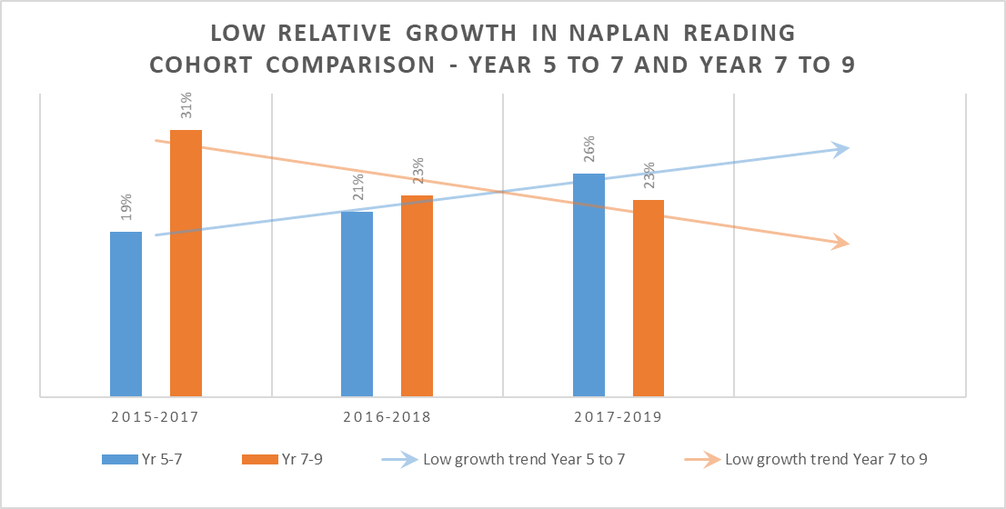
Through the model’s cycle of planning, observation and discussion, PLTs reflected on and adjusted the lesson plan based on their observation of student learning and student engagement with the lesson. PLTs recorded all observations and the final lesson delivery on video and shared these videos along with their observations, feedback and lesson plans using OneNote.
Sharne observed authentic collaboration between staff in their PLTs throughout this process.
Resources for your school:
The PLC Online Modules support the implementation of the Victorian PLC approach by teaching participants how to lead and sustain change in their own contexts.
The PLC guide helps PLCs use the FISO improvement cycle to make changes to curriculum, pedagogy and assessment.

Early Signs of impact
While the full impact of the independent reading program on student outcomes for the 2018 Year 7 cohort will not be known until 2020, there are clear indications that the school is making a difference to student literacy outcomes. The adoption of a whole school focus on independent reading and a whole school instructional model correlates to a reduction in the percentage of students with low relative growth for reading from Year 7 to Year 9. The table below highlights the trends in low relative growth for Year 7 cohorts (2015, 2016 and 2017) and the same cohorts in Year 9 (2017, 2018 and 2019).

Literacy improvement teacher
We need to have our students and our staff and our parents confident that the interventions that we’re making, the supports that we’re putting into place, and the education that’s happening through all of our programs are connected and the MYLNS program actually connects these together.
John Shaw, College Principal
In 2019, Alkira Secondary College appointed both a literacy improvement teacher and a numeracy improvement teacher using funding provided through the Middle Years Literacy and Numeracy Support (MLYNS) initiative.
The time allocation for the literacy improvement teacher role was 0.2 of a full time equivalent with a focus on providing direct teaching support to prioritised students.
Alecia Misra was appointed as the literacy improvement teacher early in 2019.
As a primary trained teacher, Alecia had both the skills and capability to teach foundational literacy skills. She was also an experienced teacher within a secondary setting, teaching Year 7 through to Year 12 at the college.

Evaluate and diagnose

Using data and evidence
Alecia reviewed the NAPLAN data for the prioritised students and triangulated it with other data and evidence, including:
- OnDemand assessments for the previous two to three years
- interviews with the students
- teacher judgements and reflections recorded through Compass.
She also used an orthographic test to develop a more detailed understanding of the students’ point of need in terms of phonemic awareness, inferencing, comprehension, fluency and grammar.
This deepened her understanding of the students’ needs, their perceptions of the learning environment and the barriers to their learning.

Prioritise and set goals

Matching strategies to point of need
The orthographic test and interviews helped Alecia to identify the type of strategies that best matched the students’ learning needs.
In her data gathering, Alecia had observed that the prioritised students tended not to ask questions and usually gave one word responses to questions in class. From this observation, she identified questioning as one of the key High Impact Teaching Strategies (HITS) to use with these students, in particular encouraging them to ask questions. She also identified summarising and inferencing strategies to use to build students’ capability and confidence in answering questions.

Drawing on educational research
In recent years, Alecia has developed her understanding of evidence-based strategies through professional reading focused on what comprehension strategies are important and how to use those strategies with students. She was able to apply this knowledge in the improvement teacher role to help select the specific strategies to use with each student.

Develop and plan

Collaboration and communication
School leaders actively supported the improvement teachers, making time for them to discuss and test ideas and approaches. School leaders also communicated their expectation of targeted support for these students to all staff.
Teachers at the college had a positive response to the introduction of the Improvement Teacher role. As an established teacher at the college, Alecia had an existing professional relationship with other teachers in the school that helped her open a dialogue on targeted support for students in their classrooms. She found her colleagues were very open and willing to engage with her, both in giving feedback and discussing student learning needs and teaching strategies with her. This openness enabled development of an ongoing dialogue between classroom teachers and the Improvement Teacher with the student at the centre.

Structuring support
Competing demands within the timetable for the Year 10 cohort presented a challenge for Alecia in scheduling time with the students, particularly as she also had a mainstream teaching load. Flexibility was critical to both meeting students’ needs and addressing the timetable challenge. Alecia alternated between observation, in-class support, small group and one to one work to create the best fit support for each student.
Some students were initially resistant to the idea of being taken out of class. Alecia’s early discussions with them focused on understanding their views and ideas of what helps them in their learning. Students then felt comfortable with coming out of class because they were confident that the support was tailored to their needs.
Resources for your school:
The Literacy Teaching Toolkit provides practical advice and high impact teaching practices that improve outcomes in literacy. The toolkit for Levels 7-10 provides teachers with strategies to support the development of literate practices within seven learning areas of the Victorian Curriculum, including English, Mathematics and Science.

Implement and monitor

Delivering support
Alecia found that small group work was highly effective as it created a space where students could discuss ideas and build their confidence. In contrast to mainstream classes where these students often stayed quiet or hid behind more confident students, there was a clear expectation of participation in the small groups. Alecia observed that students responded to that expectation, contributing to the group discussion and building their knowledge.
Connecting learning to real life requirements that students will face has also been an effective strategy for improving student engagement.
In her discussions with students, Alecia identified the learning and career pathway that each student wanted to follow. For students who wanted to pursue a trade, she downloaded the booklets for that trade and used those as both a reading resource and a guide. Similarly, she used VCE textbooks related to the students’ area of interest in the same way for those who wanted to complete VCE. Using these materials helped students to understand and identify the literacy capabilities they needed to have to be able to pursue their chosen pathway.

Changes in student learning
Alecia has observed changes in student learning behaviour since she started in the Literacy Improvement Teacher role. Students who previously had not engaged with learning in the classroom are now keen to share with her the work they are doing, demonstrating their progress and their thought patterns. She has observed these students using questioning and inferencing in their classes, taking more of an interest in their learning and drawing on the support of other students to engage with learning in the classroom.

Amplifying student voice and agency
Alecia used HITS to empower students and engage them in their learning. Her practices and approach aligns with Amplify: The student voice practice guide and the Victorian Teaching and Learning Model.

