Student induction work book – Visiting the workplace

Key messages
- When you arrive at your workplace for the first time you will be asked to complete a workplace orientation, sometimes called ‘Induction’
- Your key person i.e. your supervisor, will take you through the Induction program to help keep you safe while at work
- When you visit the workplace for the first time, it is a good opportunity for you to get to know your workplace
- Take the opportunity to find out about things that are important for you to work there
- Look out for any important safety features
- Some employment places may issue security access cards/staff ID, inform students how to acquire the ID card, how to use it and report if it is lost or stolen

Activity 1: Checklist – Know your workplace
Ask your workplace supervisor to point out the main features of the workplace.
Take a picture and place in the box below |  | Tick when completed  √
1. | Who is your Key Person or supervisor?
2. | Reception / front office
3. | Toilets / restrooms
4. | Canteen / lunch room  Tea / coffee / water facilities
5. | Locker
6. | First Aid
7. | Noticeboard
8. | Emergency exits
9. | Emergency assembly point
10 | Any restricted or “no-go” areas
11. | Any other places in the workplace you should know about
12. | Security Access Card/Staff ID

Draw the layout of the workplace, showing some of the important areas. For example: entry, exit, toilets, drinking water, staffroom, staff lockers.

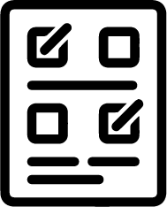 Activity 2: Emergency procedures
What do you hear or see in the workplace to tell you that you need to evacuate?
How do you exit the workplace in an emergency?
Please tick the right answer
- Run from the workplace taking the nearest exit
- Walk quietly and calmly to evacuation area as directed

Where do you assemble after you evacuate the workplace?

Personal Protective Equipment (PPE)
Do you need to wear any protective clothing and/or shoes at your workplace?

Please see examples on the next page, you can paste pictures in here

Occupational Health and Safety (OHS) Signs
These are signs that warn you about hazards, or signs that tell you where to go (or sometimes where NOT to go).

What signs do you notice in the workplace?

Workplace Orientation Checklist
Name of your key person or supervisor at the workplace
Do you need to sign in and out of the workplace?
Do you understand the terms and conditions of your employment?
Where would you find:
Reception / front office
Toilets / restrooms

Canteen / lunch room
Tea / coffee / water facilities

Lockers

First aid

Notice board
Emergency exits

Emergency assembly point
Personal Protective Equipment
Safety signs and hazardous areas

Occupational Health and Safety (OHS) Signs

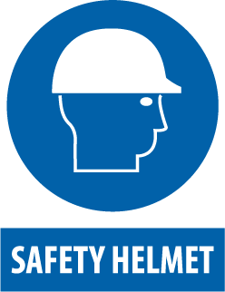 |  |  | 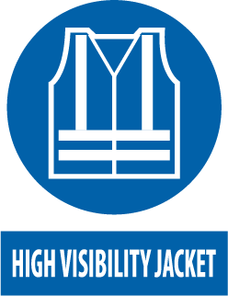 | 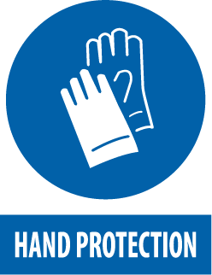 | 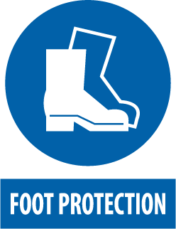
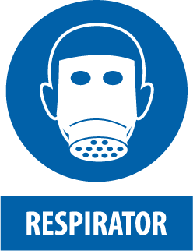 |  | 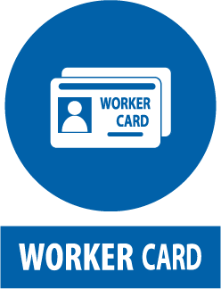 | 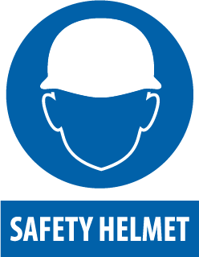 | 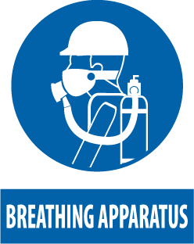 | 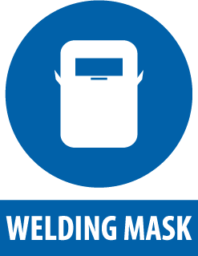
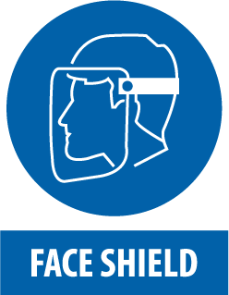 |  | 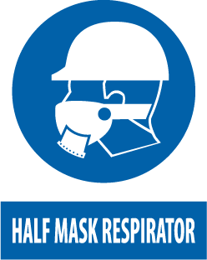 | 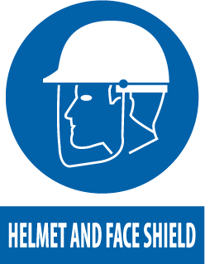 | 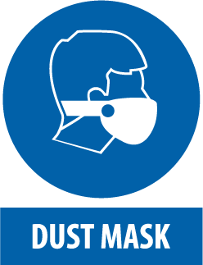
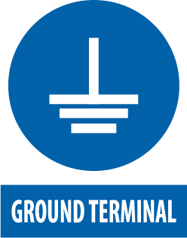 | 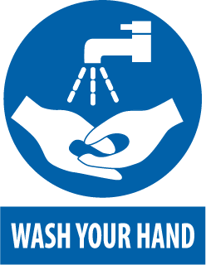 | 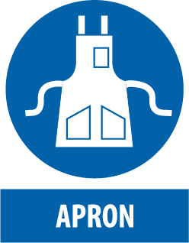 | 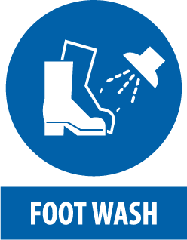 | 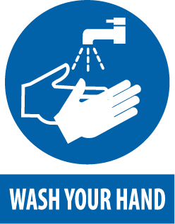 | 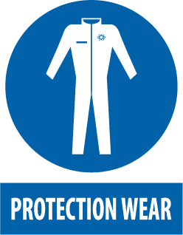
 | 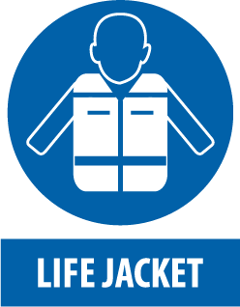 | 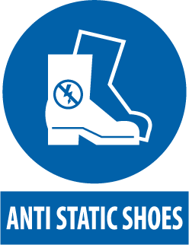 | 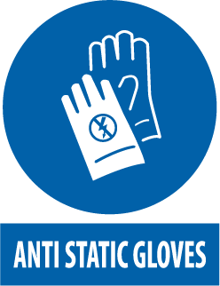 | 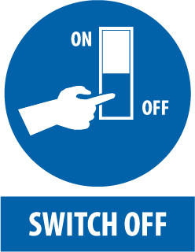 | 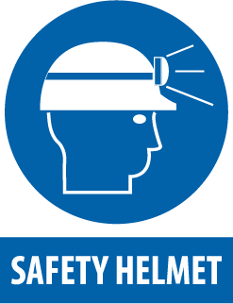
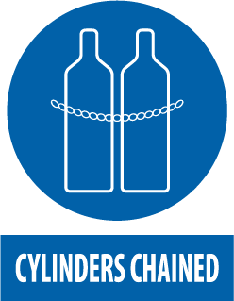 | 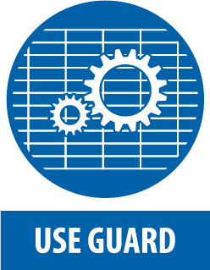 |  | 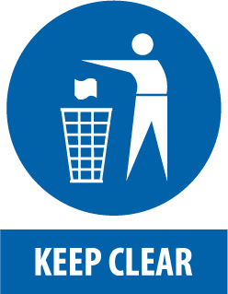 | 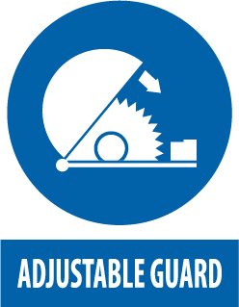 | 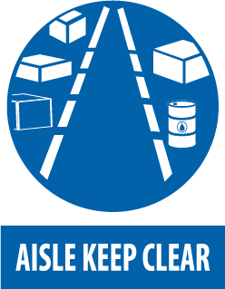
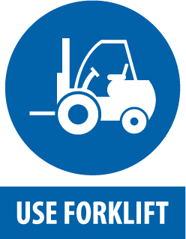 |  | 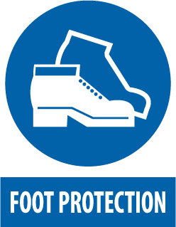 | 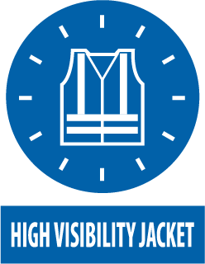 | 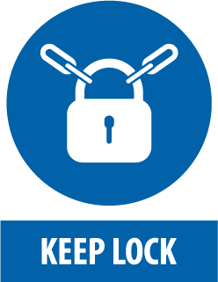 | 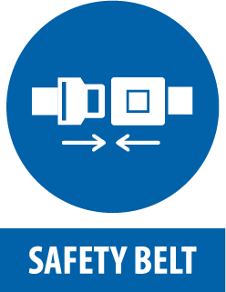
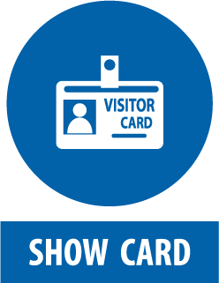 | 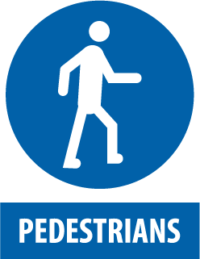 | 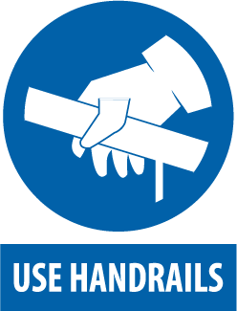 | 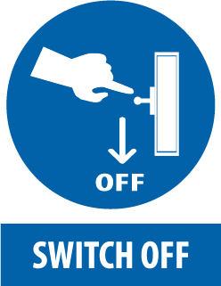 | 