Student worksheet - Personal Protective Equipment (PPE)

Key messages
- Using personal protective equipment is a ‘last resort’ – it means that there is no other way to effectively remove the hazard or reduce the risk.
- Protective equipment is provided by an employer to make a task safer.
- Work experience students must use PPE, as long as their employer has instructed them in how to use it correctly.

Activity 1: Identifying different types of PPE
Watch ‘A Job Well Done’ Industry video – Working in a warehouse.
Discuss the types of personal protective equipment and clothing worn in different workplaces.
What types of personal protective equipment have you seen?

Activity 2: Personal protective equipment signage
Label the pictures of protective clothing and equipment

Work/Rubber Boots | Dust Mask | Apron
Goggles | Gloves | Hard Hat
Respirator | Safety Glasses | Overalls
Ear Muffs | Hair Net | Face Shield

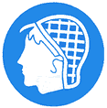
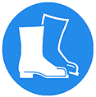

Activity 3: Personal protective equipment and its uses
Draw a line to match the protected area with the equipment |  | Which types of jobs or industries might use the equipment shown in the sign?
Ears
Eyes
Head
Feet
Hands
Body

