A Job Well Done – Webgame transcript
Please note: The answers in bold are the correct answer.

Let’s get ready for work experience.
So you’re off to do some work experience. Sounds like fun.
This game will help you prepare for work experience.
It’s focused on making sure you stay healthy and safe when you are on your work experience.
Give it a go and don’t worry if you get anything wrong, you get plenty of chances to get them right.
Good luck!
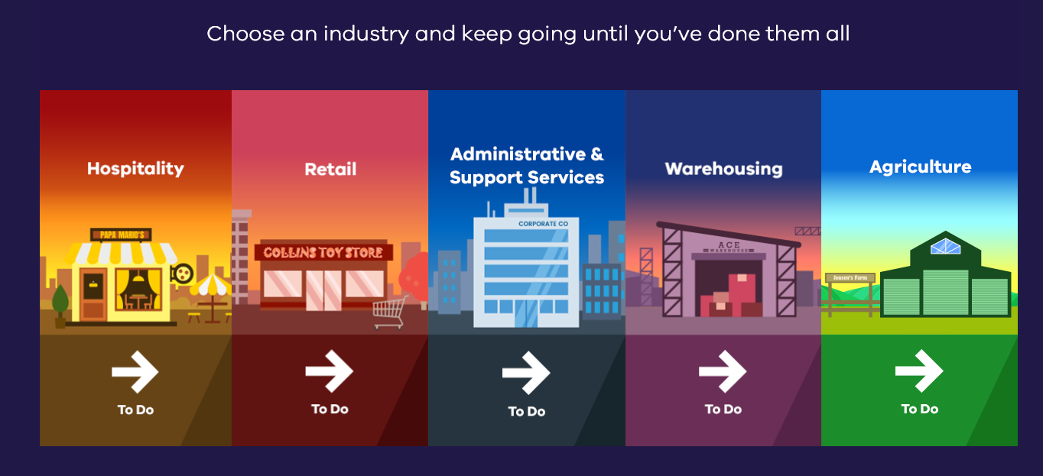

Hospitality
You’re working at Papa Mario’s, a great place to eat. You’ll be working in the busy kitchen.
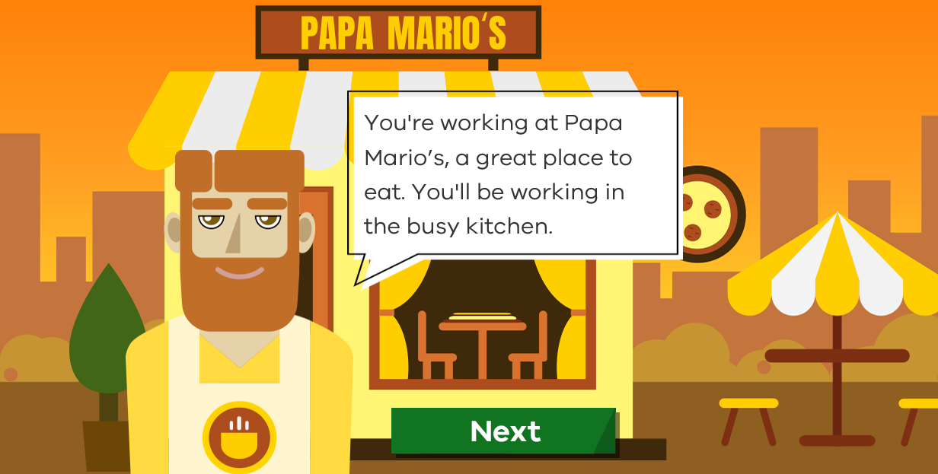
- You see a big spill on the floor. It’s a brown liquid, and it looks steaming hot. What do you do?
- Meh, that’s not my problem.
- I’ll find my supervisor and tell them right away.
- I’ll place a warning sign and then find my supervisor.
- I’ll find a mop and clean this up right now.
ANSWERS
- A hot spill could be a safety hazard. It’s important to report hazards immediately so that everyone in the workplace is aware of risks at all times. Try again!
- Good idea, but you could also place a warning sign before you leave the area. Have another go.
- Great job! Now everyone in the kitchen is aware of the spill, and your supervisor can tell you how to clean it up. Great job. Next.
- Not yet! There might be special procedures for a hot spill. Better make sure the area is safe by placing a warning sign and then find your supervisor. Make another choice.
- You’re working in the kitchen and you hear a few rude comments that sound like they are aimed at you. You’re not completely sure though. What do you do?
- Ask them if they are talking about you.
- Just ignore it, it will go away.
- Leave, you don’t want to work in a place like that.
- Speak to your supervisor about it and tell them that you are concerned about the remarks.
ANSWERS
- It’s probably best not to confront them, have a chat with your supervisor about it. Try again!
- Resilience is good, but workplace bullying is bad and you should speak with your supervisor about it. Make another choice.
- Always speak with your supervisor first, this could be a misunderstanding. Have another go.
- Correct! The safest thing is to have a chat with your supervisor. Great job! Next.
Kitchens can be dangerous. You need to know the risks and what to do if something goes wrong. There are signs which can help you. See if you can recognise these signs.
- What does this sign mean?
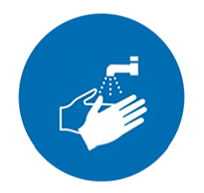
- Wash your hands.
- Wear gloves when washing dishes.
- Wear a glove on one hand.
- Only wash hands at this location.
ANSWERS
- That’s correct.
- Wrong! Try again!
- That’s not right! Have another go.
- Not right this time! Make another choice.

- What does this sign mean?

- Press to stop.
- Pick up the mushroom
- Fire hose.
- Emergency stop.

ANSWERS
- Wrong! Try again!
- Not right this time! Make another choice.
- That’s not right! Have another go.
- That’s correct! Great job!
Well done, you got all the questions right. That’s all for now at Papa Mario’s.

Retail
Now to get some experience in retail. You're going to be working at Collin's Toy Store.
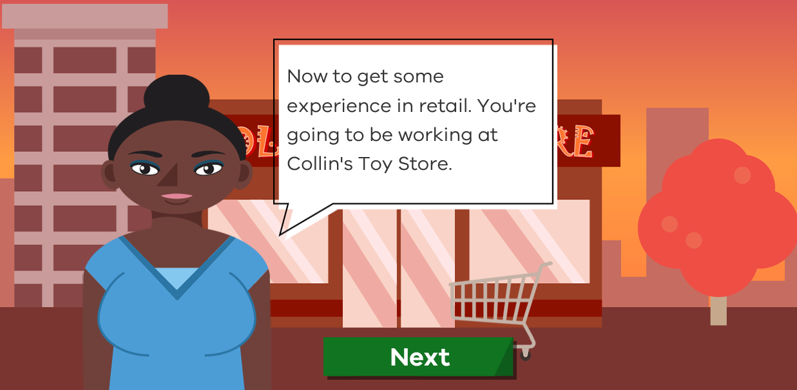
- You are working in the toy store. Your supervisor has gone to the storeroom when an angry customer approaches you. They slam a broken toy down on the counter and shout that they want a refund. What do you do?
- I am a work experience student. My supervisor is the one that can help you. They have just gone to the storeroom.
- I can't give you a refund. You'll have to come back later and speak to my supervisor.
- Can you please calm down and not shout at me, please?
- I'll get you a refund right away, sorry about that!

ANSWERS
- Great job! This is a tough situation, but you've done your best to help the customer and given them the choice of what to do next. Great Job!
- When it comes to an angry customer, tell them politely that you are sorry to hear about their experience; however, your supervisor needs to handle this. Have another go.
- Nobody likes being shouted at, but angry customers can get even angrier if you tell them what to do. Better to try and fix their problem. Make another choice.
- It's hard when a customer is angry, but providing a refund requires supervisor's permission, so you should wait for your supervisor's approval before you give a refund. Try again.

- You are refilling shelves in the store and you accidentally drop an action figure which breaks, what do you do?
- Hide it under the shelf.
- Try to fix it and put it back on the shelf.
- Tell your supervisor right away.
- Put that one at the back of the shelf, no one will notice!

ANSWERS
- It is always important to be honest. Mistakes can happen in the workplace. Tell your supervisor and they will understand. Try again.
- It's a nice idea, but if something gets broken, please tell your supervisor as it probably can't be sold. Have another go.
- Well done! You need to take care, but accidents happen and it shouldn't be a problem. Great job!
- Make sure you tell your supervisor and remove it from the shelf so that a customer doesn't accidentally buy it. That could cause more problems later. Make another choice.
Retail stores may look safe, but every workplace has safety risks.
- What does this sign mean?
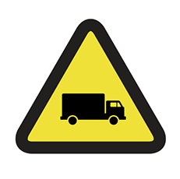

- Get a lift home here.
- Only trucks allowed.
- Toy truck crossing.
- Beware of vehicles.

ANSWERS
- Wrong! Try again.
- Not right this time! Make another choice.
- That's not right! Have another go.
- That's correct! Great job!

- What does this sign mean?
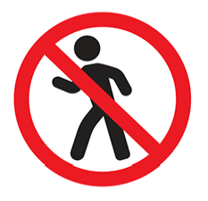
- No dancing.
- Danger - do not enter.
- No walking.
- Enter here.
ANSWERS
- Wrong! Try again.
- That's correct! Great job!
- That's not right! Have another go.
- Not right this time! Make another choice.
Your time in retail is over. Well done, you got everything right.

Administrative & Support Services.
You're going to be working in an office at CorporateCo.
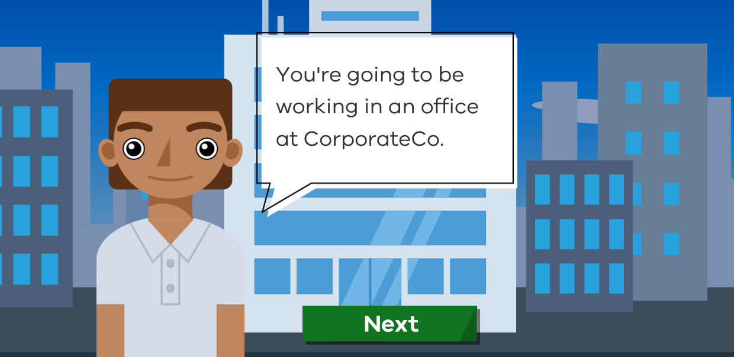
- Cindy brings you some printed pages and asks you to make them into a booklet using the spiral binder. What do you do?
- I would need to check with my supervisor before I start any new tasks.
- Okay, I'm sure I can work out how to use the spiral binder.
- Sure, can you show me how the spiral binder works?
- Sorry, I can't do that, I don't know how to use the spiral binder.
ANSWERS
- Great job! Always check with your supervisor first before starting a new task. Great job!
- It's not a good idea to try out a new task without the right training. If you need some help, all you have to do is ask. Try again.
- It is a good idea to ask for help but first check with your supervisor before starting a new task. Have another go.
- Don't be afraid of new tasks. The more skills you have, the more help you can be in the workplace. Just make sure you ask your supervisor first. Make another choice.
- Working at your desk you see some electrical cords across the floor. Someone could easily trip and injure themselves on the cord. What do you do?
- Unplug them and tidy them away.
- Ignore it, it's probably always like that.
- Place a mat or rug over them.
- Tell your supervisor about it, the first chance you get.
ANSWERS
- Please leave any cables plugged in, best to tell your supervisor, they'll know what to do. Try again.
- If you spot a hazard, please tell your supervisor, they will know what to do or where to go for help. Make another choice.
- Never put a mat or rug on cords. It can heat up and cause fire. Have another go.
- That's right! Always report a risk or hazard and don't try to fix it yourself, that could cause a bigger problem e.g. electric shock. Great job!

Even in a corporate office there are safety risks. Can you recognise these signs?
- What does this sign mean?

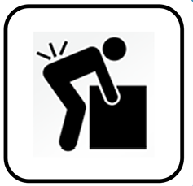
- Place boxes here.
- Bend knees when lifting.
- Always wear a reversing light.
- Warning! Boxes can be heavy.
ANSWERS
- Wrong! Try again.
- That's correct! Great job!
- That's not right! Have another go.
- Not right this time! Make another choice.

- What does this sign mean?

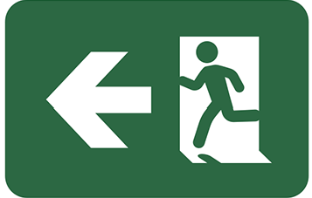

- Emergency exit.
- Run this way.
- Open the door this way.
- This way to hide!
ANSWERS
- That's correct! Great job!
- Wrong! Try again.
- That's not right! Have another go.
- Not right this time! Make another choice.
You are all done at the office and you got everything right. Great job!

Warehousing
You're going to be working at ACE warehousing.
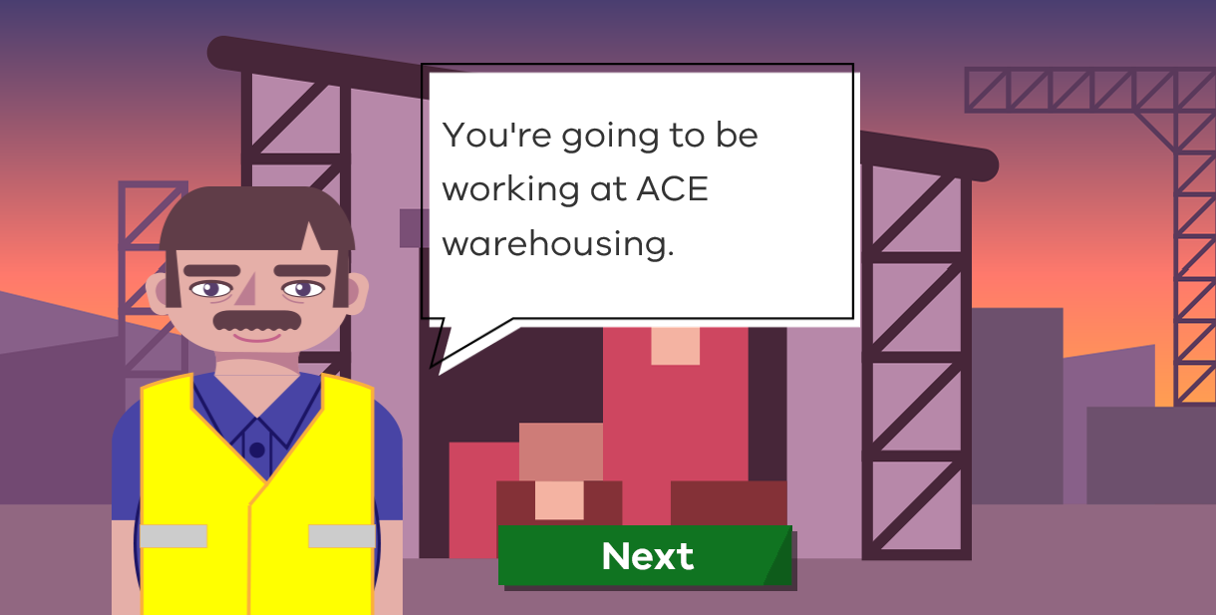
- You are working in the warehouse stocking shelves. You have to move the products to the appropriate shelves in the warehouse. Some of the shelves are very high and you need to reach up to keep the products on the higher shelves. How would you do this work safely?
- I will use a ladder to reach the higher shelves.
- Climb up the shelves to reach the top.
- Ask a fellow colleague to help.
- I would ask my supervisor for advice.
ANSWERS
- It is great that you are keen to help but as a work experience student you are not allowed to work at heights. You should always ask your supervisor before you do anything that might be dangerous. Try again.
- This is highly dangerous as shelves can tip over and hurt you. As a work experience student you are not allowed to work at heights so talk to your supervisor first and seek help. Make another choice.
- Yes you can request a fellow colleague who is authorised to work at heights to help you stock the shelves but first talk to your supervisor. Have another go.
- Right choice! If you are unsure about anything, then ask. As a work experience student you cannot work at heights as it can be dangerous. Great job! Next.

- Your next job is to move some heavy boxes. You try to pick one up and feel a sharp pain in your back. What do you do?
- Use your forklift truck to lift it, the pain will go away soon.
- Ask someone to take the box from you and tell your supervisor right away.
- Ask someone to help lift.
- Ask if there is anything else you can do as the boxes are too heavy.
ANSWERS
- If you are hurt or injured in any way, this must be reported to your supervisor. As a work experience student you are not allowed to drive a forklift. Try again.
- Correct. If you have injured yourself in any way always report it to your supervisor. You may need medical attention and they will know what to do. Great job!
- If you are hurt or injured in any way, report it to your supervisor first. Have another go.
- If you are hurt or injured in any way, report it to your supervisor first. Make another choice.
There are plenty of safety risks to look out for in a warehouse.
- What does this sign mean?

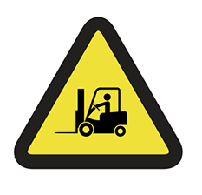
- Look out for forklift trucks.
- One driver at a time.
- No forklift racing.
- Forklift driving school.
ANSWERS
- That's correct! Great job!
- Wrong! Try again.
- That's not right! Have another go.
- Not right this time! Make another choice.
- What does this sign mean?
- Keep ears warm at all times.
- Quiet please!
- Wear headphones if listening to music.
- Wear Ear Protection.
ANSWERS
- Wrong! Try again.
- Not right this time! Make another choice.
- That's not right! Have another go.
- That's correct! Great job!
You've completed everything at the warehouse and got everything right. Well done!

Agriculture
You're off to Jensen's Farm for your work experience.
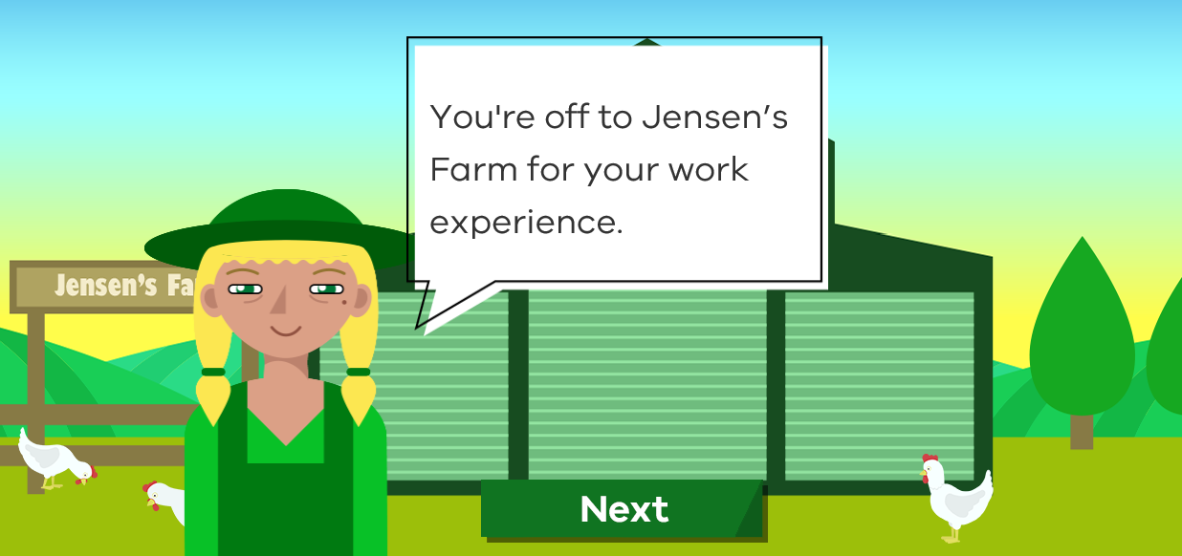
- Farmer Jane asked you to help her to water the animals. You have been working hard for a while when you feel sick in your stomach. What do you do?
- I'd better finish the job before I tell anyone that I feel unwell.
- I'll catch a bus home and rest until I feel better.
- I'll ask Farmer Jane if I can have a rest, get some first aid or even go home sick.
- I'll stop work and rest until feel better.
ANSWERS
- You don't have to push through when you're really feeling sick. If you let your supervisor know, they can help. Try again.
- That might be the best option, but you should ask your supervisor's permission first. Make another choice.
- Correct! Your supervisor will understand and help, but they need to know what's going on. Make sure that your school is also informed. Great job!
- Good idea, but you should talk to your supervisor about why you need a break. Have another go.
- You are with Farmer Jane, your supervisor, when another farmer walks past you leading a cow. The cow gets startled and starts making lots of noise and tries to get free and run away. It looks scary! What should you do?
- Try and help by holding the cow.
- Remain calm and listen to instructions from your supervisor.
- Ask people around you to help.
- Run away.
ANSWERS
- The situation could be dangerous. You should always listen to your supervisor. Try again.
- Great job! It is always important to remain calm and listen to your supervisor's instructions. They want to keep you safe. Great job!
- You should listen to instructions from your supervisor. They will know what to do. Have another go.
- It can seem scary but it is important to remain calm and listen to your supervisor. Make another choice.
It is important to be alert on a farm and pay attention to any signs.
- What does this sign mean?
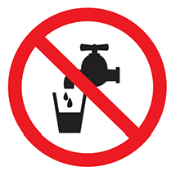
- Fill glass here.
- Tap not working.
- Flammable liquid.
- Water not suitable for drinking.
ANSWERS
- Wrong! Try again.
- Not right this time! Make another choice.
- That's not right! Have another go.
- That's correct! Great job!
- What does this sign mean?
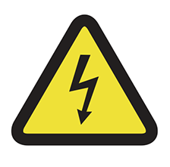
- Danger - high voltage electricity.
- Watch out for lightning.
- Look down.
- Thunder God crossing.
ANSWERS
- That's correct! Great job!
- Wrong! Try again.
- That's not right! Have another go.
- Not right this time! Make another choice.
You've finished. Well done! Are you feeling more prepared for your work experience? You should be. You got everything right. Good luck with your work experience. A Job Well Done!

© State of Victoria (Department of Education and Training) 2019. Except where otherwise noted, material in this document is provided under a
Creative Commons Attribution 4.0 International Please check the full copyright notice

