ACTIVITY INSTRUCTIONS
________________________________________________________________________________________________________________________________
Workshop Activity – Your Future
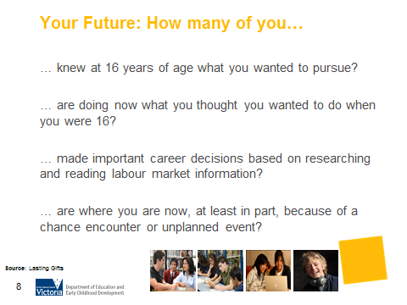
What is the purpose of this activity?
To consider your own career journey and how it is similar or different to how you imagined it when you were a teenager. To think about if you were able to be positive and uncertain at the same time when you were a teenager. This gets parents to consider how their teenager may be feeling. It also encourages parents to realise that the plans their young person is making now may change, and this is normal and OK.

Time: <1 minute

Materials: N/A

Preparation: N/A

How do I do this activity?
Show of Hands
How many of you
- … knew at 16 years of age what you wanted to pursue?
- … are doing what you thought you wanted to do when you were 16?
- … made important career decisions based on researching and reading labour market information?
- … are where you are now, at least in part, because of a chance encounter or unplanned event?
Connect participant responses to ‘positive uncertainty’ (the next slide in the presentation). They all have experience with positive uncertainty – even the decision to have children can be considered positive uncertainty. Positive uncertainty is explained on the slide 8. Some would argue that the need to be positively uncertain has perhaps always been there, but it can also be argued that it is especially so for young people right now. Consider exploring this with participants by asking “Why?”, “What’s different?” and “What has changed?”

Things to consider when using this activity:
- Be aware that for parents from a Koorie or Refugee background that this activity may raise issues of loss, fear and grief.

