WORKSHOP ACTIVITY INSTRUCTIONS
________________________________________________________________________________________________________________________________
Activity – When to talk careers with your kids
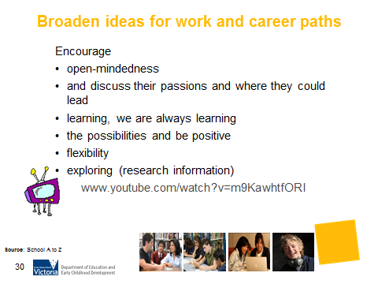 | 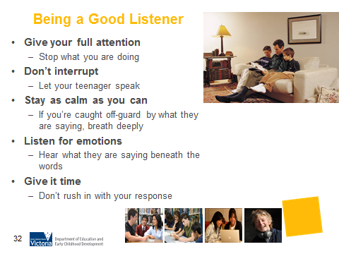

What is the purpose of this activity?
The purpose of this activity is to help parents to have career conversation. This activity will give parents ideas on how and when to have a career conversation and what to avoid.

Time: 10 minutes

Materials: ‘When to talk careers with your kids’ handout, Whiteboard, Whiteboard markers

Preparation: Each parent to receive a copy of ‘When to talk careers with your kids’ below

How do I do this activity?
- Introduce this activity by asking parents to pick a time when they and their child have had a positive career conversation. When was this? What helped? What about a time when it wasn’t a positive conversation. Why wasn’t it helpful?
- Distribute the ‘When to talk careers with your kids’ handout. Discuss the helpful hints. Where relevant reflect on the ideas from the workshop for example how these hints relate to Preferred Future, engaging young people where they are most engaged in life, strengths and skills.
- Discuss the points under the heading ‘What to avoid’. How does this relate to the earlier discussion on Why wasn’t it helpful?
- Give an overview of ‘What are some good times to talk careers with my kids?

- Allocate one of the times listed for table group discussion. For example
  - Table 1 – In the car
  - Table 2 – Watching TV
  - Table 3 – Over a meal
  - Table 4 – Playing sport or doing outdoor activities
  - Table 5 – At subject choice time
  - Table 6 – When your child has friends over

- Ask table groups to consider other conversation starters. Report back ideas to the group.
- Discuss the skills and abilities that will help you engage with your child.

What are some variations of this activity?
- Consider giving these hints in a newsletter.
- Ask parents to these conversation starters.

Source:
http://www.careers.govt.nz/plan-your-career/helping-young-people-make-decisions/when-to-talk-careers-with-your-kids/#c12867

Being responsible for guiding your child towards their future career can feel overwhelming - and can also be frustrating when your child does not listen to you or take your advice. But picking a time when you and your child are both relaxed or doing other things can help you make inroads.

Helpful hints for having a career conversation with your child
- Choosing the right time will help you make in-roads with your child. To get the best results out of any career discussions with your child or children, you should pick times when you and your child are both relaxed. If your child is not interested, or if there is any tension between you, it's better to try again another time.

- Start conversations with general questions. That way your child won't feel like you are on their case, or that they've been backed into a corner. You can then explore a wide variety of ideas without putting pressure on them.

- Once you've talked generally, ask questions to get your child to focus on themselves. Explore their interests, things they are good at and their personal values.

- If your child does not have a career idea in mind, ask them to define broad areas of interest, then encourage them to investigate options related to each area.

- Discuss what your child needs or wants from their career. Attitudes towards money, security or self-development may help to identify career options.

- Encourage any activity that develops skills. Many important skills that employers are looking for are developed at school. Skills are also gathered from part-time work, holiday jobs, and leisure activities such as sports.

- Discuss subject choices with your child each year. Would they rather keep their options open? Or if they have a career in mind, what are the best subjects for them to choose?

What to avoid
- Don’t impose your ideas - instead ask questions to clarify an issue. For example, “This is a desk job, but you said that you would like to meet different people all the time? Does that matter?”

- Don't discourage your child with comments such as "That's not right for you". This will push them away. Instead, explore the reasoning behind their career decision, and help them find out for themselves if it is the right choice.

- Don't push the conversation if your child is not responding, try another time instead. It's also good to let your child know that you're always available to talk if they need you.

What are some good times to talk careers with my kids?
There are many opportunities in the course of everyday life for you to start career conversations with your kids. For example, if your child points out something that they would like to buy when they're older, you can start a conversation with questions like, "I wonder what someone has to do to afford that?" or "That's a great ..... what do you think the owner does?"

In the car
Often the only time to catch up with family members is when you’re in the car on the way somewhere. This can be a great opportunity to have a quick chat to your kids about careers and dreams, and it can be easier for your child to talk to you, as all your attention is not on them. Keep the conversation casual and indirect.

- "If you could do any job in the world, what would it be?"
- "What would you like to do after you finish school?"

Watching TV
Some TV programmes will lend themselves to career conversations more easily than others. For example, shows like Crime Stoppers, Grey’s Anatomy, Australia’s Next Top Model can give you the opportunity to talk about different types of careers. For example:
- Crime Stoppers: "Wow, the police have to deal with some difficult people. I'm not sure I could do that job. What do you think?"
- Grey’s Anatomy: "I think this show gives you the wrong idea about what doctors and nurses actually do. I think everyone interested in these jobs should do some real-life work experience."
- Australia’s Next Top Model: "These girls spend so much time practising! They seem willing to give up a lot of time to get into this career - I'm not sure I could be bothered, could you?"

Over a meal
Ease your way into the conversation. A lot of children might get defensive. Talk about your own experiences or observations to start the conversation - you don't have to talk about your child's situation, you can start with yourself or someone else.
- "The kid next door is starting an apprenticeship in carpet laying next year. I wonder how he came up with that?"
- "My parents talked me into being a teacher, but I would rather have tried landscaping. Hey, I might still do that!"
- "It can be scary to think you have to do the same job all your life. I know a lot of people who managed to do well after changing careers. Some have tried several different jobs."

Playing sport or doing outdoor activities
You may not want to spoil this quality time with your children by bringing up career or training plans.

Some possible starters for your conversations could be:
- "Wouldn't it be great to have a job outdoors? Especially on a day like today."
- "Being sporty helps make up for spending all week behind a desk!"

At subject choice time
Though you may not feel comfortable about helping your child with making subject choices, this is a good time to talk over their hopes for the future.

You don't have to make the decision for them, but ask open-ended questions like:

- "What subjects do you like doing? Why?"
- "What types of jobs can your favourite subject lead to?"
- "What's your dream job? What sorts of subjects would you need to do that?"
- "It's OK that you haven't decided what to do after school yet. Maybe you should keep your subject choices broad, to give you more options later."

When your child has friends over
- Starting a career conversation with your child and their friends can take a lot of pressure out of the situation. You can start out by asking your child's friends about their ideas for the future. Your child can listen and you can express your ideas to their friends without sounding patronising.
- It will also help prevent your child from feeling like they're being pressed into a corner.
- Remember to ask your questions casually, and if the conversation doesn't go where you want it to, stop and try another time.

Possible questions you could ask your child's friends?
- "What are your favourite subjects? Why?"
- "What are your plans after you're done with school?"
- "Have you guys done any work experience before? What did you think about it?/Do you reckon it's a good way to see if you'd like a job?"

Skills and abilities that will help you engage with your child
- Listening - be patient and try to avoid correcting your child, or rushing into solutions. Your child may just want to talk without getting answers.
- Guiding - make suggestions and offer advice. Don’t force them into anything. This may push them away.
- Questioning - ask questions that will help your children to clarify their interests, sports, hobbies and academic subjects.
- Lateral thinking - help your child to see links between skills, interests and jobs.
- Encouraging - let your child know that you are there to support and help them in whatever way they need.
- http://www.careers.govt.nz/plan-your-career/helping-young-people-make-decisions/when-to-talk-careers-with-your-kids/#c12867

