WORKSHOP ACTIVITY INSTRUCTIONS
________________________________________________________________________________________________________________________________
Activity – Strengths and Skills
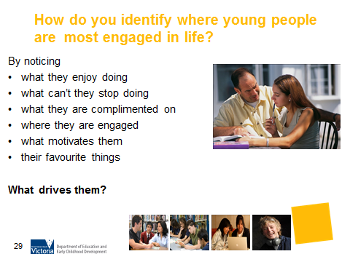
What is the purpose of this activity?
To assist parents to recognise the strengths and skills demonstrated by their teenager. By giving their teenager positive information about their strengths and skills the teenager will become more aware of their own skills.

Time: 10 minutes

Materials: Strengths and Skills Worksheet below.

Preparation: Each parent to receive a copy of the worksheet Strengths and Skills.

How do I do this activity?
- Distribute the Strengths and Skills workshop below.
- What do we mean by strengths and skills? “Strength” refers to how well a person performs something. A “skill” is something that a person can do no matter how well. (page 60, Hope-Filled Engagement)
- Ask participants to identify their teenager’s current strengths and skills.
- For each of the identified strengths or skills, ask participants to complete the following sentences:
  - My teenager has the strength/skill of _____________________.
  - He/she demonstrates this strength/skill by _____________________ (describe one thing that they do that services to demonstrate the strength/ skill).
  - His/her level of competence (how well they do it) is ____________________ (assess the level of competence that can be observed).

- Emphasise that parents usually know their teenager better than anyone – even though they may not always think so! They may not always understand their behaviour, BUT they have watched their basic skills develop over a very long period.

- Prepare examples to guide participants who may be struggling to identify strengths and skills in their teenager.

For example

Katie has commitment. She demonstrates this when babysitting by always calling a responsible adult to check when she feels a little uncertain about what the children are doing. Her competence is high. Her commitment is also evidenced by the fact that she is frequently asked to babysit the neighbour’s children.

What are some variations of this activity?
Presenters may like to discuss this in the context of employability skills, using the sheet “Skills employers are looking for”.

Things to consider when using this activity:
- Some cultures may find this activity challenging due to different parenting styles and values. Being sensitive to this important.
- Parents of young people with a disability may need to be encouraged and supported in this activity due to feelings of grief and loss. This is an important activity for the parents of these young people to identify the strengths and skills their child has.

Sources:
- The Strengths & Skills activity is modified from the Lasting Gifts resource (workshop 1), Canadian Career Development Foundation.
- Hope-Filled Engagement Gray Poehnell & Norman E. Amundson
http://www.ergoncommunications.com/books/
http://www.brightandassociates.com.au/cgi-bin/oscommerce/product_info.php?products_id=58
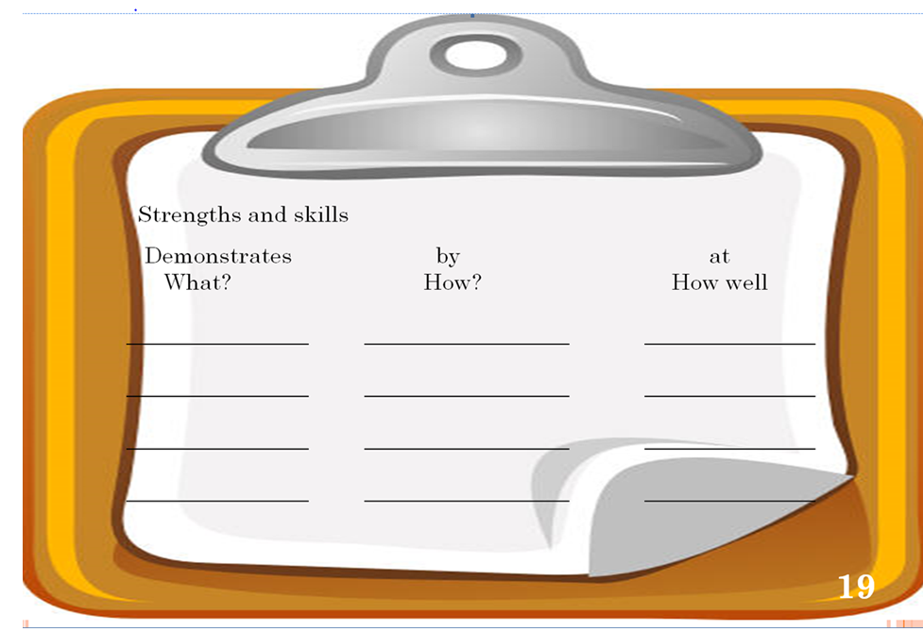
Source: “Lasting Gifts” – Canadian Career Development Foundation
