WORKSHOP ACTIVITY INSTRUCTIONS
________________________________________________________________________________________________________________________________
Activity – Round Table Helping Hands
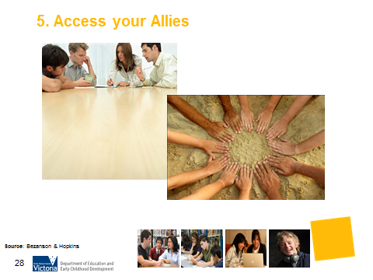

What is the purpose of this activity?
Through their various connections, parents can help their teenager to access resources, expertise and the community through people they respect and trust. By accessing their allies, their teenager will begin to understand the value of networking and developing a team of supportive people who can be their career development allies. This activity encourages parents to think about people they know and who could be a support.

Time: 10 minutes

Materials: Round Table Helping Hands Worksheet below.

Preparation: Each parent to receive a copy of the worksheet Round Table Helping Hands.

How do I do this activity?
- Introduce this activity by brainstorming with parents ‘What is an ally?’ All of us have at some point had someone (or several persons) who were our allies, for short or long periods of time. Ask parents to recall the allies of their lives. Give a little time for them to connect to these images and persons.
- Distribute the worksheet ‘Round Table Helping Hands’. This could also be called ‘helping hands’ or ‘table of allies’.
- Ask parents to think about people they know and who could be their support.
- Ask parents to consider what support they would value or might need. Examples include:
- someone with financial knowhow;
- someone who listens and encourages;
- someone well-connected who can provide work experience of information gathering opportunities;
- a trades person well connected to the community;
- someone with computer skills;
- a good counsellor;
- a loving parent; and
- a good friend (or two).

- Once the individuals and organisations have been identified, invite parents to complete the worksheet to create their own roundtable.

- Encourage parents to discuss how they could do this activity with their teenager by coming up with relevant examples.

- Ask parents to discuss how they could have a conversation with their teenager about this message.

- Ask parents to report back. Facilitator compiles a list of examples for each message on the whiteboard.

What are some variations of this activity?
- Invite parents to think about their own role as allies to a young person, what they can do.
- Discuss what some of the challenges might be for parents in being an ally in this way.
- Ask what participants have gained from this activity and what they might practically do to create this kind of visible and accessible information network for their teenager.
- Point out that having the contact and connections and actually making use of them are two different things. How do we encourage our young people to go further and be curious and courageous enough to actually interview someone and get first-hand information?

Things to consider when using this activity:
- If presenting to a group that includes refugees, the use of the word “ally” should be avoided, as it may have connotations of war or conflict. “Supporter” may be one alternative.
- Some participants may be isolated and have limited support networks. This activity may be a way to introduce them to agencies and community groups that are available to provide support. Presenters may wish to provide a directory of local contacts to participants and encourage them to connect with their community.

Source: The Roundtable activity is modified from: Bezanson, L & Hopkins, S (2011). Lasting Gifts: Parents, Teens and the Career Journey. Canadian Career Development Foundation. Adapted by the Career Education Association of Victoria in 2010.

