WORKSHOP ACTIVITY INSTRUCTIONS
________________________________________________________________________________________________________________________________
Activity – Step In/Step Out
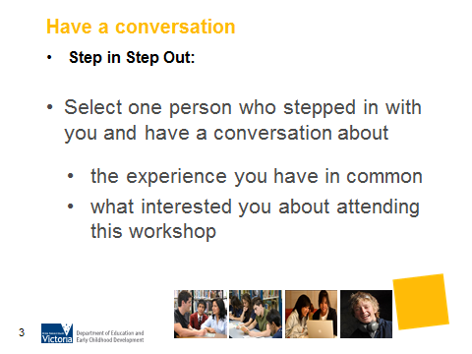
What is the purpose of this activity?
This activity provides an opportunity for parents to get to know each other by identifying the things they have in common. It provides an opportunity for parents to have a conversation about their own career development, changes they have made and sharing what their teenagers may have in common. It sets the scene for some of the key themes that will be explored throughout the workshop.

Time: 10 minutes

Materials: None

Preparation: Arrange a space for parents to stand in a circle

How do I do this activity?
Have parents stand in a circle. Tell them that this activity will be done without talking but there will be time for discussion after. Different questions will be asked and parents are asked to step in if this describes them. Ask parents to make eye contact with those who are inside the circle with them. Ask parents to step out again before asking the next question.

Step in if:
- Your son/daughter/young person is not sure about what they want to do after they leave school?
- Your son/daughter/young person recognises their skills and interests?
- You have continued to learn since leaving school?
- You have more than one paid role at the moment?
- You have had the same paid role since starting employment?
- You volunteer for a charity or community organisation?
- You have worked overseas or interstate?
- Your contacts helped you to obtain your occupation/voluntary position?

- Select one person who stepped in with you and have a conversation about the experience you have in common. Also have a conversation about why you have come to this workshop and what interested you?

- Return to seats

What are some variations of this activity?
- You can create your own questions that suit the intent of your workshop

Things to consider when using this activity:
- If the participants of your workshop come from an EAL/Refugee, Koorie, Disability or Low SES background consider the wording of your questions carefully to ensure inclusiveness and avoid bringing up feeling of grief or loss.

