WORKSHOP ACTIVITY INSTRUCTIONS
________________________________________________________________________________________________________________________________
Activity – High 5 Career Development Messages
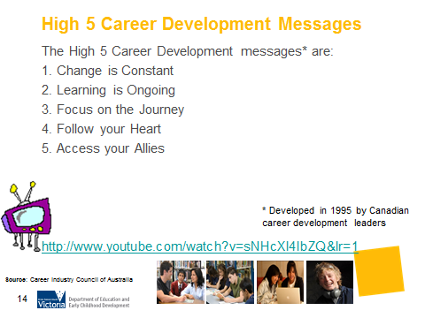
What is the purpose of this activity?
The purpose of this activity is to encourage parents to consider the career messages they carry with them and communicate to their teenager. Very often the messages are unconscious and parents may not necessarily be aware of the thinking behind them and their impact on behaviour. The purpose of this activity gently challenges parents to think about their own messages and how they can communicate and model more effective career development messages and therefore more effective career conversations.

Time: 10 minutes

Materials: A4 paper, envelopes, scissors, Whiteboard, Whiteboard markers.

Preparation:
- Print copies of the High 5 Career Development Messages handouts, enough for each pair of participants. Cut out each separate message and place in an envelope.

- Print one copy of the blank table of High 5 Career Development messages for each pair of participants.

How do I do this activity?

- Ask each pair to identify which of the Career Development messages are old, and which are current.
- Discuss the current High 5 career development messages and get participants to place them on Table 1. Parents should have the following High 5 Messages:

High 5 Career Development Messages
These principles were identified by many Canadian Career Development specialists.

Change is Constant | Recognise that the world around you is constantly changing. Be open to change and remain alert to new opportunities.
Follow your Heart | Pursue your passion to find fulfilment. Discover ways to combine your interests with career opportunities.
Focus on the Journey | Don’t focus on one destination only. Recognise that your career journey will be throughout your lifetime. Appreciate and value each experience along the way.
Access your Allies | Rely on the support of your family, friends, mentors, colleagues and peers. Career success can be a team effort.
Learning is ongoing | Strive for continuous personal improvement. Stay motivated by learning new skills and developing new talents.

- Ask parents to discuss how they could have a conversation with their teenager about this message.

- Ask parents to report back. Facilitator compiles a list of examples for each message on the whiteboard.

What are some variations of this activity?
You may wish to show the videos that describe each of the High 5 messages.

Due to copyright restrictions, the video file is not embedded into this presentation. Please copy and paste the following URL into a web browser to view the video: http://www.youtube.com/watch?v=sNHcXl4IbZQ&lr=1“Intro to NCDW Videos” 3:50min

Things to consider when using this activity:
- If workshop participants come from an EAL background, the messages and definitions may need to be translated. If using interpreters or Multicultural Education Aides, the messages should be discussed prior to the workshop to assist in explaining them to the participants.
- The video that has been linked to this slide contains colloquialisms that may be confusing to participants from an EAL background.
- Depending on the age and background of the workshop participants, the “old” messages may not resonate.

Source: www.ncdw.com.au

High 5 Career Development Messages
These principles were identified by many Canadian Career Development specialists.

Change is Constant

Follow your Heart

Focus on the Journey

Access your Allies

Learning is ongoing

High 5 Career Development Messages
These principles were identified by many Canadian Career Development specialists.

Change is Constant | Recognise that the world around you is constantly changing. Be open to change and remain alert to new opportunities.
Follow your Heart | Pursue your passion to find fulfilment. Discover ways to combine your interests with career opportunities.
Focus on the Journey | Don’t focus on one destination only. Recognise that your career journey will be throughout your lifetime. Appreciate and value each experience along the way.
Access your Allies | Rely on the support of your family, friends, mentors, colleagues and peers. Career success can be a team effort.
Learning is ongoing | Strive for continuous improvement. Stay motivated by learning new skills and developing new talents.

High 5 Career Development Messages
These principles were identified by many Canadian Career Development specialists.

Change is Constant | Change is inevitable BUT secure jobs are still there. Go where there is a proven track record, stick with it. There will be a reward at the end of the day!
Follow your Heart | Find out where the growth sectors are and get in!
Focus on the Journey | Know what you want and know where you are going. Make up your mind.
Access your Allies | The way to success is to learn to write your own ticket. You will be on your own and you will have to make it on your own.
Learning is ongoing | Learn while you’re in school – then you can relax! Get a degree and you are on your way.  Typical question is: “What did you learn?”

