R U Ready Student Profile

User Guide

Who is it for?
The R U Ready Student Profile (the Profile) is designed for young people with disabilities.

What is the purpose?
The Profile is a tool for engaging young people, their parents and teachers in career conversations. It is a key component of Strengthened Pathways Planning.
The Profile provides a snapshot of a young person’s work-related skills and employability, and seeks to identify what the young person can do, rather than what they can’t do.
Completing the Profile while the young person is still at school can:
- help identify existing skill sets and prompt discussion between the young person, their parents and teachers, about potential career options.
- assist in recognising opportunities for targeted skill development and setting learning goals within the young person’s Individual Learning Plan.
- assist in planning for workplace learning opportunities.

What does it profile?
The R U Ready Student Profile focuses on two types of information about young people with disabilities which are relevant to their capacity to engage in work activities:
- Work Skills
- Work Adjustments

What are Work Skills and Work Adjustments?
Work Skills are the range of competencies the young person displays which contribute to successful participation in the workplace.
The Profile includes a set of skills within five categories:
- Working with others
- Work habits
- Communication
- Learning
- Travel.
Examples of work skills include following instructions, organisational skills, and numeracy.
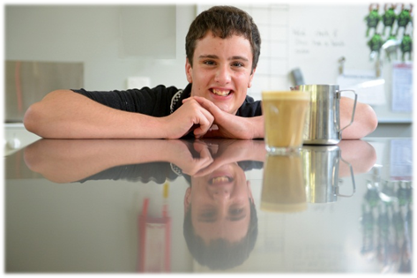
Work Adjustments are the actions or supports needed for the young person with a disability to participate in the workplace. The work adjustments are grouped into the following categories:
- Vision
- Hearing
- Communication
- Mobility
- Health
- Motor skills
- Cognition
- Behaviour.

Examples of work adjustments, such as modified equipment, can be found at: http://jobaccess.gov.au/work_place_adjustment_tool

Who completes the profile?
The R U Ready Student Profile is most effective when completed collaboratively by the Student Support Group, which includes school staff, parents and the young person.

How can the results be used?
Completing the Work Skills profile pages can:
- prompt conversations between young people, their parents and teachers about the young person’s post school options. Completing the Work Skills profile pages can highlight the range of skills a young person has, and open up discussions about their career options.
- contribute to educational planning processes. Completing the Work Skills profile pages can help identify those specific work skills which are relevant to the young person’s career aspirations and require further development. The Student Support Group can set learning goals to address these skills.
Completing the Work Adjustments profile page can:
- assist the Student Support Group to identify which specific supports may be required to facilitate the young person’s access to a workplace.
- provide helpful information for employers and external agencies offering workplace learning opportunities to young people with disabilities.

When is it used?
The Profile provides an assessment of a young person’s work readiness at a point in time, and can be applied at various times in the secondary years of schooling.
It is recommended that the Student Support Group completes the Profile in Year 9, or equivalent, to establish a baseline profile. Recognising strengths and opportunities for targeted skill development at this time can assist in developing an Individual Learning Plan which prepares the young person for workplace learning opportunities in the senior secondary years.
The Profile can be readministered annually to monitor progress and refine the learning goals in the young person’s Individual Learning Plan. In the senior secondary years the Profile can assist in preparing for workplace learning opportunities, and identifying realistic post school pathways.

How long does it take to complete the Profile?
The Student Support Group should allow approximately 30 minutes to complete the Profile.
For expediency, members of the Student Support Group may choose to complete a draft version of the Profile prior to meeting, and prioritise the meeting time for discussion, agreement on ratings, and the development of learning goals.
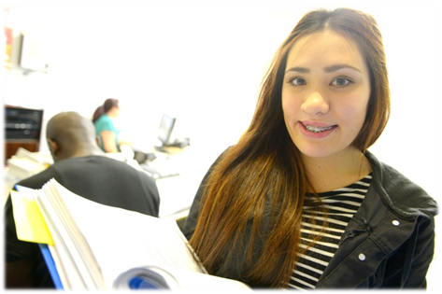

How do I complete the R U Ready Student Profile?
- Enter details for Student, Date and Completed by.
Work Skills pages
- Discuss the work skills listed within each category e.g. ‘Can work in a team’ in the ‘Working with others’ category.
- Tick the box which aligns most accurately with the frequency the young person displays this work skill (not yet demonstrated, sometimes, most of the time, always).
- For Travel to workplace and Learning, circle the descriptor which best describes the young person’s current ability.
- Consider recording specific examples of the young person’s skills in the ‘Personal examples’ section.
- Identify which work skills are most relevant to the young person’s career aspirations, and where further development is required, enter a learning goal in the ‘Learning goals’ section.

Work Adjustments page
- Discuss any work adjustments that may be required for the young person to participate in a workplace.
- Where work adjustments are not required beyond those readily available in the workplaces, tick ‘No adjustment’.
- If a work adjustment is required, record specific details under ‘Personal examples’ in the relevant category in the Work Adjustments page.

What if there is disagreement about the descriptor to be selected?
Where possible the Student Support Group (SSG) should rate a young person’s skills and work adjustments based on observed real life examples, rather than perceptions or assumptions.
If members of the SSG continue to disagree on the descriptor, then both ratings can be separately entered with the name of the rater beside their tick /circle.
If the rating is applied consistently by these members of the SSG, progress can still be identified when readministering the profile the following year.

Why record ‘Personal examples’?
It is recommended that members of the SSG record specific personal examples of a young person’s work skills or necessary work adjustments, in addition to ticking /circling a descriptor in the Profile. This can provide more personalised information and a stronger basis for comparison over the years.

Why enter ‘Learning goals’?
The SSG can discuss which work skills are most relevant to the young person’s career aspirations, and consider whether the skill should be targeted within their Individual Learning Plan as a learning goal.
This provides the SSG with an opportunity to extend the value of the Profile by using the information as a basis for student planning.

How else could the R U Ready Student Profile be used?
Following work experience placements, schools may ask employers to complete the Profile as a form of structured feedback regarding the student’s performance. Gaining an employer’s perspective may provide further insights into the young person’s skill set and help identify areas for future skill development.
