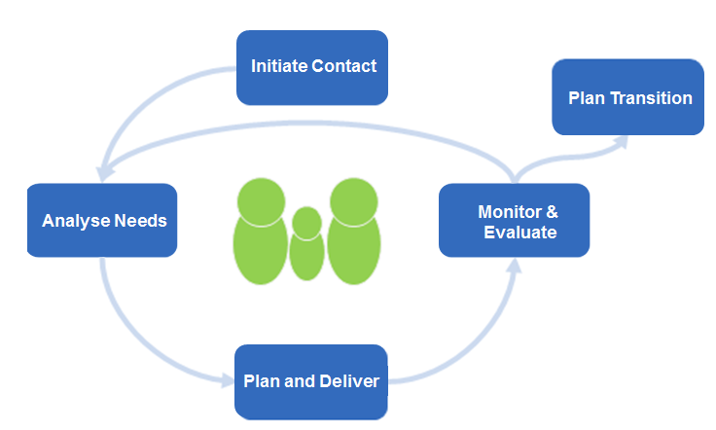
Behaviour Support Plan
Monitor & Evaluate
Plan & Coordinate
Analyse Needs
Plan Transition
Monitor & Evaluate
Initiate Contact
Plan & Coordinate
Analyse Needs
Plan Transition
Learner: Teacher:
Date: Review Date:
Team Members | Role | Signature
Learner Strengths |  | Addition information

Behaviour
Potential Behaviour Triggers | Potential Behaviour | Potential Functions

Behaviour Goals
Long term goal:
(SMARTAR)
Short term goal:
(SMARTAR)

Monitor/ Review
INSERT LEARNER’S NAME’s Behaviour Support Plan will be monitored throughout its implementation and will be reviewed at HIS/ HER Individual Learning Plan meeting or Student Support group meeting.

PREVENT STRATEGIES
Intervention type | Specific Steps

TEACH STRATEGIES
Intervention type | Specific Steps

REINFORCE STRATEGIES
Intervention type | Specific Steps

Review date: _____________________________________

Adapted from Prevent-Teach-Reinforce: The School-Based Model of Individualized Positive Behaviour Support by G.Dunlap, R.Iovannone, D.Kincaid, K.Wilson, K.Christiansen, P.Strain, and C.English, 2010.

REFERENCE GUIDE
Team Members | Team members will include the learner, a parent/carer/guardian, school staff implementing the Behaviour Support Plan and additional professionals working with the learner or team e.g., Occupational Therapist, Psychologist, aide. It is valuable to include a professional with experience in functional behaviour assessment in the team.
Strengths of the learner | Refer to the comprehensive Analyse Needs phase of the Team Around the Learner approach to support the identification of the learner’s strengths.
Additional information | Team members to include additional context information to ensure that everyone is informed of factors which may influence the learner’s behaviour and assist them to implement the behaviour support plan effectively. Such information could include learner preferences, updated personal circumstances, relevant health information or links to addition plans e.g., Safety Management Plan.
Potential behaviour triggers | Based on observations by the team, the team identifies events that occur immediately before the problem behaviour is displayed. The team discusses and agrees on potential triggers for the problem behaviour/s.
Potential behaviour | Based on observations by team members, the team identifies the form of the problem behaviour/s e.g., what the behaviour looks like. The team develops a clear and measurable definition of the behaviour to promote a consistent understanding of the behaviour by all users of the Behaviour Support Plan.
Potential functions | Based on observations by team members, the team determines what the learner is communicating through his/her problem behaviour. Team members then develop and test a hypothesis regarding the function of this behaviour.
Long term goal (s) (vison) | The vision should be developed collaboratively and be clear and simple and summarised into 1-2 sentences. The learner and family should be given the opportunity to present their views on what they think it should look like. Refer to the comprehensive Analyse Needs phase of the Team Around the Learner approach to support the development of the vision.
Short term goal | The team should develop a number of goals that when achieved will be successful in meeting the prioritised needs of the learner. The learner should be integral in the development of these goals.  Teams are encouraged to use the SMARTAR approach to goal development:  Specific  Measurable  Attainable  Relevant  Timed  Agreed  Reviewed
Monitor/ Review | Team members commit to ongoing monitoring of the intervention, review of the Behaviour Support Plan and the documentation of agreed changes. Team members provide details of the next review meeting in the Behaviour Support Plan. The frequency of team meetings may vary at various points within the intervention. Team members can initiate a team meeting at any stage.
Prevent Strategies | Team members identify and outline environmental modifications that will reduce the occurrence of behaviour triggers. Examples of environmental modifications may include the use of visual cues, motivators or changes to the physical environment. Team members should consider the variety of domains the learner operates within (eg bus, classroom, specialist lessons, playground, home, respite etc.) and promote a consistent use of the strategies across each domain. This may require the training of Behaviour Support Plan users in the desired strategies.
Teach Strategies | Team members determine what alternative or replacement behaviour and any new skills they would like to teach the learner. Again, team members should consider the variety of domains the learner operates within and promote a consistent use of strategies across each domain. This may require the training of Behaviour Support Plan users in the desired strategies.
Reinforce Strategies | Team members determine what strategies will be used to reinforce the positive behaviour (alternative or replacement behaviour). Team members should promote a consistent use of strategies across each domain the learner operates within and facilitate the training of Behaviour Support Plan users in the desired strategies.

