PRACTICE PRINCIPLES FOR EXCELLENCE IN TEACHING AND LEARNING

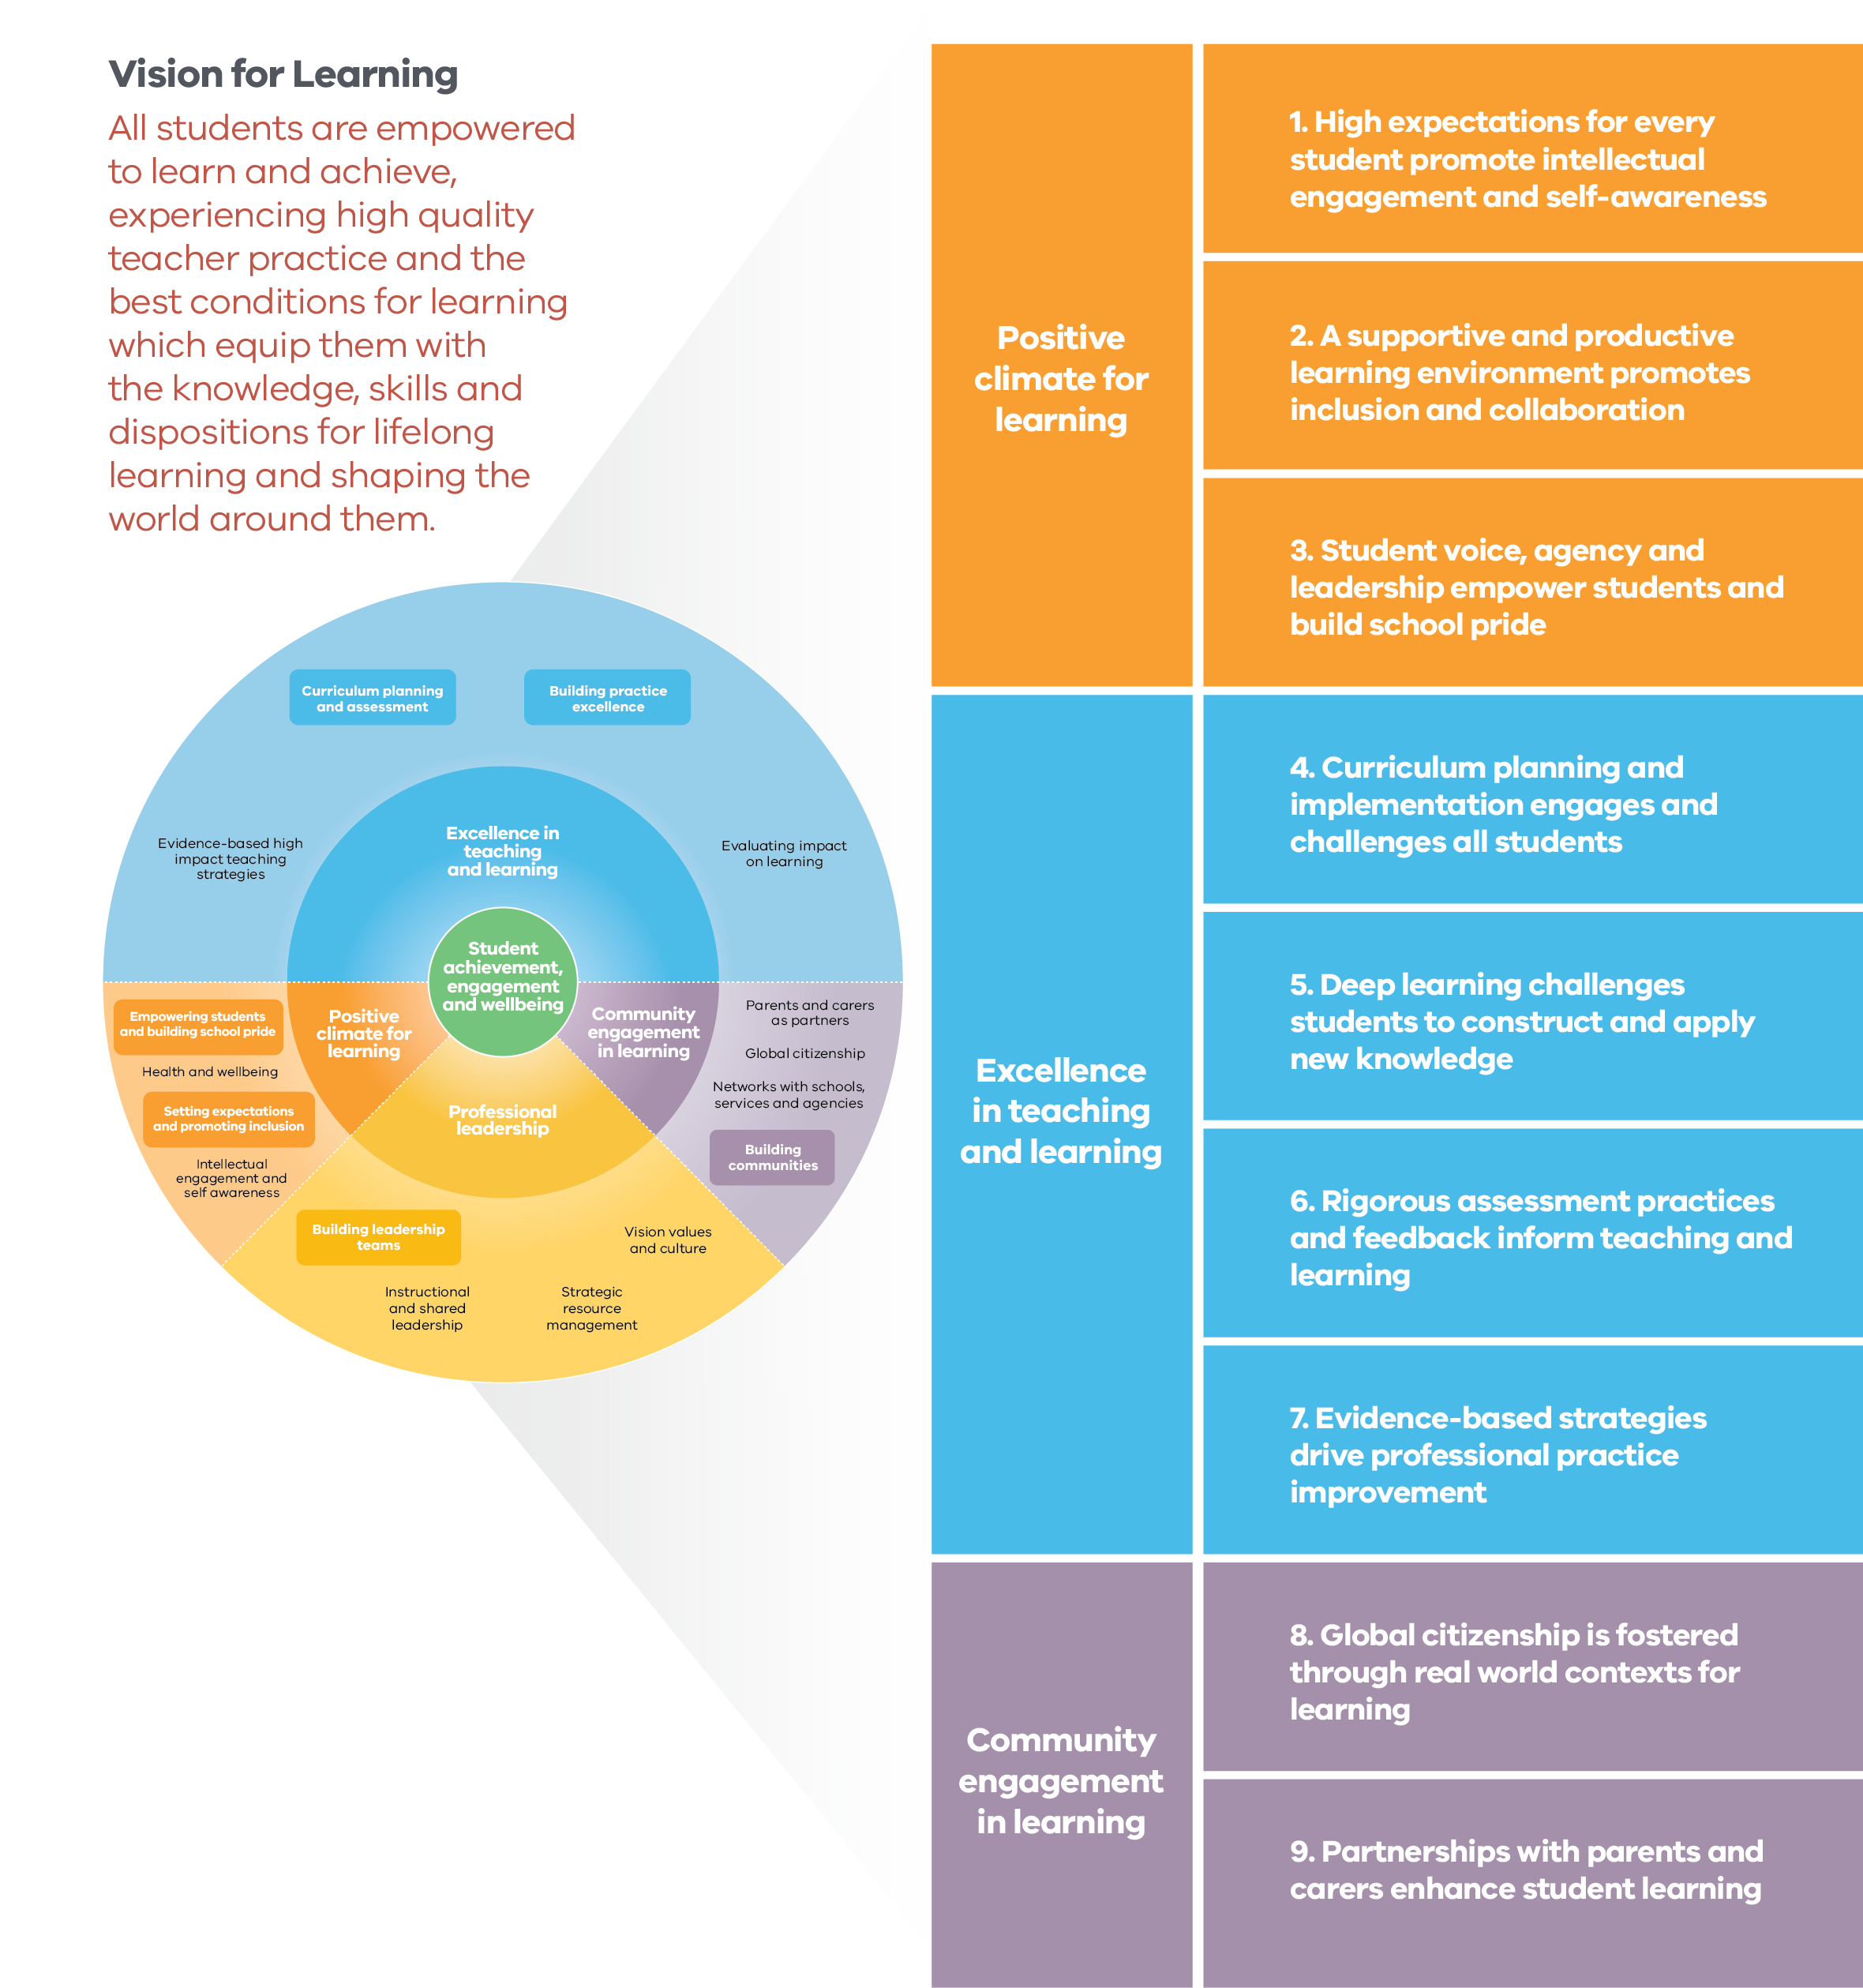

Text alternative for ‘FISO Improvement Model and Practice Principles chart’, including detailed information regarding practice principles is available at pages 18 – 50 of the Practice Principles for Excellence in Teaching and Learning accessible document: http://www.education.vic.gov.au/Documents/school/teachers/support/practiceprinciples.docx

Published by the Department of Education and Training Melbourne February 2018
© State of Victoria (Department of Education and Training) 2018
The copyright in this document is owned by the State of Victoria (Department of Education and Training), or in the case of some materials, by third parties (third party materials). No part may be reproduced by any process except in accordance with the provisions of the Copyright Act 1968, the National Education Access Licence for Schools (NEALS) (see below) or with permission.
An educational institution situated in Australia which is not conducted for profit, or a body responsible for administering such an institution may copy and communicate the materials, other than third party materials, for the educational purposes of the institution.
Authorised by the Department of Education and Training, 2 Treasury Place, East Melbourne, Victoria, 3002.

CONTENTS

GUIDED WHOLE-SCHOOL REFLECTION ACTIVITY 7
Purpose 7
Instructions 7
WHOLE-SCHOOL REFLECTION TOOL 9
1. High expectations for every student promote intellectual engagement and self-awareness 9
2. A supportive and productive learning environment promotes inclusion and collaboration 10
3. Student voice, agency and leadership empower students and build school pride 11
4. Curriculum planning and implementation engages and challenges all students 12
5. Deep learning challenges students to construct and apply new knowledge 13
6. Rigorous assessment practices and feedback inform teaching and learning 14
7. Evidence-based strategies drive professional practice improvement 15
8. Global citizenship is fostered through real world contexts for learning 16
9. Partnerships with parents and carers enhance student learning 17
Heat map 18
GUIDED TEACHER SELF-REFLECTION ACTIVITIES 19
Purpose 19
Instructions 19
TEACHER SELF-REFLECTION TOOL: PRACTICE PRINCIPLE 1 20
Action 1.1. Teachers convey high expectations of learning, effort and engagement for all students 20
Action 1.2. Teachers co-design aspirational goals with students 21
Action 1.3. Teachers scaffold and differentiate learning to enable students to achieve their goals 22
Action 1.4. Teachers build student capacity to monitor and evaluate their own progress and achievement 23
TEACHER SELF-REFLECTION TOOL: PRACTICE PRINCIPLE 2 24
Action 2.1. Teachers build quality relationships that enhance student engagement, self-confidence and growth as a learner 24
Action 2.2. Teachers ensure all students’ cultural backgrounds, needs and abilities are recognised and addressed in the learning program 25
Action 2.3. Teachers develop student capacity to collaborate 26
Action 2.4. Teachers maintain an energised and focused learning environment 27
TEACHER SELF-REFLECTION TOOL: PRACTICE PRINCIPLE 3 28
Action 3.1. Teachers empower students to have a democratic voice in the running of the communities in which they learn 28
Action 3.2. Teachers co-design opportunities for students to exercise authentic agency in their own learning 29
Action 3.3. Teachers co-design leadership opportunities 30
Action 3.4. Teachers build school pride and connectedness 31
TEACHER SELF-REFLECTION TOOL: PRACTICE PRINCIPLE 4 32
Action 4.1. Teachers place student needs at the centre of program planning and delivery 32
Action 4.2. Teachers collaboratively design and implement a scope and sequence of learning 33
Action 4.3. Teachers regularly review and update learning programs in line with school curriculum plans 34
TEACHER SELF-REFLECTION TOOL: PRACTICE PRINCIPLE 5 35
Action 5.1. Teachers design learning programs to explicitly build deep levels of thinking and application 35
Action 5.2. Teachers support students to explore the construction of knowledge 36
Action 5.3. Teachers support students to be reflective, questioning and self-monitoring learners 37
TEACHER SELF-REFLECTION TOOL: PRACTICE PRINCIPLE 6 38
Action 6.1. Teachers design authentic, fit for purpose assessments to reflect the learning program and objectives 38
Action 6.2. Teachers moderate student assessment and use data to diagnose student learning needs and plan for learning 39
Action 6.3. Teachers provide regular feedback to students on their progress against individual learning goals and curriculum standards 40
Action 6.4. Teachers analyse student achievement data to improve their practice 41
TEACHER SELF-REFLECTION TOOL: PRACTICE PRINCIPLE 7 42
Action 7.1. Teachers evaluate the impact of teaching on learning by analysing multiple sources of data 42
Action 7.2. Teachers identify and target areas for professional learning 43
Action 7.3. Teachers draw on current research and use an inquiry improvement cycle 44
Action 7.4. Teachers challenge and support each other to improve practice 45
TEACHER SELF-REFLECTION TOOL: PRACTICE PRINCIPLE 8 46
Action 8.1. Teachers support students to explore their role as global citizens 46
Action 8.2. Teachers model and facilitate using digital tools and resources to access, use and share learning 47
Action 8.3. Teachers and students co-design learning that connects to real world contexts 48
Action 8.4. Teachers and students collaborate in learning partnerships in and beyond the school 49
TEACHER SELF-REFLECTION TOOL: PRACTICE PRINCIPLE 9 50
Action 9.1. Teachers establish open and sustained communications with parents/carers 50
Action 9.2. Teachers seek and use parents’/carers’ knowledge and feedback 51
Action 9.3. Teachers facilitate parent/carer involvement in education within the classroom, school and beyond 52

GUIDED WHOLE-SCHOOL REFLECTION ACTIVITY

Purpose
This Guided Whole-School Reflection Activity is designed to facilitate discussion to support continuous improvement of teaching and learning practices at your school. This activity is best conducted in alignment with the new AIP design to reflect on the year passed, and to plan for the year ahead. The school self-evaluation against the FISO Continua of Practice, including evidence of impact of school improvement initiatives, will support the discussion. This activity will help to:
- facilitate open conversations and record reflections about pedagogical practices in your school
- build teachers’ knowledge of the Practice Principles for Excellence in Teaching and Learning
- deepen understandings of the imperatives for consistently high quality teaching across your school
- deepen knowledge and skills in recognising and evidencing excellent teaching practices
- plan next steps to improve school-wide excellence in teaching and learning.
This activity will not be used as a formal assessment of school performance.

Instructions
- Distribute copies of the Practice Principles to all staff prior to a whole staff meeting.
- At the whole staff meeting, distribute copies of the Guided Whole-School Reflection Tool
- Using the template below, ask teachers to work in small groups, led by a Learning Specialist, Leading Teacher or a PLC Instructional Leader, to discuss and note their perceptions of pedagogical practices at the school. Group leaders should refer to the Teacher Evidence Guide (see https://edugate.eduweb.vic.gov.au/Services/Schools/SchoolStaffPerformanceDev/Pages/Teacher%20Performance%20and%20Development.aspx).
- Report the reflections from the small groups to the whole school, particularly noting:
» Strengths, listing what teachers are already doing well
» Opportunities for improvement of teaching practices
» Evidence that supports your conclusions (e.g. student assessment data, student feedback, peer observations)
» Next steps that need to take place (e.g. work in a PLC to learn or direct learning, create new or update existing professional development goals).
- For each Practice Principle, collectively make the final judgement regarding your school’s performance and select the place of your school on the School-Wide Proficiency Scale.
- Invite teachers to mark their individual copies of the Whole- School Reflection Tool, noting which Practice Principles they will consider for their own professional development.
- Use the Heat Map (p.15) to indicate your school’s performance on each of the Practice Principles (x-axis) and the importance of these Principles to school improvement goals (y-axis).
- School leadership teams may use the Heat Map to shortlist key areas for inclusion in the whole-school or team professional learning programs.
- Teachers may take the next step and use Teacher Self-Reflection Activities (pp.17-) to engage in deeper reflection on the Practice Principles which they have identified for their own professional learning.
- At mid-cycle PDP review, the leadership team may refer to the completed Whole-School Reflection Tool and Heat Map to reflect on the school-wide progress toward meeting AIP targets and adjust the approach where needed. At the end-cycle PDP review, this tool may be used in the all-staff meeting to summarise the year’s efforts and inform new AIP targets.

WHOLE-SCHOOL REFLECTION TOOL

1. High expectations for every student promote intellectual engagement and self-awareness
1.1 Teachers convey high expectations of learning, effort and engagement for all students
1.2 Teachers co-design aspirational goals with students
1.3 Teachers scaffold and differentiate learning to enable students to achieve their goals
1.4 Teachers build student capacity to monitor and evaluate their own progress and achievement

Strengths | Opportunities for Improvement | Next steps
Evidence
School-Wide Proficiency Scale
Needs Improvement Excelling
Will you consider this Practice Principle for your own professional development? YES / NO
Review notes (mid-cycle, end-cycle)

2. A supportive and productive learning environment promotes inclusion and collaboration
2.1 Teachers build quality relationships that enhance student engagement, self-confidence and growth as a learner
2.2 Teachers ensure all students’ cultural backgrounds, needs and abilities are recognised and addressed in the learning program
2.3 Teachers develop student capacity to collaborate
2.4 Teachers maintain an energised and focused learning environment

Strengths | Opportunities for Improvement | Next steps
Evidence
School-Wide Proficiency Scale
Needs Improvement Excelling
Will you consider this Practice Principle for your own professional development? YES / NO
Review notes (mid-cycle, end-cycle)

3. Student voice, agency and leadership empower students and build school pride
3.1 Teachers empower students to have a democratic voice in the running of the communities in which they learn
3.2 Teachers co-design opportunities for students to exercise authentic agency in their own learning
3.3 Teachers co-design leadership opportunities
3.4 Teachers build school pride and connectedness

Strengths | Opportunities for Improvement | Next steps
Evidence
School-Wide Proficiency Scale
Needs Improvement Excelling
Will you consider this Practice Principle for your own professional development? YES / NO
Review notes (mid-cycle, end-cycle)

4. Curriculum planning and implementation engages and challenges all students
4.1 Teachers place student needs at the centre of program planning and delivery
4.2 Teachers collaboratively design and implement a scope and sequence of learning
4.3 Teachers regularly review and update learning programs in line with school curriculum plans

Strengths | Opportunities for Improvement | Next steps
Evidence
School-Wide Proficiency Scale
Needs Improvement Excelling
Will you consider this Practice Principle for your own professional development? YES / NO
Review notes (mid-cycle, end-cycle)

5. Deep learning challenges students to construct and apply new knowledge
5.1 Teachers design learning programs to explicitly build deep levels of thinking and application
5.2 Teachers support students to explore the construction of knowledge
5.3 Teachers support students to reflective, questioning and self-monitoring learners

Strengths | Opportunities for Improvement | Next steps
Evidence
School-Wide Proficiency Scale
Needs Improvement Excelling
Will you consider this Practice Principle for your own professional development? YES / NO
Review notes (mid-cycle, end-cycle)

6. Rigorous assessment practices and feedback inform teaching and learning
6.1 Teachers design authentic, fit for purpose assessments to reflect the learning program and objectives
6.2 Teachers moderate student assessment and use data to diagnose student learning needs and plan for learning
6.3 Teachers provide regular feedback to students on their progress against individual learning goals and curriculum standards
6.4 Teachers analyse student achievement data to improve their practice

Strengths | Opportunities for Improvement | Next steps
Evidence
School-Wide Proficiency Scale
Needs Improvement Excelling
Will you consider this Practice Principle for your own professional development? YES / NO
Review notes (mid-cycle, end-cycle)

7. Evidence-based strategies drive professional practice improvement
7.1 Teachers evaluate the impact of teaching on learning by analysing multiple sources of data
7.2 Teachers identify and target areas for professional learning
7.3 Teachers draw on current research and use an inquiry improvement cycle
7.4 Teachers challenge and support each other to improve practice

Strengths | Opportunities for Improvement | Next steps
Evidence
School-Wide Proficiency Scale
Needs Improvement Excelling
Will you consider this Practice Principle for your own professional development? YES / NO
Review notes (mid-cycle, end-cycle)

8. Global citizenship is fostered through real world contexts for learning
8.1 Teachers support students to explore their role as global citizens
8.2 Teachers model and facilitate using digital tools and resources to access, use and share learning
8.3 Teachers and students co-design learning that connects to real world contexts
8.4 Teachers and students collaborate in learning partnerships in and beyond the school

Strengths | Opportunities for Improvement | Next steps
Evidence
School-Wide Proficiency Scale
Needs Improvement Excelling
Will you consider this Practice Principle for your own professional development? YES / NO
Review notes (mid-cycle, end-cycle)

9. Partnerships with parents and carers enhance student learning
9.1 Teachers establish open and sustained communications with parents/carers
9.2 Teachers seek and use parents’/carers’ knowledge and feedback
9.3 Teachers facilitate parent/carer involvement in education within the classroom, school and beyond

Strengths | Opportunities for Improvement | Next steps
Evidence
School-Wide Proficiency Scale
Needs Improvement Excelling
Will you consider this Practice Principle for your own professional development? YES / NO
Review notes (mid-cycle, end-cycle)

Heat map
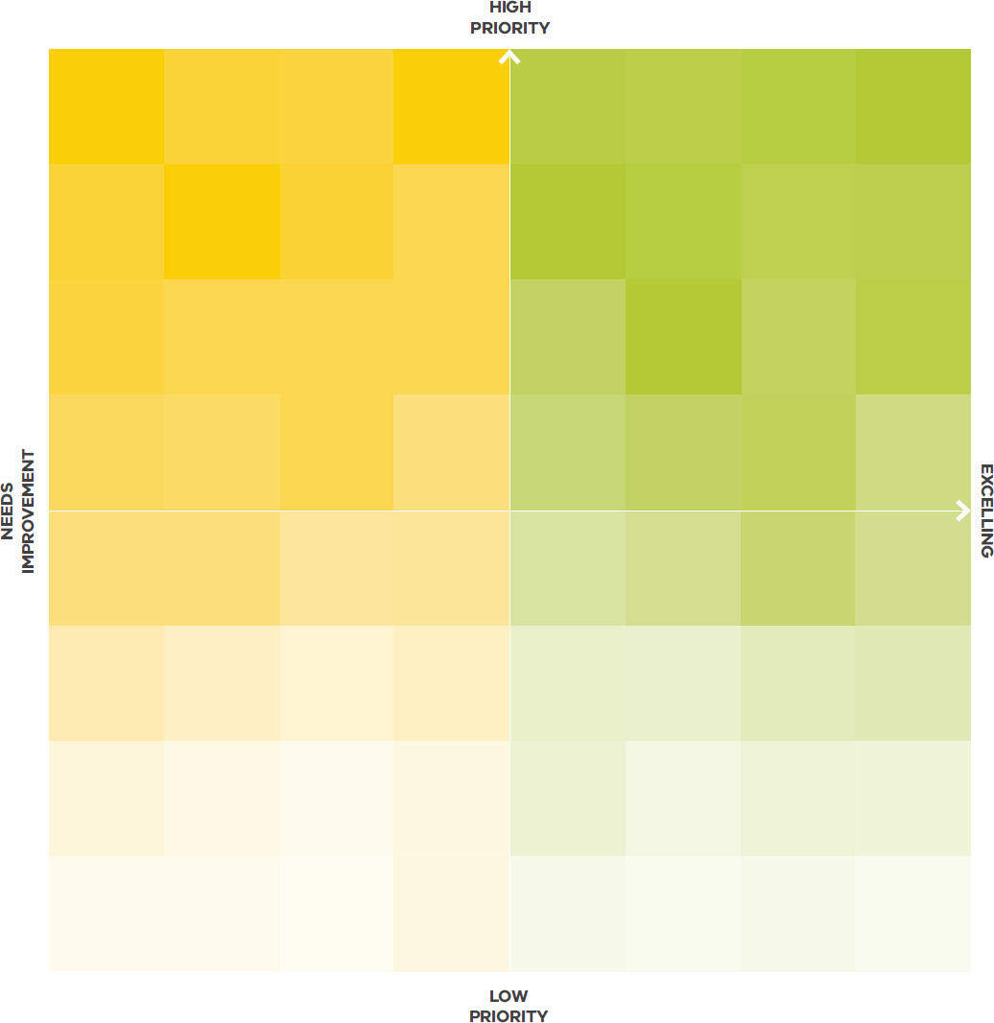

GUIDED TEACHER SELF-REFLECTION ACTIVITIES

Purpose

These Guided Teacher Self-Reflection Activities are designed to help you dive deeper into the Practice Principles and plan next steps to improve your teaching practice. Following up from the whole-school discussion, you can use the Teacher Self-Reflection Tool to work individually and in collaboration with colleagues.
These activities will help to:
- build your knowledge of the individual Practice Principles
- reflect on your teaching practice in relation to the Practice Principles
- deepen knowledge and skills in collecting and interpreting relevant evidence to evaluate your teaching practice
- plan next steps to improve your teaching or help others to improve their teaching practice.
This activity will not be used as a formal assessment of your performance.

Instructions
- Use the Teacher Self-Reflection Tool to reflect on your practice. For each Action, record:
» Strengths, listing what you are already doing well
» Opportunities for improvement of your practice
» Evidence that supports your conclusions (e.g. student assessment data, student feedback, peer observations)
» Next steps that need to take place (e.g. work in a PLC to learn or direct learning, create new or update existing PDP goals).
- Select areas of focus for the Practice Principles. Work with colleagues to engage in professional learning to improve your skills, knowledge and practice. Use multiple sources of data to monitor student attitudes and achievement.
- At mid-cycle or end-cycle PDP review, refer to this completed Teacher Self-reflection Tool to reflect on your progress.

TEACHER SELF-REFLECTION TOOL: PRACTICE PRINCIPLE 1

Action 1.1. Teachers convey high expectations of learning, effort and engagement for all students
I communicate high expectations about all aspects of school
I emphasise the quality of learning with the valuing of effort
I ensure all students understand the standards expected of them
I provide constructive feedback and challenges students to further their learning

Strengths | Opportunities for improvement | Next steps
Evidence
Will you consider this Action for your own professional development? YES / NO
Review notes (mid-cycle, end-cycle)

Action 1.2. Teachers co-design aspirational goals with students
I build students’ confidence, optimism and self-belief
I support students to identify strengths and areas for improvement
I support specific groups of students (e.g. English as an additional language, disabilities and additional needs) with appropriate resources to tailor support and modify learning goals
I collaborate with students to identify appropriate goals to progress their learning

Strengths | Opportunities for improvement | Next steps
Evidence
Will you consider this Action for your own professional development? YES / NO
Review notes (mid-cycle, end-cycle)

Action 1.3. Teachers scaffold and differentiate learning to enable students to achieve their goals
I determine prior knowledge to understand students’ interests, aspirations and readiness for learning
I use a range of teaching strategies that leverage and develop different skills and abilities to enable achievement of goals
I empower students to make decisions about what and how they learn
I structure learning to support students to achieve challenging goals

Strengths | Opportunities for improvement | Next steps
Evidence
Will you consider this Action for your own professional development? YES / NO
Review notes (mid-cycle, end-cycle)

Action 1.4. Teachers build student capacity to monitor and evaluate their own progress and achievement
I ensure assessment criteria are explicit
I provide a range of strategies, tools and rubrics to support student self-evaluation and self-assessment
I assist students to frame future learning goals based on strengths and areas for improvement

Strengths | Opportunities for improvement | Next steps
Evidence
Will you consider this Action for your own professional development? YES / NO
Review notes (mid-cycle, end-cycle)

TEACHER SELF-REFLECTION TOOL: PRACTICE PRINCIPLE 2

Action 2.1. Teachers build quality relationships that enhance student engagement, self-confidence and growth as a learner
I demonstrate genuine interest in, and values, all students
I co-design, with the students, learning and behaviour norms and protocols
I engage in one-on-one conversations with students to build and enhance productive relationships
I use a range of tools to receive regular student feedback on classroom climate

Strengths | Opportunities for improvement | Next steps
Evidence
Will you consider this Action for your own professional development? YES / NO
Review notes (mid-cycle, end-cycle)

Action 2.2. Teachers ensure all students’ cultural backgrounds, needs and abilities are recognised and addressed in the learning program
I ensure the learning program is relevant to student needs, interests and learning goals
I ensure learning experiences explore and extend intercultural connections and awareness (Intercultural Capability, Victorian Curriculum F 10)
I co-design learning plans with students and seeks input from parents/carers
I ensure targeted supports for individual students are in place and effective

Strengths | Opportunities for improvement | Next steps
Evidence
Will you consider this Action for your own professional development? YES / NO
Review notes (mid-cycle, end-cycle)

Action 2.3. Teachers develop student capacity to collaborate
I develop team building skills which enable students to collaborate, negotiate and contribute to shared tasks (Personal and Social Capability, Victorian Curriculum F-10)
I support specific groups of students (e.g. English as an additional language, disabilities and additional needs) with appropriate scaffolding and resourcing to effectively participate in collaboration activities
I enable students to share roles, responsibilities and ownership of outcomes
I provide opportunities for students to reflect on and evaluate the value of working together

Strengths | Opportunities for improvement | Next steps
Evidence
Will you consider this Action for your own professional development? YES / NO
Review notes (mid-cycle, end-cycle)

Action 2.4. Teachers maintain an energised and focused learning environment
I provide learning intentions and success criteria to support student achievement of learning goals
I identify and uses appropriately engaging resources
I ensure learning time is maximised and students are engaged and on task

Strengths | Opportunities for improvement | Next steps
Evidence
Will you consider this Action for your own professional development? YES / NO
Review notes (mid-cycle, end-cycle)

TEACHER SELF-REFLECTION TOOL: PRACTICE PRINCIPLE 3

Action 3.1. Teachers empower students to have a democratic voice in the running of the communities in which they learn
I consider students’ backgrounds, interests and needs to create authentic and meaningful learning opportunities
I involve students in curriculum planning and implementation
I empower students to present their own ideas, opinions, knowledge and experience
I build students’ capacity to participate in whole school decision making

Strengths | Opportunities for improvement | Next steps
Evidence
Will you consider this Action for your own professional development? YES / NO
Review notes (mid-cycle, end-cycle)

Action 3.2. Teachers co-design opportunities for students to exercise authentic agency in their own learning
I assist students to take ownership of their learning by identifying strategies that support them to attain learning goals
I assist students to become increasingly self-directed over time, and to gain confidence in their ability to complete learning tasks
I provide opportunities for students to reflect on the effectiveness of their learning and plan for future development
I enable students to negotiate assessment methods and criteria matched to their learning goals

Strengths | Opportunities for improvement | Next steps
Evidence
Will you consider this Action for your own professional development? YES / NO
Review notes (mid-cycle, end-cycle)

Action 3.3. Teachers co-design leadership opportunities
I explicitly teach leadership skills
I co-design opportunities for students to initiate school events, and to engage in planning and facilitating them
I co-design opportunities for students to build partnerships that connect learning within and beyond the school
I support students to engage with the school community in different forums

Strengths | Opportunities for improvement | Next steps
Evidence
Will you consider this Action for your own professional development? YES / NO
Review notes (mid-cycle, end-cycle)

Action 3.4. Teachers build school pride and connectedness
I promote and celebrate individual student and school achievements
I build connectedness with parents/carers and the broader community to strengthen social ties, care and support for students
I co-design opportunities for students to share and exhibit the outcomes of their learning with the school community and beyond

Strengths | Opportunities for improvement | Next steps
Evidence
Will you consider this Action for your own professional development? YES / NO
Review notes (mid-cycle, end-cycle)

TEACHER SELF-REFLECTION TOOL: PRACTICE PRINCIPLE 4

Action 4.1. Teachers place student needs at the centre of program planning and delivery
I analyse a range of student data to design learning programs with multiple entry points
I select and use a range of resources, including digital tools, to enhance learning
I incorporate real life contexts and learning beyond the classroom
I include students in curriculum planning

Strengths | Opportunities for improvement | Next steps
Evidence
Will you consider this Action for your own professional development? YES / NO
Review notes (mid-cycle, end-cycle)

Action 4.2. Teachers collaboratively design and implement a scope and sequence of learning
I work in Professional Learning Communities (PLC) to design learning programs that integrate the Victorian Curriculum Content Descriptions, and Achievement Standards for Learning Areas and Capabilities
I design learning programs that are developmental and scaffolded to meet students’ needs
I implement assessment strategies that meet the Achievement Standards for Learning Areas and Capabilities

Strengths | Opportunities for improvement | Next steps
Evidence
Will you consider this Action for your own professional development? YES / NO
Review notes (mid-cycle, end-cycle)

Action 4.3. Teachers regularly review and update learning programs in line with school curriculum plans
I work in a PLC to ensure learning programs (curriculum implementation, pedagogical practices and assessment strategies) are consistent across the school
I use evidence to regularly monitor the effectiveness of the programs in meeting student learning needs and establishing challenging learning goals
I access contemporary research and resources to enrich teaching and learning programs, and to enhance student engagement.

Strengths | Opportunities for improvement | Next steps
Evidence
Will you consider this Action for your own professional development? YES / NO
Review notes (mid-cycle, end-cycle)

TEACHER SELF-REFLECTION TOOL: PRACTICE PRINCIPLE 5

Action 5.1. Teachers design learning programs to explicitly build deep levels of thinking and application
I sequence learning programs to include both surface and deep learning based on the Victorian Curriculum achievement standards
I design open-ended learning experiences for students to investigate complex ideas
I model and develop students’ critical, creative and higher order thinking skills

Strengths | Opportunities for improvement | Next steps
Evidence
Will you consider this Action for your own professional development? YES / NO
Review notes (mid-cycle, end-cycle)

Action 5.2. Teachers support students to explore the construction of knowledge
I support students to form theories, find patterns and make connections in their learning
I build understanding of knowledge construction in different learning disciplines
I design investigations of current issues for students to compare and contrast different perspectives
I develop students’ capacity to critically analyse and use data and information for different purposes

Strengths | Opportunities for improvement | Next steps
Evidence
Will you consider this Action for your own professional development? YES / NO
Review notes (mid-cycle, end-cycle)

Action 5.3. Teachers support students to be reflective, questioning and self-monitoring learners
I stimulate students to explore their own beliefs, assumptions and understandings
I prioritise time and resources for students to analyse and reflect on how they learn
I provide opportunities for students to share their learning, teach, question and challenge each other
I support students to question and form conclusions about the value of the learning

Strengths | Opportunities for improvement | Next steps
Evidence
Will you consider this Action for your own professional development? YES / NO
Review notes (mid-cycle, end-cycle)

TEACHER SELF-REFLECTION TOOL: PRACTICE PRINCIPLE 6

Action 6.1. Teachers design authentic, fit for purpose assessments to reflect the learning program and objectives
I collaboratively develop assessment strategies that measure progress of student learning against achievement standards
I integrate assessment strategies into the learning sequence
I engage students in developing explicit assessment criteria
I use a range of formative and summative assessment strategies

Strengths | Opportunities for improvement | Next steps
Evidence
Will you consider this Action for your own professional development? YES / NO
Review notes (mid-cycle, end-cycle)

Action 6.2. Teachers moderate student assessment and use data to diagnose student learning needs and plan for learning
I work with colleagues to moderate and analyse multiple sources of assessment data
I use a range of evidence to diagnose student learning
I embed a range of assessment strategies within the learning program
I use student self-assessment in the planning process

Strengths | Opportunities for improvement | Next steps
Evidence
Will you consider this Action for your own professional development? YES / NO
Review notes (mid-cycle, end-cycle)

Action 6.3. Teachers provide regular feedback to students on their progress against individual learning goals and curriculum standards
I make the assessment criteria explicit to students and parents/carers
I organise a variety of audiences to provide feedback, including peer feedback
I provide feedback to students that articulates progress as well as the next steps required to advance their learning
I support students to self-evaluate, building the skills to monitor, review and reflect on their progress

Strengths | Opportunities for improvement | Next steps
Evidence
Will you consider this Action for your own professional development? YES / NO
Review notes (mid-cycle, end-cycle)

Action 6.4. Teachers analyse student achievement data to improve their practice
I regularly collaborate with colleagues to moderate student work
I analyse student assessment data to identify areas of practice for improvement
I actively seek student feedback about their teaching practice
I collaborate with colleagues to share knowledge and skills in identified areas for improvement

Strengths | Opportunities for improvement | Next steps
Evidence
Will you consider this Action for your own professional development? YES / NO
Review notes (mid-cycle, end-cycle)

TEACHER SELF-REFLECTION TOOL: PRACTICE PRINCIPLE 7

Action 7.1. Teachers evaluate the impact of teaching on learning by analysing multiple sources of data
I use high quality, fit for purpose assessment tasks that reflect the full range of learning goals
I use explicit criteria referenced against the achievement standards and learning goals
I make consistent judgements validated by moderation in professional learning teams
I use peer, student and parent/carer feedback

Strengths | Opportunities for improvement | Next steps
Evidence
Will you consider this Action for your own professional development? YES / NO
Review notes (mid-cycle, end-cycle)

Action 7.2. Teachers identify and target areas for professional learning
I link student achievement data to my own practice improvement goals
I anchor my professional learning goals in my Performance and Development Plan (PDP)
I work collaboratively with colleagues on shared development goals

Strengths | Opportunities for improvement | Next steps
Evidence
Will you consider this Action for your own professional development? YES / NO
Review notes (mid-cycle, end-cycle)

Action 7.3. Teachers draw on current research and use an inquiry improvement cycle
I undertake research to build knowledge and skills of evidence-based strategies
I plan and implement new practices using the Framework for Improving Student Outcomes (FISO) improvement cycle
I continuously monitor, self-assess and reflect on changes to practice

Strengths | Opportunities for improvement | Next steps
Evidence
Will you consider this Action for your own professional development? YES / NO
Review notes (mid-cycle, end-cycle)

Action 7.4. Teachers challenge and support each other to improve practice
I regularly undertake peer observation and receive/provide feedback on teaching practice
I collaborate with colleagues to trial and refine application of high impact teaching strategies
I seek expert practitioner advice, coaching and mentoring

Strengths | Opportunities for improvement | Next steps
Evidence
Will you consider this Action for your own professional development? YES / NO
Review notes (mid-cycle, end-cycle)

TEACHER SELF-REFLECTION TOOL: PRACTICE PRINCIPLE 8

Action 8.1. Teachers support students to explore their role as global citizens
I actively support students to identify and share their own stories, background and cultures
I acknowledge and integrate Indigenous cultural, historical and social perspectives in teaching and learning
I support students to recognise their perspectives on issues
I create opportunities for students to investigate and connect with community and action group endeavours

Strengths | Opportunities for improvement | Next steps
Evidence
Will you consider this Action for your own professional development? YES / NO
Review notes (mid-cycle, end-cycle)

Action 8.2. Teachers model and facilitate using digital tools and resources to access, use and share learning
I model and facilitate technology use for investigation, problem solving and knowledge construction
I model and encourage technology use that fosters creativity and innovation
I model and support technology use for communication
I use technology to connect students to real world contexts and engage with authentic audiences

Strengths | Opportunities for improvement | Next steps
Evidence
Will you consider this Action for your own professional development? YES / NO
Review notes (mid-cycle, end-cycle)

Action 8.3. Teachers and students co-design learning that connects to real world contexts
I integrate the learning areas and capabilities, and support students to identify learning connections across a range of contexts
I support students to identify and explore real world issues and problems
I empower students to take action to develop innovative solutions that address local and global issues

Strengths | Opportunities for improvement | Next steps
Evidence
Will you consider this Action for your own professional development? YES / NO
Review notes (mid-cycle, end-cycle)

Action 8.4. Teachers and students collaborate in learning partnerships in and beyond the school
I use collaborative practices in the classroom
I support and facilitate local and global student connections with peers and experts
I develop students’ skills and confidence to seek and sustain partnerships for learning

Strengths | Opportunities for improvement | Next steps
Evidence
Will you consider this Action for your own professional development? YES / NO
Review notes (mid-cycle, end-cycle)

TEACHER SELF-REFLECTION TOOL: PRACTICE PRINCIPLE 9

Action 9.1. Teachers establish open and sustained communications with parents/carers
I appreciate the uniqueness of each family and work to overcome potential challenges to establish and strengthen partnerships
I provide parents/carers with a range of communication channels to accommodate different needs
I provide regular updates on student progress, health and wellbeing, and information about school policies and practice
I make regular contact with parents/carers to celebrate successes and identify concerns

Strengths | Opportunities for improvement | Next steps
Evidence
Will you consider this Action for your own professional development? YES / NO
Review notes (mid-cycle, end-cycle)

Action 9.2. Teachers seek and use parents’/carers’ knowledge and feedback
I value the unique perspectives that parents/carers bring, seeking insights on the strengths, abilities, interests and challenges of each student
I consult with parents/carers to develop learning plans to support student learning needs
I provide parents/carers with opportunities to present their expectations, understanding and perspectives on their child’s education
I invite parents/carers to provide feedback on school policies and practices

Strengths | Opportunities for improvement | Next steps
Evidence
Will you consider this Action for your own professional development? YES / NO
Review notes (mid-cycle, end-cycle)

Action 9.3. Teachers facilitate parent/carer involvement in education within the classroom, school and beyond
I actively engage parents/carers to establish aspirational student learning goals and plan learning programs
I support parents/carers with information, strategies and resources to link school and home learning
I provide opportunities for parents/carers to contribute to school learning programs
I facilitate parental/carer participation in whole school improvement, governance and initiatives

Strengths | Opportunities for improvement | Next steps
Evidence
Will you consider this Action for your own professional development? YES / NO
Review notes (mid-cycle, end-cycle)

