# School reunions GUIDE





School Reunions

School reunions are events that provide people with an opportunity to reacquaint with ‘old school’ students and staff. School reunions are now an expected event and contacting the ‘old school’ seems a place to start when trying to organise a reunion. However personal information held by schools is not generally available to the public.

## Is this because of the privacy laws?

No, though privacy laws have made people more aware of their responsibility to protect personal information.

While school principals may provide a list of names of students for a particular period they cannot supply you with contact details they hold.

A school may not be able to provide you with names when it is impractical to retrieve the specified records or to separate names from contact details or other personal information about ex-students.

Also, given the passage of time, contact details the ‘old school’ has are probably out of date and some student’s names will also have changed.

It is also important to remember that some students will not want to be contacted nor have their parents contacted.

## Freedom of Information

This legislation enables people to obtain information about themselves. Information about other people is usually not given out under this legislation. Application to the Department’s Freedom of Information Unit is unlikely to be successful.

## How do I inform people about a school reunion?

There are various ways you can inform people of an upcoming reunion:

* Contact the school and ask if you can put an ad in their newsletter giving details of the reunion.
* Contact your local newspaper who can run an ad for you (for a fee).
* Contact magazines such as the *Australian Women’s Weekly* who will display your ad for free (however, they receive many requests so there is no guarantee your ad will appear). Or you can pay for an ad to be placed.
* Place an ad in the *Connections* section of the *Herald Sun* on Fridays

## What else can I do?

There are websites dedicated to reuniting school friends and to assist with school reunions. These websites are extremely popular and are considered by many to be the best starting point to finding old schoolmates. They usually charge a fee but these are reasonable. Here are the most used Australian websites:

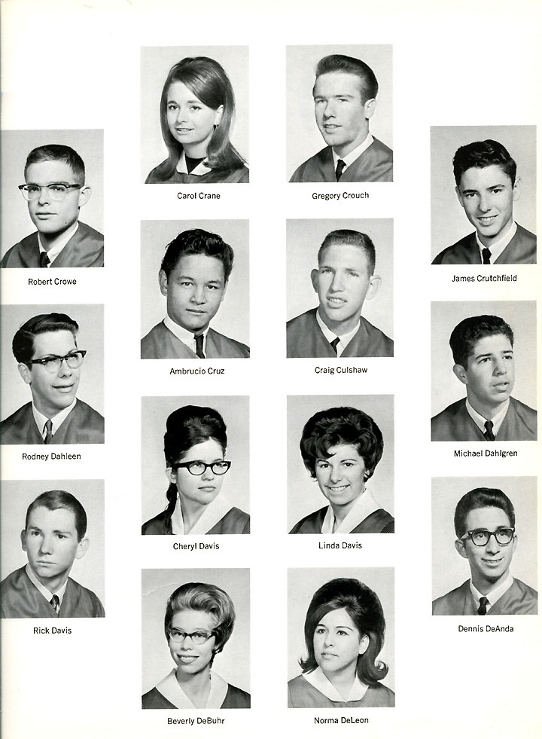

www.schoolfriends.com.au

www.friendsreunited.com.au

www.ozreunion.com.au

www.aussieschoolpals.com

www.personsmissing.org

www.webfront.net.au/~compucom/reunion

If you are trying to contact ex-students that may be living overseas these sites have links to worldwide school reunion sites.

## Can I contact a person if they attended a previous reunion?

Yes. If a person has given their contact details in order to attend a school reunion then it is reasonable to expect that they would like to be informed of similar future events. However using their contact details for other purposes such as fundraising for the ‘old school’ should only be done if the person has consented to being contacted for such purposes.

A school reunion is an obvious opportunity to ask people if they would like to be contacted for fundraising for the ‘old school’ or to provide help in organising future events. If these purposes are made clear on the reunion registration form, and the person is given the opportunity to ‘opt out’ from being contacted for other purposes, the use of their contact details for these other purposes (when the person has indicated such an approach is acceptable) is ok.

## What if the school I attended is now closed?

Most closed primary schools have enrolment records available at the Public Records of Victoria (PROV), but few closed secondary schools have such records accessible because of additional personal information with the enrolment.

Contact PROV on www.prov.vic.gov.au or phone 9348 5600.Open consignments of closed school records at PROV can hold other records of interest to reunion organisers such as photographs and school magazines.

## Can we display ‘old’ class photographs as part of a school reunion event?

Yes. These photos are readily available and such a use, as part of a school reunion event, is both reasonable and expected.

## Are there any other privacy concerns that organisers of a school reunion should be aware of?

If you establish a website or web ‘bulletin board’ to advertise your reunion you should maintain strict control over content that is put on the site and able to be viewed by anyone. Unfortunately, websites set up by school reunion organisers have been used to place derogatory, untrue and defamatory remarks about ‘old school’ staff and students.

## For further information and advice contact our email address via:

[privacy.enquiries@edumail.vic.gov.au](mailto:privacy.enquiries@edumail.vic.gov.au)

You can also contact the Office of the Victorian Information Commissioner Privacy & Data Protection on 1300 666 444 or via email: [enquiries@privacy.vic.gov.au](mailto:enquiries@privacy.vic.gov.au)