using spot in a small, rural school

EILDON PRIMARY SCHOOL
Area: Goulburn, North-Eastern Victoria
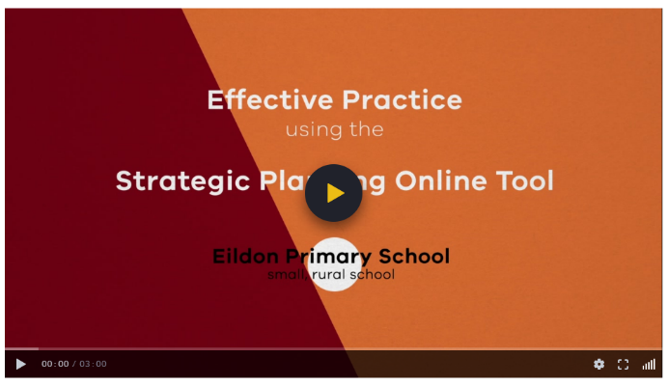
Population: approximately 50 students

video SNAPSHOT
This video features Eildon Primary School, a small, rural school located in North-Eastern Victoria. It discusses the benefits of using SPOT to provide a collective understanding about the schools improvement efforts. It also looks at using SPOT to monitor progress and ensure focused effort on achieving goals and targets.

Key Themes
- Supporting the school review process
- Providing transparency to teachers
- Reducing administrative burden
- Focus on implementation
- Driving effort in the right direction

Discussion Prompts and reflective activity
- To what extent do we collaborate with the broader school community in our annual planning?
- What systems, structures and processes do we have in place for using SPOT to monitor our AIP?
- Complete a SOAR analysis of how you use SPOT in your school (see next page for a template).

SUPPORTING DOCUMENTATION
SOAR ANALYSIS
A SOAR analysis is a technique used to reflect on strengths and opportunities and highlight future aspirations.
- Framework for Improving Student Outcomes
- Annual Implementation Planning
- School Strategic Plan
- School Review Process
- Strategic Planning Online Tool

Strengths: What can we build on? | Aspirations: What do we want to achieve?
Opportunities: What is our school community asking for? | Results: How do we know we are succeeding?

SOAR analysis of SPOT

© State of Victoria (Department of Education and Training) 2019. Except where otherwise noted, material in this document is provided under a
Creative Commons Attribution 4.0 International Please check the full copyright notice

