using spot in a multi-campus school

warringa park SCHOOL
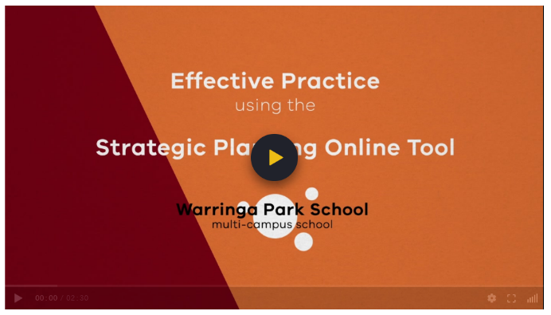
Area: Western Melbourne, South-Western Victoria
Population: approximately 500 students

video SNAPSHOT
This video features Warringa Park School, located in South-Western Victoria. It discusses strategies that the leadership team uses to build a collective understanding of their strategic planning and school improvement across multiple campuses.

Key Themes
- Provide clarity for staff
- Informs work at every level
- Work collaboratively to review progress
- Develop a collective understanding

Discussion Prompts and reflective activity
- How does our school use SPOT across campuses to ensure collective understanding of our goals, targets and key improvement strategies in focus for the year?
- What systems, structures, and processes support collaborative planning in our school?
- Complete a SWOT analysis of how you use SPOT in your school (see next page for a template).
SWOT Analysis
A SWOT analysis is a technique used to help identify strengths, weaknesses, opportunities and threats.

SUPPORTING DOCUMENTATION
- Framework for Improving Student Outcomes
- Annual Implementation Planning
- School Strategic Plan
- School Review Process
- Strategic Planning Online Tool

Strengths | Weaknesses
Opportunities | Threats

SWOT analysis of SPOT

© State of Victoria (Department of Education and Training) 2019. Except where otherwise noted, material in this document is provided under a
Creative Commons Attribution 4.0 International Please check the full copyright notice

