USING SPOT IN A LARGE COLLEGE

ROXBURGH COLLEGE
Area: Hume Moreland, North-Western Victoria
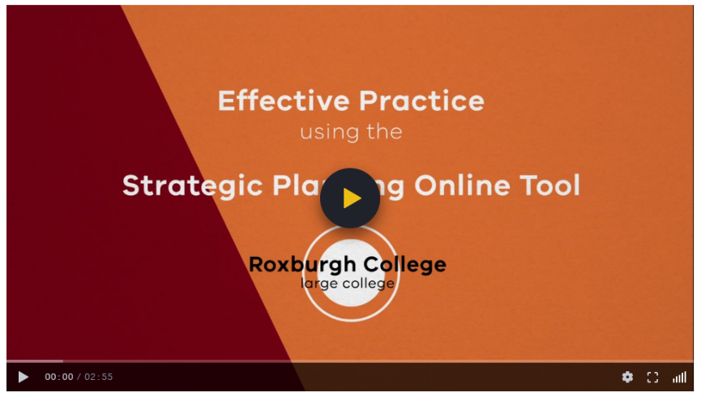
Population: approximately 1400 students

video SNAPSHOT
This video features Roxburgh College, a large college in North-Western Victoria. It discusses strategies to provide access to school strategic planning documentation across all levels of staff. It also highlights their work to provide voice and agency to teachers, as key implementers of the school’s improvement strategy.

Key Themes
- Distributed leadership
- Giving teachers voice and agency
- Supporting school improvement discussions
- Providing line of sight
- Plan for professional learning

Discussion Prompts and reflective activity
- What opportunities does SPOT provide for building middle leadership capability and enacting distributed leadership?
- How do we ensure that we are capturing the voice of all members of the school community?
- To what extent is our AIP a ‘living, breathing’ document?
- Complete a NOISE analysis of how your school uses SPOT (see next page for a template).
NOISE ANALYSIS
A NOISE analysis is a technique used to help identify needs, opportunities, improvements, strengths and exceptions.

SUPPORTING DOCUMENTATION
- Framework for Improving Student Outcomes
- Annual Implementation Planning
- School Strategic Plan
- School Review Process
- Strategic Planning Online Tool

NOISE analysis of SPOT

Strengths  Exceptions | Needs
Opportunities | Improvements

© State of Victoria (Department of Education and Training) 2019. Except where otherwise noted, material in this document is provided under a
Creative Commons Attribution 4.0 International Please check the full copyright notice

