Measures used in the Differentiated School Performance Method

Contents

This document provides the definition of each of the measures included in the Method.

MEASURE: Percentage of students in the top two bands of NAPLAN Reading 4
MEASURE: Percentage of students in the top two bands of NAPLAN Numeracy 5
MEASURE: Percentage of students in the bottom two bands of NAPLAN REading 6
MEASURE: Percentage of students in the bottom two bands of NAPLAN Numeracy 7
MEASURE: Percentage of students with high or medium levels of learning gain, reading 8
MEASURE: Percentage of students with high or medium levels of learning gain, numeracy 9
MEASURE: Percentage of staff with positive endorsement in Collective Efficacy 10
MEASURE: Percentage of staff with positive endorsement in Academic Emphasis 11
MEASURE: Percentage of staff with positive endorsement in Instructional Leadership 12
MEASURE: Percentage of students with positive attitude to Stimulating Learning 13
MEASURE: Percentage of students with positive attitude to Learning Confidence 14
MEASURE: Percentage of students with positive attitude to School Safety 15
MEASURE: Attendance rate 16
MEASURE: Percentage of students participating in NAPLAN assessment 17
MEASURE: Percentage of students participating in Attitudes to School Survey 18
MEASURE: Percentage of staff participating in School Staff Survey 19
MEASURE: Completing School 20
MEASURE: Mean VCE English score 21

Introduction: The Differentiated School Performance Method
From 2018, a new review and improvement approach is being implemented across the state. The new approach emphasises continuous improvement, with the implementation of targeted, differentiated supports, and affirms that every student, no matter their background or circumstances, has a right to learn in a school deeply committed to improvement.
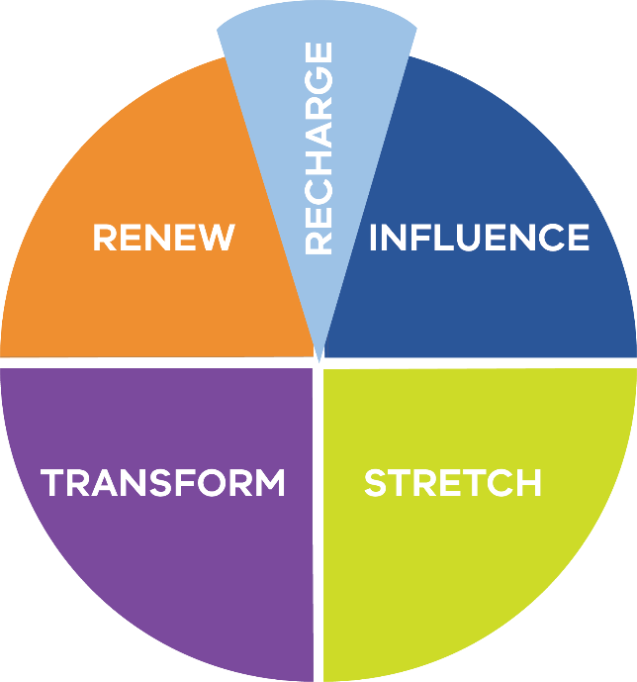
This new approach requires a constant focus on collecting and analysing evidence about student learning, teacher practice and curriculum content. By measuring each school’s performance, we can pinpoint their current level of accomplishment across a range of measures, and identify the areas for improvement that will lead to the greatest lift in outcomes for students.
Fig 1: The Five Differentiated School Performance Groups.
The new Differentiated School Performance Method has been developed to enable a more precise method for measuring school performance across the system and complements the new school review and differentiated support for school improvement initiatives. The Differentiated School Performance Method uses fewer measures, holds all schools to the same standards and assigns schools to one of five Differentiated School Performance Groups (Fig 1). The focus remains on measuring outcomes in student achievement, engagement and wellbeing.

How are Performance Groups Determined?
The Differentiated School Performance Method measures a school’s most recent level of achievement, as well as its change in performance over time in six domains (achievement, school climate, engagement, participation, attitudes to school and senior secondary*), across a range of applicable measures (Fig 2).
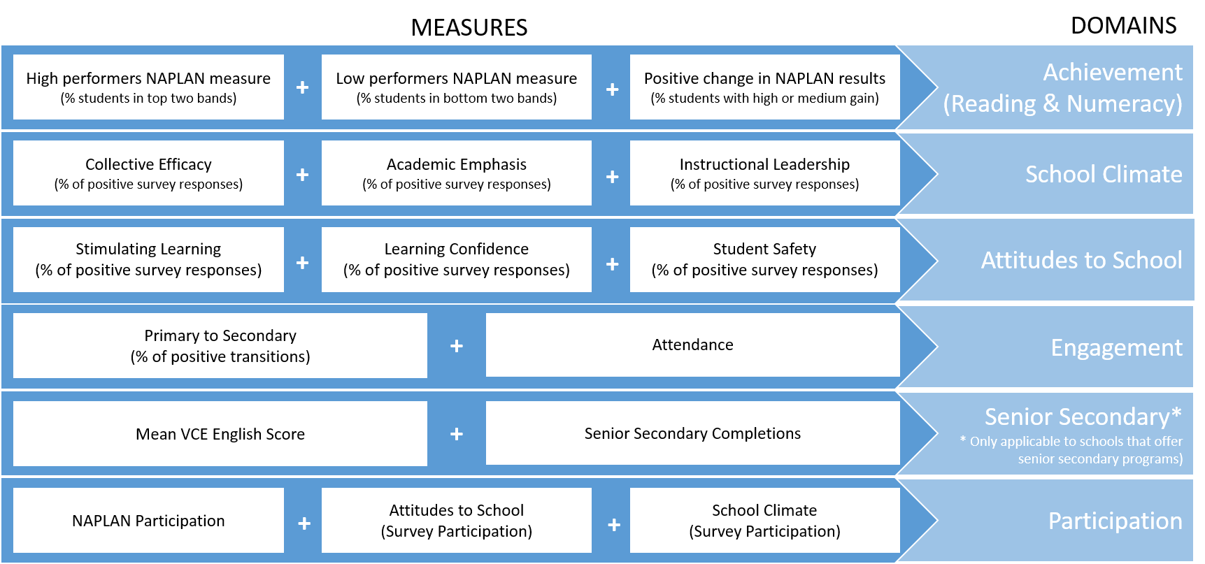
Fig 2: The School Performance Group Method Measures and Domains

For each measure, the current (most recent) result and the change in results (over the last three years) for all schools in Victoria are collated and categorised into five levels:

Current Level | Change Level
5 – Very high | 5 – Increased significantly
4 – High | 4 – Increased
3 – Medium | 3 – Maintained
2 – Low | 2 – Decreased
1 – Very low | 1 – Decreased significantly

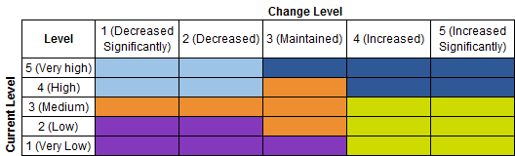
These levels are combined into a five-by-five table, and each school’s performance is plotted into one of 25 segments, for each measure.
A school’s placement within the table, based on their current performance and change in performance over the last three years, determines their performance group for each measure.
The performance group results for each measure are then combined to give a domain performance group, and the domain performance groups are combined to give the overall performance group for the school.
To receive a performance group result, schools must have a sufficient number of statistically valid measures. A valid measure can only be calculated if there are more than 5 data points or respondents. Therefore, performance measures for a domain can only be aggregated when there are enough valid measures available. Schools will receive a performance group against the domains and measures for which sufficient data is available. Their school performance report identifies how many domains and measures had sufficient data to determine a performance group.
This following pages provide the definition of each of the measures included in the Method.

DOMAIN: Achievement (Literacy)

MEASURE: Percentage of students in the top two bands of NAPLAN Reading

What is it?
The proportion of students in each school who achieved in the top two bands of NAPLAN reading.
The measure is reported for:
- Year 5 (Primary, Pri/Sec)
- Year 9 (Secondary, Pri/Sec)
The measure is aligned to the Education State target of more students achieving the highest levels of achievement in reading.
This measure does not apply to senior secondary colleges that provide only Years 10, 11 and 12.

How is it calculated?
The percentage of students in the top two bands is calculated by dividing the total number of students who achieve in the top two NAPLAN bands for reading (the numerator) by the number of students who sat NAPLAN reading, including exempt students (the denominator).

How is current result calculated?
The latest year of NAPLAN data is used to calculate the current result.

How is change result calculated?
The average change is calculated from the difference in current result and result two years prior divided by two.

When is it updated?
Annually, August (using preliminary data). For the first release (August 2017) of the school performance groups, preliminary August 2017 is used for current result and 2015 to preliminary 2017 for change result.

Data provider:
Victoria Curriculum and Assessment Authority (VCAA)

DOMAIN: Achievement (NUMERacy)

MEASURE: Percentage of students in the top two bands of NAPLAN Numeracy

What is it?
The proportion of students in each school who achieved in the top two bands of NAPLAN numeracy.
The measure is reported for:
- Year 5 (Primary, Pri/Sec)
- Year 9 (Secondary, Pri/Sec)
The measure is aligned to the Education State target of more students achieving the highest levels of achievement in reading.
This measure does not apply to senior secondary colleges that provide only Years 10, 11 and 12.

How is it calculated?
The percentage of students in the top two bands is calculated by dividing the total number of students who achieve in the top two NAPLAN bands for numeracy (the numerator) by the number of students who sat NAPLAN numeracy, including exempt students (the denominator).

How is current result calculated?
The latest year of NAPLAN data is used to calculate the current result.

How is change result calculated?
The average change is calculated from the difference in current result and result two years prior divided by two.

When is it updated?
Annually, August (using preliminary data). For the first release (August 2017) of the school performance groups, preliminary August 2017 is used for current result and 2015 to preliminary 2017 for change result.

Data provider:
Victoria Curriculum and Assessment Authority (VCAA)

DOMAIN: Achievement (LITERacy)

MEASURE: Percentage of students in the bottom two bands of NAPLAN REading

What is it?
The proportion of students in each school who achieved in the bottom two bands of NAPLAN reading.
The measure is reported for:
- Year 5 (Primary, Pri/Sec)
- Year 9 (Secondary, Pri/Sec)
The measure focusses on lifting the performance of students above the National Minimum Standard in reading by reducing the proportion of students in the bottom two bands.
This measure does not apply to senior secondary colleges that provide only Years 10, 11 and 12.

How is it calculated?
The percentage of students in the bottom two bands is calculated by dividing the total number of students who achieved in the bottom two NAPLAN bands for reading (the numerator) by the number of students who sat NAPLAN reading, including exempt students (the denominator).

How is current result calculated?
The latest year of NAPLAN data is used to calculate the current result.

How is change result calculated?
The average change is calculated from the difference in current result and result two years prior divided by two.

When is it updated?
Annually, August (using preliminary data). For the first release (August 2017) of the school performance groups, preliminary August 2017 is used for current result and 2015 to preliminary 2017 for change result.

Data provider:
Victoria Curriculum and Assessment Authority (VCAA)

DOMAIN: Achievement (NUMERacy)

MEASURE: Percentage of students in the bottom two bands of NAPLAN Numeracy

What is it?
The proportion of students in each school who achieved in the bottom two bands of NAPLAN numeracy.
The measure is reported for:
- Year 5 (Primary, Pri/Sec)
- Year 9 (Secondary, Pri/Sec)
The measure focusses on lifting the performance of students above the National Minimum Standard in numeracy by reducing the proportion of students in the bottom two bands.
This measure does not apply to senior secondary colleges that provide only Years 10, 11 and 12.

How is it calculated?
The percentage of students in the bottom two bands is calculated by dividing the total number of students who achieved in the bottom two NAPLAN bands for numeracy (the numerator) by the number of students who sat NAPLAN numeracy, including exempt students (the denominator).

How is current result calculated?
The latest year of NAPLAN data is used to calculate the current result.

How is change result calculated?
The average change is calculated from the difference in current result and result two years prior divided by two.

When is it updated?
Annually, August (using preliminary data). For the first release (August 2017) of the school performance groups, preliminary August 2017 is used for current result and 2015 to preliminary 2017 for change result.

Data provider:
Victoria Curriculum and Assessment Authority (VCAA)

DOMAIN: Achievement (literacy)

MEASURE: Percentage of students with high or medium levels of learning gain, reading

What is it?
The proportion of students in each school who have experienced either a high or medium level of learning gain over the previous two years in reading. This measure is relative to their ‘peers’ who started on exactly the same NAPLAN score in reading two years earlier.
The measure is reported for students across the State from:
- Years 3 to 5 (Primary, Pri/Sec)
- Years 7 to 9 (Secondary, Pri/Sec)
The measure focusses on the growth of individuals and cohorts, acknowledging that with the right support and expert teaching, all students can improve their learning, regardless of their starting point. Because the relative gain measures take account of students’ different starting points, they provide a fairer way to compare the gain/growth achieved in schools with different student intake characteristics. As such, within the ‘Achievement (Literacy)’ domain this measure is given more emphasis by attracting three times the weight of other achievement measures.
This measure does not apply to senior secondary colleges that provide only Years 10, 11 and 12.

How is it calculated?
This measure is calculated by comparing the growth of each student across the State in Years 5 and 9, to the growth of all other students who achieved exactly the same starting score two years earlier, in Years 3 and 7 respectively.

How is current result calculated?
The average change is calculated from the difference in current results and results two years prior, divided by two.

How is change result calculated?
The average change is calculated from the difference in current result and result two years prior divided by two.

When is it updated?
Annually, August (using preliminary data). For the first release (August 2017) of the school performance groups, preliminary August 2017 is used for current result and 2015 to preliminary 2017 for change result.

Data provider:
Victoria Curriculum and Assessment Authority (VCAA)

DOMAIN: Achievement (NUMERAcy)

MEASURE: Percentage of students with high or medium levels of learning gain, numeracy

What is it?
The proportion of students in each school who have experienced either a high or medium level of learning gain over the previous two years in numeracy. This measure is relative to their ‘peers’ who started on exactly the same NAPLAN score in numeracy two years earlier.
The measure is reported for students across the State from:
- Years 3 to 5 (Primary, Pri/Sec)
- Years 7 to 9 (Secondary, Pri/Sec)
The measure focusses on the growth of individuals and cohorts, acknowledging that with the right support and expert teaching, all students can improve their learning, regardless of their starting point. Because the relative gain measures take account of students’ different starting points, they provide a fairer way to compare the gain/growth achieved in schools with different student intake characteristics. As such, within the ‘Achievement (Numeracy)’ domain this measure is given more emphasis by attracting three times the weight of other achievement measures.
This measure does not apply to senior secondary colleges that provide only Years 10, 11 and 12.

How is it calculated?
This measure is calculated by comparing the growth of each student across the State in Years 5 and 9, to the growth of all other students who achieved exactly the same starting score two years earlier, in Years 3 and 7 respectively.

How is current result calculated?
The average change is calculated from the difference in current results and results two years prior, divided by two.

How is change result calculated?
The average change is calculated from the difference in current result and result two years prior divided by two.

When is it updated?
Annually, August (using preliminary data). For the first release (August 2017) of the school performance groups, preliminary August 2017 is used for current result and 2015 to preliminary 2017 for change result.

Data provider:
Victoria Curriculum and Assessment Authority (VCAA)

DOMAIN: SCHOOL CLIMATE

MEASURE: Percentage of staff with positive endorsement in Collective Efficacy

What is it?
The measure indicates the extent to which the staff in a school endorse their school as having a positive climate in ‘Collective Efficacy’.
The measure is a lead indicator for achievement.
The measure is reported by school type.

How is it calculated?
This measure is calculated as the total proportion of positive responses (strongly agree/agree) to the ‘Collective Efficacy’ component in the School Climate module of the annual School Staff Survey. It shows the strength of positive endorsement by the staff.
The numerator is the number of positive responses against the ‘Collective Efficacy‘ component. Non-teaching staff that responded to the survey are also included. The denominator is the total number of responses (including invalid responses).

How is current result calculated?
The latest year of School Staff Survey is used to calculate the current result.

How is change result calculated?
The average change is calculated from the difference in current result and result two years prior divided by two.

When is it updated?
Annually in October, based on the survey conducted in August-September. For the first release (August 2017) of the school performance groups, the 2016 survey results are used for current result and 2014 to 2016 for change result.

Data provider:
Victorian government schools

DOMAIN: SCHOOL CLIMATE

MEASURE: Percentage of staff with positive endorsement in Academic Emphasis

What is it?
The measure indicates the extent to which the staff in a school endorse their school as having a positive climate in ‘Academic Emphasis’.
The measure is a lead indicator for achievement.
The measure is reported by school type.

How is it calculated?
This measure is calculated as the total proportion of positive responses (strongly agree/agree) to the ‘Academic Emphasis’ component in the School Climate module of the annual School Staff Survey. It shows the strength of positive endorsement by the staff.
The numerator is the number of positive responses against the ‘Academic Emphasis‘ component. Non-teaching staff that responded to the survey are also included. The denominator is the total number of responses (including invalid responses).

How is current result calculated?
The latest year of School Staff Survey is used to calculate the current result.

How is change result calculated?
The average change is calculated from the difference in current result and result two years prior divided by two.

When is it updated?
Annually in October, based on the survey conducted in August-September. For the first release (August 2017) of the school performance groups, the 2016 survey results are used for current result and 2014 to 2016 for change result.

Data provider:
Victorian government schools

DOMAIN: SCHOOL CLIMATE

MEASURE: Percentage of staff with positive endorsement in Instructional Leadership

(not yet included)

What is it?
The measure indicates the extent to which the staff in a school endorse their school as having a positive climate in ‘Instructional Leadership’.
The measure is reported by school type.

How is it calculated?
This measure is calculated as the total proportion of positive responses (strongly agree/agree) to the ‘Instructional Leadership’ component in the School Leadership module (from 2017) of the annual School Staff Survey. It shows the strength of positive endorsement by the staff.
The numerator is the number of positive responses against the ‘Instructional Leadership‘ component. Non-teaching staff that responded to the survey are also included. The denominator is the total number of responses (including invalid responses).

How is current result calculated?
The latest year of School Staff Survey will be used to calculate the current result.

How is change result calculated?
The average change will be calculated from the difference in current result and result two years prior divided by two.

When is it updated?
Annually in October, based on the survey conducted in August-September. For the first release (August 2017) of the school performance groups, this measure is not incorporated as is it reliant on the 2017 survey results (where all schools were required to respond to the Instructional Leadership items, which were previously part of the optional School Leadership module).

Data provider:
Victorian government schools

DOMAIN: Attitudes to School

MEASURE: Percentage of students with positive attitude to Stimulating Learning

What is it?
The measure indicates the extent to which the students in a school are positive about their school in ‘Stimulating Learning’.
The measure is a lead indicator for the Education State Learning for Life targets (reading and numeracy achievement).
The measure is reported for students in:
- Years 5 to 6 (Primary, Pri/Sec)
- Years 7 to 12 (Secondary, Pri/Sec)

How is it calculated?
This measure is calculated as the total proportion of positive responses (strongly agree/agree) to the ‘Stimulating Learning’ factor in the Student Attitudes to School survey. It shows the strength of positive attitude by the students.
The numerator is the number of positive responses against the ‘Stimulation Learning’ factor. The denominator is the total number of responses (including invalid responses).

How is current result calculated?
The latest year of Student Attitudes to School survey is used to calculate the current result.

How is change result calculated?
The average change is calculated from the difference in current result and result two years prior divided by two.

When is it updated?
Annually in August, based on survey conducted in July. For the first release (August 2017) of the school performance groups, the 2016 survey results are used for current result and 2014 to 2016 for change result. This was due to a new survey being run in 2017 and the timeline for data availability varying from previous years.

Data provider:
Victorian government schools

DOMAIN: Attitudes to School

MEASURE: Percentage of students with positive attitude to Learning Confidence

What is it?
The measure indicates the extent to which the students in a school are positive about their school in ‘Learning Confidence’.
The measure is a lead indicator for the Education State Learning for Life targets (reading and numeracy achievement).
The measure is reported for students in:
- Years 5 to 6 (Primary, Pri/Sec)
- Years 7 to 12 (Secondary, Pri/Sec)

How is it calculated?
This measure is calculated as the total proportion of positive responses (strongly agree/agree) to the ‘Learning Confidence’ factor in the Student Attitudes to School survey. It shows the strength of positive attitude by the students.
The numerator is the number of positive responses against the ‘Learning Confidence’ factor. The denominator is the total number of responses (including invalid responses).

How is current result calculated?
The latest year of Student Attitudes to School survey is used to calculate the current result.

How is change result calculated?
The average change is calculated from the difference in current result and result two years prior divided by two.

When is it updated?
Annually in August, based on survey conducted in July. For the first release (August 2017) of the school performance groups, the 2016 survey results are used for current result and 2014 to 2016 for change result. This was due to a new survey being run in 2017 and the timeline for data availability varying from previous years.

Data provider:
Victorian government schools

DOMAIN: Attitudes to School

MEASURE: Percentage of students with positive attitude to School Safety

What is it?
The measure indicates the extent to which the students in a school are positive about their school in ‘School Safety’.
The measure is reported for students in:
- Years 5 to 6 (Primary, Pri/Sec)
- Years 7 to 12 (Secondary, Pri/Sec)

How is it calculated?
This measure is calculated as the total proportion of positive responses (strongly agree/agree) to the ‘School Safety’ factor in the Student Attitudes to School survey. It shows the strength of positive attitude by the students.
The numerator is the number of positive responses against the ‘School Safety’ factor. The denominator is the total number of responses (including invalid responses).

How is current result calculated?
The latest year of Student Attitudes to School survey is used to calculate the current result.

How is change result calculated?
The average change is calculated from the difference in current result and result two years prior divided by two.

When is it updated?
Annually in August, based on survey conducted in July. For the first release (August 2017) of the school performance groups, the 2016 survey results are used for current result and 2014 to 2016 for change result. This was due to a new survey being run in 2017 and the timeline for data availability varying from previous years.

Data provider:
Victorian government schools

DOMAIN: engagement

MEASURE: Attendance rate

What is it?
The measure indicates the proportion of enrolled days (accounting for the student’s FTE) that were attended by students in each school, where attendance is based on school days and excludes any absences taken in the course of delivering the curriculum (camps, excursions, work-experience, etc.).
The measure is reported by school type.

How is it calculated?
The attendance rate is calculated by dividing the total enrolled days less the total number of days of absence taken (the numerator) by the total enrolled days (the denominator).
The number of days of absence taken is calculated in either half day units or school periods.

How is current result calculated?
The latest full year attendance data is used to calculate the current result.

How is change result calculated?
The average change is calculated from the difference in current result and result two years prior divided by two.

When is it updated?
Student attendance rates are updated daily, however a full year of data is required for this measure. For the first release (August 2017) of the school performance groups, the 2016 attendance data is used for the current result and 2014 to 2016 for change result.

Data provider:
Victorian government schools

DOMAIN: participation

MEASURE: Percentage of students participating in NAPLAN assessment

What is it?
The proportion of students in each school who sat or were exempted from NAPLAN assessment in reading.
The measure is reported for:
- Year 5 (Primary, Pri/Sec)
- Year 9 (Secondary, Pri/Sec)
This measure does not apply to senior secondary colleges that provide only Years 10, 11 and 12.

How is it calculated?
The percentage of students participating in NAPLAN is calculated by dividing the total number of students who attended (including exempted) NAPLAN reading (the numerator), by the total number of students who either attended, exempted, absent or withdrawn from NAPLAN reading (the denominator).

How is current result calculated?
The latest year of NAPLAN data is used to calculate the current result.

How is change result calculated?
The average change is calculated from the difference in current result and result two years prior divided by two.

When is it updated?
Annually, August (using preliminary data). For the first release (August 2017) of the school performance groups, preliminary August 2017 is used for current result and 2015 to preliminary 2017 for change result.

Data provider:
Victoria Curriculum and Assessment Authority (VCAA)

DOMAIN: participation

MEASURE: Percentage of students participating in Attitudes to School Survey

What is it?
The proportion of students in each school who participated in the Attitudes to School survey (ATOSS).
The measure is reported for:
- Year 5 (Primary, Pri/Sec)
- Year 9 (Secondary, Pri/Sec)
This measure does not apply to senior secondary colleges that provide only Years 10, 11 and 12.

How is it calculated?
The percentage of students participating in ATOSS is calculated by dividing the total number of students who responded to the survey (the numerator) by the total number of students who were enrolled in the relevant year levels (the denominator).

How is current result calculated?
The latest year of ATOSS data is used to calculate the current result.

How is change result calculated?
The average change is calculated from the difference in current result and result two years prior divided by two.

When is it updated?
Annually in August, based on survey conducted in July. For the first release (August 2017) of the school performance groups, the 2016 survey results are used for current result and 2014 to 2016 for change result. This was due to a new survey being run in 2017 and the timeline for data availability varying from previous years.

Data provider:
Victorian government schools

DOMAIN: participation

MEASURE: Percentage of staff participating in School Staff Survey

What is it?
The proportion of staff in each school who participated in the School Staff Survey.
The measure is reported by school type.

How is it calculated?
The percentage of staff participating in School Staff Survey is calculated by dividing the total number of staff who responded to the survey (the numerator) by the total number of staff who were invited to participate the survey (the denominator).

How is current result calculated?
The latest year of School Staff Survey is used to calculate the current result.

How is change result calculated?
The average change is calculated from the difference in current result and result two years prior divided by two.
For schools that were invited to participate in the staff survey for the first time in the latest year, the change result is set to “Maintained” in order to include as many schools as possible.

When is it updated?
Annually in October, based on the survey conducted in August-September. For the first release (August 2017) of the school performance groups, the 2016 survey results are used for current result and 2014 to 2016 for change result.

Data provider:
Victorian government schools

DOMAIN: senior secondary

MEASURE: Completing School

What is it?
The proportion of eligible Year 12 students who completed a Victorian Certificate of Education (VCE) or Victorian Certificate of Applied Learning (VCAL).
The measure tracks the Education State Target for Staying in Education. This is an interim measure. It may be replaced with a measure which also accounts for VET completion.
The measure is reported for Secondary and Pri/Sec schools only.

How is it calculated?
The percentage of Year 12 or equivalent completion is calculated by dividing the total number of students who completed either VCE and/or VCAL (the numerator) by the total number of students who were eligible to complete VCE or enrolled in a VCAL certificate at the Intermediate or Senior Level (the denominator).

How is current result calculated?
The latest year of Year 12 or equivalent completion data is used to calculate the current result.

How is change result calculated?
The average change is calculated from the difference in current result and result two years prior divided by two.

When is it updated?
Annually in January. For the first release (August 2017) of the school performance groups, the Year 12 or equivalent completion data for 2016 is used for the current result and 2014 to 2016 for the change result.

Data provider:
Victorian Curriculum and Assessment Authority (VCAA)

DOMAIN: senior secondary

MEASURE: Mean VCE English score

What is it?
The average study score achieved by students in VCE English (subject).
This is an interim measure. It may be replaced with a measure that measures the school ‘value add’ to the student learning in Year 12.
The measure is reported for Secondary and Pri/Sec schools only.

How is it calculated?
The mean VCE English score is calculated by dividing the total scores achieved by students who sat the VCE English subject (the numerator) by the total number of students who sat the VCE English subject (the denominator).

How is current result calculated?
The latest year of mean VCE English score is used to calculate the current result.

How is change result calculated?
The average change is calculated as the average annual percentage change between the mean score in the current result and the mean score two years prior.

When is it updated?
Annually in January. For the first release (August 2017) of the school performance groups, the mean VCE score data for 2016 is used for the current result and 2014 to 2016 for the change result.

Data provider:
Victorian Curriculum and Assessment Authority (VCAA)

