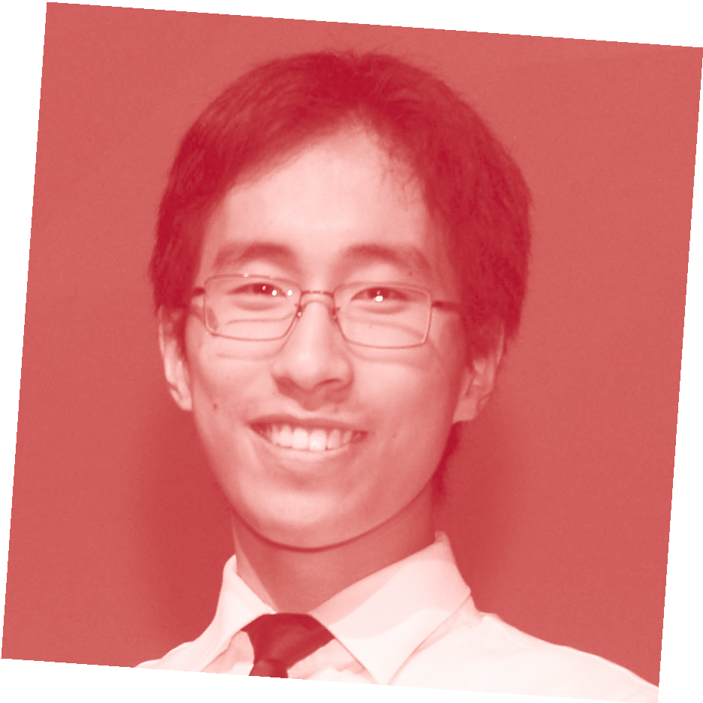SPECIALIST MATHEMATICS
VCE EXAM ADVICE FROM PREMIER’S VCE AWARD RECIPIENTS

STEPHEN ZHANG RECEIVED A VCE SCORE 50 IN CHEMISTRY AND 47 IN SPECIALIST MATHEMATICS IN 2015. HIS ADVICE BELOW RELATES TO SPECIALIST MATHEMATICS WHICH HE CLAIMS AS HIS “FIRST LOVE”.
My name is…
Stephen Zhang
I went to…
Distance Education Centre Victoria
In Specialist Mathematics , I received a score of…
47
The thing I liked best about doing this subject was…
I was fascinated by how the same ideas and techniques I learned could be applied to solve problems in a vast
range of situations. For instance, vectors and calculus (my favourite!) were linked closely to physics and chemistry, whilst differential equations can be used to explain a range of diverse phenomena.
The best advice I can give VCE students about this exam is…
Throughout the year, focus on fully understanding the concepts inside out, rather than purely doing questions.
Unlike science subjects, mathematics is one of those subjects for which
everything is precise and absolute - there are never exceptions to principles but only deeper meaning. I would strongly thinking through derivations and drawing links rather than memorising formulas.
For instance, why does integration by substitution work? And why is dy/dx=1/ (dx/dy)? Harder exam questions subtly test conceptual understanding as well as problem solving skills by requiring
students to apply known concepts to new situations. Importantly, many concepts have geometrical interpretations, and an ability to visualise concepts in problems is key to exam success.
Specialist Maths, like Maths Methods, relies heavily on the CAS calculator.

However, as a general rule, I always did what I could by hand. Nevertheless, I was very adept at using the CAS from early on in the year, writing programs to automate speciﬁc calculations. These
came in very handy in the exam to check a computation I had done by hand! The exams themselves are quite gruelling and there is a lot of competition. Neatness and meticulousness in working greatly
is important to maintain a logical line of thought and not get ‘lost’ in mid- question. Highlight key information when it comes to exam questions - this may sound silly, but an unbelievable number of marks can be lost simply
by not carefully reading the question! Finally, practice makes perfect. The more questions you do, the more familiar you become with the methods and concepts being tested.
The best advice I got from my teacher about this exam was…
Relax and do your best! There comes a point when the best thing to do is simply to relax and have conﬁdence in yourself.
In the month before this VCE exam, I…
I had ﬁnished the course content in July, and was down to doing practice exams. I marked my practice exams according to the examiner’s reports, and made
a compilation of all my mistakes on my computer. A large proportion (say over 90%) of my mistakes were due to careless errors. (If you can manage to only make careless mistakes, then that is a sign that you have at least
mastered the concepts!). As time went on, I experimented with techniques to
combat these errors, including re-reading the question after working through it, checking that I’ve answered all aspects of the question, put appropriate units in, etc.
- a true lifesaver! I regularly contacted my teacher, asking for advice on how to set out working, etc. My teacher was also able to mark some of my practice exams, which was a great help.
In the week before this VCE exam I… I rested well, and did some practice questions for the upcoming Methods

and Specialist exams in order to keep my performance on peak.
On exam day, I prepared myself by…
For the ﬁrst exam, I was rather exhausted from my exertions in the two preceding Methods exams. Further, I couldn’t
sleep the night before, probably due to excitement! As it happened, I didn’t end up doing as well as I had hoped in the ﬁrst exam. I spent the ensuing weekend psyching up for the upcoming Exam 2. The day of Exam 2 I spent in a state of rest, leisurely looking through my bound reference. My mum drove me on the hour-long journey to the exam centre, during which I relaxed and let my mind rest, listening to some music. Keeping my mind off the exam helped me to calm my nerves.
After the exam, I….
I relaxed on the long drive home. I’ll be honest and say that I couldn’t help thinking over the questions I had
done. I slept early, preparing myself for Chemistry the next day.
The best exam advice I received from my parents, siblings or friends was…
To keep doing my best no matter what, and to face the exam with conﬁdence.
I did/didn’t work a part-time job during year 12 because…
was a bit busy with all 6 subjects in one year. I felt that, just for that one year, I needed to keep my attention on studying.

For more tips like this and for advice about looking after yourself during vce exams, please visit www.education.vic.gov.au/school/students/pages/vce.aspx

