PSYCHOLOGY
VCE EXAM ADVICE FROM PREMIER’S VCE AWARD RECIPIENTS

JANET DAVEY RECEIVED A PERFECT VCE PSYCHOLOGY SCORE IN 2013.
My name is…
Janet Davey
I went to…
Ruyton Girls’ School
In VCE Psychology, I received a score of…
50
The thing I liked best about doing this subject was…
that not only was it interesting, but the topics – such as sleep, memory, and learning – felt relevant (unlike many other subjects) and helped me in my other subjects as well.
This year (2014) I am doing…
a Bachelor of Science/Asia-Paciﬁc Studies at ANU, majoring in Physics and Chinese.
The best advice I can give VCE students about this exam is… word your answers carefully, and
make sure you get the key terms in.
Know research methods inside out, because many students neglect it.
Have examples prepared beforehand and check with your teacher that they’re right. Don’t try to be really original with them, just keep them simple and nail them.
The best advice I got from my teacher about this exam was…
this is probably a pretty speciﬁc problem, but my wonderful teacher kept telling me to stop overthinking the questions and not waffle on in my
answers. Many students don’t know this, but you can actually write your answers in dot-points, and many examiners prefer this because it’s clearer.
In the month before this VCE exam, I… guess I studied Psych at least a little bit every day. I made a million tables and mind-maps summarising topics or comparing different theories and stuck them up all around my house until there were no free walls left.
After reading these for months, the information stuck with me. To stay sane in the lead-up to exams I went running or cycling every afternoon and drank a lot of tea.
In the week before this VCE exam I... did practice exams. But almost more important than completing practice exams is correcting them and understanding how your answer differs from the given solution. I kept a little notebook, and I’d write down every question I got wrong, what
the correct answer was, and the key terms needed to get full marks.
On exam day, I prepared myself by…
the Psych exam started at 9:00 am, so I don’t think I did anything beforehand, other than have breakfast and read over my errors notebook.
After the exam, I…
went straight home. The exam was on a Friday and I didn’t have another exam until mid-way through the
following week, so that afternoon I just did some ‘light’ Methods study and went for a run.

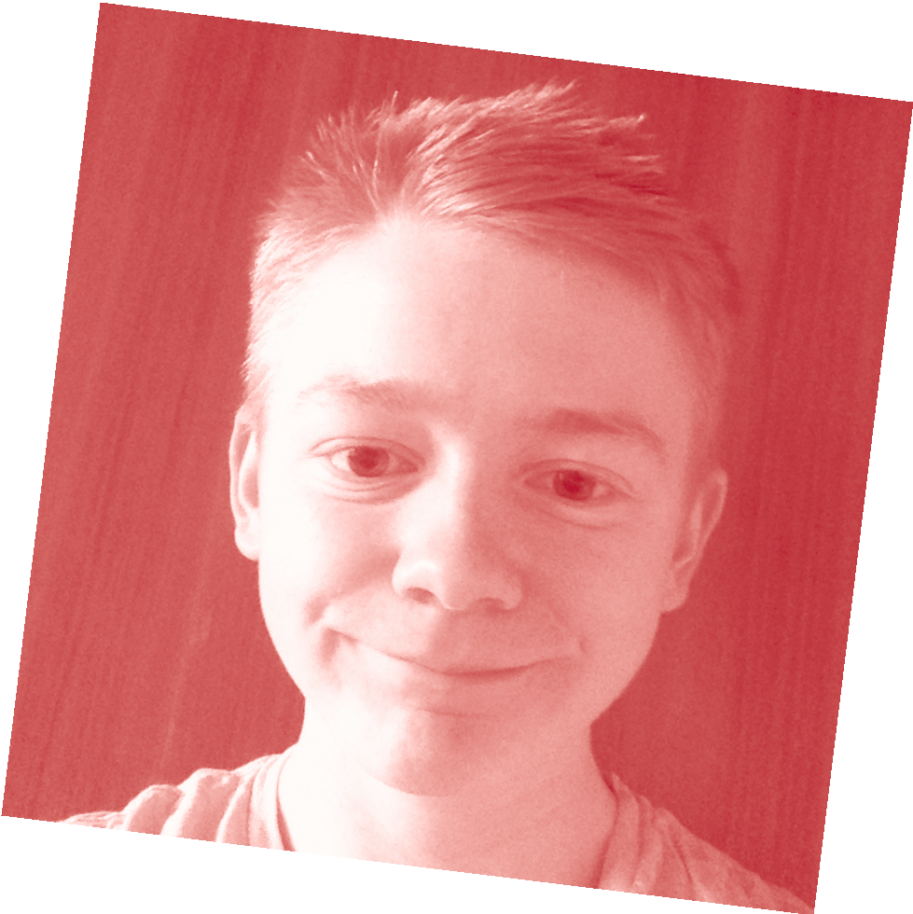

The best exam advice I received from my parents, siblings or friends was… calm down.
I didn’t work a part-time job during year 12 because…
I didn’t want to add another thing to an already stressful year, and would have struggled to ﬁnd the time for it.

For more tips like this and for advice about looking after yourself during vce exams, please visit
www.education.vic.gov.au/school/ students/pages/vce.aspx

