PSYCHOLOGY
VCE EXAM ADVICE FROM PREMIER’S VCE AWARD RECIPIENTS

CHERRY SKINNER TARLO RECEIVED A PERFECT PSYCHOLOGY SCORE IN 2013.
My name is…
Cherry Skinner Tarlo
I went to…
Newhaven College, Philip Island.
In VCE Psychology, I received a score of…
50
The thing I liked best about doing this subject was…
Learning about how we, as humans, function and respond to our environment. I also enjoyed analysing the brain and its complex ability to create life in people.
This year (2014) I am doing… Bachelor of Psychology/Criminology at RMIT University, City Campus.
The best advice I can give VCE students about this exam is… always use the name of the person if it is mentioned in the question (often used in examples).
Use your time wisely: look at the allocated marks and structure your time accordingly.
When doing practice exams, try completing the sections (multiple choice, short answer and extended response) in different orders and ﬁnd out what works best for you.
The best advice I got from my teacher about this exam was…
In the month before this VCE exam, I…
devised a study plan for myself, and stuck to it, giving myself small
rewards after chunks of study, such as watching a tv show or online shopping! I made cue cards and practised with friends and family, talked often with my teacher about areas I felt unsure of and explained concepts to friends/ family (this really is conﬁrmation of your knowledge when you have to teach it). I maintained a study/life balance by remembering that it will all be okay in the long run, making plans for things I was excited about, doing regular exercise, taking time out to enjoy meals, and organising my time so I wasn’t having to stay up late at night studying.
In the week before this VCE exam I… went to as many revision lectures/ workshops as possible (run both inside and outside of school), meticulously worked through past exams with my teacher, spent time at school studying, familiarised myself with the classroom where exams were to be held, continued to do timed practice exams and worked with my teacher to ﬁgure out how I could optimise my mark.
I forced myself to have breaks, do exercise every day, follow a study plan to ensure I was managing my time correctly, made posters, flash cards, notes, and stuck them all around my house, including my bedroom, the bathroom, toilet and kitchen.
On exam day, I prepared myself by…

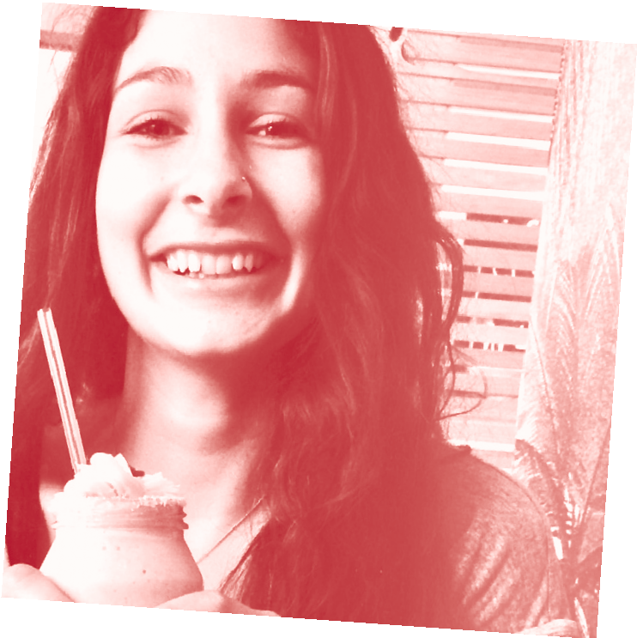

After the exam, I….
talked with my friends and other students about how they went, debriefed with my teacher, had a break for lunch, felt conﬁdent that I had done my best, and then began studying for another exam.
The best exam advice I received from my parents, siblings or friends was… that all you can do is your best, and that if you’re unhappy with your results, it’s not the end of the world, and there are always alternative pathways.
I didn’t work a part-time job during year 12 because…
I found I had no spare time, and what little time I did have, I thought it was more important to create balance
in my life with healthy food, exercise and time out for myself and my family, rather than earn a subsidiary income.

do as many accredited practice exams as possible under timed
briefly reviewing my notes, but not in
too much depth. I ate a good, hearty

conditions in an exam-like setting.
Only write as much as you need to gain the full marks.
Have faith in yourself.
breakfast, had my bag packed the
night before, left more than enough time to get there, reassured myself that everything was going to be okay and that if I didn’t go as well as I hoped, that it wasn’t the end of the world. I sought conﬁrmation from my teacher and knew that all I could do was my best.
For more tips like this and for advice
about looking after yourself during vce exams, please visit
www.education.vic.gov.au/school/ students/pages/vce.aspx

