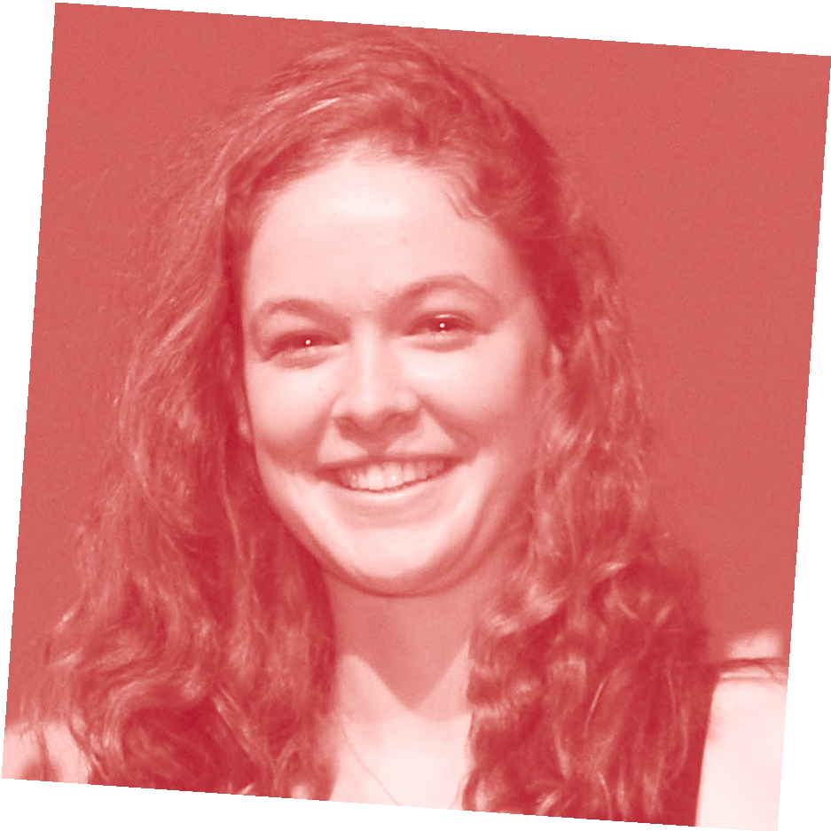PHYSICAL EDUCATION
VCE EXAM ADVICE FROM PREMIER’S VCE AWARD RECIPIENTS

ANGHARAD NEAL-WILLIAMS RECEIVED A PERFECT VCE PE SCORE IN 2015.
My name is…
Angharad Neal-Williams
I went to…
Canterbury Girls’ Secondary College
In Physical Education , I received a score of…
50
The thing I liked best about doing this subject was…
Physical Education was an enjoyable and rewarding subject as the content I learnt in class could be applied to the sports I played and to my everyday life. I found the information I learnt interesting; it helped me to understand how my body was working when I was playing sport, and therefore provided me with practical knowledge that I could use every day. PE was also a great subject to study in Year 12 because the practical classes meant that I got a break from sedentary study and could have a chance to exercise and refresh my mind before returning to class.
The best advice I can give VCE students about this exam is…
Keep your answers short and to the point. Only include information in your answer that direct relates to the question being asked, otherwise it is a waste of time.
This is very hard to learn to do and it took me a long time to adjust to doing it as it can be very tempting to write everything you know! It is also a good idea to provide examples in your answers where appropriate. Then, if your explanation isn’t as clear as it could be, providing
a relevant example can enhance the answer and show to the examiner that you understand the question and have the ability to apply your knowledge.
The best advice I got from my teacher about this exam was…
To stay calm, and enjoy it! This made me feel more conﬁdent: that I was prepared for the exam and to not have any last minute doubts. Other good advice from my teacher was to think about the exam as the year’s SACs all in the one paper. This made the exam seem more simple and achievable and reduced the build-up that is associated with exams.
In the month before this VCE exam, I… I had just about ﬁnished all my revision and was spending every spare minute completing practice exams. Practice exams are the best form of revision as they are the closest thing you can get to the actual day. Revision of notes is
important, but I tried to ﬁnish this as early as possible so that I had time to reﬁne the concepts I had the most trouble with and could spend all my time doing exams.
In the week before this VCE exam I…
I had done all revision and completed all of the exams I could get my hands on. I did the most recent VCAA exam one or two weeks before the day then spent the rest of the week reading the suggested answers from that; I ﬁgured the exam wouldn’t change that much from year to year so looking at the highest response answers could be highly valuable. I also did one last check over the study design to ensure I’d covered and exhausted absolutely every concept.
On exam day, I prepared myself by… Going for a swim! I swam laps in the local pool either on the morning of, or the night before, all of my exams. This helped me to avoid stressing or doubting myself. It helped me to relax and to get in a calm and resilient headspace, which is vital
in the examination. Also, I arrived at the exam on time but not too early. This helped me avoid the nervousness of other people getting me out of this zone!

After the exam, I….
ripped down all the study posters that I had stuck all around the house as a way of revision, put my notes and exams in the lounge room out of my sight, and put the exam behind me. There was no point dwelling or thinking about it, so I began focusing on my next exams.
The best exam advice I received from my parents, siblings or friends was…
It doesn’t matter, it’s just an exam. Advice like this helped me to keep perspective, and to focus on trying my absolute hardest, but not worrying about the outcome because I had enjoyed the classes and the year. Lots of people gave me advice such as ‘hard work will pay off’. Although I didn’t really believe it at the time, it proved to be true. My main advice is to go in to the exam feeling conﬁdent. Backing yourself is vital.
I did/didn’t work a part-time job during year 12 because…
It gave me time away from study and I could be with fun people at work who
weren’t doing Year 12. It was a good stress relief because whenever I was at work, VCE was irrelevant. I worked around 10hours
a week but stopped a bit over a month before exams so I could focus on study. I had a really busy timetable in Year 12;
I worked, played sport, socialised with friends and was school captain. I ﬁgured the more spare time I had, the more time I had to waste. By ﬁlling my schedule it meant I savoured every minute and used my time most effectively.

For more tips like this and for advice about looking after yourself during vce exams, please visit www.education.vic.gov.au/school/students/pages/vce.aspx

