HEALTH AND HUMAN DEVELOPMENT
VCE EXAM ADVICE FROM PREMIER’S VCE AWARD RECIPIENTS

CHLOE NALL RECEIVED A PERFECT VCE HEALTH AND HUMAN DEVELOPMENT SCORE IN 2013
My name is…
Chloe Nall
I went to…
Strathcona Baptist Girls Grammar School
In VCE Health and Human Development,
I received a score of…
50
The thing I liked best about doing this subject was…
that the content was always very relevant to current issues concerning worldwide health. I really enjoyed studying topics that wouldn’t necessarily be covered in other subjects, such as the differences in health status between developed and developing countries, and about various national and international health organisations.
This year (2014) I am doing…
the Bachelor of Nursing/Bachelor of Midwifery at La Trobe University.
The best advice I can give VCE students about this exam is… ensure you know the content and speciﬁc examples very well
(particularly deﬁnitions; know these off by heart!).
Look at the mark weighting for each
The best advice I got from my teacher about this exam was…
when completing Past Exam Papers, refer to the Examination Reports when correcting them; these were
a very useful resource, as they provided ideal responses to questions (including phrasing and deﬁnitions) that should be used in order to achieve top results.
In the exam, work through the paper logically; if there is a question that you’re ﬁnding particularly difﬁcult, move onto another question and then revisit that question later, in order to maximise time and avoid stress.
In the month before this VCE exam, I… tried to study Health every second day, if not every day; I would usually spend about 2 hours on it each time (enough time to complete a paper and mark
it). I found the best way to study was to recite my notes, rather than rewrite them, to ensure I had all deﬁnitions and concepts memorised perfectly.
I always had Friday nights off, and would catch up with friends; this was great motivation during the week.
In the week before this VCE exam I… handed heaps of practice exam papers and questions in to my teacher to mark. Her feedback was invaluable, as there was always room for improvement. I tried to make the most of my breaks during the day, and didn’t work past 9.00pm.
On exam day, I prepared myself by…

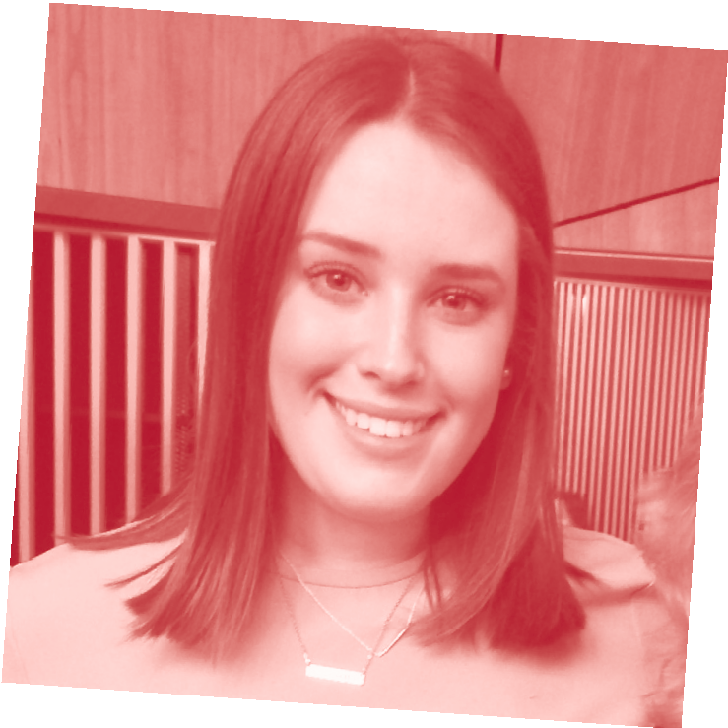

After the exam, I…
didn’t discuss it with my peers; it was out of my hands now! Health was my last exam, so I went out for dinner and saw a movie with a friend that night, and then spent the following weekend away to celebrate.
The best exam advice I received from my parents, siblings or family member was…
from my parents, but wasn’t necessarily ‘advice’ – “all we can ask is that you just try your hardest, we will be proud of you no matter what.”
I did work a part-time job during year 12 because…
I found study was much more effective when I had a few things on my plate (i.e. sport and working part- time). This meant I had to be more disciplined and time-efﬁcient when I did sit down to study.

question before answering; questions
that are weighted more heavily will
having a sleep in. Health was in the afternoon, so I just had a leisurely

require greater explanation and
discussion than those worth only 1 or 2 marks.
Be direct and straight to the point; read over your answers to ensure you have appropriately answered the question without waffling on.
morning at home. I didn’t review my notes at all that day – I was conﬁdent that I’d studied sufﬁciently and that there was nothing more I could do.
For more tips like this and for advice about looking after yourself during vce exams, please visit
www.education.vic.gov.au/school/ students/pages/vce.aspx

