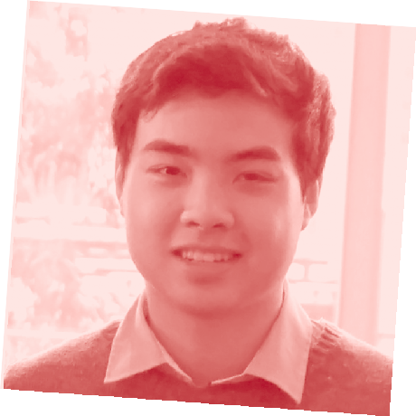FURTHER MATHS
VCE EXAM ADVICE FROM PREMIER’S VCE AWARD RECIPIENTS

SAMUEL GOH RECEIVED A PERFECT VCE FURTHER
MATHEMATICS SCORE IN 2013.
My name is…
Samuel Goh
I went to…
Rowville Secondary College.
In VCE Further Maths I received a score of…
50
The thing I liked best about doing this subject was…
Studying a wide range of topics due to the different modules available.
Doing maths that could actually be a little useful in the future.
The best advice I can give VCE students about this exam is… get to know your calculators well:
for both exams you can use a CAS calculator AND a scientiﬁc calculator. The better you are with the calculator, the less time you may spend ﬁddling around and the more time you have to solve problems.
Make a bound reference, but don’t go overboard: a bound reference in the exam can be really handy for quickly conﬁrming some knowledge, but there is no need for hundreds of pages. In the real exam there isn’t enough time to look through all your notes. Remember that the exam also comes with a formula sheet which covers MOST
of the formulas you need to know. Also, when constructing your bound reference make sure to look at the Study Design from the VCAA website which outlines everything you need to know for the exam.
Underline important information: There are often worded questions in exams with lots of information to introduce the question. Underline the most important pieces of information which you can use in your calculations such as angles, dates or prices.
If you have time, double check your answers and ﬁnd a way to make sure you’re correct!
This could mean eliminating other multiple choice answers, taking a different approach to the calculations or re-doing calculations on your CAS to make sure you didn’t type anything incorrectly.
The best advice I got from my teacher about this exam was…
take your time: if you’ve done a lot of practice, you may start to recognise similar questions showing up on exam papers. Sometimes it’s good to avoid rushing and slowing down, really taking in the details of the question and asking yourself: ‘is this really the same question I’ve done before? Or is there something different about it?’ It’s a little bit about speed versus accuracy. In the exam it’s good to have a balance.
Show working out and make it clear: there are often working marks allocated for longer questions. When tackling them, make sure your working out is clear and follows a logical order. The examiners need to understand what you’re doing so they can see that you know the content. It also makes it easier for you to spot any errors if you have time to check through your exam.
In the month before this VCE exam, I… worked through different practice exam papers, trying to get as
much exposure to different types of questions so I was well prepared for anything that could show up on the exam. I made sure I spent time
reviewing VCAA past year papers and their assessment reports – the reports are very detailed and can be very helpful. I made sure to record any big mistakes from the practice exams in a document on my computer.
In the week before this VCE exam I… continued working through practice exam papers – I think they are the best form of revision for mathematics subjects. I then ﬁnished off my bound reference by compiling all my recorded
mistakes into a word document, printing that off and putting it at the front of my bound reference. All of the areas which I was weak in could easily be seen on my bound reference.

On exam day, I prepared myself by… getting as much sleep possible, eating well, praying, watching videos online – I tried to stay as relaxed as possible and didn’t let the pressures of the imminent exam get to me. I already had my stationery and calculator ready the night before. I didn’t think cramming would do much on exam day for me; I had to trust that I had done all I could to prepare.
After the exam, I….
made sure I didn’t discuss the exam with others as I didn’t want to think about results until results day – there was nothing I could do about the exam that I had just completed. It was a bit of a personal preference. And I also had another exam the next day, so I had to get studying for that.
The best exam advice I received from my parents, siblings or friends was… simply to do my best. You can often get caught up in numbers, trying to ﬁgure out SAC scores work and how all the statistical moderation works. But the bottom line is, if you get to the end of the year having done all you can and tried your best with no regrets then there is deﬁnitely success in that.
I did work a part-time job during year 12 because…
I felt it was a good way to take a break from studying. In the second semester, I decreased the number of shifts I was working and when exams neared I let my supervisors know about exams and made sure I took many days off during exam period.

For more tips like this and for advice about looking after yourself during vce exams, please visit www.education.vic.gov.au/school/students/pages/vce.aspx

