CASES21 Student Supports tab
Quick Guide

The new Student Supports tab can be accessed via the Enter or Modify Student Enrolment Details – Daisychain Version [ST11001] or Tab Version [ST11001T]. The fields on this tab are to be checked and updated for all students before transferring to their new school. The example below provides a summary of what information would be entered for each field. Refer to Chapter 2 of the CASES21 Administration User Guide for further information regarding the student data transfer process. All information entered via this tab is included on the Current Student Details form.

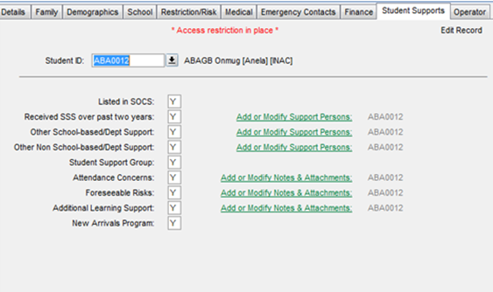
Is a record for the student listed in the Student Online Case System (SOCS)?
Has the student received Student Support Services (SSS) in the past two years? If yes, click on the Add or Modify Support Persons link.
Has the student received any other school-based or departmental support in the past two years (e.g. school nurse, chaplain, welfare officer or welfare coordinator, Koorie Education Support Officer or school-engaged allied health practitioner such as psychologist, counsellor, speech therapist, youth worker)? If yes, click on the Add or Modify Support Persons link to enter their details.

Has the student received external support (outside of the school) in the past two years (e.g. psychologist, counsellor, social worker, paediatrician, other medical specialists)? If yes, click on the Add or Modify Support Persons link to enter their details.

Has a Student Support Group been formed for the student?
Are there any concerns regarding the student’s attendance, including truancy? If yes, click on the Add or Modify Notes & Attachments link to enter details.
Has the student participated in a New Arrivals Program?
Is the student receiving additional learning support (e.g. English as an Additional Language, English/Maths intervention, gifted and talented)? If yes, click on the Add or Modify Notes & Attachments link to enter details.

Are there any foreseeable risks of harm to the student, or to others, due to the student’s behaviour, disability, family circumstances or background? If yes, click on the Add or Modify Notes & Attachments link to enter details.
For advice in regards to identifying and assessing foreseeable risk please see; Transferring ‘Foreseeable Risk’ Information Sheet

When you click on the Add or Modify Support Persons daisy chain link the following screen appears. The First Name, Surname and Support Role fields are mandatory.  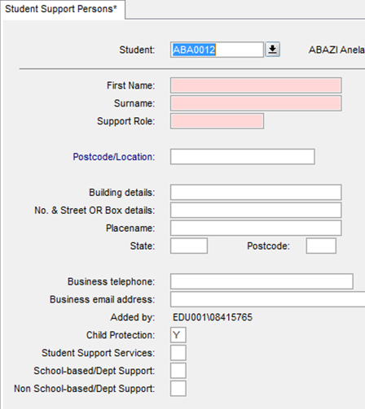 |  | When you click on the Add or Modify Notes and Attachments daisy chain link the following screen appears.  The drop down list under Notes/Attachment Type will default to the type of issue identified on the first screen. This can be changed if you wish to insert an additional comment or make a recommendation/s.  Documents can be attached to CASES21 via the Attachment field but will not be transferred as part of the Student Data Transfer process.

